How to use NodeEclipse

Install the nodejs plugin

Refer this link

<http://www.nodeclipse.org/updates/>

help -> install new software - > add link

http://www.nodeclipse.org/updates/

press enter

select 1stnodeeclipse and press next-finish

restart the eclipse

create the new workspace under the unit workspace

File –new node js project

RMB on the create project and import -> file system

From directory browse to the src directory of the dev unit

D:\workdir\devunits\patila_spilt_3.1>\src

Select the gulpfile.js and gulp.js from node application/module in unit

Make sure to select the adavnaced tab and select the chek box create links in workspace

This will ensure that your parent workspace is updated with your code

To debug

Select the gulpfile.js and in left select build folder

RMB and debug as node application

Open the node eclipse console in eclipse

You will get the string as

node --debug-brk=5858 D:\workdir\devunits\patila_spilt_3.1\node_modules\gulp\bin\gulp.js

start the cmd prompt from the dev unit

D:\workdir\devunits\patila_spilt_3.1>start cmd

Go to the src

Go to the eclipse again

In node application we can see project-name and file name

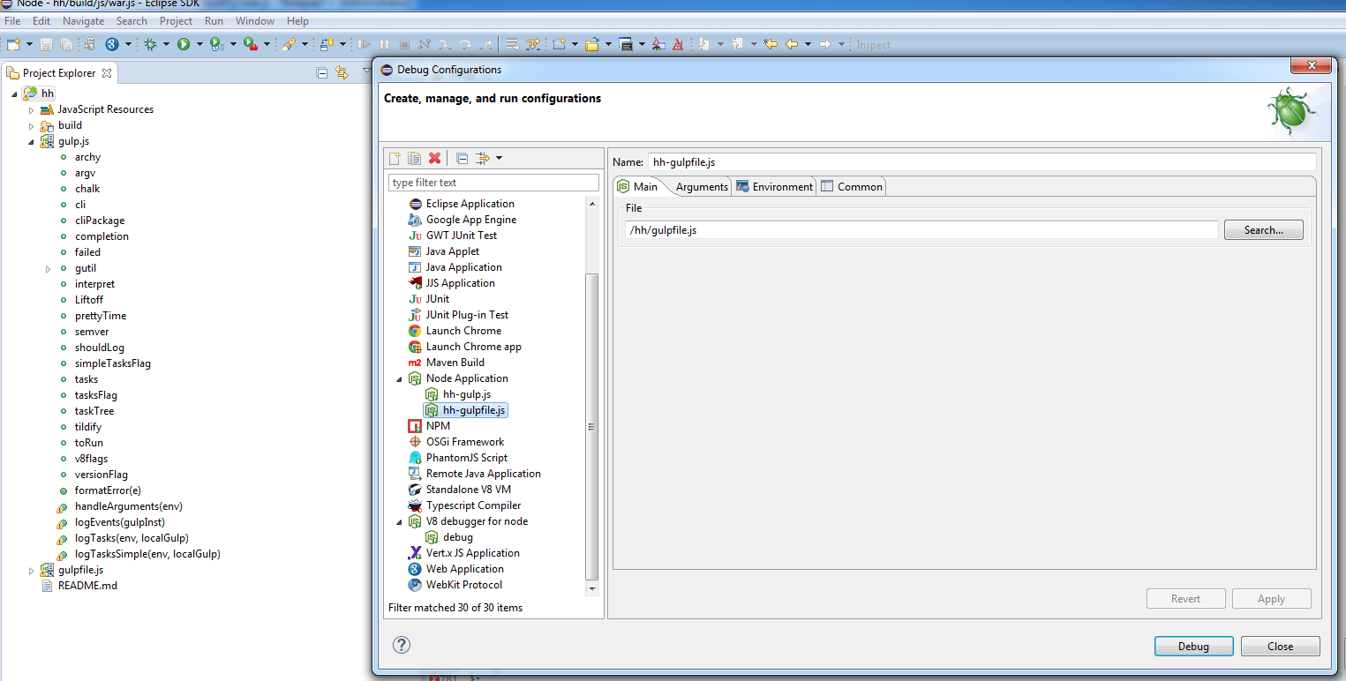

Go to the VB debugger for node

Create new

Give host as localhost

give port as 5858 ( this is the same port that we got from nodeeclipse console )

select the option of the merge

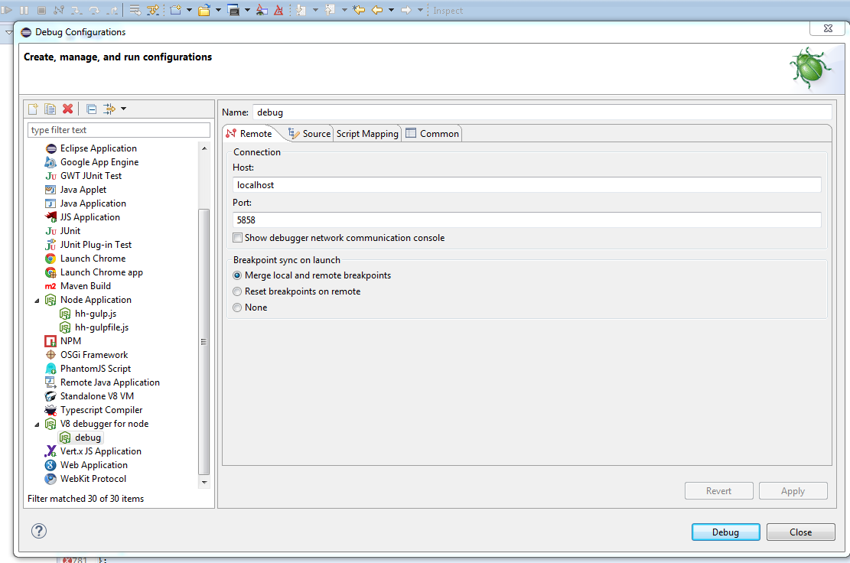

And give the following command

D:\workdir\devunits\patila_spilt_3.1\src>node --debug-brk=5858 D:\workdir\devuni

ts\patila_spilt_3.1\node_modules\gulp\bin\gulp.js war

note : war is the war.js file , that I need to debug for this project

press enter ( F6 , f8 , f5 )in eclipse will help for debug

troubleshoot : if after giving command , we are getting error like file is not found , check the icon of the file , icon should contain the arraow , means it is link