How to Use NodeEclipse to debug .js file in eclipse

1. Install the nodejs plugin, refer this link:

<http://www.nodeclipse.org/updates/>

In your eclipse , help -> install new software , it will show the window as below:

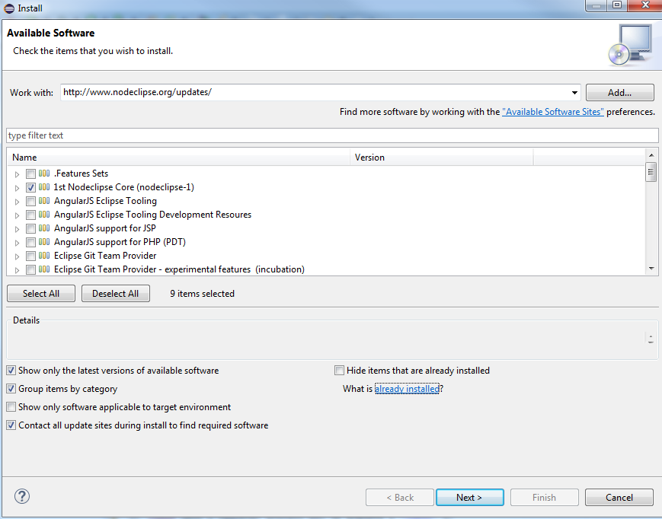

Select 1st Nodeclipse Core, and click on next, then finish. It will ask you to restart your eclipse.

1. Start your eclipse in your unit window:

Using the command line:

%eclipse install path%\eclipse.exe



Find your eclipse install folder, then drag the .exe file to your eclipse, then you can start a new eclipse window.

Then set your nodejs workspace under your unit:

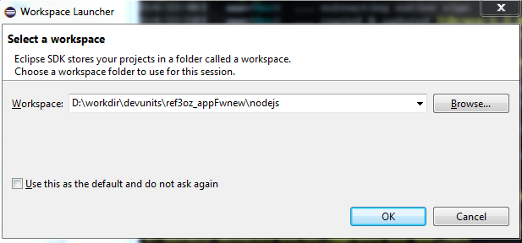

1. File -> New -> Project -> Node.js Project ,click on next, and give your project name:

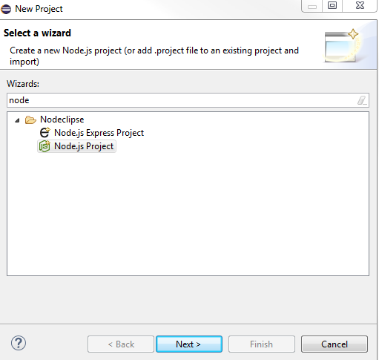 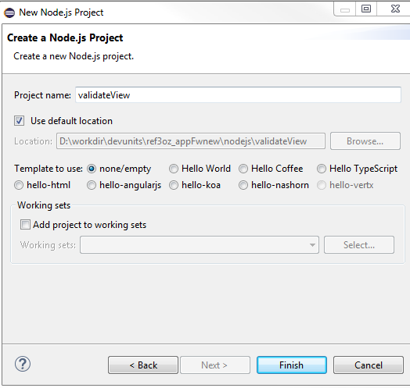

1. Import the node_modules\gulp\bin\gulp.js file and src\gulpfile.js file and src\build folder

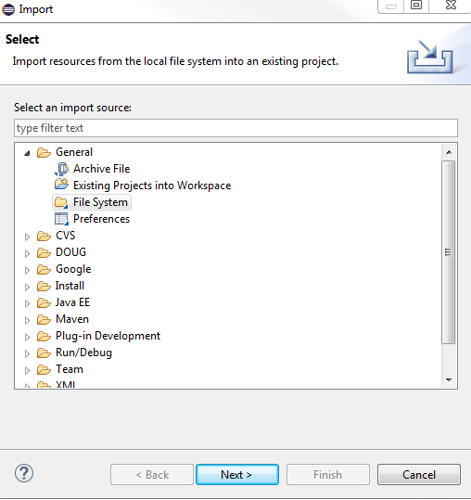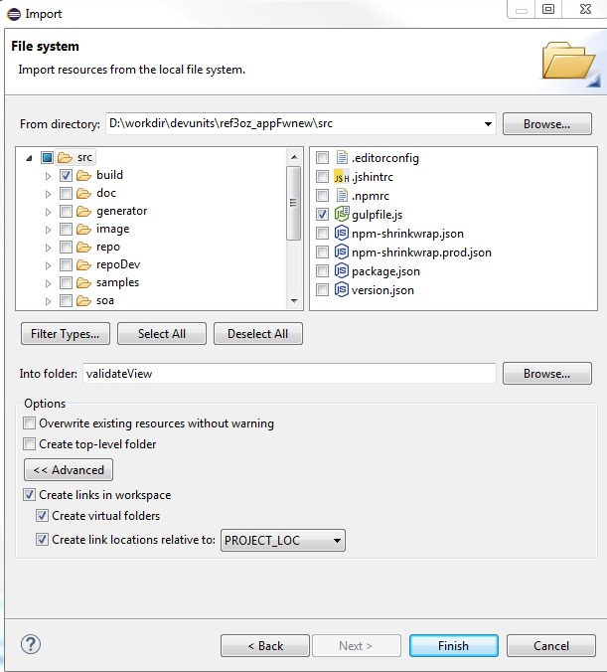

1. In your debug configurations , you can set the Port as 5858 in the V8 debugger for node:

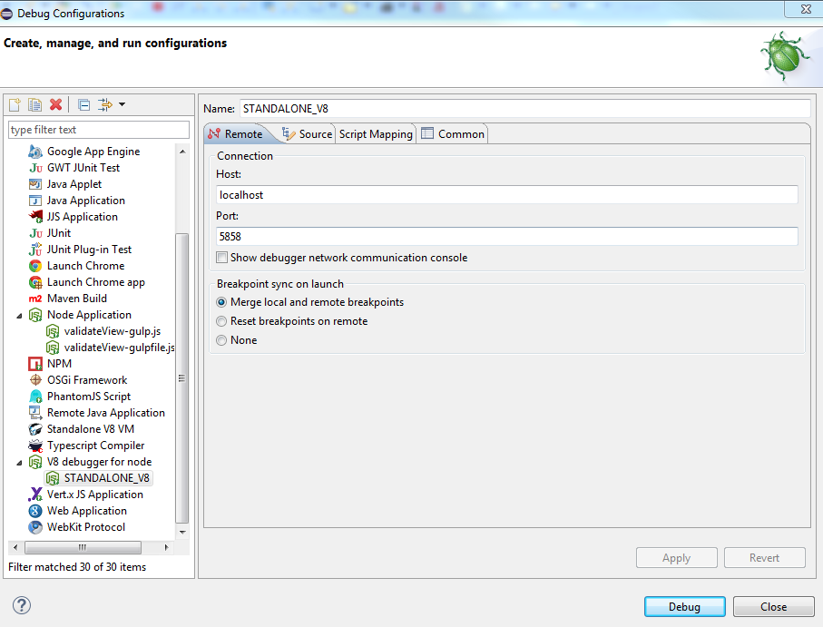

Note : the port is the same as the eclipse output.

1. Select gulp.js -> debug as nodeApplication ->

Note : in this step , you should terminate it before running the command line in your cmd prompt window ,otherwise you may meet an error that the Error:

listen EADDRINUSE :::5858

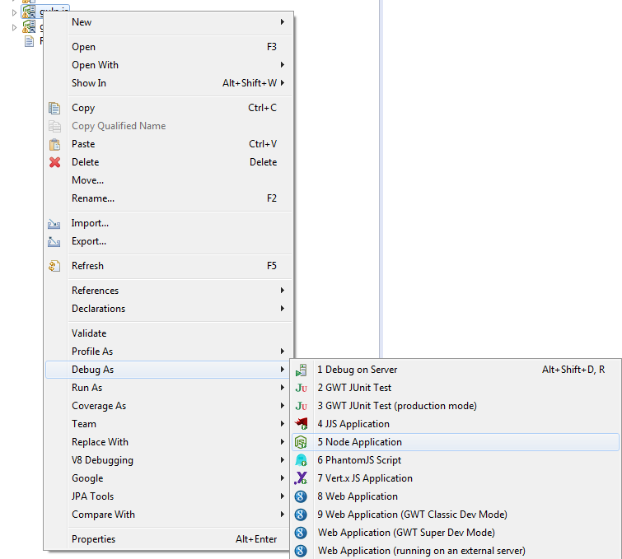

Then in the Nodeclipse Console:

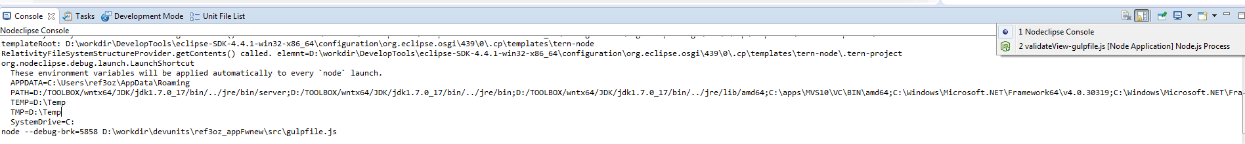

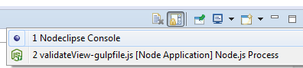

You will see the command :

Is the same as the console output

node --debug-brk=5858 D:\workdir\devunits\ref3oz_appFwnew\node_modules\gulp\bin\gulp.js

1. In your unit, run the command :

To start the cmd prompt : start cmd

1. In the cmd prompt window:

go to src folder : cd src

Then start the listener:

node --debug-brk=5858 D:\workdir\devunits\ref3oz_appFwnew\node_modules\gulp\bin\gulp.js audit

This is your the war.js file, that you need to debug for this project, here is audit

1. Then in the eclipse , you can select the gulpfile.js -> debug as nodeApplication ->

Then you can see the log in your cmd prompt window.

Troubleshoot :

1. if after giving command , we are getting error like file is not found , check the icon of

the file , icon should contain the arraow , means it is link

1. If raise an error that eaddrinuse , then you need terminate all the running debug thing, and do the step 9 again.

Note:

1. The only use for step 6 is to get the command line :

node --debug-brk=5858 D:\workdir\devunits\ref3oz_appFwnew\node_modules\gulp\bin\gulp.js

so if you know the command line , you can skip the step 6 ,and do the following steps.