Data visualization Project  
a storytelling dashboard about health insurance & Quality

January 2019

**Team Members:** Cuong Huynh Erica Rosa Jensen Binoji Ted Stagner

## Project Topic and Rationale

One of the healthcare industry’s main challenges is improving health outcomes while reducing costs. The health of a population can be characterized by understanding two important measures: the accessibility to health services and the quality of health services. We will build an interactive dashboard which will take a focused look at end-stage renal disease health quality, and health insurance coverage among the US states.

## Dataset

Data was loaded into a Jupyter Notebook for analysis and transformation.

**Data Source:** ESRD QIP Measures Data ([link](https://catalog.data.gov/dataset?q=qip&sort=views_recent+desc&publisher=Centers+for+Medicare+%26+Medicaid+Services&organization=hhs-gov&as_sfid=AAAAAAWFyfg2ZtMvhEdwfIRubVd_OPL2ApXXDeHLbzyVydMJPvrVA_1YMicXYC8FvuHYRSn5wpu2CXh_DcaVA_EaudJ7Oa1MVICS3iBGjRY6ypJesXHLmdOurdYLzCZXxBW_8bU%3D&as_fid=5ed58c8575d7bd19e491e769888c273657ac799e&ext_location=&ext_bbox=&ext_prev_extent=-142.03125%2C8.754794702435618%2C-59.0625%2C61.77312286453146))

**Format:** CSV / JSON

**Data Source:** Health Insurance Coverage Data (link)

**Format:**

## Inspiration

## Image result for interactive dashboard health performance

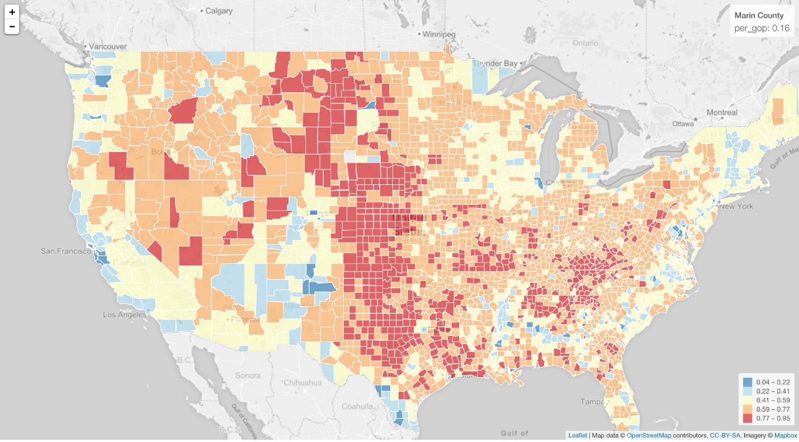

## Sketch

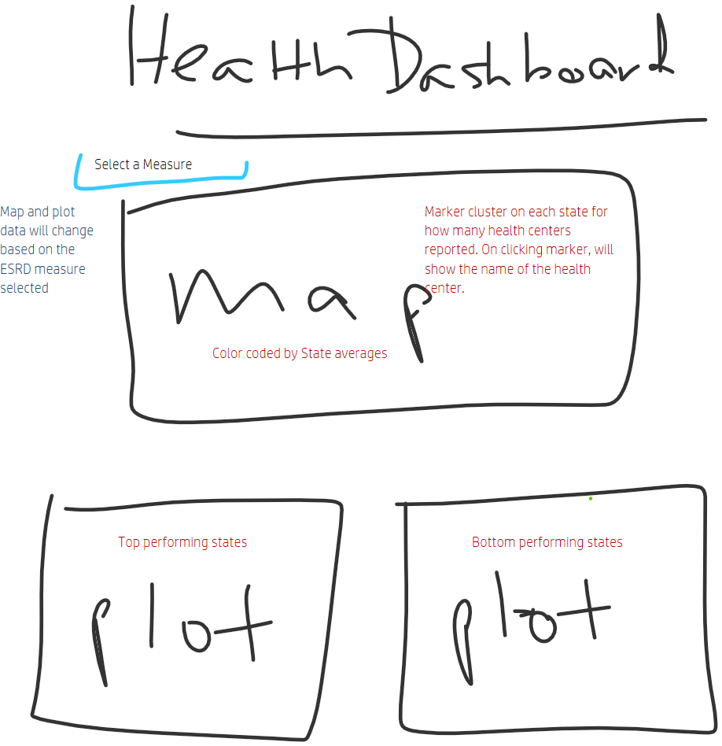

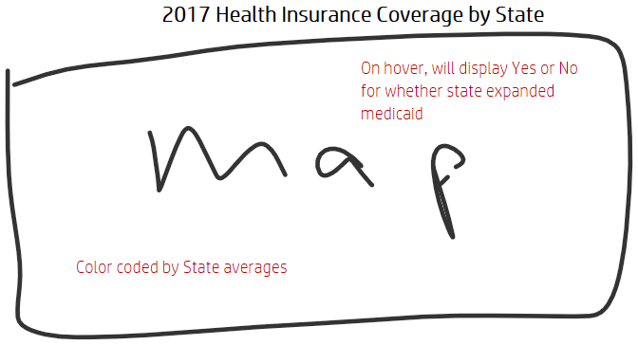

## Repo: