Homework 5 prepared for Prof. M. Khalid Jawed teaching
MAE 263F in Fall 2025
Jens Dekker

Code Description
The code structure is broken up into the mesh generating, simulating, and plotting.
The node generation is as described, it generates four files, the nodes, stretch springs, bending springs, and parameters. All the parameters for the system are defined in the initSpringNetwork.py file and then run to generate the files.
The solver takes in the four files created by the initSpringNetwork file and then initializes and runs the simulation using a Newton-Raphson Solver. The script only tests the beam under its own weight, where each node has an equivalent share of the weight. This may cause the beam to deform more than expected, since the load at the free end of the beam would be larger than in other parts of the beam relative to the surrounding area. Each step of the simulation is saved into a file for a plotter to plot the data. The simulation is complete when the oscillations are less than a fraction of their thickness for a multiple of the system’s natural period.
The plotter averages the z-coordinate of the two nodes at the free end of the beam at each time step and plots this over time. It also imports the parameters created by the initSpringNetwork to plot the expected steady state value as seen in Figure 1.
The simulation finds the steady state to be -0.03536 meters while the Euler-Bernoulli Beam Theory expects a deflection of -0.03679 meters.
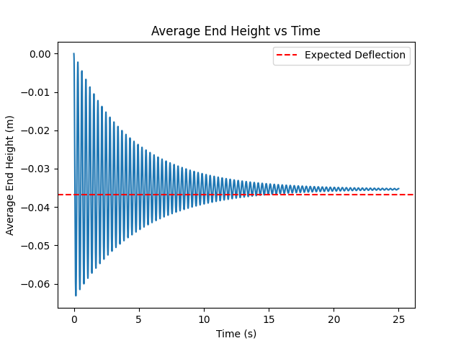
Figure 1: Average End Height over Time.

