Homework 4 prepared for Prof. M. Khalid Jawed teaching
MAE 263F in Fall 2025
Jens Dekker

Code Description
The code structure is broken up into the node generating, solving, data filtering and plotting.
The node generation is as described, it generates five files, the nodes, stretch springs, bending springs, and torsion springs, and parameters. All the parameters for the system are defined in the initSpringNetwork.py file and then run to generate the files.
The solver takes in the five files which describe the system and runs a Newton-Raphson solver. This script can iterate over multiple loads but will only do so when the previous one completes. The simulation will continue running until it is found to not converge. The criteria for this were to have run 50 iterations where the error increases from the previous iteration. This means that more than 50 iterations can be run, so long as there are iterations which are decreasing. In the case the simulation does not converge, the time step increases, to increase the numerical damping in the solver. The simulation is completed when the simulation stays within a certain tolerance for a certain period. The tolerance is defined as a fraction of the axial length of the coil spring, and the steady period is defined as a multiple of the system time scale. The output is saved into a text file.
The data filter removes all the failed variations of the simulation and stores the passing simulations in a new file. There is also a summary file generated which has all the simulation variations and which ones passed.
The plotter scripts are divided into the three main parts of the homework assignment.
Plotter 1 will take the successful simulation result and plot the z-coordinate of the final node over time. It determines the steady state value of the simulation based on the same parameters as the solver and plots a horizonal line. In addition five snapshots are generated of the coil spring and saved in a separate folder.
Plotter 2 takes the results of multiple simulations and determines the steady state value of each one. It plots the steady state versus the force applied in the simulation with a line of best fit going through the origin.
Plotter 3 takes the results from ten simulations with varying helix diameters. It plots the expected spring value versus the one generated by a model provided from a textbook.

Single Load Level
First, confirm that you have the correct template for your paper size. This template has been tailored for output on the US-letter paper size. Please do not use it for A4 paper since the margin requirements for A4 papers may be different from Letter paper size.
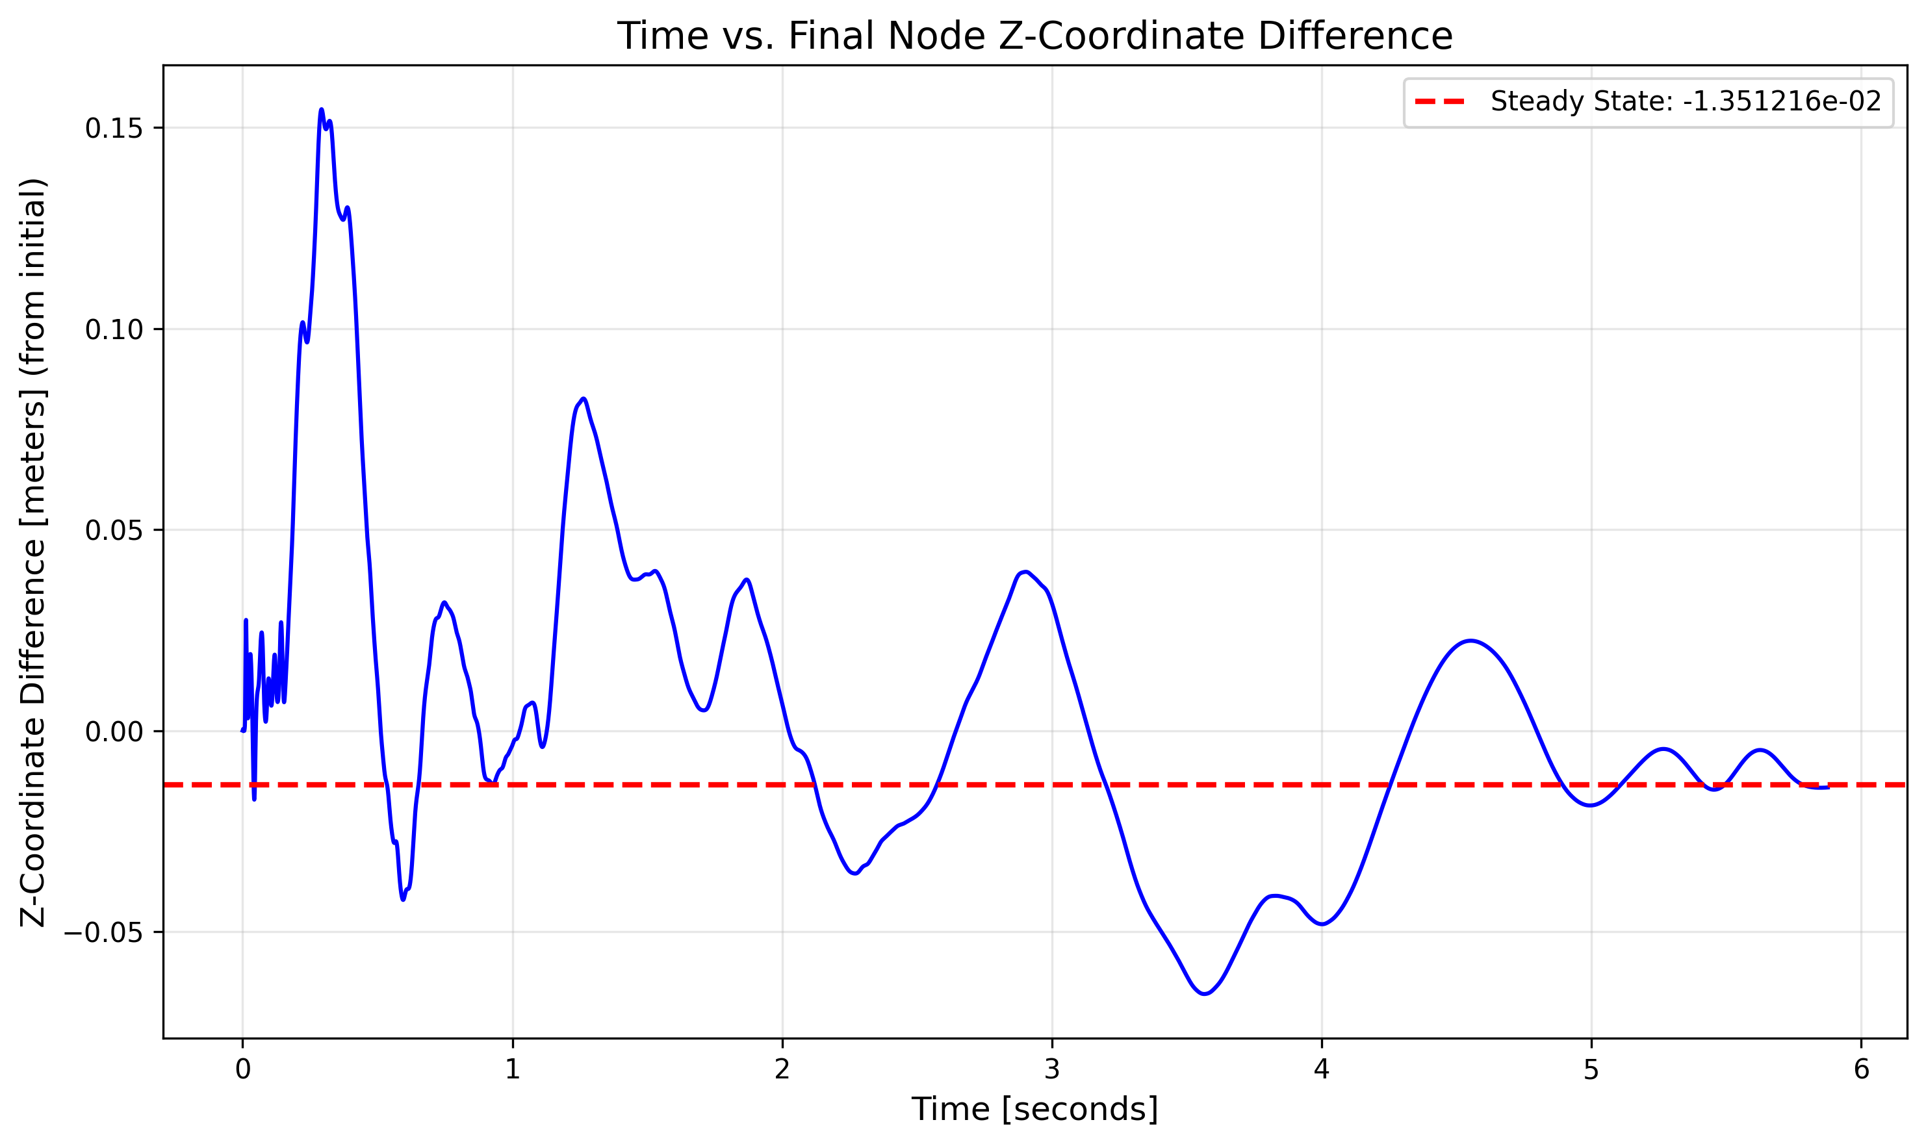
Figure 1: Last Node Z-Coordinate over Time with the Characteristic Force Loaded
The steady state value is -1.351216e-02 meters.
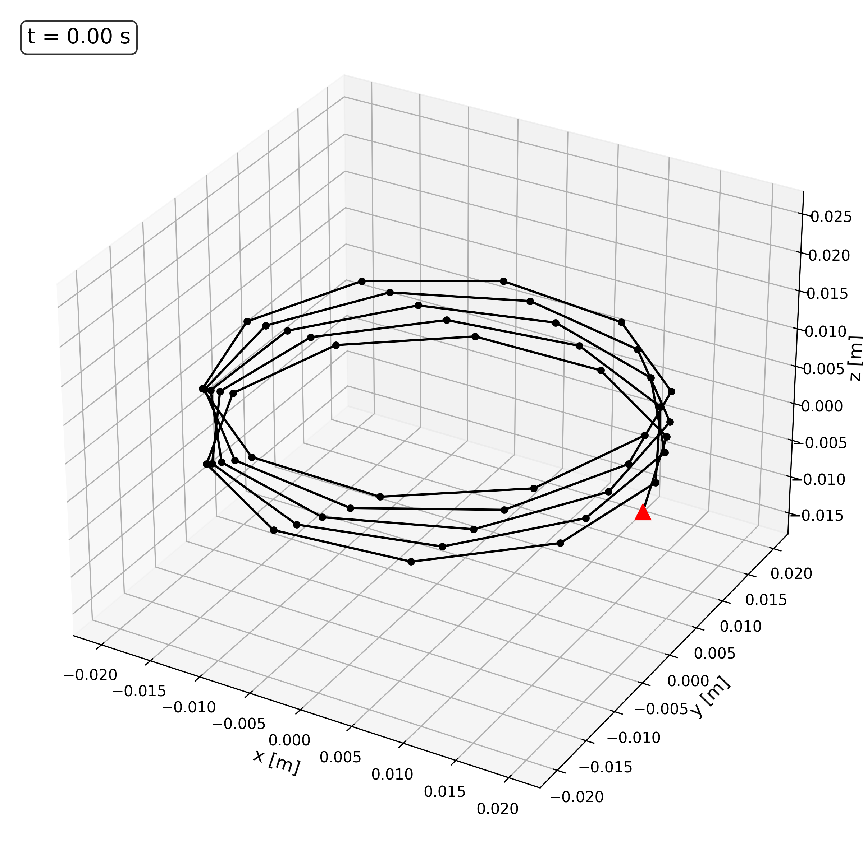
Figure 2: Spring Snapshot with Characteristic Load at t = 0.00 s
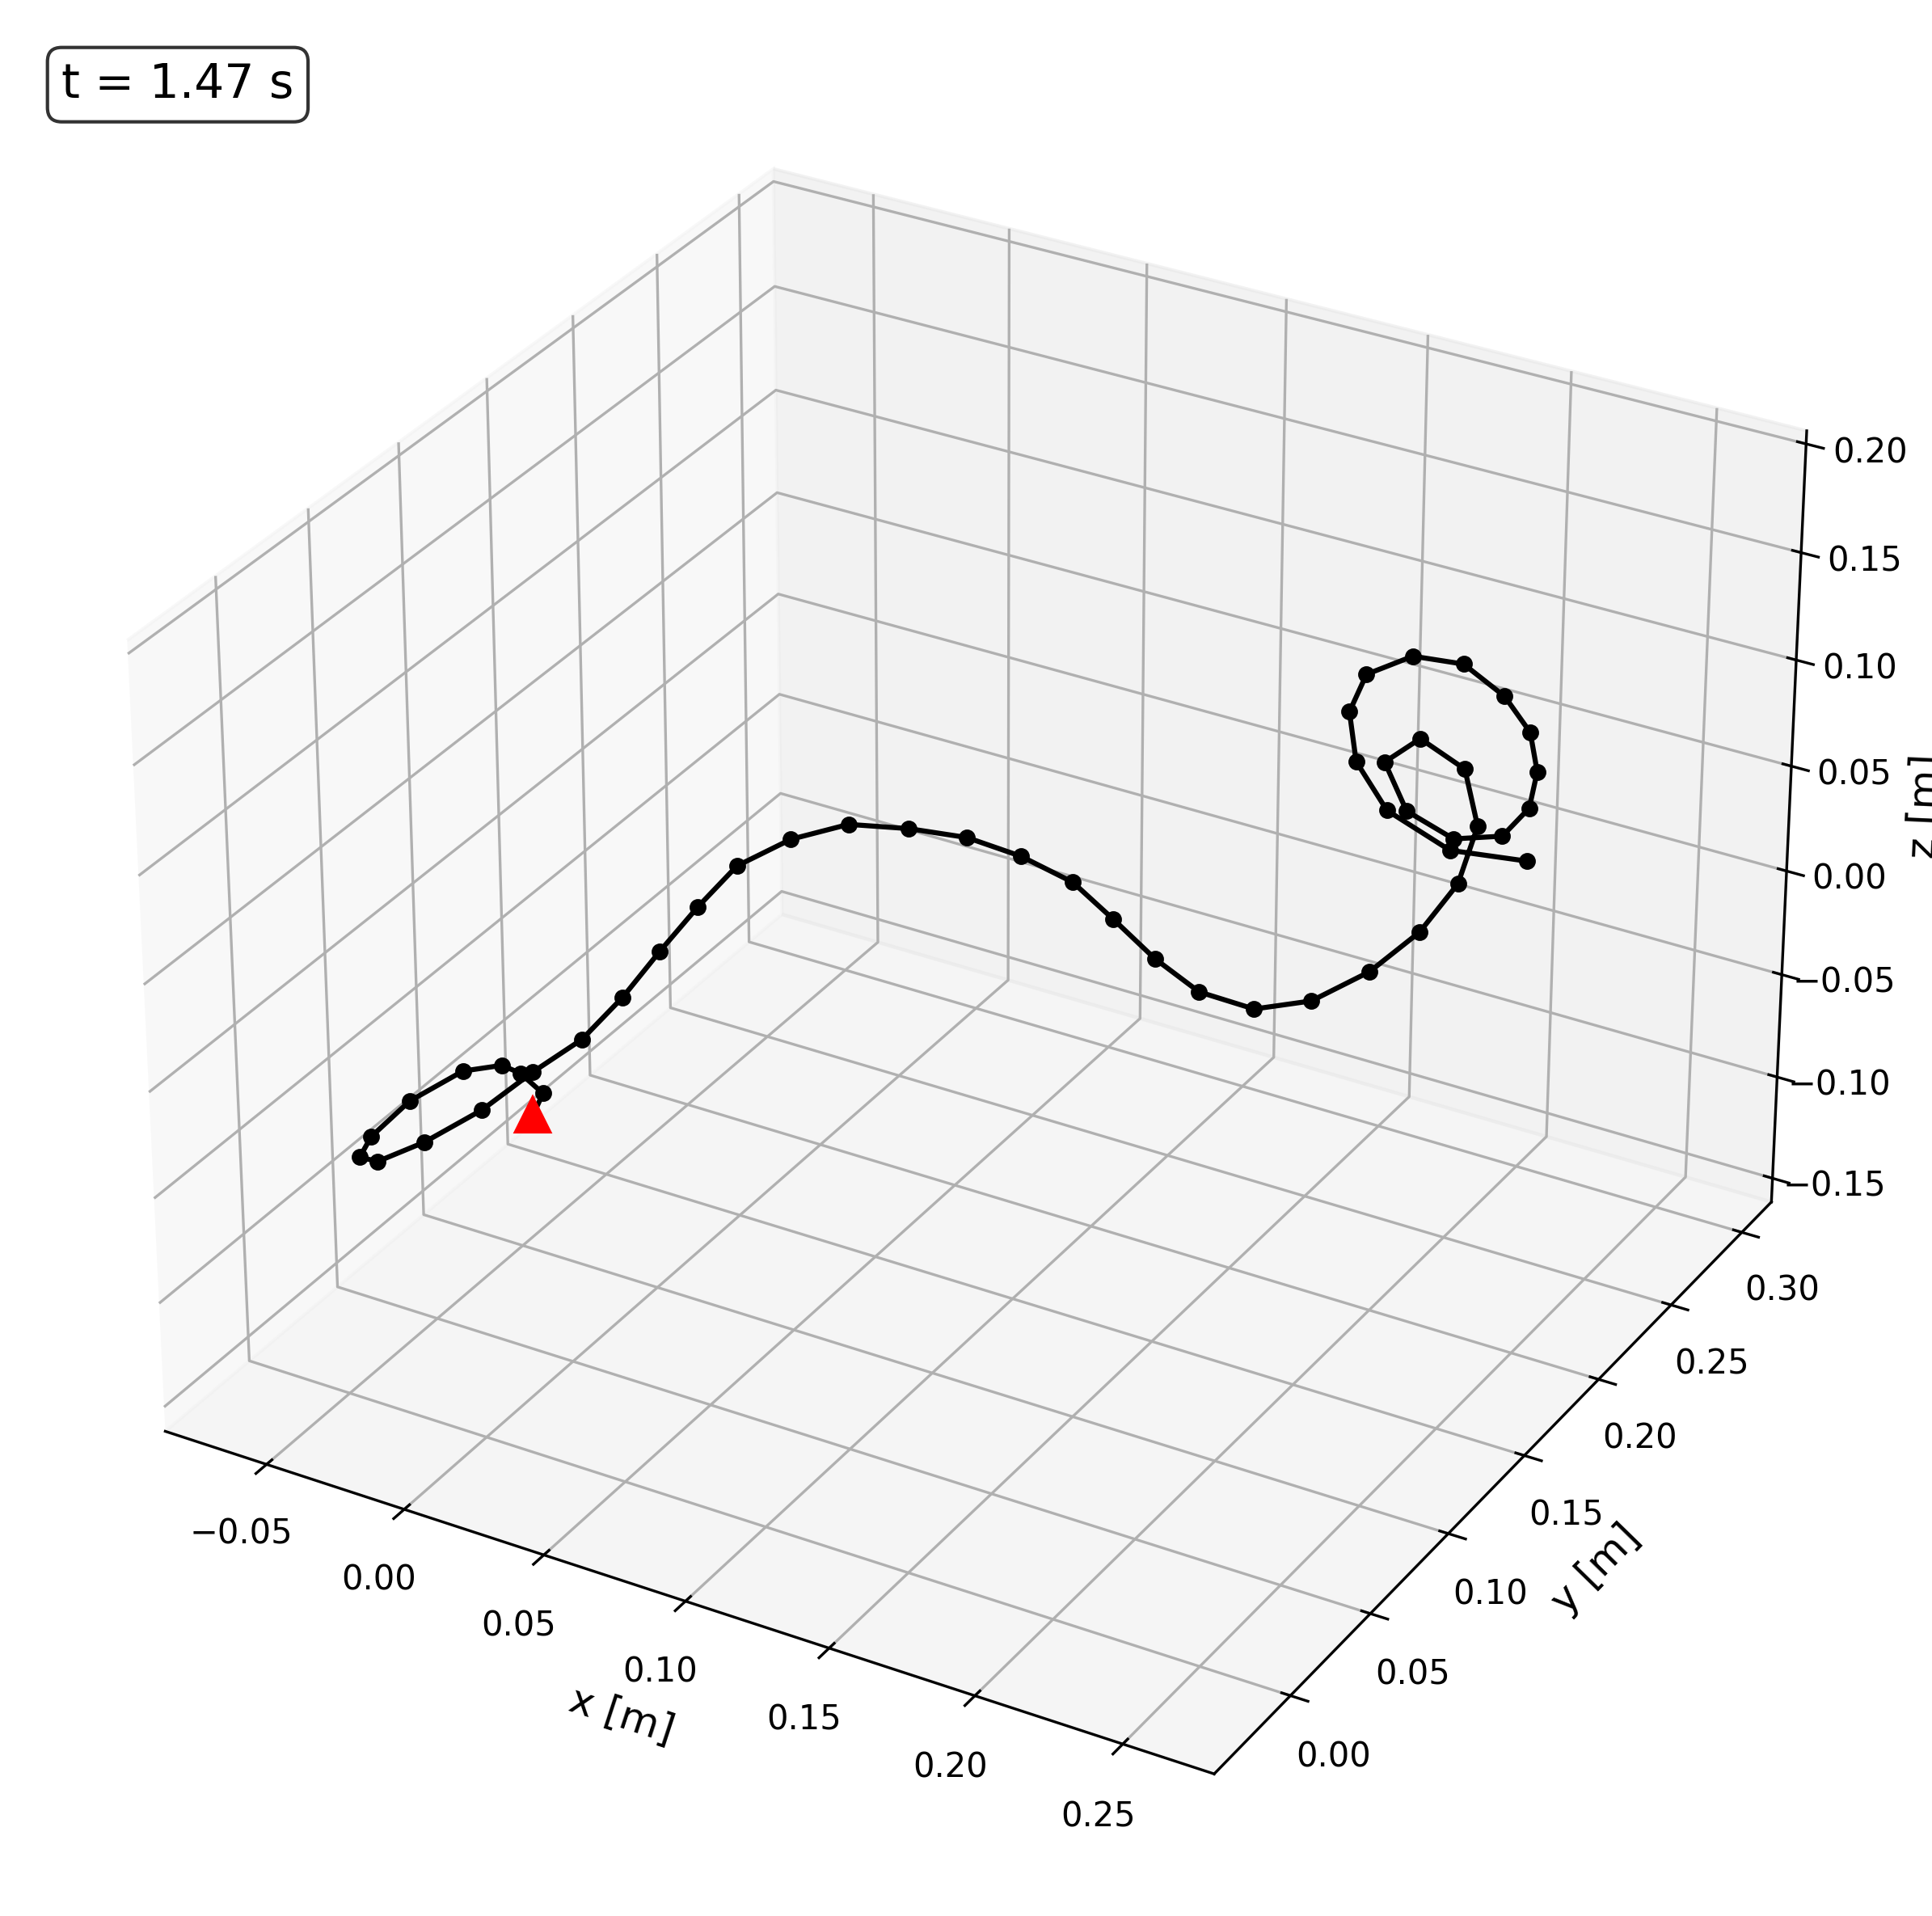
Figure 3: Spring Snapshot with Characteristic Load at t = 1.47 s
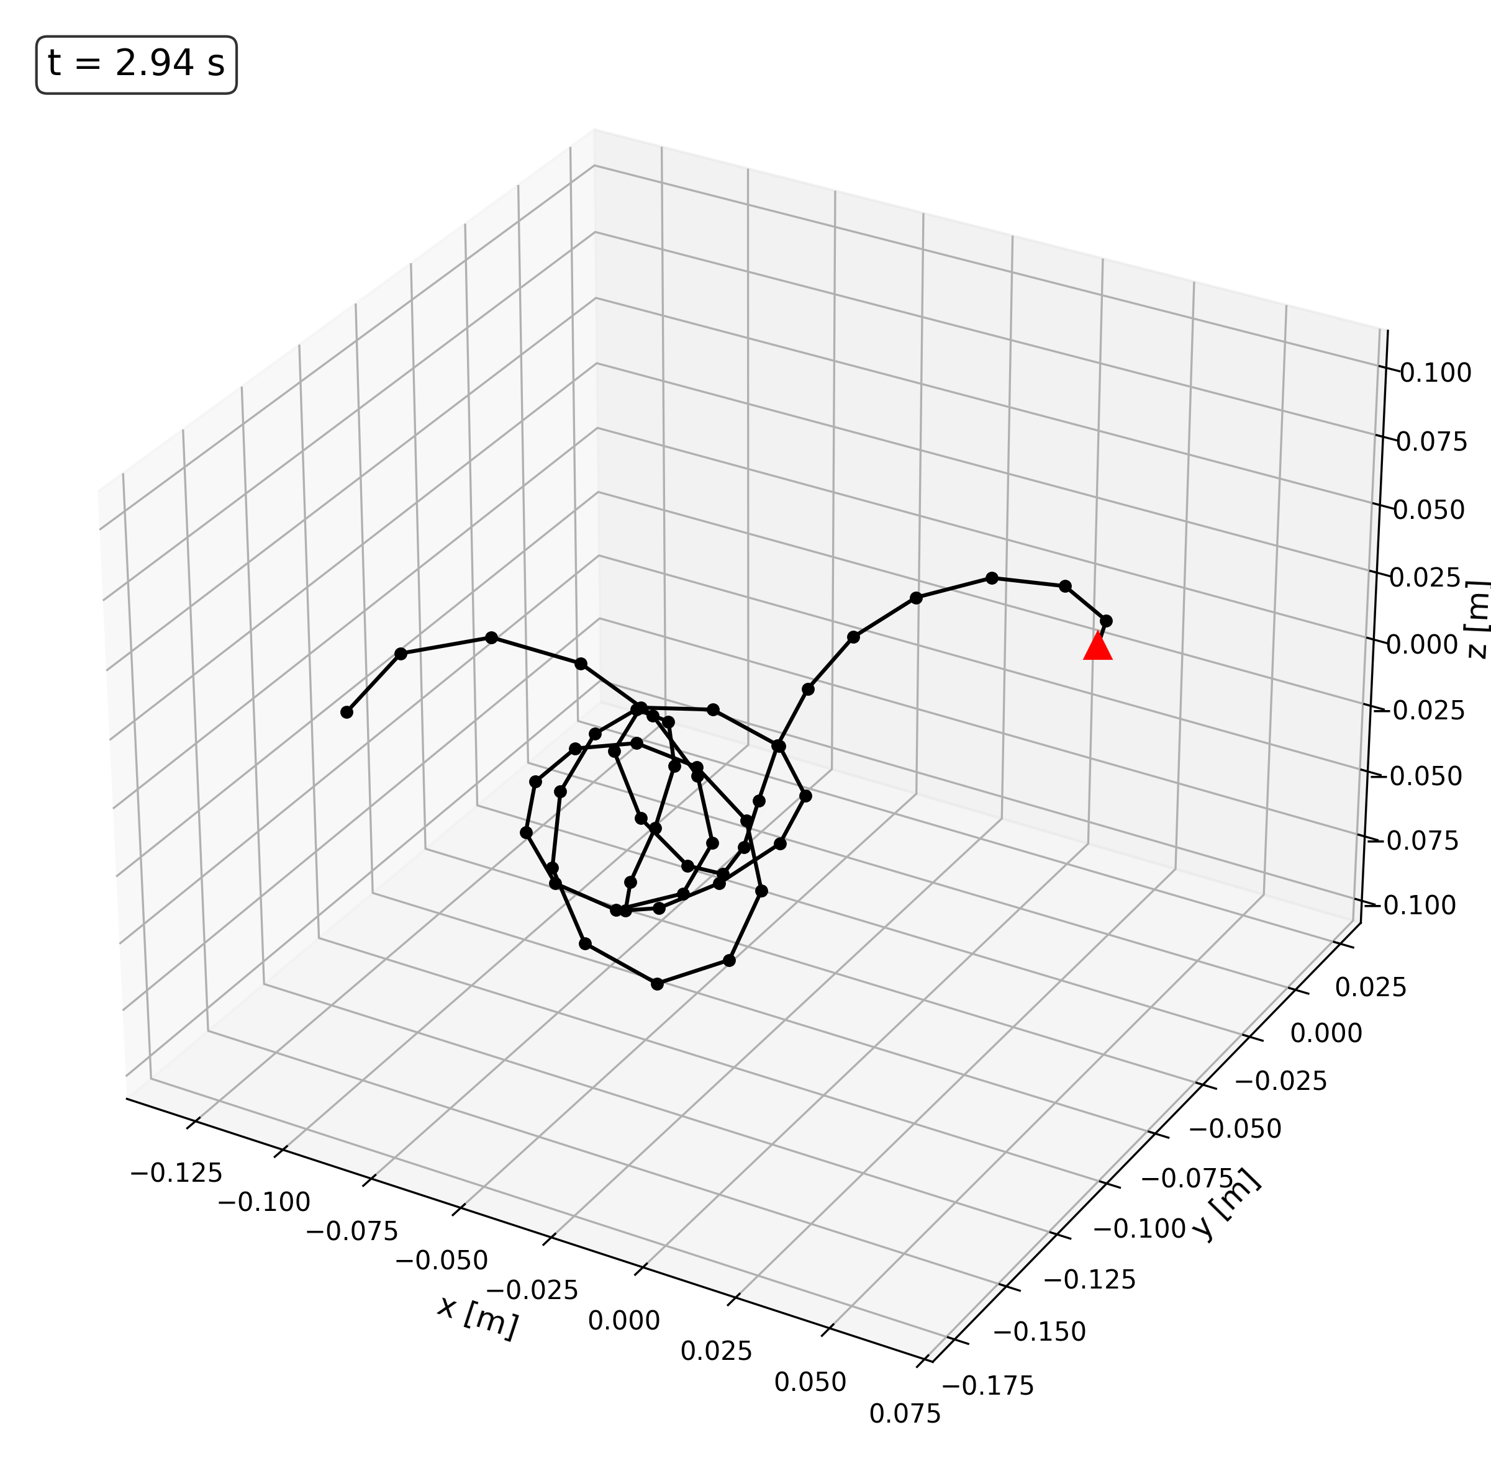
Figure 4: Spring Snapshot with Characteristic Load at 2.94 s
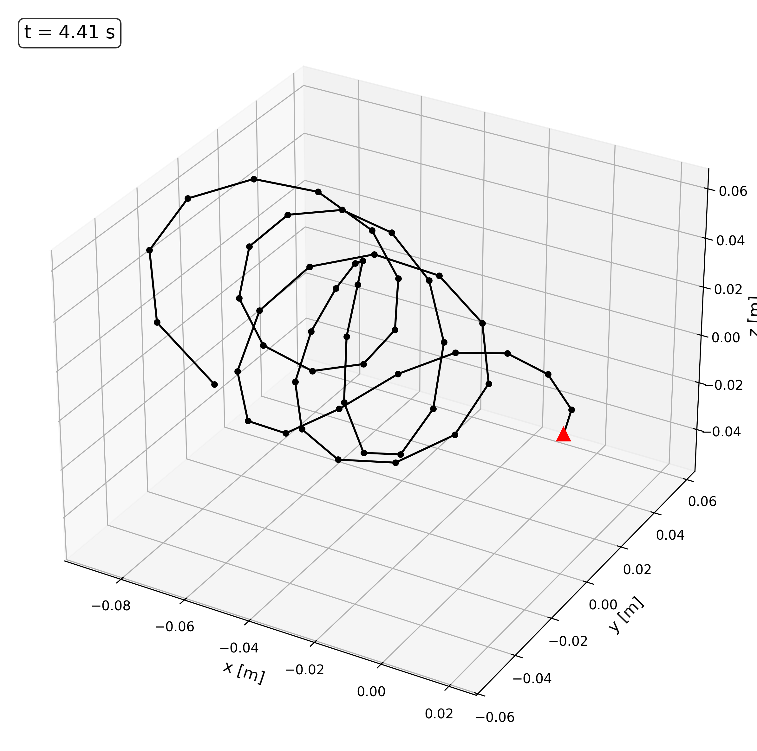
Figure 5: Spring Snapshot with Characteristic Load at 4.41 s
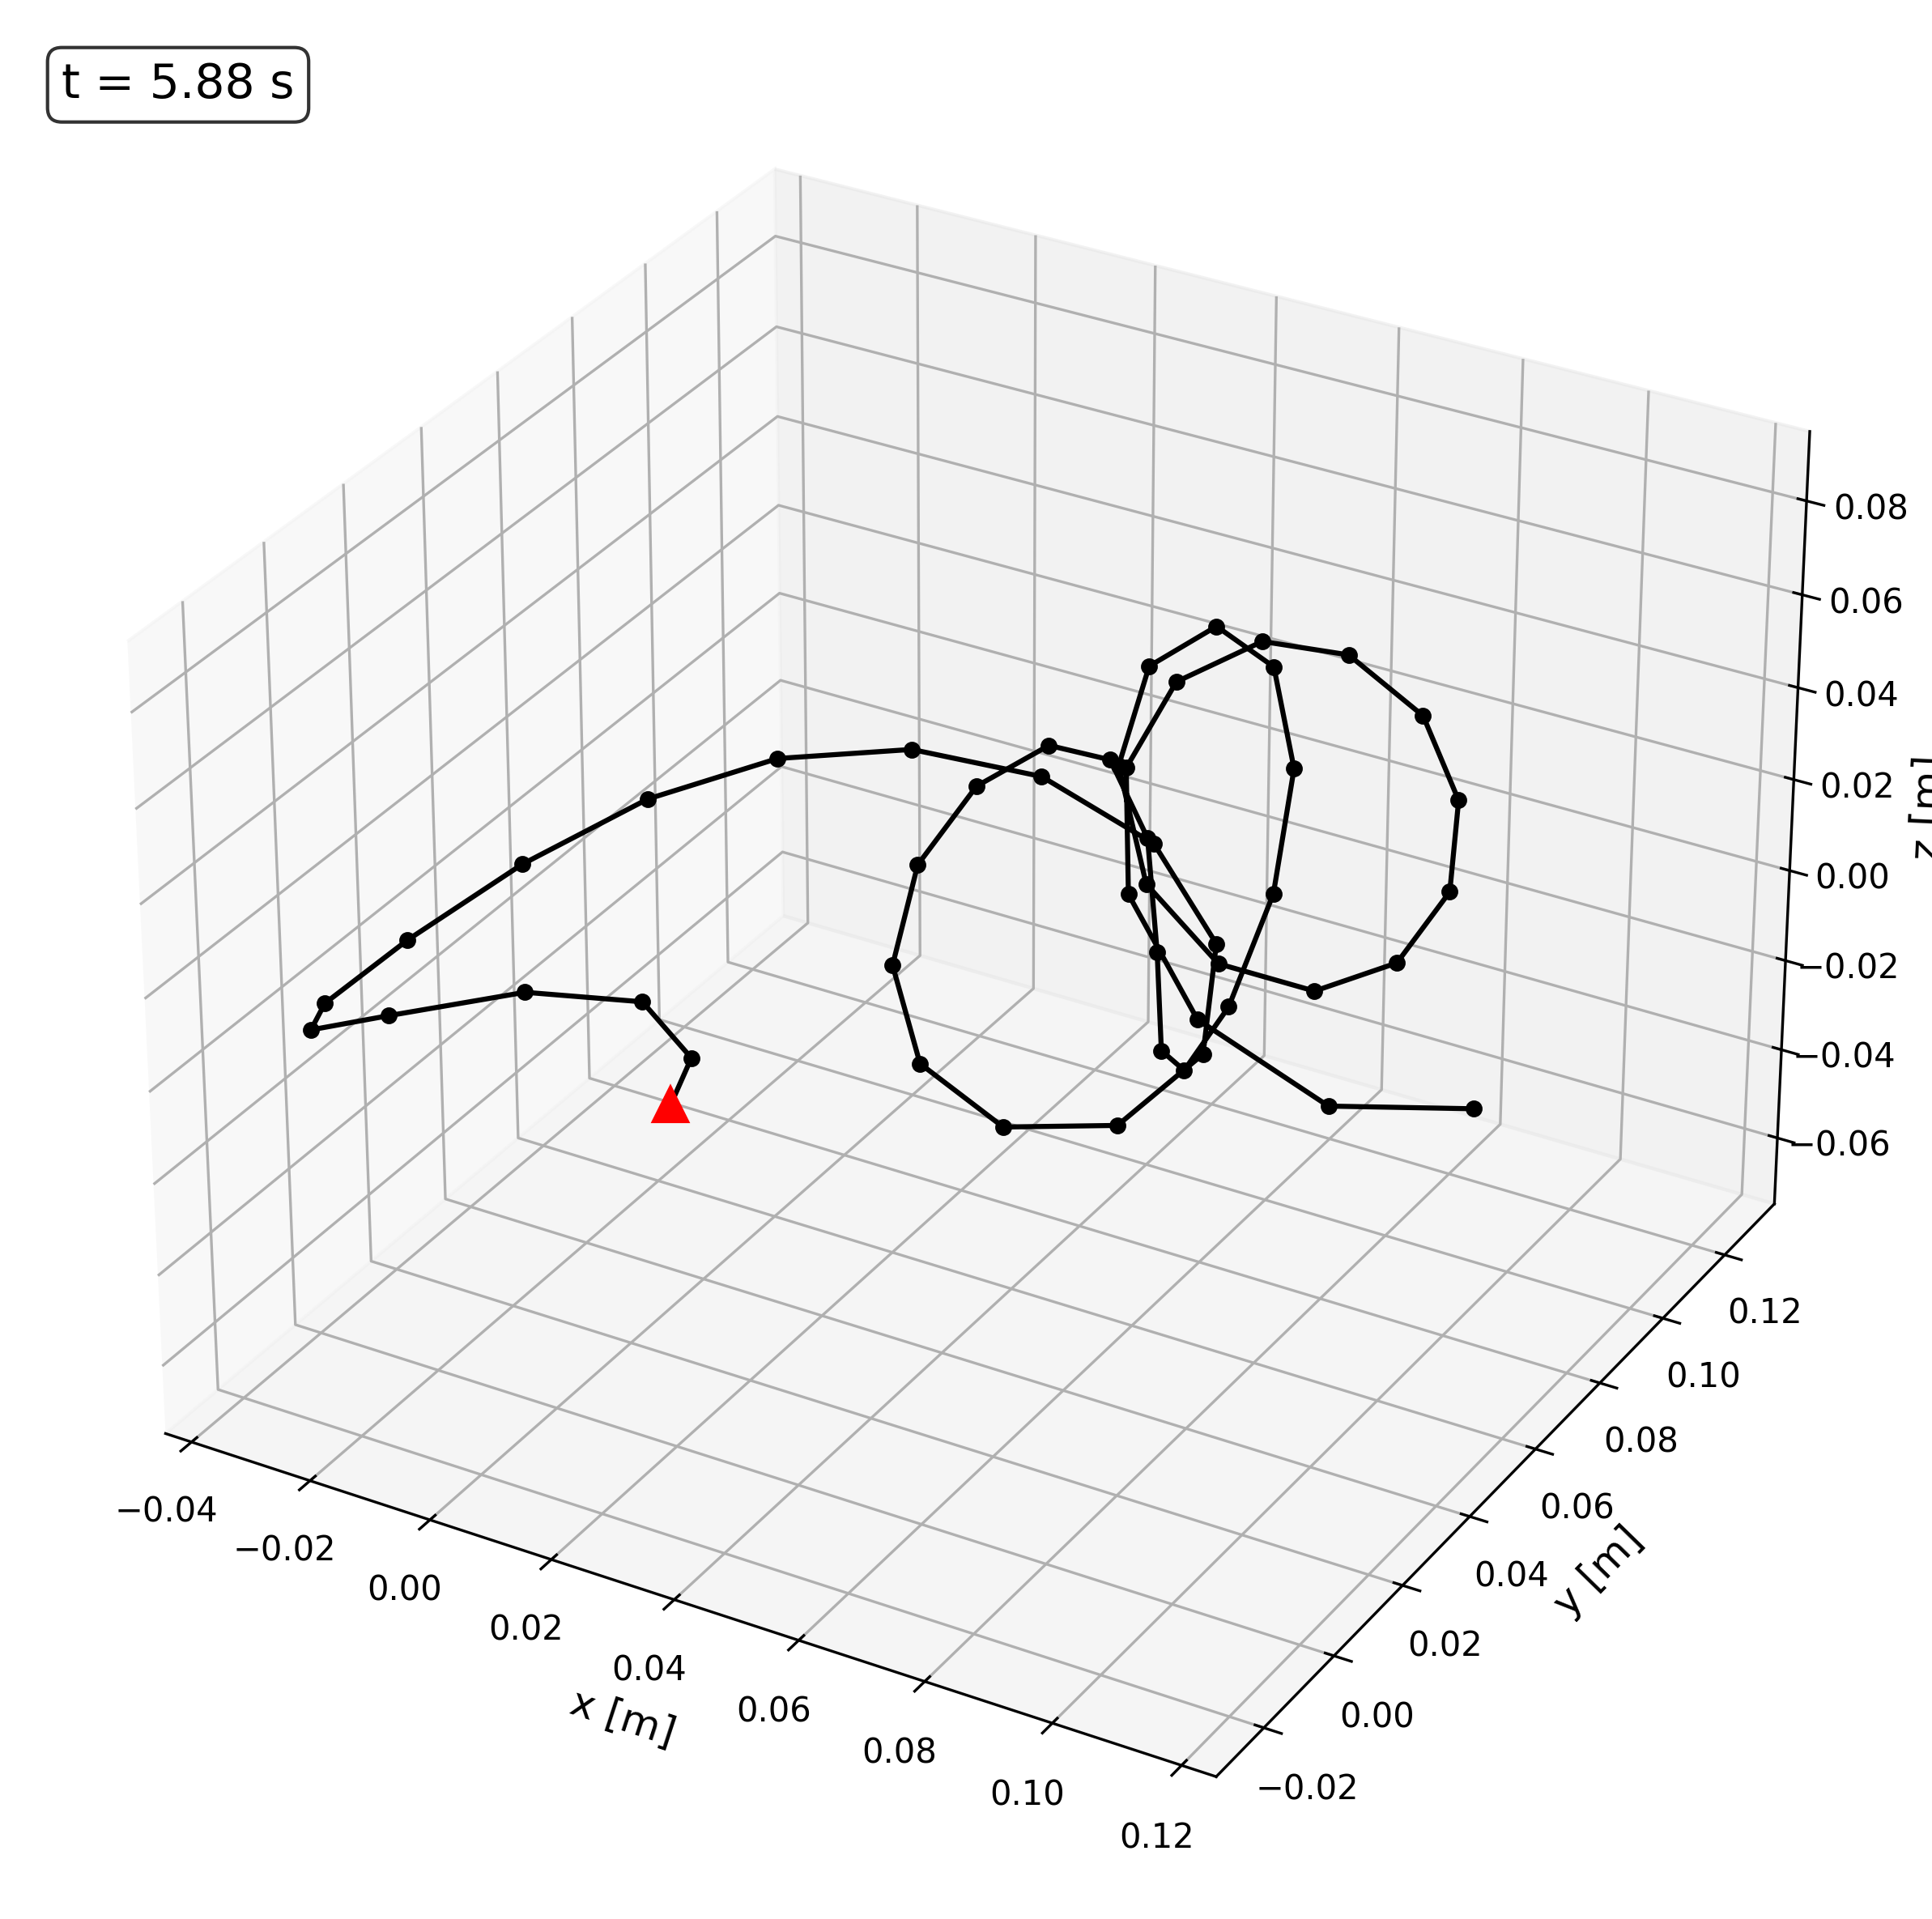
Figure 6: Spring Snapshot with Characteristic Load at 5.88 s

Force Sweep or Linear Fit
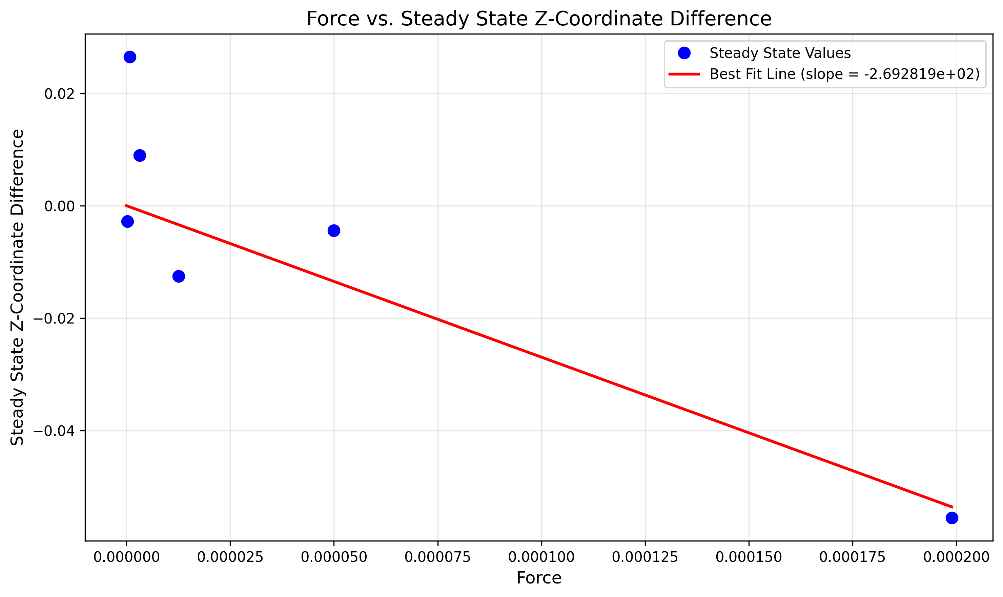
Figure 7: Force vs Steady State Z-Coordinate
The line of best fit (spring constant) is approximately -2.692819e+02.

Diameter Sweep vs Textbook Trend
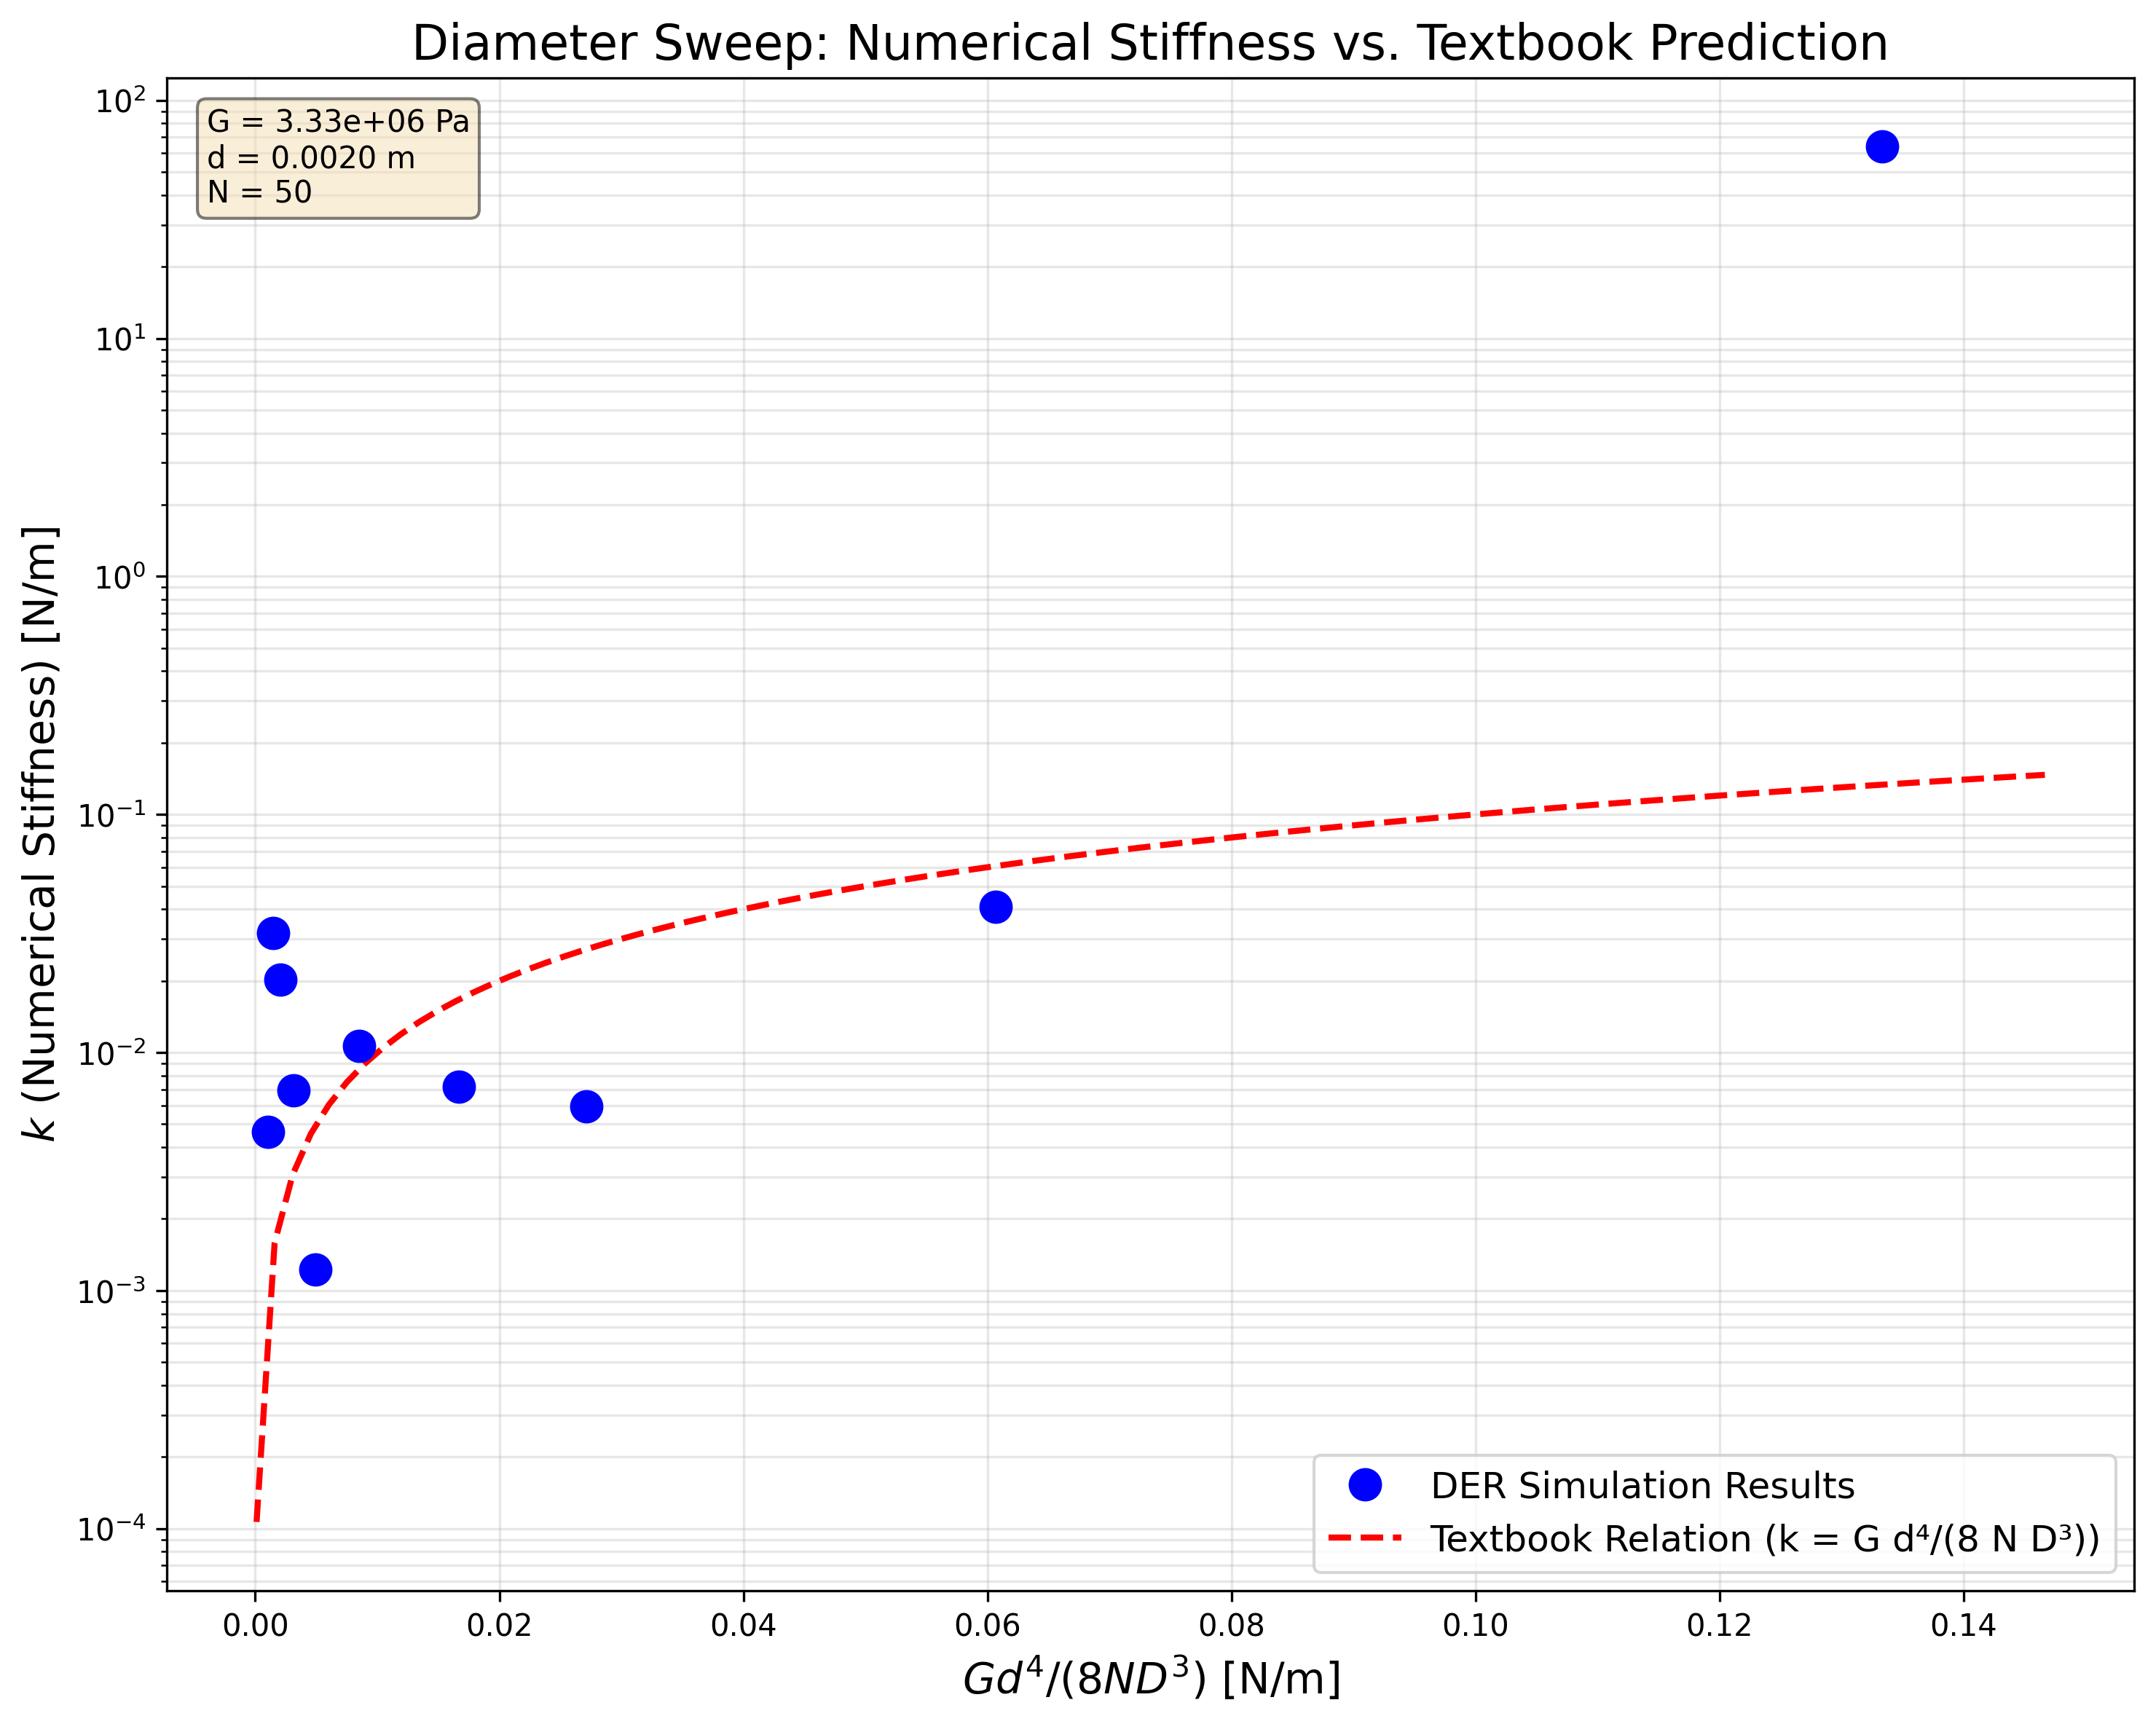
Figure 8: Diameter Sweep and Simulated Spring Constant Compared to a Textbook Trend
Looking at the plot in Figure 7 and the snapshots in Figure 2 to Figure 6, the spring in not deforming in a predicted way with the spring constant (a relatively uniform increase in the pitch of the spring. Thus, neither the force sweep nor diameter sweep are truly representative of a linear spring’s behavior.

