Participants:

Jacob Munkholm, 20140479

Jens Jakob Mikkelsen, 201506215

Yang Hanshou, 201902791

**Embedded Real Time Systems – Assignment 1**

**System level modeling using SystemC**

# Modules, threads, methods and events

## 3.1:

The module ’moduleSingle’ is created:

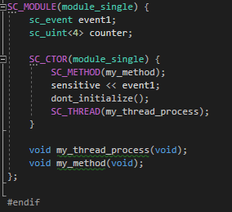

The thread to continuously notify the method, and the method to count, is initialized in the constructor. Static sensitivity is used, my_method is called everytime the event is raised.

The functions looks like this:

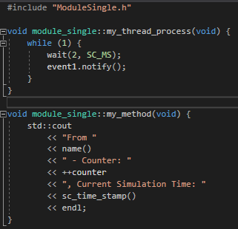

’Trigger thread’ is an unending loop, calling counter_event.notify() every other ms. In the main function, the simulation is limited to 200 ms:

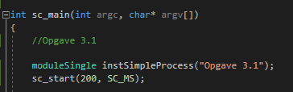

The following is the result:

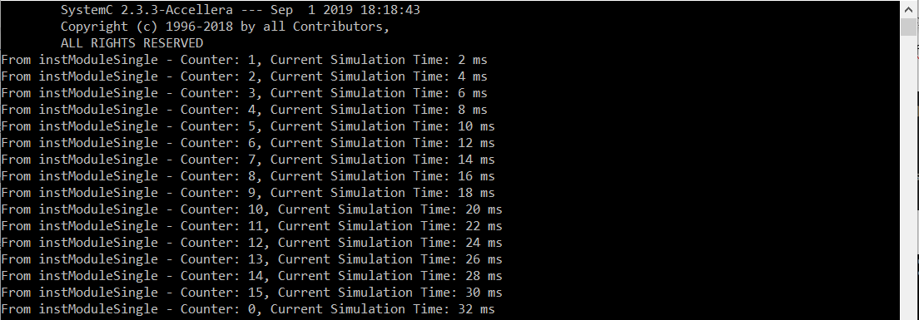

When sc_uint<4> counter overflows, the program will count from zero again.

## 3.2.

The different threads and events and the method is created:

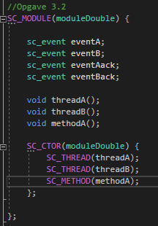

The threads and the method looks like this:

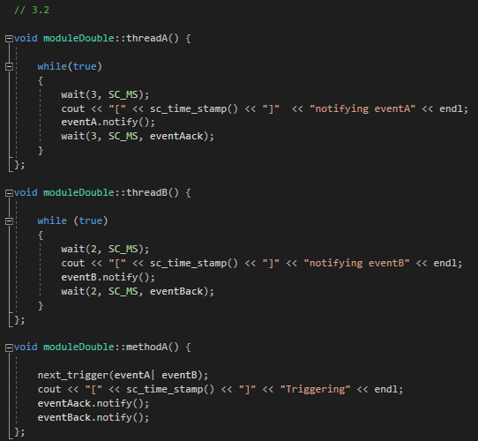

In methodA(), dynamic sensitivity in the form of next_trigger(eventA | eventB) is used, så the method will be called by if either of the events are called. If the program should work so that methodA knows exactly which event is called, signals would need to be used.

Both event threadA and threadB wait for their event to be called. If no event is called, the thread will timeout and restart. This it done in the wait function by specifying eventAack and eventBack as parameters.

The result looks like this:

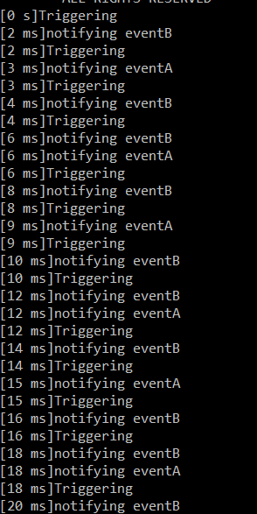

At 6, 12 and 18 ms the events overlap, but eventB is seen to be quickest everytime (because it is called first).

# Channels, signals, hierarchy, communication

## 3.3

A producer and consumer-thread is created:

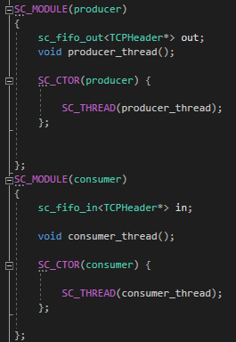

The main object to be used is the sc_fifo_in/out, through which data is transferred.

The producer thread is written like this:

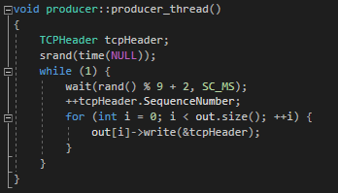

The thread will wait a random amount of time between 2 and 10 ms, increment the sequence-number (the whole TCP segment structure is not used) and write the sequence to the queue. The TCP-struct is defined, but only the sequenceNumber is used to demonstrate the concept:

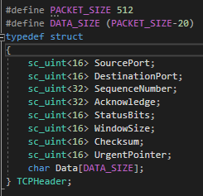

The consumer-thread read the queues continuously and then writes out the sequenceNumber:

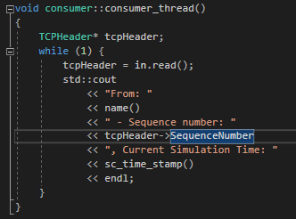

In the top-module, the producer, consumer and fifos are created. More consumers and producers could be added like this, if need be.

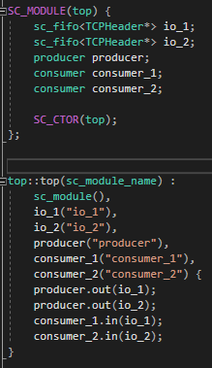

## 3.4

The program consists of the following files:

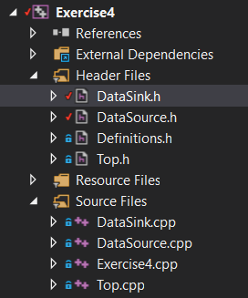

As usually, the top module initializes all the signals mm. It also creates the clock and creates the traces on the signals. SC_METHOD(clock_signal) uses static sensitivity to be called every time the clock raised.

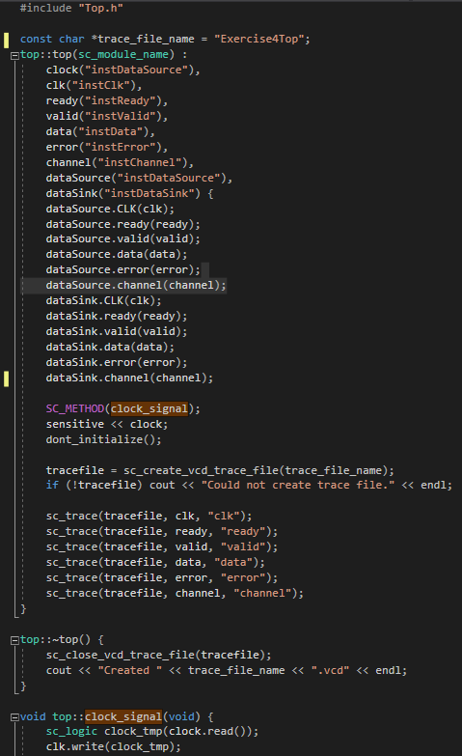

The dataSource looks like this:

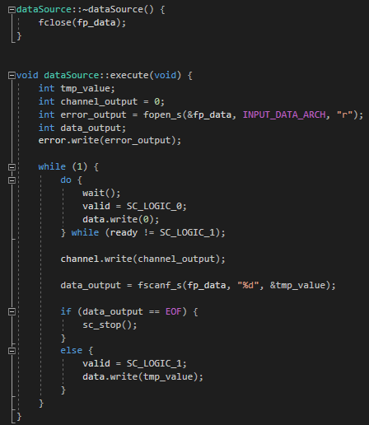

The loop runs until the end of the file fp_data points to has been read. The loop follows the protocol, so it only sends data when the valid signal is high, and 1 with a 1 clock cycle delay from when the ready signal is high. If not, it only sends zero’s to simulate not receiving data.

The sink then looks like this:

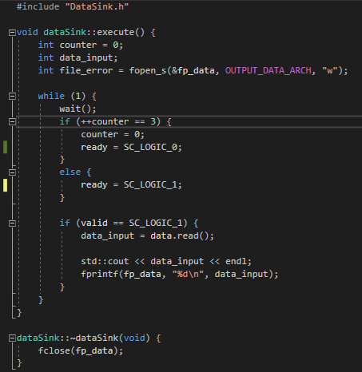

It waits one clock cycle, and pulls the ready signal high for the source to react on. Then it itself expects the valid signal, after which it will read the data from the queue. On the third cycle, it sets the ready-signal low, which is the cycle in which it will receive zero’s from the source.

The tracefile in the end, looks like this:

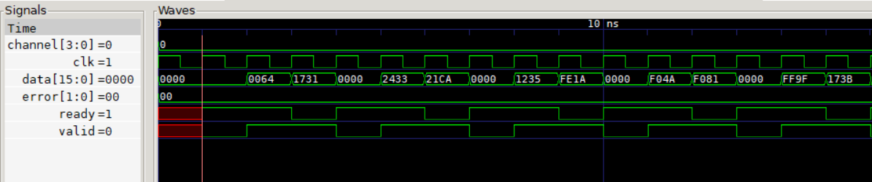

It is seen that then one data byte is send out every clock-cycle when the valid signal is high, delayed by one clock cycle from the ready signal.

The error byte and data signals are made so they can be chosen manually, but does not affect the code in the source or sink for now.