TDT4195: Visual Computing Fundamentals
Computer Graphics - Assignment 3
Oktober 7th, 2022
by: Jens Christian Valen Leynse

Task 1c
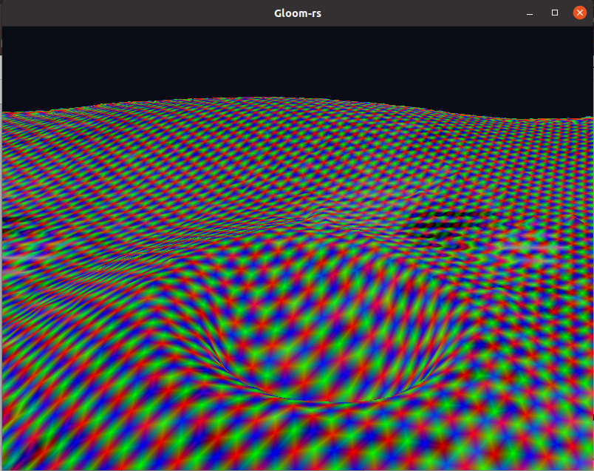

Task 1c
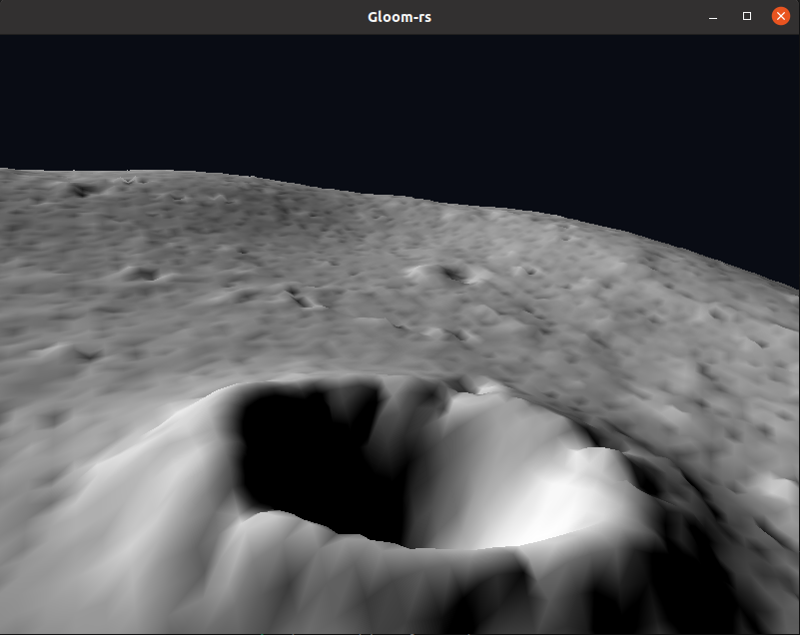

Task 2c
Changed the colors Changed the depth
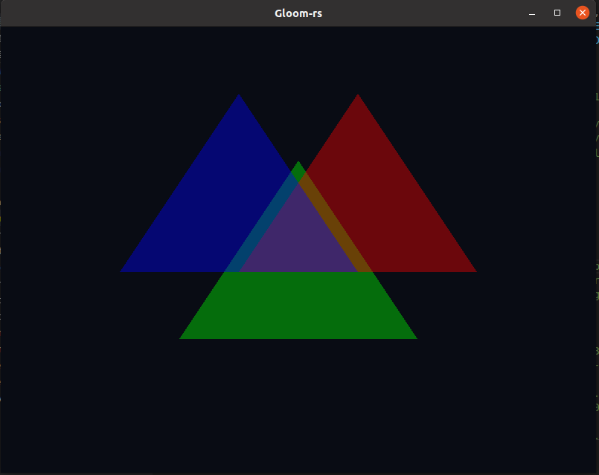
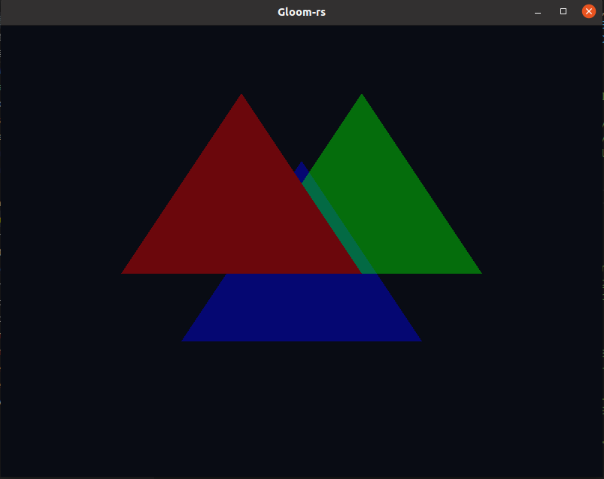

The color focus in the blended overlap of the colors changed. This happened because the color translates the color behind it. So changing the order made the values add together differently.
Changing the depth order as shown above meant the red triangle got drawn in front. So the colors behind got hidden by it making them invisible at that angle. This happened because openGL only draws the visible objects, which is why the assignment included making the correct drawing order from the back to the front.

Task3b
a: Manipulates the x-coordinate of all the triangles. It looks like it's rotating around the y-axis.
b: Manipulates the y-coordinate of all of the triangles. Looks like it's stretching towards the corners.
c: Normalizes the xyz values so they exponantionally changes. Looks like it's rotating around the y-axis in a way that it stretches behind the viewpoint.
d: Manipulates the x-coordinate of all the triangles. It looks like it's stretching to either left or right of the viewpoint.
e: Manipulates the y-coordinate of all of the triangles. Looks like it's rotating around the x-axis.
f: Normalizes the xyz values so they exponantionally changes. Looks like it's stretching towards the top and bottom of the viewpoint.

Task3c
The reason that I can know none of the transformations were rotations is because changing the values in the matrix only manipulates the vertices given a sine if time input. So even if they looked like they were spinning, the were in fact only moving along the axis's in a wave like manner.

