INF-1400: Object-oriented programming

Mandatory assignment 3
Jens Christian Valen Leynse
April 19th, 2024

1 Introduction
The assignment was to create a mayhem clone, which is a game where two spaceships try to take each other down, while surviving all obstacles. The code is written in python 3, and the code includes the requirements of the assignment implemented with classes and methods.

1.1 Requirements
- The two spaceships shall have four controls: rotating left and right, thrust for propulsion, and fire which should shoot a projectile.
- Minimum one obstacle in the game world.
- The ships shall be able to collide with obstacles, the walls and each other.
- A gravity shall affect the ships.
- Each ship shall have a score that increases and decreases according to if the player shoots the opponent down, or if the player crashes or gets shot down.
- Each ship shall have a limited amount of fuel. This fuel decreases so that the player will have to refuel at a landing pad or at a refueling object placed on the screen.

2 Technical Background
The classes are all connected through a has-a relationship to send the information around. This is done through instances where a class is called from within another class. It’s done once to connect every class, except for one class which is instantiated several time into a list. Three python libraries are included in the code; pygame, random and time.

3 Design
In the design section, the class organization is discussed, highlighting the separation of classes into interacting and non-interacting categories. Each class's role and contribution to the game are outlined, emphasizing their impact on gameplay mechanics, visual presentation, and player feedback.
Interacting classes, such as the Obstacle, Landing Pad, and Fuel Sheet classes, are described in terms of their gameplay functions, such as obstacle movement, safe refueling zones, and dynamic fuel collection mechanics. These classes add depth and challenge to the gameplay experience.
Non-interacting classes, including the Explosion, Score, Health Bar, Fuel Bar, and Bullets classes, focus on providing visual feedback and managing game state information. These classes enhance player immersion and awareness by rendering visual elements and displaying critical game state data.
The Spaceship class is detailed in terms of its attributes, functionalities, and interactions with other game objects. It serves as the primary player-controlled entity, managing ship movement, controls, collision detection, and resource management.
Finally, the Game class is discussed in terms of its role in orchestrating the overall gameplay experience. It handles game setup, execution, and state management, ensuring smooth gameplay flow, player interaction, and event handling throughout the game session.

4 Implementation
In the implementation section, the interactions between various game objects are detailed, outlining how each class contributes to the overall gameplay experience. The implementation of interacting classes, such as the Obstacle, Landing Pad, and Fuel Sheet classes, focuses on managing dynamic gameplay elements, such as obstacles' movement and refueling mechanics.
Non-interacting classes, including the Explosion, Score, Health Bar, Fuel Bar, and Bullets classes, are responsible for providing visual feedback to players and managing game state information. These classes handle tasks such as rendering explosion animations, displaying player scores, and managing health and fuel levels.
The Spaceship class implementation encompasses various functionalities, including initialization, drawing, movement, controls, collision handling, and resource management. This class serves as the central entity for player interaction, managing player input, ship movement, and interactions with other game objects.
Similarly, the Game class implementation covers aspects related to game setup, the main game loop, player interaction, score tracking, and event handling. This class orchestrates the overall gameplay experience, coordinating interactions between game objects and managing game state transitions.
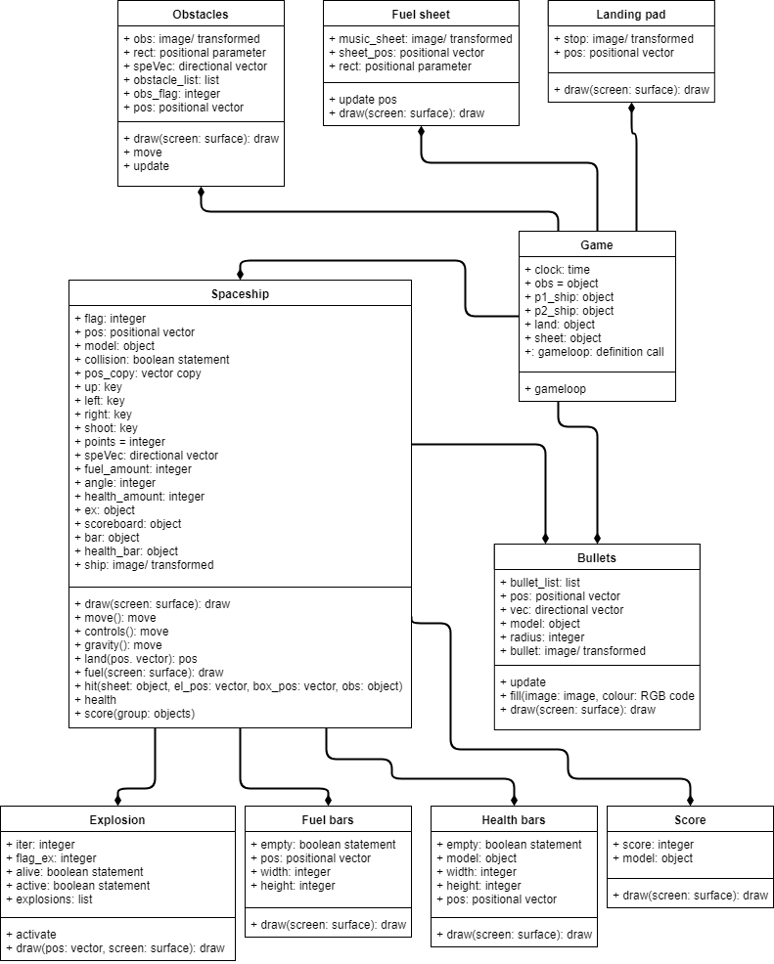

The UML diagram illustrates how the spaceship and game classes instantiate other classes, demonstrating the overall structure of the project. Additionally, a configuration file contains constants used throughout the code, providing easy access and management of these values.

5 Discussion
The alteration to convert all interactable objects in the game into sprite.Sprite and then place them into a group led to some issues. While it was relatively straightforward to adapt them to run, remodeling the interactions became necessary, as the previous method relied heavily on object lists for interactions. Additionally, there was some back-and-forth regarding interaction detection methods in general. Up until delivery, two of the interactions were more troublesome than the others. The ship-on-ship interaction and the bullet-on-ship interaction didn’t detect properly for a while, however increasing the detection radius and creating two death flags resolved the issue last minute.

6 Conclusion

All the requirements for the assignment have been successfully met. The spaceships move independently and can lose points through crashes or destruction, while also gaining points for destroying the opponent.

7 References
The pygame library with its many functions included: pygame docs. 2018. pygame dozumentation. [ONLINE] Available at: https://pygame.org/docs/. [Accessed 20 April 2018].
The tool to make an UML-diagram:
draw. 2018. Mayhem_UML. [ONLINE] Available at: https://www.draw.io/. [Accessed 19 April 2018].
The book of this course:
Philips, D., 2015. Python 3 Object-oriented Programming. 2nd ed. Birmingham: Packt Publishing Ltd.

