INF-1400:
Objektorientert programmering
Assignment 1, 24V
Jens Christian Valen Leynse
jeley4465
Feb 02th, 2024

Introduction
The assignment focuses on implementing a Sudoku game using Python, utilizing a structured approach with classes that encapsulate the Sudoku board, individual squares, and essential elements such as rows, columns, and boxes. The goal is to develop a solution to solve a 2D array as a Sudoku board, showing the algorithm used in the process along with the solved board.
Design & Implementation
The SudokuBoard Class is a subclass of the Board class from the precode and represent a single game of sudoku. Inheriting from the board class it can use the attributes and methods to modify specific board behavior towards specifically a sudoku board. The class utilizes a super function to initialize the board class (as it accesses the parent without name conflicts with this function (“init)). This sublass introduces two essential methods: the first translates integers from the input string into Square objects, while the second establishes connections between squares and elements (representing rows, columns, and boxes). Lastly, the 'solve' method invokes the parent class's solving algorithm, employing a backtracking approach to crack the Sudoku puzzle.
The Square Class represents a single square on the sudoku board. Its constructor initializes the object to store a value, along with references to the row, column, and box it is a part of. The class features two essential methods: one to verify the legality of a new value, cross-referencing it with the values in the associated row, column, and box; and another to set the value if it aligns with the puzzle's rules.
The Element Class represents a row, column, or box within the sudoku game. In addition to the constructor, it features a method to compare values within the squares of the current element.
The SudokuGUI class serves as the primary graphical interface for the Sudoku game. Upon instantiation, it initializes the GUI, creating a grid of Entry widgets for the Sudoku board and incorporating buttons for various grid operations. The class handles arrow keypress events for navigation and establishes a connection with the SudokuGrid class.
In turn, the SudokuGrid class effectively manages the Sudoku board and its operations. It fetches new boards, updates the associated GUI, and provides functionality for solving, restarting, and checking the Sudoku board. The connection between SudokuGrid and SudokuGUI is facilitated through event bindings, allowing the GUI to respond to arrow keypresses for navigation. Additionally, instances of the SudokuBoard class are utilized within SudokuGrid to represent the initial, current, and solved states of the Sudoku board.
Class Diagram: 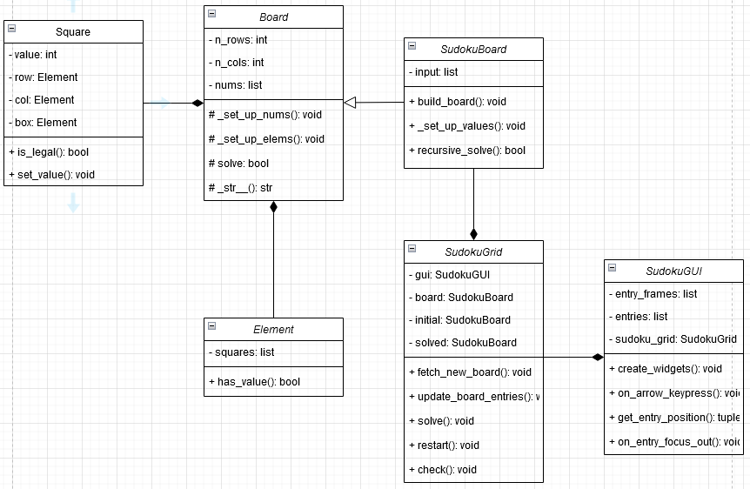
Discussion
The brute-force method, acknowledged as the simplest Sudoku-solving algorithm, involves finding the lowest legal value for each square, iterating through the board until a solution is found. If no legal values are found, it backtracks to the previous square. In the provided code this algorithm was put in the board’s solve method, as it had listed to place the algorithm there. Although this algorithm was directly connected to a sudoku board, I choose to keep it there for simplicity’s sake. considering potential implementations of diverse board types it would be more beneficial to replace this algorithm with a simple backtracking one, and move some of the logic to the sudokuboard class itself.
Regarding future enhancements, the current implementation requires clicking on another square to unfocus and save the current number when using the check button. . Although an attempt was made to automate this process, satisfactory results were not achieved. A more advanced feature, albeit challenging within the provided time constraints, could involve not only highlighting mistakes but also offering hints for finding the next number. The primary area for improvement lies in reconsidering the solving algorithm, with potential alternatives such as constraint-based, rule-based, or candidate removal methods.
Conclusion
The assignment covers the implementation of Sudoku game classes, emphasizing the relationship between SudokuBoard, Square, and Element. The chosen solving algorithm, a straightforward brute-force method, was selected for its simplicity and ease of implementation. The assignment provided valuable insights into programming concepts and Sudoku-solving strategies.

