TDT4195: Visual Computing Fundamentals
Computer Graphics - Assignment 3
Oktober 7th, 2022
by: Jens Christian Valen Leynse

Task 1c
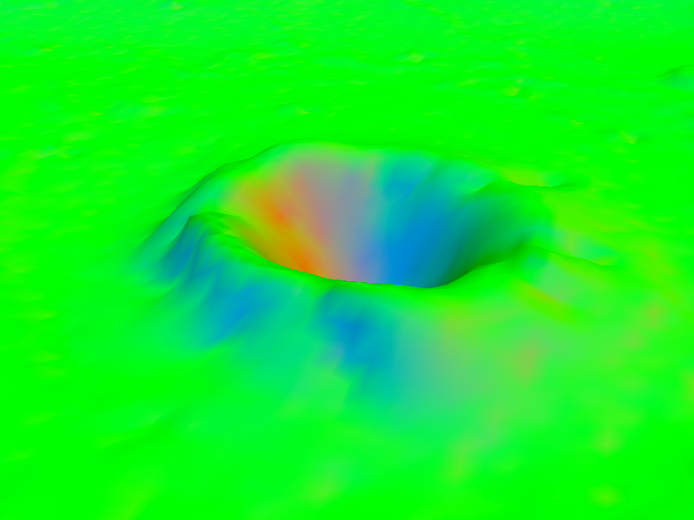

The crater is created with the normal vector. So the colors are based by the normal vector from the mesh terrain. The vector direction for up (y) corresponds to green, while the sides of the crater shows the color changing based on the direction the normal vector is moving.

Task 1d
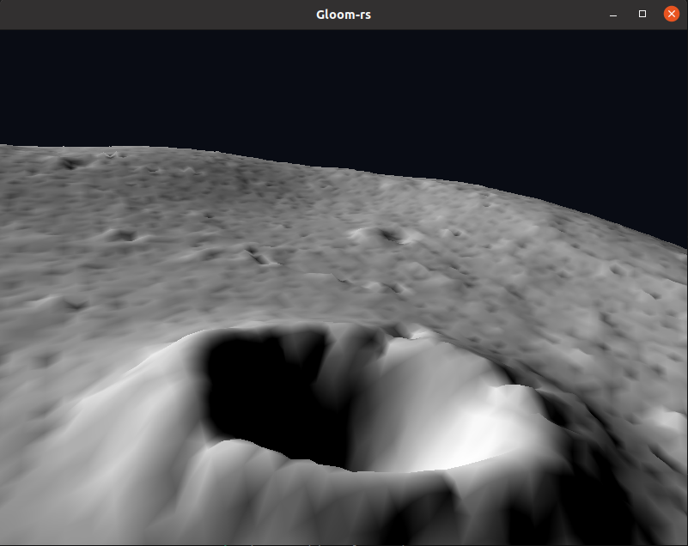
When the surface is lit the crater uses the normal vectors (as shown earlier) to change the default color to darker or lighter tones based on the vector direction.

Task 2c
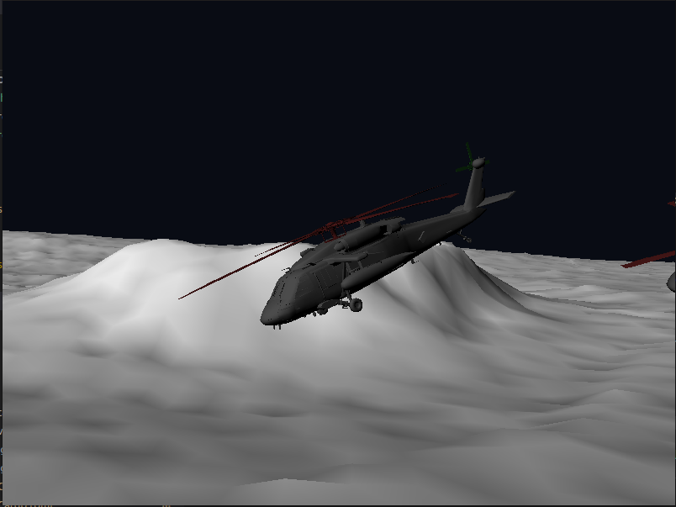

The helicopter being drawn along with the terrain mesh.

Task 5a (Task 6)
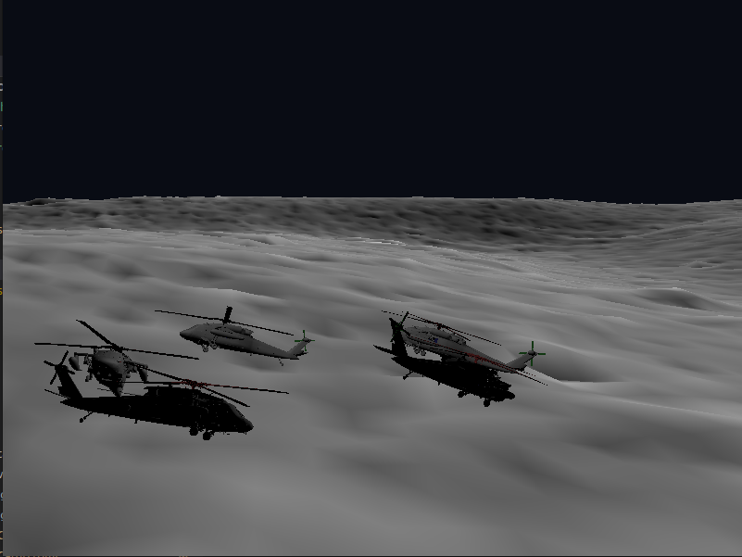

Instead of two images I found that this screenshot showed the lighting problem in a well enough manner. The helicopters, following the same path, are all shown to have lighting from the left side. After turning this still remains true.

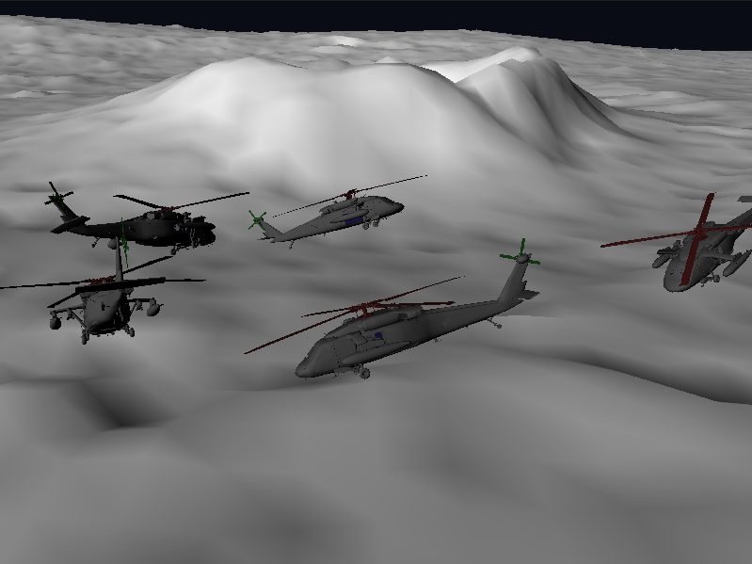

As opposed to the earlier image here you can see that the helicopters are lighted from the same side (normal vector). Meaning the light direction has determined the color tone of the helicopters given the angle of the normal.

Task 6
The images above shows the rendering of the five helicopters.

