Assignment 1 Experimental Design and Data Analysis Group 57 - Layla Nolte, Jensen Valkenhoff, Richard Pereira e Silva

Exercise 1a) Seeded clouds
We compare rainfall from two independent samples (26 seeded vs 26 unseeded clouds). The data are not paired, since different clouds were assigned to treatment and control groups.
The research question is whether seeding increases rainfall, so we mainly consider the one-sided alternative $H_{1}:μ_{\text{seeded}}>μ_{\text{unseeded}}$, but we also report two-sided p-values.
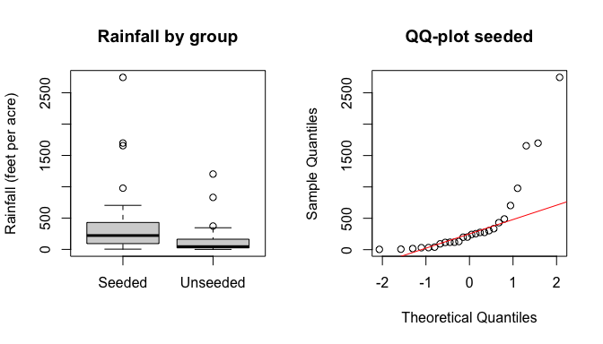
## Test p..two.sided. p..seeded...unseeded.
## 1 Welch t-test 0.0538 0.02688
## 2 Mann–Whitney 0.0138 0.00692
## 3 KS test 0.0177 NA
##
## Conclusion (alpha = 0.05):
## - Welch t-test: two-sided p = 0.0538; one-sided (seeded > unseeded) p = 0.0269.
## - Mann–Whitney: two-sided p = 0.0138; one-sided p = 0.0069.
## - KS test (two-sided): p = 0.0177.
##
## Interpretation:
## Rainfall is highly skewed with extreme values, so the t-test assumptions are questionable.
## Nonparametric tests (Mann–Whitney and KS) indicate a significant difference between groups.
## Because assignment to seeded/unseeded clouds was randomized, a permutation test is applicable and valid.
Applicability.
Welch t-test targets means and is sensitive to skewness/outliers.
Mann–Whitney compares location (often interpreted as median shift under assumptions).
KS compares entire distributions. A permutation test is applicable because treatment assignment was randomized.

Exercise 1b) Transformations of rainfall
To reduce skewness and stabilize variance, we repeat the analysis using the square root and the fourth root (sqrt of sqrt) transformations of rainfall.
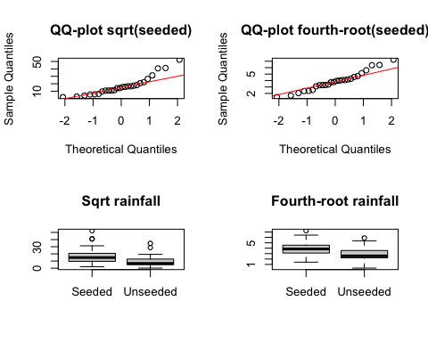
## Transformation Welch.p Mann.Whitney.p KS..two.sided..p
## 1 Sqrt 0.00978 0.00692 0.0177
## 2 Fourth-root 0.00620 0.00692 0.0177
The square-root transformation reduces skewness compared to the original data, and the fourth-root transformation improves symmetry even further, as seen in the QQ-plots.
After transformation, the Welch t-test becomes more reliable because the normality assumption is better satisfied. The significance levels remain similar, and the evidence that seeded clouds produce more rainfall persists.
The nonparametric tests (Mann–Whitney and KS) are largely unaffected by transformation, since they do not rely on normality assumptions.
Overall, the conclusion from Exercise 1a remains unchanged: there is evidence that seeding increases rainfall.

Exercise 1c) Testing Population Mean
## [1] 3.88
## [1] 20
##
## Exact binomial test
##
## data: 20 and 26
## number of successes = 20, number of trials = 26, p-value = 0.005
## alternative hypothesis: true probability of success is greater than 0.5
## 95 percent confidence interval:
## 0.595 1.000
## sample estimates:
## probability of success
## 0.769
##
## Wilcoxon signed rank test with continuity correction
##
## data: t1
## V = 280, p-value = 0.004
## alternative hypothesis: true location is greater than 3
## Transformation Mu...3 Mu...4 M...3.5
## 1 P-Value 0.00242 0.663 0.0973
The true mean of t1 is 3.88. The t-tests applied indicate that by rejecting that t1 mean is greater than 4 and failing to reject that it is greater than 3. The binomial test corroborates that. We can use the wilcoxon sign test rank to achieve the same result as shown above, Wilcoxon test doesn’t rule out m > 3 either.

Exercise 1d) Using Median as Bootstrap Statistic
## [1] 272
## [1] 612
## 97.5% 2.5%
## 581 767
## [1] 0.002
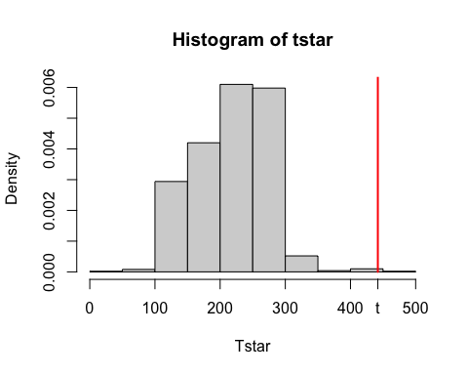
##
## Asymptotic one-sample Kolmogorov-Smirnov test
##
## data: jitter(Tstar)
## D = 1, p-value <2e-16
## alternative hypothesis: two-sided
Using the Central Limit Theorem we found a mean of 442 with a 95% CI of [272,612]. Using the boostrap method with median as statistic we ruled out that the data is following a exponential distribution by first assuming that it was exponential and then testing it with the bootstrap test and Kolmogorov-Smirnov test. Both tests returned very small p-values indicating that the original distribution is not exponential. That is also clear looking at the histogram above.

Exercise 1e) Median and fraction tests (seeded clouds)
We consider only the seeded sample ($n=26$). Because rainfall is highly skewed, we use exact binomial tests.

(i) Test whether the median precipitation is less than 300
We perform a sign test:
$$H_{0}:\text{median}=300 \text{vs} H_{1}:\text{median}<300.$$
Out of 26 observations, 17 are below 300. The exact binomial test yields $p=0.084$.
Conclusion ($α=0.05$). Since $p=0.084>0.05$, we do not reject $H_{0}$.
There is insufficient evidence that the median precipitation of seeded clouds is less than 300.

(ii) Test whether the fraction with precipitation < 30 is at most 25%
Let $p=P\left(X<30\right)$. We test:
$$H_{0}:p≤0.25 \text{vs} H_{1}:p>0.25.$$
We observe 3 out of 26 clouds with precipitation below 30, so $\hat{p}=3/26=0.115$. The exact binomial test yields $p=0.974$, with a 95% confidence interval for $p$ equal to $\left[0.024, 0.302\right]$.
Conclusion ($α=0.05$). Since $p=0.974>0.05$, we do not reject $H_{0}$.
The data are consistent with the fraction of seeded clouds with precipitation below 30 being at most 25%.

Exercise 2)
The second exercise is an analysis of how three different types of diet influence the weight loss among a population with N=78. Each person followed a specific diet during 6 weeks and the weight before and after this time period are measured. The considered dataset is diet.txt, which contains 7 variables for each member of the population. preweight here describes the initial weight and weight6weeks the after taking the diet for 6 weeks. An additional variable weight.loss is added to the data to perform paired sample testing during the exercise. The resulting dataset is as follows:
##
## 1 function (..., list = character(), package = NULL, lib.loc = NULL,
## 2 verbose = getOption("verbose"), envir = .GlobalEnv, overwrite = TRUE)
## 3 {
## 4 fileExt <- function(x) {
## 5 db <- grepl("\\\\.[^.]+\\\\.(gz|bz2|xz)$", x)
## 6 ans <- sub(".*\\\\.", "", x)

Exercise 2a)
This section contains the informative graphical summary of the effect of diet on weight loss. Since the data is measured for the same individuals before and after six weeks on the diet, the data are paired. The following assumptions have to be met before performing a paired t-test: independency of pairs, normality of weight loss, and the absence of extreme outliers. The considered response variable is data$weight_loss for this sub-exercise.
a) The first assumption is met by the definition of the dataset, since the measurements are all indepent of each other.
b) The second assumption can be checked by a QQ-plot. The red line represents the reference line under normality. Since the majority of the data points lie close to this line, there is strong evidence that normality can be assumed. Since this is the case in the figure, it is reasonable that the data is normally distributed.
c) A boxplot is created to visually check whether the data contains outliers or not. The boxplot shows the median, interquartile range, and potential extreme values. To asses the amount of outliers numerically, the command boxplot.stats(weight_loss)$out is used, which gave numeric(0) as output, meaning that the data does not contain any outliers.
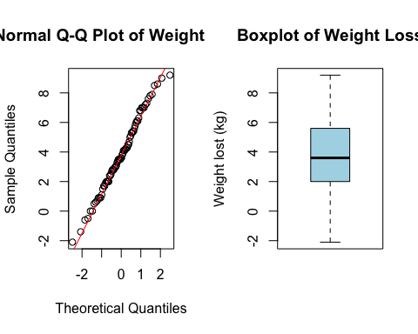
To test claim that the diet affects the weight loss, a paired t-test was performed with data$weight_loss as response variable. The hypotheses are:
- H0:The mean weight loss is equal to zero. $\left(μ_{x}=0\right)$
- H1: The mean weight loss is not equal to zero. $\left(μ_{x}≠0\right)$ The paired t-test resulted in a p-value of 1.17 × 10⁻²¹, which is far below the significance level of $α=0.05$. Consequently, the null hypothesis that there is no difference between preweight and weight6weeks is rejected, such that HA: The mean weight loss is not equal to zero, is accepted $μ_{x}≠0$. In other words, there is an observed difference between the variables preweight and weight6weeks and the mean difference is 3.84, implying that an individual loses 3.84 kg weight on average by taking a diet according to the data.
##
## Paired t-test
##
## data: preweight and weight6weeks
## t = 13, df = 77, p-value <2e-16
## alternative hypothesis: true mean difference is not equal to 0
## 95 percent confidence interval:
## 3.27 4.42
## sample estimates:
## mean difference
## 3.84

exercise 2b
This section investigates whether weight loss differs between the three diet groups. The response variable is the weight_loss, computed as the difference between preweight and weight6weeks. Since the factor diet contains three independent groups, a one-way ANOVA is used to test whether the mean weight loss is equal across diets. The hypotheses are:
- H0: The mean weight loss is equal across all diet groups. $\left(μ_{1}=μ_{2}=μ_{3}\right)$
- H1: At least one diet group has a different mean weight loss. A boxplot is created to compare the distribution of weight loss across the three diet groups. The differences of the mean and the spread among the groups give a visual indication of whether the diets may lead to different outcomes.
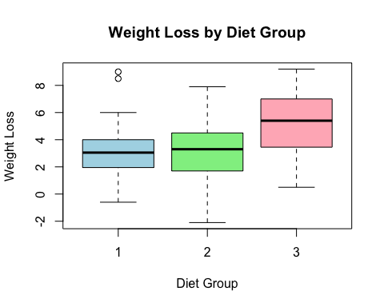
A one-way ANOVA is performed to test whether the mean weight loss differs between diet group. The results of the analysis are summarized in the table below, displaying that the null hypothesis is rejected since p = 0.003 < 0.05. This means that ‘H1: At least one diet group has a different mean weight loss.’ is true.
## Df Sum Sq Mean Sq F value Pr(>F)
## diet 2 71 35.5 6.2 0.0032 **
## Residuals 75 430 5.7
## ---
## Signif. codes: 0 '***' 0.001 '**' 0.01 '*' 0.05 '.' 0.1 ' ' 1
To determine whether every separate diet leads to weight loss, three one-sample t-test were performed on each diet group, with the following hypotheses:
- H0: Mean weight loss = 0.
- H1: Mean weight loss > 0.
Again, weight_loss is the computed response variable and is used as before. To perform the one sample t-tests, see Section 2a to see which conditions have to be met to perform a proper t-test. The partitions of group 2 and group 3 seem to be suitable for a one-sample t-test, as the majority of the datapoints lie around the linear line and there are no extreme outliers. Although the first dataset shows two potential outliers in both the Q-Q plot and the boxplot, the overall distribution does differ much from normality, suggestingn that a t-test can be used in this.
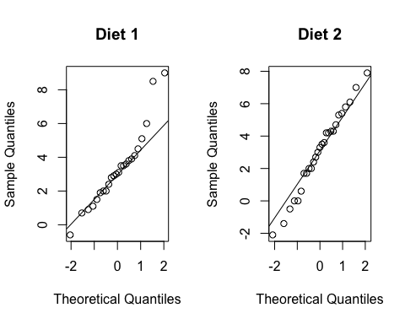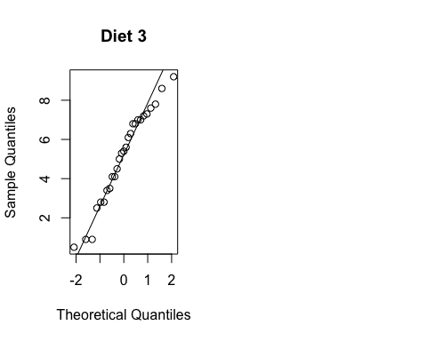 According to the performed t-test, every outcome implies that H0 is rejected since p < 0.05, such that ‘H1: Mean weight loss > 0.’ is accepted for every diet group. $\left(μ_{1},μ_{2},μ_{3}\right)≈\left(2.516,3.026,5.148\right)$, suggesting that diet group 3 has the highest observed weight loss with a mean value of $μ_{3}≈5.148$.
##
## One Sample t-test
##
## data: data$weight_loss[data$diet == 1]
## t = 7, df = 23, p-value = 1e-07
## alternative hypothesis: true mean is greater than 0
## 95 percent confidence interval:
## 2.52 Inf
## sample estimates:
## mean of x
## 3.3
##
## One Sample t-test
##
## data: data$weight_loss[data$diet == 2]
## t = 6, df = 26, p-value = 7e-07
## alternative hypothesis: true mean is greater than 0
## 95 percent confidence interval:
## 2.2 Inf
## sample estimates:
## mean of x
## 3.03
##
## One Sample t-test
##
## data: data$weight_loss[data$diet == 3]
## t = 11, df = 26, p-value = 1e-11
## alternative hypothesis: true mean is greater than 0
## 95 percent confidence interval:
## 4.36 Inf
## sample estimates:
## mean of x
## 5.15

exercise 2C)
Question 2C investigates whether weight loss depends on diet, gender, and their interaction. The response variable is weight_loss, computed as the difference between preweight and weight6weeks. Since we have two categorical factors (diet with three groups, and gender with two groups), a two-way ANOVA is used.

Hypotheses
We test three effects: diet, gender, and their interaction.

Main effect of Diet
- H0: The mean weight loss is equal across all diet groups. $\left(μ_{1}=μ_{2}=μ_{3}\right)$
- H1: At least one diet group has a different mean weight loss.

Main effect of Gender
- H0: The mean weight loss is equal for both genders. $\left(μ_{M}=μ_{F}\right)$
- H1: The mean weight loss differs between genders. $\left(μ_{M}≠μ_{F}\right)$

Interaction effect (Diet × Gender)
- H0: There is no interaction between diet and gender (the effect of diet is the same for both genders).
- H1: There is an interaction between diet and gender (the effect of diet depends on gender).
## diet weight_loss
## 1 1 3.30
## 2 2 3.03
## 3 3 5.15
## gender weight_loss
## 1 0 3.89
## 2 1 4.02
The below figures are used to give a visual indication of the effects and the interactions. The boxplot for weight loss by gender indicates that although the spread among men is higher than for women, the average mean weight loss is almost equal $μ_{m}=3.893∧μ_{f}=4.015)$. For the diet groups, we clearly observe visually that the third diet group (purple) causes a higher weight loss $\left(μ_{3}=5.148\right)$ than the first and the second group $\left(μ_{1}=3.300∧μ_{2}=3.026\right)$. 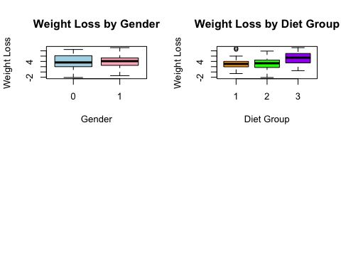
## diet gender weight_loss
## 1 1 0 3.05
## 2 2 0 2.61
## 3 3 0 5.88
## 4 1 1 3.65
## 5 2 1 4.11
## 6 3 1 4.23
The interaction plots below show that the effect of diet on weight loss differs between genders. In the table above, 0 is translated to m (men) and 1 to f (female). To support this interpretation, we consider the cell means (interaction means) for each combination of diet group and gender. For women, the mean weight loss equals$\left(μ_{1,m},μ_{2,m},μ_{3,m}\right)=\left(3.05,2.61,5.88\right).$ This indicates that diet 3 leads to a clearly higher mean weight loss compared with diets 1 and 2.
For womenn, the mean weight loss equals $\left(μ_{1,f},μ_{2,f},μ_{3,f}\right)=\left(3.65,4.11,4.23\right)$. Here, the mean weight loss is more equally divided across the three diets. This suggests that the diet effect is more pronounced for men, especially for diet 3.
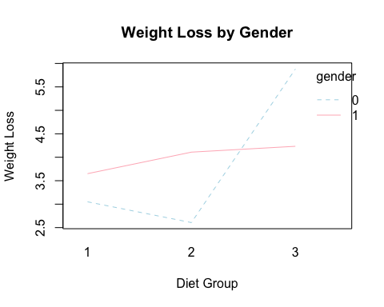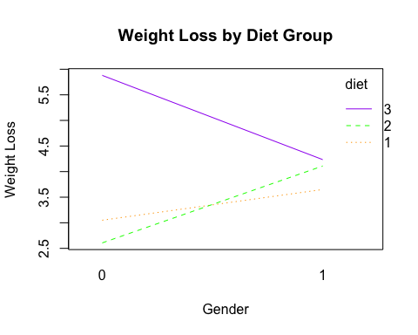
Two-way ANOVA was perfofrmed to determine the effects of diet, gender, and their interaction on weight loss. There was a significant main effect of diet, $F(=5.63$, $p=0.005$, indicating that mean weight loss differs between the three diet groups. The main effect of gender was not significant, $F=0.03$, $p=0.860$, suggesting that overall weight loss does not differ between men and women. Importantly, a significant interaction between diet and gender was found,$F=3.15$, $p=0.049$. This is evidence that the effect of diet on weight loss depends on gender.
## Analysis of Variance Table
##
## Response: weight_loss
## Df Sum Sq Mean Sq F value Pr(>F)
## diet_factor 2 61 30.26 5.63 0.0054 **
## gender_factor 1 0 0.17 0.03 0.8599
## diet_factor:gender_factor 2 34 16.95 3.15 0.0488 *
## Residuals 70 376 5.38
## ---
## Signif. codes: 0 '***' 0.001 '**' 0.01 '*' 0.05 '.' 0.1 ' ' 1

exercise 2D
For exercise 2D, we included the variables gender, height and age to investigate whether these covariates influence weight loss. The models used are linear models (lm), which fits linear regression models by least squares. We use an ANCOVA (analysis of covariance) model because both categorical (diet group & gender and continuous variables (height & age) are included in this case.
The four scatterplots of weight_loss against age and height, are categorized by either gender or diet group. None of the scatterplots shows a clear linear relationship, suggesting that both height and age do not influence weight loss, neither show crossover effects with diet and age. These observations will be formally tested using regression analysis. Only the interaction diet*gender will be analyzed in this part, since the interaction is significant according to exc 2C.
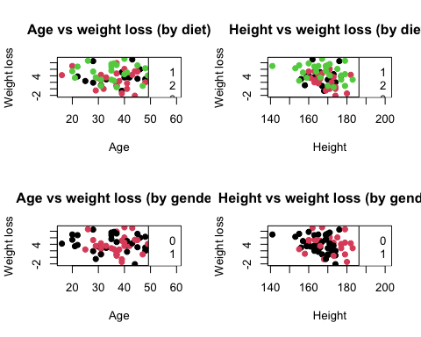
An ANOVA test is performed on the linear model including diet, gender, height and age. The ANOVA table shows that diet has a significant effect on weight_loss (p < 0.05), but gender, height and age are not statistically significant (p > 0.05). This means that there is no evidence that these variables independently influence weight_loss in the linear model.
## Analysis of Variance Table
##
## Response: weight_loss
## Df Sum Sq Mean Sq F value Pr(>F)
## diet 2 61 30.26 5.18 0.008 **
## gender 1 0 0.17 0.03 0.866
## height 1 1 0.78 0.13 0.715
## age 1 0 0.43 0.07 0.786
## Residuals 70 409 5.84
## ---
## Signif. codes: 0 '***' 0.001 '**' 0.01 '*' 0.05 '.' 0.1 ' ' 1
We included the interaction between diet and gender as well to investigate whether the effect of diet differs between genders. The interaction term diet ~ gender is statistically significant (p = 0.048 < 0.05), which means that the interaction between gender and diet has effect on weight_loss. This means that the model fit is improved compared to the first model. The remaining variables (excluding diet), do not show a significant effect on the model fit.
## Analysis of Variance Table
##
## Response: weight_loss
## Df Sum Sq Mean Sq F value Pr(>F)
## diet 2 61 30.26 5.50 0.0061 **
## gender 1 0 0.17 0.03 0.8615
## height 1 1 0.78 0.14 0.7069
## age 1 0 0.43 0.08 0.7800
## diet:gender 2 35 17.48 3.18 0.0479 *
## Residuals 68 374 5.50
## ---
## Signif. codes: 0 '***' 0.001 '**' 0.01 '*' 0.05 '.' 0.1 ' ' 1
To investigate which model should be chosen, an additional ANOVA test is performed on the two models. Since p = 0.048 < 0.05, H0 is rejected, so we can conclude that the interaction has effect on the model. This means that we should rather use model_int for, since including the interaction diet * gender improves the model according to the ANOVA test.
## Analysis of Variance Table
##
## Model 1: weight_loss ~ diet + gender + height + age
## Model 2: weight_loss ~ diet * gender + height + age
## Res.Df RSS Df Sum of Sq F Pr(>F)
## 1 70 409
## 2 68 374 2 35 3.18 0.048 *
## ---
## Signif. codes: 0 '***' 0.001 '**' 0.01 '*' 0.05 '.' 0.1 ' ' 1

exercise 2E
For the selected model from Exercise 2D,
$$\text{weight_loss}∼\text{diet}*\text{gender}+\text{height}+\text{age},$$
predictions were computed for an average person (age and height set to their sample means). Here, gender = 0 denotes men and gender = 1 denotes women.
## diet gender age height fit lwr upr
## 3 3 0 39.2 171 5.76 4.47 7.05
## 5 2 1 39.2 171 4.30 2.70 5.90
## 6 3 1 39.2 171 4.24 2.88 5.60
## 4 1 1 39.2 171 3.63 2.14 5.12
## 1 1 0 39.2 171 3.09 1.83 4.34
## 2 2 0 39.2 171 2.56 1.29 3.82

