Bankrate was founded in 1976 as Bank Rate Monitor, a print publisher for the banking industry. Our experience has fueled our reputation as the premier financial authority. When you visit Bankrate.com, the reviews, guides and educational content have been developed by leading personal finance experts. Bankrate’s product comparison tools, calculators and educational content help over 100 million consumers make smarter financial decisions each year. No matter where you are in your financial journey, Bankrate can help you reach your goals.

One area Bankrate specializes in is personal loans. Bankrate’s goal is to help match the best lending partner for each individual customer. To do that, we collect information about the customer to understand who would be the best fit. We want to maximize the likelihood someone will be approved for the loan at the best “deal” possible.

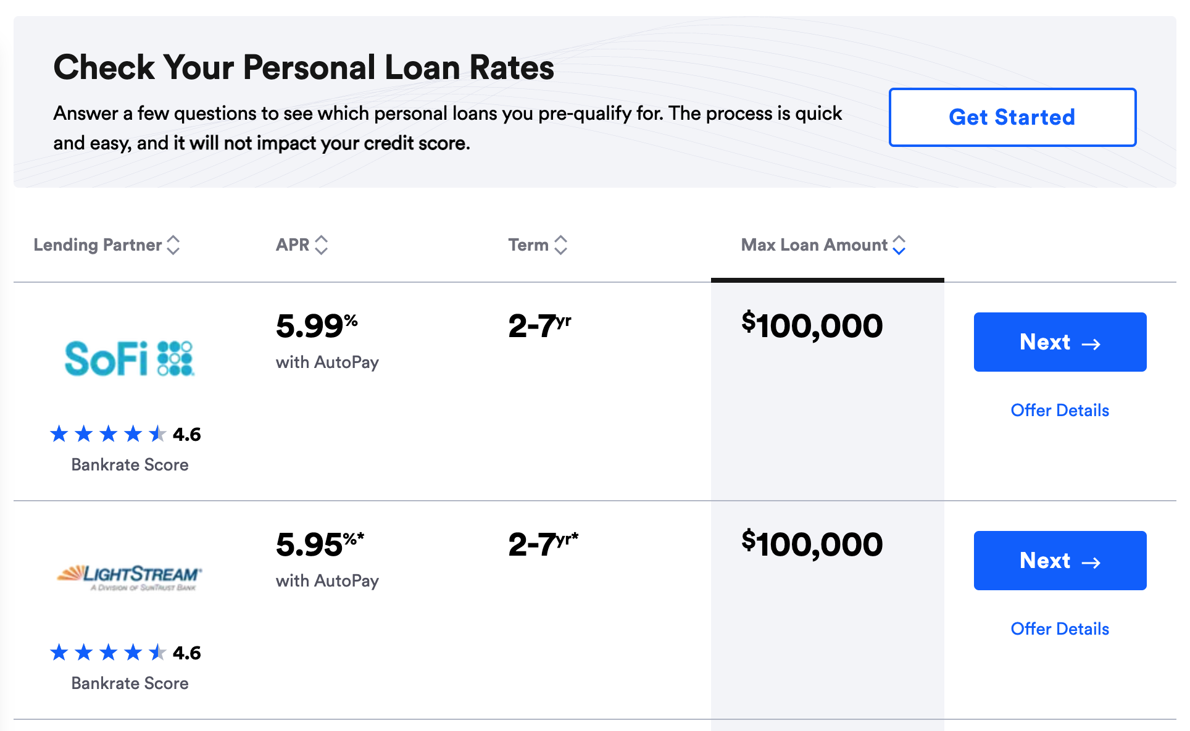

In this case, let’s imagine we have three lending partners, “A”, “B”, and “C”. In this scenario, let’s imagine that each lender is providing the same offer. However, for each approval, lender A provides us **$250**, lender B pays us **$350**, and lender C pays us **$150**.

For 100K of our customers, we have collected a set of data in hopes to understand what variables are most important in determining approvability. We believe if we collect the right information, we will be able to show the appropriate lender to each customer to maximize **approval rate** and **revenue**. The team knows there are many possible data points that we could collect to help us better understand the likelihood of someone approving for the loan, but they started with this list for now.

The business team has recently collected this data and has asked you to help make sense of it. They want to know if they can increase **revenue per application** by matching certain groups of customers to specific lenders.

There are three broad categories that they would like you to investigate.

1. Tell us about the variables:
   1. *Possible things to consider:* Which variables are the most helpful in understanding if a customer is going to be approved or denied for a loan? Are there certain variables that are not useful to collect?
2. Tell us about the lenders:
   1. *Possible things to consider:* What is each Lender’s average approval rate? How does their revenue per approval differ? Are there any clear differences between the three different lenders on what type of customers they approve?
3. Tell us about which customers we should match to each lender:
   1. *Possible things to consider:* Are there groups of customers that would be a better fit for a different lender? How much incremental revenue could we have made if we matched certain groups of customers more appropriately?

**Feel free to use any tool to answer these questions**. Please submit both your answers and your work to get to those answers for the three categories. Make sure that your work is legible and able to be referenced for your answers.

Data Dict:

**User ID** - unique ID to represent the customer who submitted the application (string)

**Application** - count of application - each row is 1 application submitted (int)

**Reason** - the purpose for requesting a loan (string)

**Loan Amount** - the loan value size (int)

**FICO Score** - score used to make credit risk decisions (int)

**FICO Score Group** - categorical grouping of FICO scores in the five common buckets (string)

**Employment Status** - current employment designation for the customer applying for the loan (string)

**Employment Sector** - categorical representation of the industry the customer works in (string)

**Monthly Gross Income** - the amount of money the user makes pre-taxes and deductions (int)

**Monthly Housing Payment** - how much a month do they pay in housing costs (int)

**Ever Bankrupt or Foreclose** - has the customer ever had to file for bankruptcy or had a foreclosure on their house (bool)

**Loaner** - the lending partner (string)

**Approved** - did the customer get approved for the loan or not (bool)

**Bounty** - how much did we get paid for the application - only occurs on an approval (int)

Please feel free to feature engineer if you’d like to create new columns.