

|  |
| --- |
| Business Template  **KINDERGARTEN** |
|  |

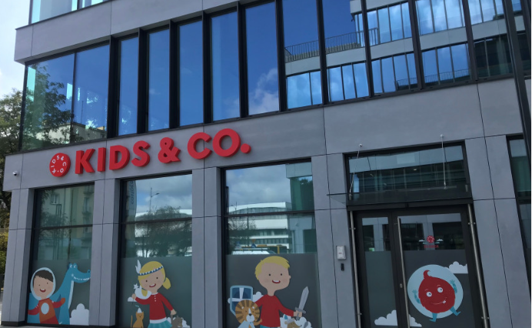

Contents

1 Business Description 3

1.1 Business background 3

1.2 Problems. Current Situation 3

1.3 Benefits from implementing a database. Project Vision 3

2 Model description 3

2.1 Definitions & Acronyms 3

2.2 Logical Scheme 3

2.3 Objects 3

# 

# Business Description

## Business background

Private kindergarten for residents of the European district (residential area). The kindergarten is located on the first floor of a residential building. Has a fenced playground area.

Suitable only for residents from adjacent houses (2-3 streets adjacent to the kindergarten).

Maximum three groups. Up to 18 children per group.

There are two educators per group (According to the schedule). Working all day only duty nurse and a security guard.

Time to time work (by schedule) educators: Foreign Language Teacher, Music Teacher. and Teacher of Modern Dance.

Food for children is ordered from a local cafe. The menu is coordinated for the week. You can choose from two soups. three side dishes. four main courses and five salads. Juice and water in an assortment

## Problems. Current Situation

Necessarily:

- children only from the nearest houses can attend kindergarten. (List of Accepted Streets and Buildings)

- possibility add new Streets and Buildings when the kindergarten receives additional premises.

- children from kindergarten can only pick up parents/guardians.

Not necessary:

- accounting for children's attendance

- staff work schedule

## Benefits from implementing a database. Project Vision

Possibility to admit children to the kindergarten only from adjacent houses. It will be done to prevent the overflow of the kindergarten. And will enable teachers to focus on teaching children

Plan the working hours of kindergarten staff. Holidays

Reduce staffing costs. For example, to refuse the Music Teacher for a full day.

# Model description

## Definitions & Acronyms

**FName** – First Name (like Eugene)

**LName** – Lastt Name (like Yurchenko)

**WTime –** Work Time

**DOB –** Day of birthday

## Logical Scheme

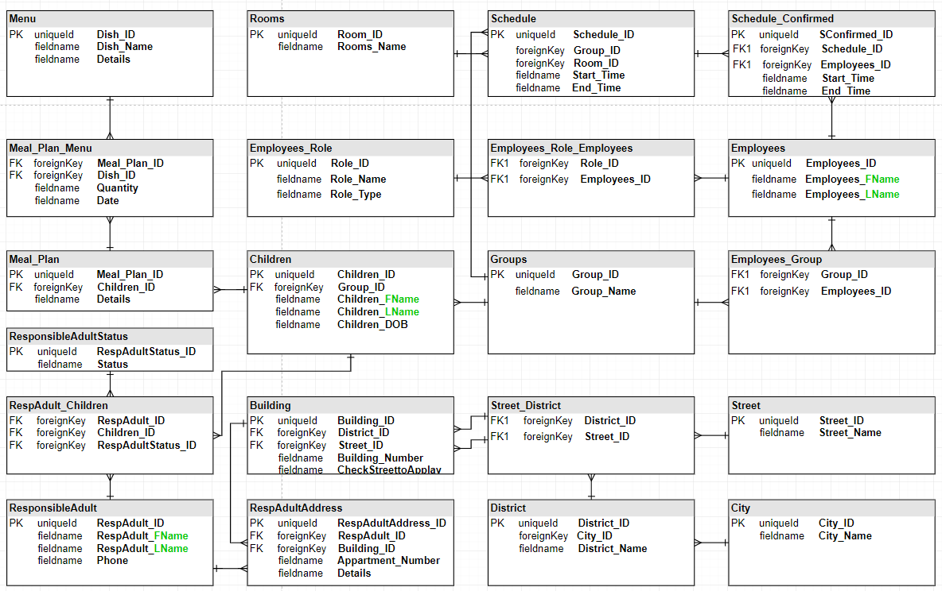

## Objects

**Employees**

It stores employee data

|  |  |  |  |
| --- | --- | --- | --- |
| Table Name | Field name | Field Description | Data Type |
| **Employees** | **Employees_ID** | PK | Int |
| **Employees_FName** | First name | Text |
|  | **Employees_LName** | Last name | Text |

Tables Relations: many to many with **Table Role**,   
 many to many with **Schedule**  
 many to many with **Groups**

Example with filled data

|  |  |  |
| --- | --- | --- |
| Employees_ID | Employees_FName | Employees_LName |
| 1 | Reksio | NOWAK |
| 2 | Bolek | KOWALSKI |
| 3 | Lolek | WIŚNIEWSKI |
| 4 | Maya | WÓJCIK |
| 5 | Willy | KOWALCZYK |
| 6 | Miss Cassandra | LEWANDOWSKI |

**Groups**

It stores employee data

|  |  |  |  |
| --- | --- | --- | --- |
| Table Name | Field name | Field Description | Data Type |
| **Groups** | **Group_ID** | PK | Int |
| **Group_Name** | Description | Text |

Tables Relations: many to many with **Employees**,   
 one to many with **Children**  
 one to many with **Schedule**

Example with filled data

|  |  |
| --- | --- |
| Group_ID_ID | Schedule_ID |
| 1 | Raspberry |
| 2 | Strawberry |
| 3 | Blackberry |

**Schedule**

It stores Date and Time for reserved rooms. And group booking room

|  |  |  |  |
| --- | --- | --- | --- |
| Table Name | Field name | Field Description | Data Type |
| **Schedule** | **Schedule_ID** | PK | Int |
| **Group_ID** | FK | Int |
|  | **Room_ID** | FK | Int |
|  | **Start_Time** | Start booking a room | datetime |
|  | **End_Time** | End booking a room | datetime |

Tables Relations: many to many with **Employees**,   
 one to many with **Groups**  
 one to many with **Rooms**

Example with filled data

|  |  |  |  |  |
| --- | --- | --- | --- | --- |
| Schedule_ID | Group_ID | Room_ID | Start_Tme | End_Tme |
| 1 | 1 | 5 | 19-11-22 07:00 | 19-11-22 08:00 |
| 2 | 1 | 1 | 19-11-22 08:00 | 19-11-22 12:00 |
| 3 | 1 | 4 | 19-11-22 12:00 | 19-11-22 13:00 |
| 4 | 1 | 1 | 19-11-22 13:00 | 19-11-22 18:00 |
| 5 | 2 | 4 | 19-11-22 07:00 | 19-11-22 08:00 |
| 6 | 2 | 2 | 19-11-22 08:00 | 19-11-22 12:00 |
| 7 | 2 | 5 | 19-11-22 12:00 | 19-11-22 13:00 |
| 8 | 2 | 2 | 19-11-22 13:00 | 19-11-22 18:00 |

**Schedule_Confirmed**

It stores Date and Time for employees. For calculating wok time and planning.

Connecting Employees and Schedule

|  |  |  |  |
| --- | --- | --- | --- |
| Table Name | Field name | Field Description | Data Type |
| **Schedule_Confirmed** | **SConfirmed_ID** | PK | Int |
| **Schedule_ID** | FK | Int |
|  | **Employees_ID** | FK | Int |
|  | **Start_WTime** | Start time emp work | datetime |
|  | **End_Time** | End time emp work | datetime |

Tables Relations: one to many with **Employees**,   
 one to many with **Schedule**

Example with filled data

|  |  |  |  |  |
| --- | --- | --- | --- | --- |
| SConfirmed_ID | Schedule_ID | Employees_ID | Start_WTime | End_WTime |
| 1 | 1 | 3 | 19-11-22 07:00 | 19-11-22 08:00 |
| 2 | 2 | 3 | 19-11-22 08:00 | 19-11-22 12:00 |
| 3 | 3 | 3 | 19-11-22 12:00 | 19-11-22 13:00 |
| 4 | **4** | 3 | **19-11-22 13:00** | **19-11-22 14:00** |
| 5 | **4** | 4 | 19-11-22 13:00 | 19-11-22 18:00 |

**Children**

It stores Full name Children and Date of birthday

|  |  |  |  |
| --- | --- | --- | --- |
| Table Name | Field name | Field Description | Data Type |
| **Children** | **Children_ID** | PK | Int |
| **Group_ID** | FK | Int |
|  | **Children_FName** | Description | text |
|  | **Children_LName** | Description | text |
|  | **Children_DOB** | Date of birthday | date |

Tables Relations: many to many with **ResponsibleAdult**  
 one to many with **Groups** one to many with **Meal_Plan**

Example with filled data

|  |  |  |  |  |
| --- | --- | --- | --- | --- |
| Children_ID | Group_ID | Children_FName | Children_LName | Children_DOB |
| 1 | 3 | Pikachu | WOŹNIAK | 2018 |
| 2 | 1 | Voltorb | SZYMAŃSKI | 2019 |
| 3 | 2 | Jolteon | ZIELIŃSKI | 2017 |

**Meal_Plan**

It stores Food for children for a day

|  |  |  |  |
| --- | --- | --- | --- |
| Table Name | Field name | Field Description | Data Type |
| **Meal_Plan** | **Meal_Plan_ID** | PK | Int |
| **Children_ID** | FK | Int |
|  | **Details** | Description | text |

Tables Relations: many to many with **Menu**  
 one to many with **Children**

Example with filled data

|  |  |  |
| --- | --- | --- |
| Meal_Plan_ID | Children_ID | Details |
| 1 | 3 | Vegan food |
| 2 | 1 | Half portion |
| 3 | 2 | w/o oranges |

**Menu**

It stores Menu from local Cafe

|  |  |  |  |
| --- | --- | --- | --- |
| Table Name | Field name | Field Description | Data Type |
| **Menu** | **Dish_ID** | PK | Int |
| **Dish_Name** | Description | text |
|  | **Details** | Description | text |

Tables Relations: many to many with **Meal_Plan**

Example with filled data

|  |  |  |
| --- | --- | --- |
| Dish_ID | Dish_Name | Details |
| 1 | Zupa | Spice |
| 2 | Steak | Rare |
| 3 | Water | cold |

**ResponsibleAdult**

It stores data about parents or another responsible person

|  |  |  |  |
| --- | --- | --- | --- |
| Table Name | Field name | Field Description | Data Type |
| **ResponsibleAdult** | **RespAdult_ID** | PK | Int |
| **RespAdult_FName** | Description | text |
|  | **RespAdult_LName** | Description | text |
|  | **Phone** | Description | text |

Tables Relations: many to many with **Building**  
 many to many with **ResponsibleAdultStatus** many to many with **Children**

Example with filled data

|  |  |  |  |
| --- | --- | --- | --- |
| RespAdult_ID | RespAdult_FName | RespAdult_LName | Phone |
| 1 | Shinx | WOŹNIAK | +48 50012312 |
| 2 | Luxio | SZYMAŃSKI | +48 50012313 |
| 3 | Luxray | ZIELIŃSKI | +48 50012314 |

**RespAdult_Children**

It stores data about Responsible Adultstatus. Connect Responsible Adult with Child

|  |  |  |  |
| --- | --- | --- | --- |
| Table Name | Field name | Field Description | Data Type |
| **RespAdult_Children** | **RespAdult_ID** | PK | Int |
| **Children_ID** | FK | Int |
|  | **RespAdultStatus_ID** | Father or Mother | text |

Tables Relations: one to many with **Building**  
 one to many with **ResponsibleAdultStatus** one to many with **Children**

Example with filled data

|  |  |  |
| --- | --- | --- |
| RespAdult_ID | Children_ID | RespAdult_Status |
| 1 | 1 | 1 |
| 2 | 1 | 2 |
| 3 | 2 | 3 |

**ResponsibleAdultStatus**

It stores Status for Parents (Farther or Mother)

|  |  |  |  |
| --- | --- | --- | --- |
| Table Name | Field name | Field Description | Data Type |
| **ResponsibleAdultStatus** | **RespAdultStatus_ID** | PK | Int |
| **Status** | Farther or Mother | text |

Tables Relations: one to many with **RespAdult_Children**

Example with filled data

|  |  |
| --- | --- |
| RespAdultStatus | Status |
| 1 | Farther |
| 2 | Mother |
| 3 | Mother |

**Building**

It stores data about Building number and status to apply

|  |  |  |  |
| --- | --- | --- | --- |
| Table Name | Field name | Field Description | Data Type |
| **Building** | **Building_ID** | PK | Int |
| **District_ID** | FK | Int |
|  | **Street_ID** | Description | text |
|  | **Building_Number** | Description(like 45B) | text |
|  | **CheckStreettoApplay** | Yes / No | text |

Tables Relations: one to many with **Street**  
 many to many with **ResponsibleAdult**

Example with filled data

|  |  |  |  |  |
| --- | --- | --- | --- | --- |
| Building_ID | District_ID | Street_ID | Building_Number | CheckStreettoApplay |
| 1 | 2 | 4 | 45B | Yes |
| 2 | 3 | 5 | 13 | No |
| 3 | 4 | 6 | 44/4 | No |

**RespAdultAddress**

Connect Responsible Adult with Address

|  |  |  |  |
| --- | --- | --- | --- |
| Table Name | Field name | Field Description | Data Type |
| **RespAdultAddress** | **RespAdultAddress_ID** | PK | Int |
| **RespAdult_ID** | FK | Int |
|  | **Building_ID** | FK | Int |
|  | **Appartment_Number** | Description | text |
|  | **Details** | Description | text |

Tables Relations: one to many with **Building**  
 one to many with **ResponsibleAdult**

Example with filled data

|  |  |  |  |  |
| --- | --- | --- | --- | --- |
| RespAdultAddress_ID | RespAdult_ID | Building_ID | Appartment_Number | Details |
| 1 | 1 | 1 | 12 | Code 45B12 |
| 2 | 1 | 2 | 88 | w/o ring |
| 3 | 2 | 3 | 104 | dog |

Tables used for relation many to many:

1. **RespAdultAddress**
2. **Employees_Group**
3. **RespAdult_Children**
4. **Meal_Plan_Menu**
5. **Schedule_Confirmed**
6. **Employees_Role**