BULLANDAY JENALEE S.
BSIT 2 BLOCK 1

Part A – Basic Join
1.Display the patient name and doctor name for all appointments

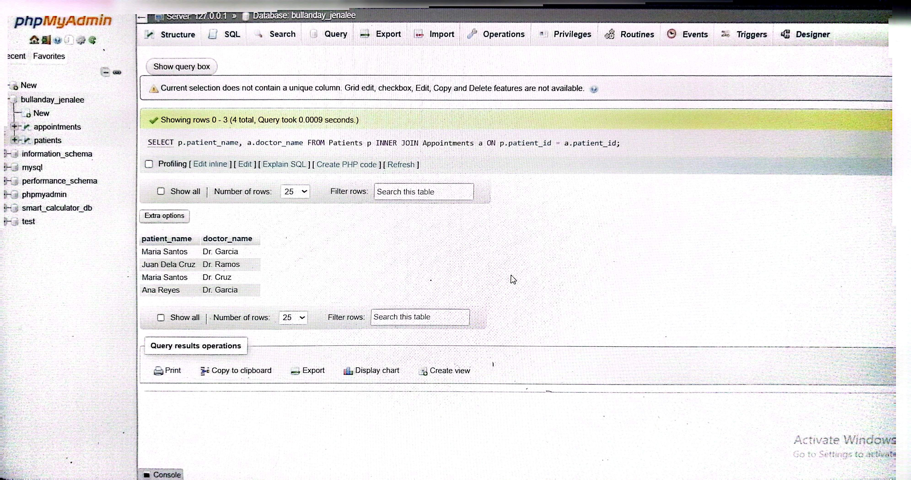
Part B – Filtering with Join
2..Display all patients from Cebu and their appointments.
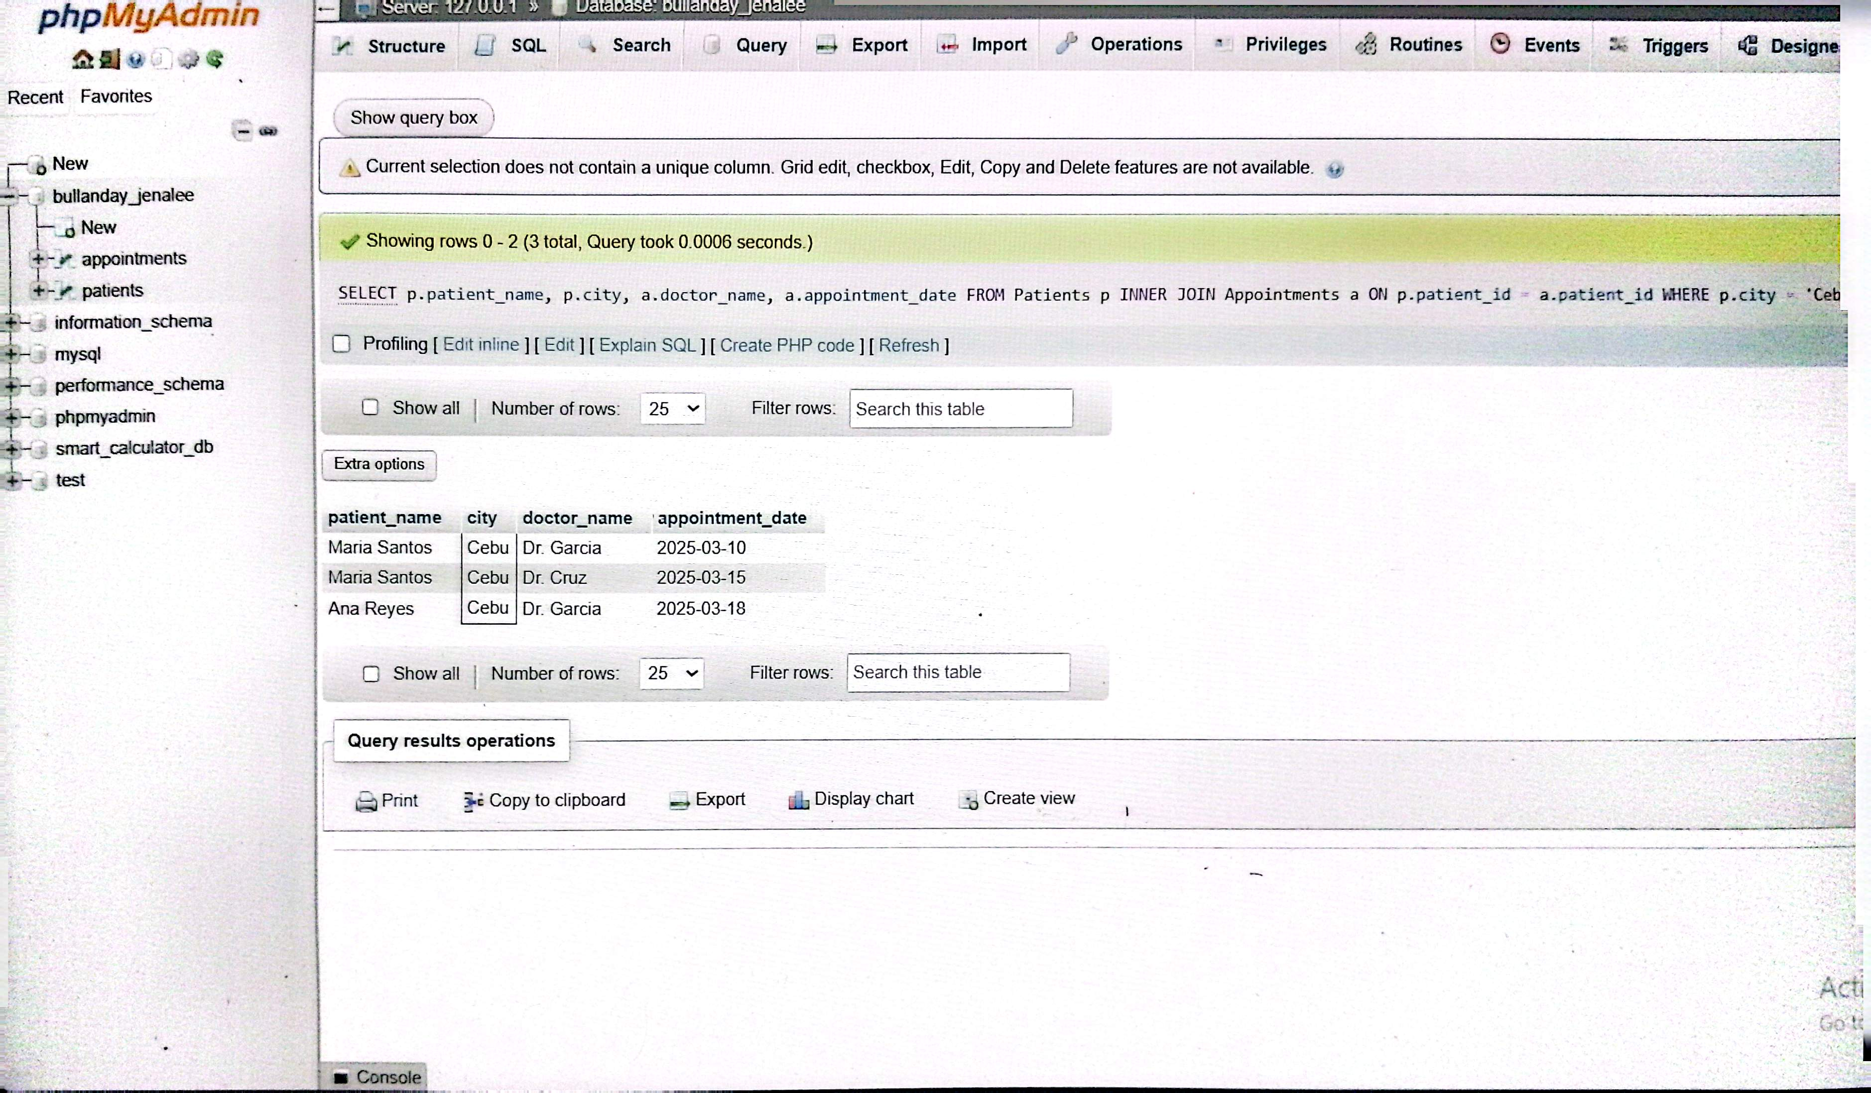
3.Display appointments handled by Dr. Garcia with the patient names.
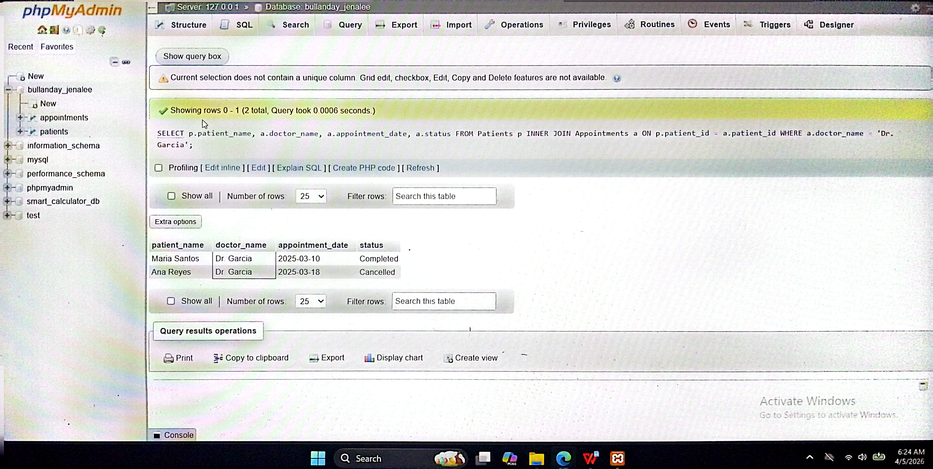
Part C – Analytical Queries
4.Show all patients and their appointments, including patients who do not have appointments.
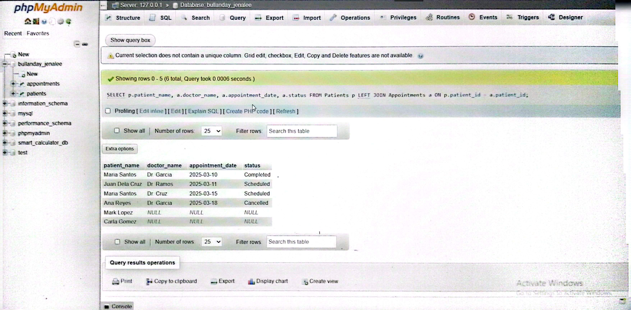
5.Show all appointments even if the patient information does not exist in the Patients table.

