Software Requirements Specification
for
<Egg Clock>
Version 1.0 approved
Prepared by <Jesse Nieminen>
<KAMK>
<2.2.2016>
Table of Contents
Table of Contents ii
Revision History ii
1. Introduction 1
1.1 Purpose 1
1.2 Document Conventions 1
1.3 Intended Audience and Reading Suggestions 1
1.4 Product Scope 1
1.5 References 1
2. Overall Description 2
2.1 Product Perspective 2
2.2 Product Functions 2
2.3 User Classes and Characteristics 2
2.4 Operating Environment 2
2.5 Design and Implementation Constraints 2
2.6 User Documentation 2
2.7 Assumptions and Dependencies 3
3. External Interface Requirements 3
3.1 User Interfaces 3
3.2 Hardware Interfaces 3
3.3 Software Interfaces 3
3.4 Communications Interfaces 3
4. System Features 4
4.1 System Feature 1 4
4.2 System Feature 2 (and so on) 4
5. Other Nonfunctional Requirements 4
5.1 Performance Requirements 4
5.2 Safety Requirements 5
5.3 Security Requirements 5
5.4 Software Quality Attributes 5
5.5 Business Rules 5
6. Other Requirements 5
Appendix A: Glossary 5
Appendix B: Analysis Models 5
Appendix C: To Be Determined List 6

Revision History
Name | Date | Reason For Changes | Version

Introduction

Purpose
Purpose of this software is to tell how long it takes for egg to get to specific doneness level.

Document Conventions
There are no specific conventions on this document.

Intended Audience and Reading Suggestions
This software is intended for everyone who needs egg clock. It is simple software so there are no reading suggestions.

Product Scope
Benefits for this egg clock is that this application for mobile devices and you don’t have to buy any physical egg clocks. Goal is to sell this egg clock for Apple and Android for high money so they can use this as default application that comes with operating system.

References
This document does not have any references.

Overall Description

Product Perspective
Origin of this egg clock comes from very old physical device that just counts time. This is application more simple and better version of that.

Product Functions
-Shows cooking time of specific doneness levels off egg.
-Ability to track multiple eggs at same time
-Counts how many eggs have been cooked.

User Classes and Characteristics
This application is for every kind of user. If you just want to cook egg, this is perfect for you.

Operating Environment
This software will work on Android, iOS and Windows operating systems.

Design and Implementation Constraints
This software is available as English only.

User Documentation
User manual will be provided within download and it can be accessed from application.

Assumptions and Dependencies
-

External Interface Requirements

User Interfaces
User Interface consists of 3 Sliders. First slider sets Egg size in grams, second slider sets Start temperature in Celsius. Third slider sets altitude from sea level (higher altitude the boiling point is lower than at sea level). In settings you can change these sliders to not so specific menu. For example Egg size you can choose from small to extra large and temperature you can choose from room fridge temperature or room temperature. There is button for quick start that starts the timer or many eggs so you can choose how many eggs you want to cook. There is also button for settings. You can change weight, temperature and altitude unit. You can also change Egg class type.

Hardware Interfaces
All smartphone devices are supported but it is recommended to have location information to calculate altitude. External Storage access is needed to store the application configuration so that it does not get lost on application update. WLAN state is needed to do a better location calculation indoors.

Software Interfaces
<Describe the connections between this product and other specific software components (name and version), including databases, operating systems, tools, libraries, and integrated commercial

Communications Interfaces
WLAN state - is needed to do a better location calculation indoors.
Full internet access, Phone state and Network state are needed for advertisement.

System Features

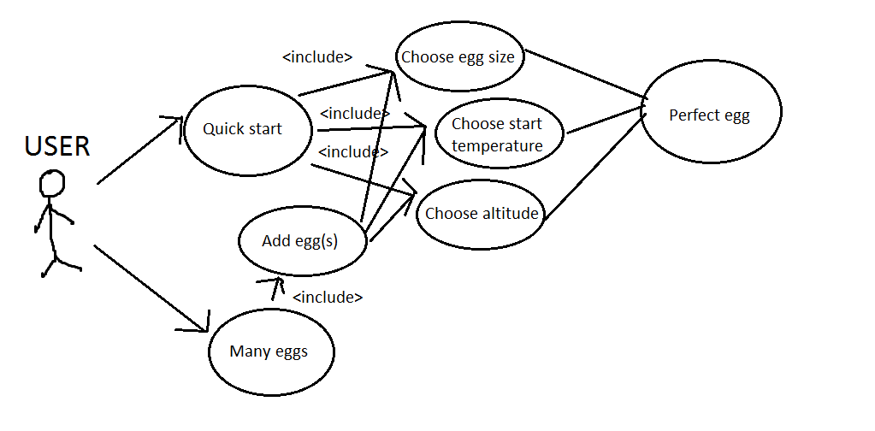Quick start

Description and Priority

Starts egg timer for one egg when given egg size, start temperature and current altitude.

Stimulus/Response Sequences

Choose egg size, start temperature and altitude.

Functional Requirements

There are no functional requirements, it is impossible to input wrong data.

Many Eggs

Description and Priority

Ability to add multiple eggs with different doneness levels.

Stimulus/Response Sequences

Choose how many eggs you want to add.

Functional Requirements
There are no functional requirements, it is impossible to input wrong data.

Other Nonfunctional Requirements

Performance Requirements
It is suggested for phone to have ability to tell current location for altitude.

Safety Requirements
There are no special safety requirements

Security Requirements
Application needs to know your current location.

Software Quality Attributes
This application is usable on every smart phone device.

Business Rules
<List any operating principles about the product, such as which individuals or roles can perform which functions under specific circumstances. These are not functional requirements in themselves, but they may imply certain functional requirements to enforce the rules.>

Other Requirements
<Define any other requirements not covered elsewhere in the SRS. This might include database requirements, internationalization requirements, legal requirements, reuse objectives for the project, and so on. Add any new sections that are pertinent to the project.>
Appendix A: Glossary
<Define all the terms necessary to properly interpret the SRS, including acronyms and abbreviations. You may wish to build a separate glossary that spans multiple projects or the entire organization, and just include terms specific to a single project in each SRS.>
Appendix B: Analysis Models
<Optionally, include any pertinent analysis models, such as data flow diagrams, class diagrams, state-transition diagrams, or entity-relationship diagrams.>
Appendix C: To Be Determined List
<Collect a numbered list of the TBD (to be determined) references that remain in the SRS so they can be tracked to closure.>

