CIONELO, JEOBEN ALDOUS M. 

Jeobenaldous@gmail.com

476 kastanas st. Barangay 118 zone 1, Tondo Manila

09099913670

[Jeobenaldous@gmail.com](mailto:Jeobenaldous@gmail.com)/61802662@ntc.edu.ph/[Jeoben Aldous Cionelo | Facebook](https://www.facebook.com/jeoben.cionelo)

# OBJECTIVES

I am applying to this respective company as an intern for me to be able to gain knowledge and experience in your work field. I know that this might be a very challenging role to attain but with the passion and eagerness I have I know that I can attain my goal. Apart from that I wanted to exhibit my skills in computers and I know that this is the perfect place for me and to be able to enhance more of my given skills and knowledge and a possible job opportunity.

# EDUCATION

## National Teacher College (Manila)

***2018- up to present*** Bachelor of Science in Information Technology (BSIT)

Currently enrolled 1st year - 4th year 85 – 93% GWA AVE. Currently graduating

## Gymnazo Christian Academy (Manila)

***2006-2016*** Elementary and Senior High School

* Senior High Strand k12 strand SCIENCE TECHNOLOGY ENGINEERING AND MATHEMATICS STEM (2016-2018)
* Best actor award 2015-2016 Cinematic Movie competition
* Basketball Varsity 2016-2018
* 2nd place in trams basketball competition
* APSSAM, MAPESA AT MAPPRESA tagisan ng Talino at Talento 6th place out of 18 contenders
* Leadership training certificate
* Immersion 2018 SHS- Makati

Position- Editing of blueprint /Auto-CAD(facilities)

# EXPERIENCE

## Canteen | | Pier Port, Delpan, Tondo Manila

***Service Crew*** *2017 – 2018*

All around service crew, Cashier and service to customers.

**247ai (BPO company)**

Customer service representative

account: Retail

September 5 2022 to January 21 2023 (6 months contract-With COE)

Address: 9F Cybergate Plaza, Cybergate Complex, EDSA corner Pioneer, Mandaluyong City

Landmarks: Go Hotels and Boni MRT station

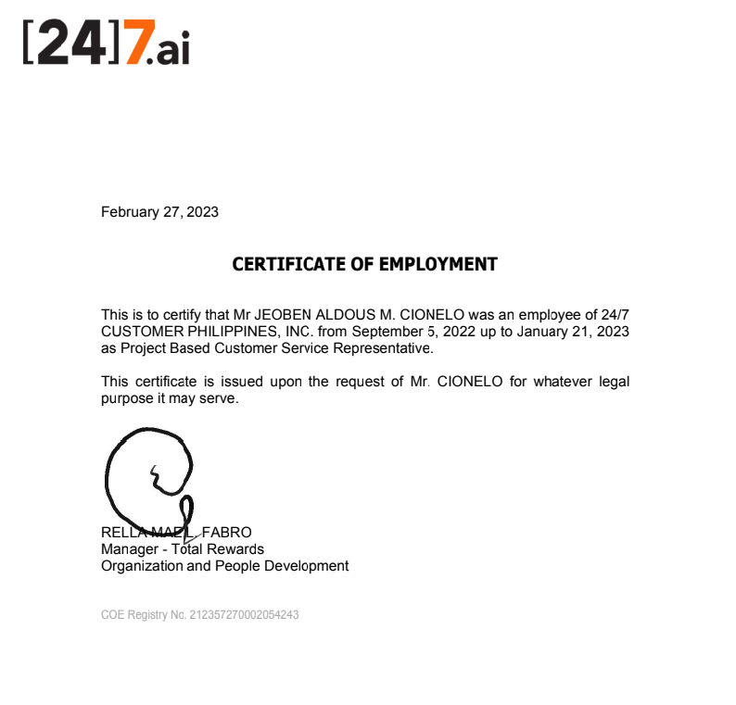

# SKILLS

COMPUTER LITERATE

* programming
* Data mining
* Advance excel, PowerPoint and MS word
* Animation in blender
* Mobile app game developing skills
* Computer fixing Software/hardware
* (AWS) amazon web service Knowledge
* knowledge about machine learning system
* python programming
* facial recognition

# • SKILLS

* Can easily adapt to environment
* Mentally and physically fit
* Good analytic
* Good communication skills
* Good problem solver
* Flexibility