Report of Lab2

Reporter: Vilius Ciuzelis

Yuan Yi Lin

Yang Liu

Date: Oct.21, 2015

**Lab2A**

Tasks 1 & 2

Both trajectories (a square and a circle) has been designed in the prelab. Plots 1 & 2 below show the theta angles for the three motors for the square and the circle reference trajectories. The response of the omnibot is also included in the plots.

Plot 1:

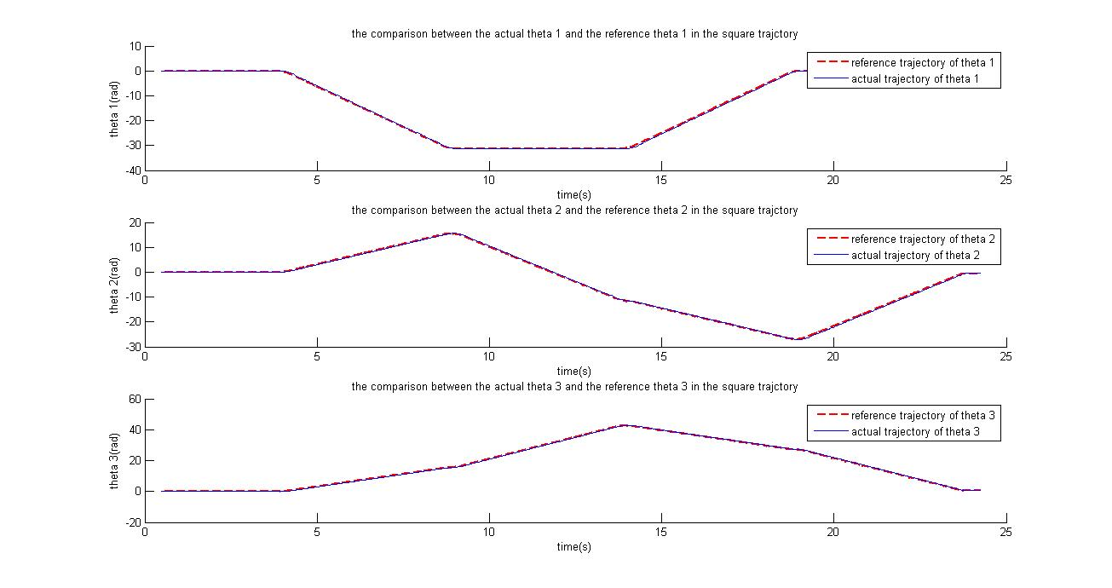

Plot 2:

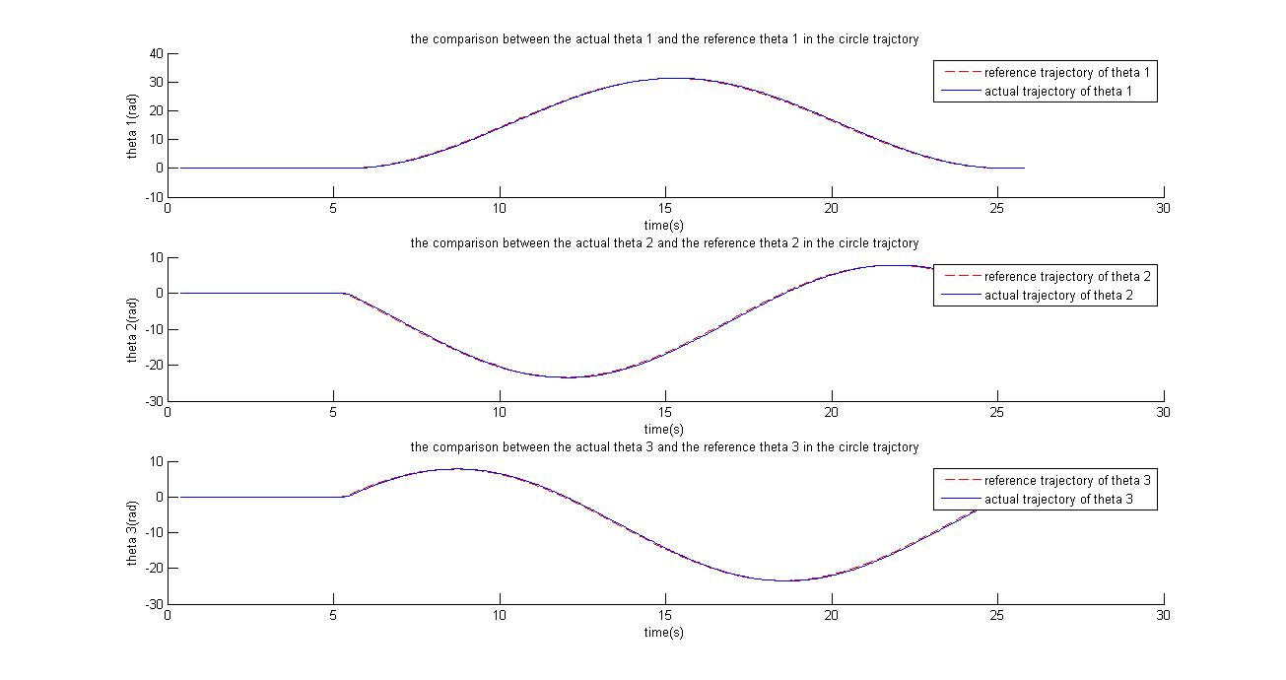

The plots show the omnibots ability to follow the given reference trajectories with minimal deviations. PID controller with the gains Kp=100, Kd=1 and Ki=5 was used. A negligible overdamp was present in the control dynamics.

Task 3

To improve the results of the robot, various techniques were used. Firstly, the reference trajectories and motor inputs were smoothened as to diminish abrupt changes in acceleration. MATLAB function “smooth” proved to be of help. Afterwards, the tuning of the PID constants gave better performance. The final values which were used and gave the least error in trajectory traversal were Ki=50, Kp=200 and Kd = 1.

Plot 3

For circle trajectory:

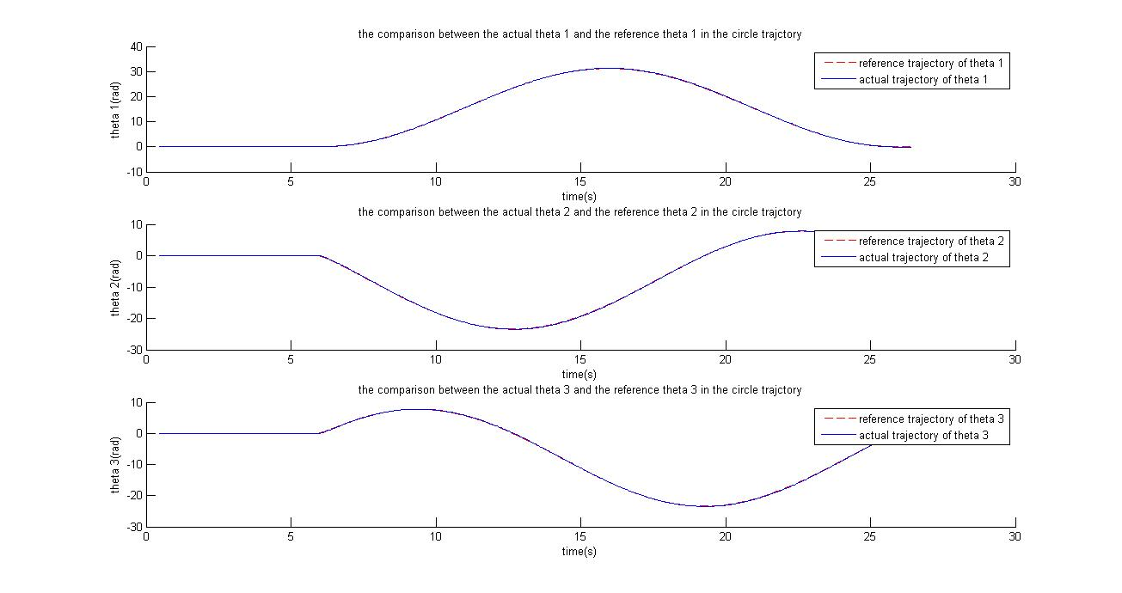

For square trajectory:

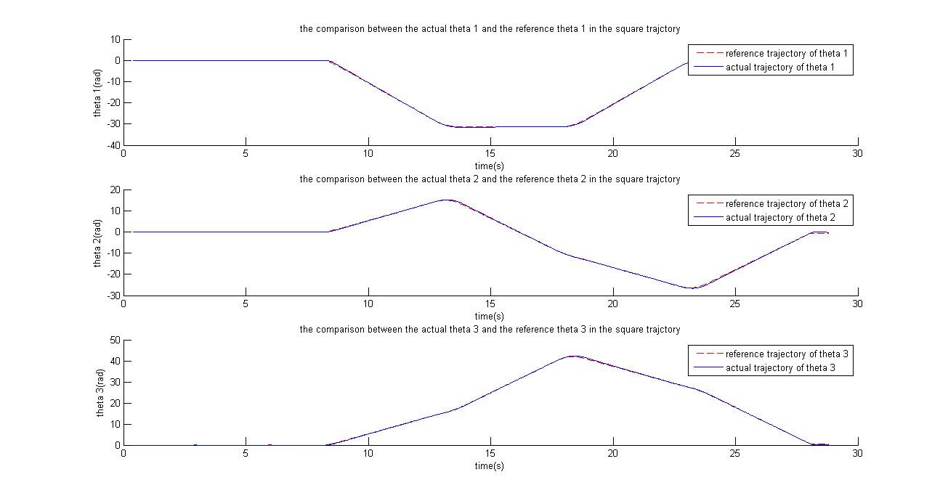

Post lab work

1.

Square trajectory:

Theta 1:

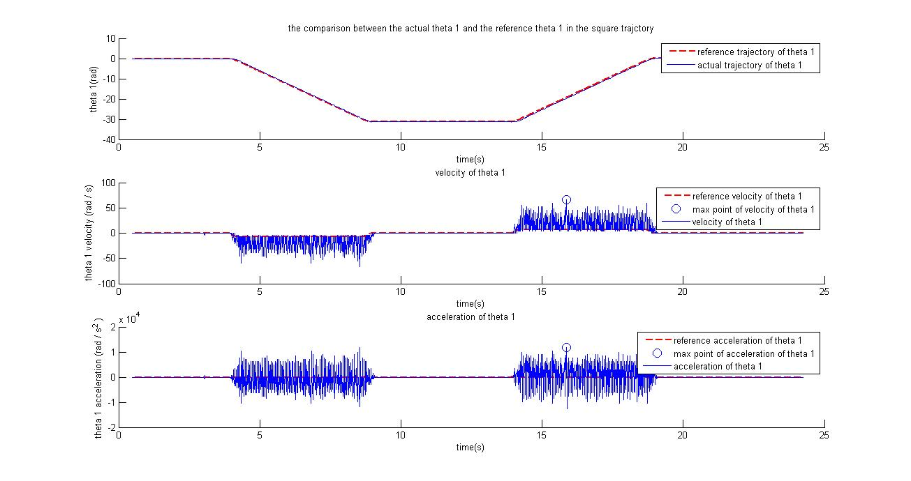

The maximum velocity of theta 1 is 66.3225 rad/s

The maximum acceleration of theta 1 is 11868 rad/

Theta 2:

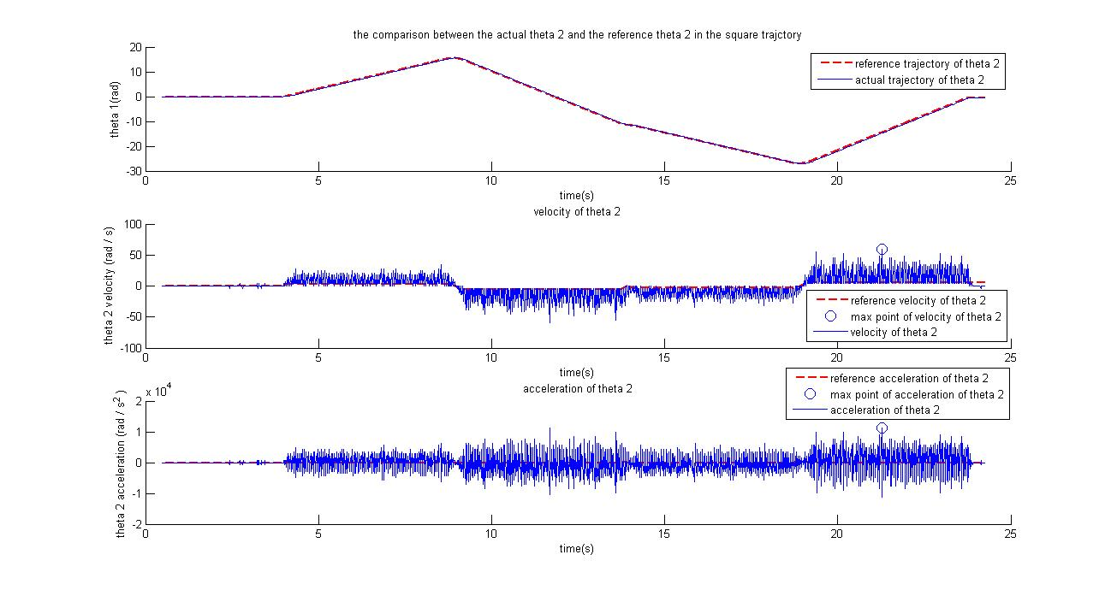

The maximum velocity of theta 2 is 59.3412 rad/s

The maximum acceleration of theta 2 is 11170 rad/

Theta 3:

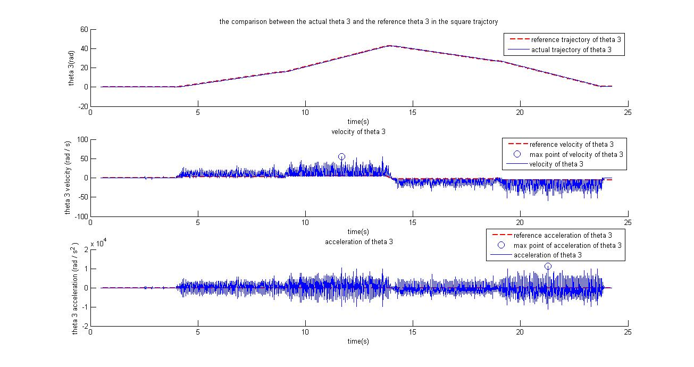

The maximum velocity of theta 3 is 55.8505 rad/s

The maximum acceleration of theta 3 is 11170 rad/

Circle trajectory:

Theta 1:

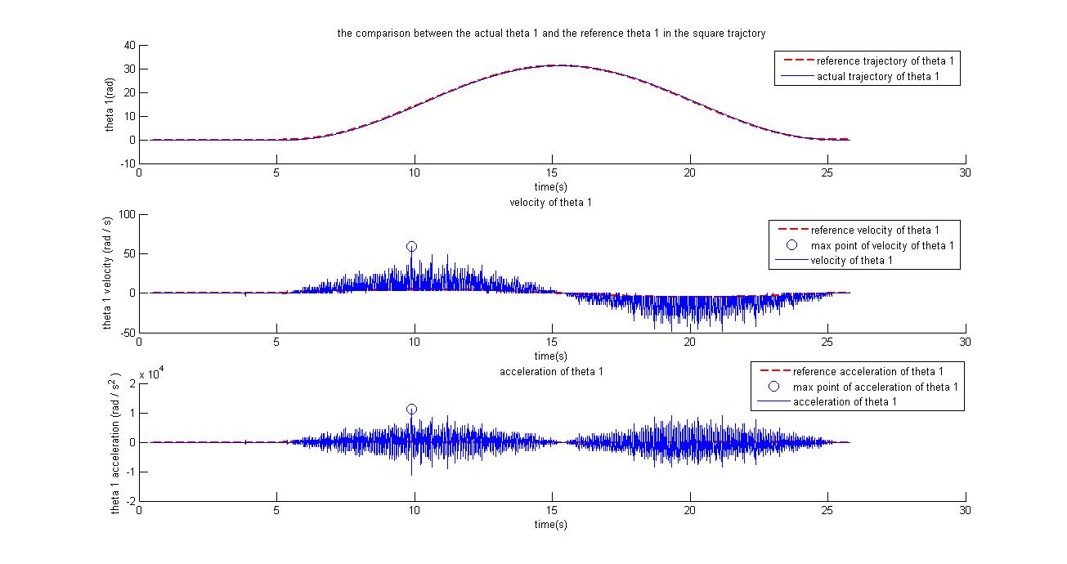

The maximum velocity of theta 1 is 59.3412 rad/s

The maximum acceleration of theta 1 is 11170 rad/

Theta 2:

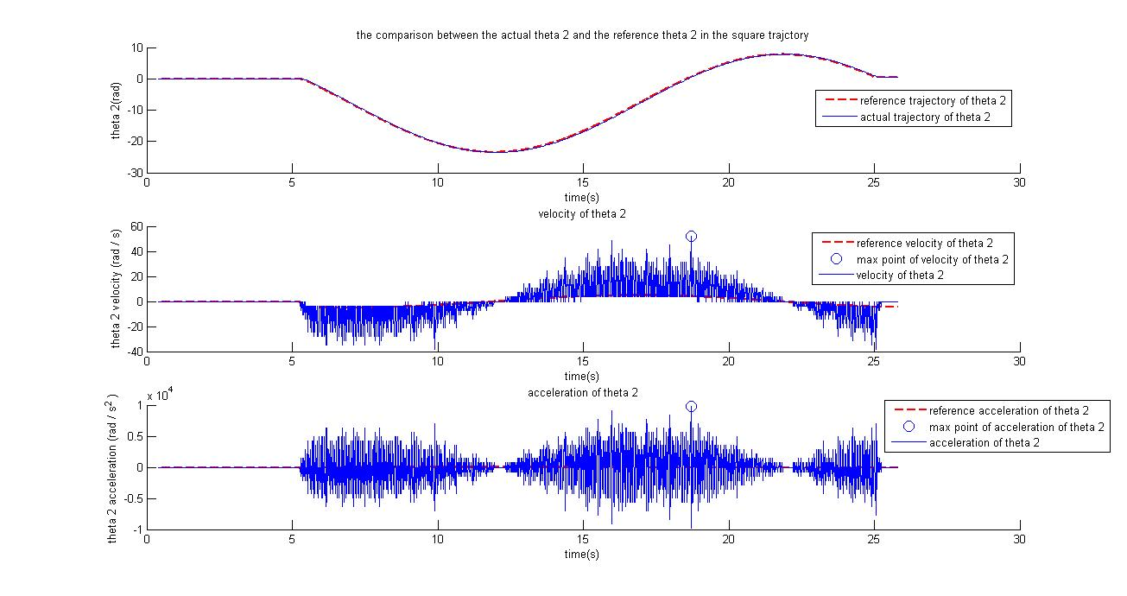

The maximum velocity of theta 2 is 52.3599 rad/s

The maximum acceleration of theta 2 is 9773.8 rad/

Theta 3:

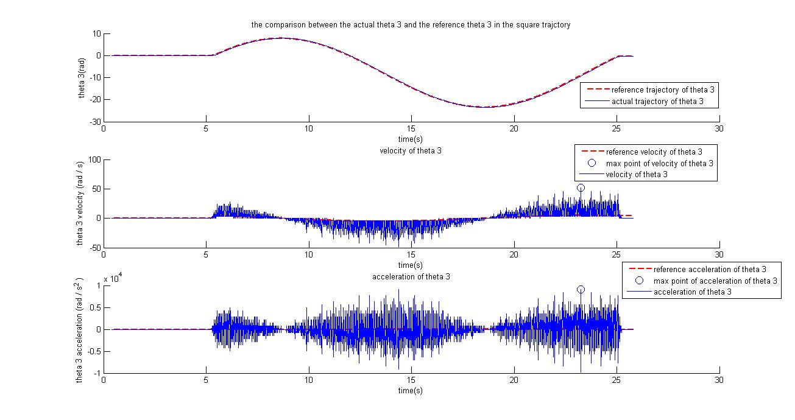

The maximum velocity of theta 3 is 52.3599 rad/s

The maximum acceleration of theta 3 is 9075.7 rad/

After the improvement,

Square trajectory:

Theta 1:

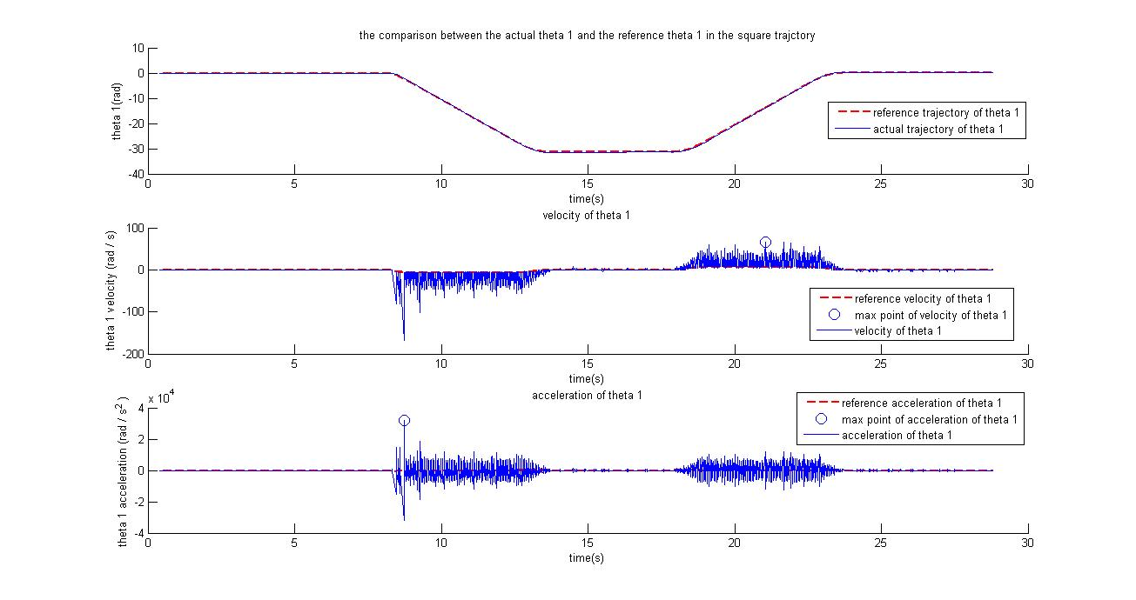

The maximum velocity of theta 1 is 66.3225 rad/s

The maximum acceleration of theta 1 is 32114 rad/

Theta 2:

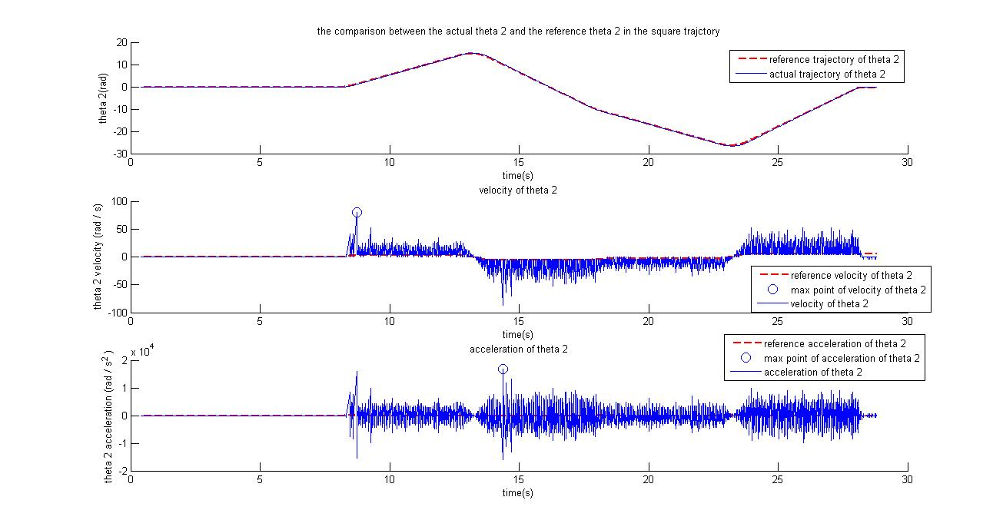

The maximum velocity of theta 2 is 80.2851 rad/s

The maximum acceleration of theta 2 is 16755 rad/

Theta 3:

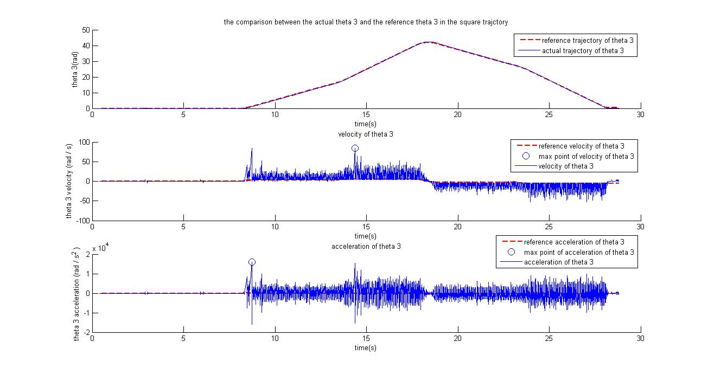

The maximum velocity of theta 3 is 83.7758 rad/s

The maximum acceleration of theta 3 is 16057 rad/

Circle trajectory:

Theta 1:

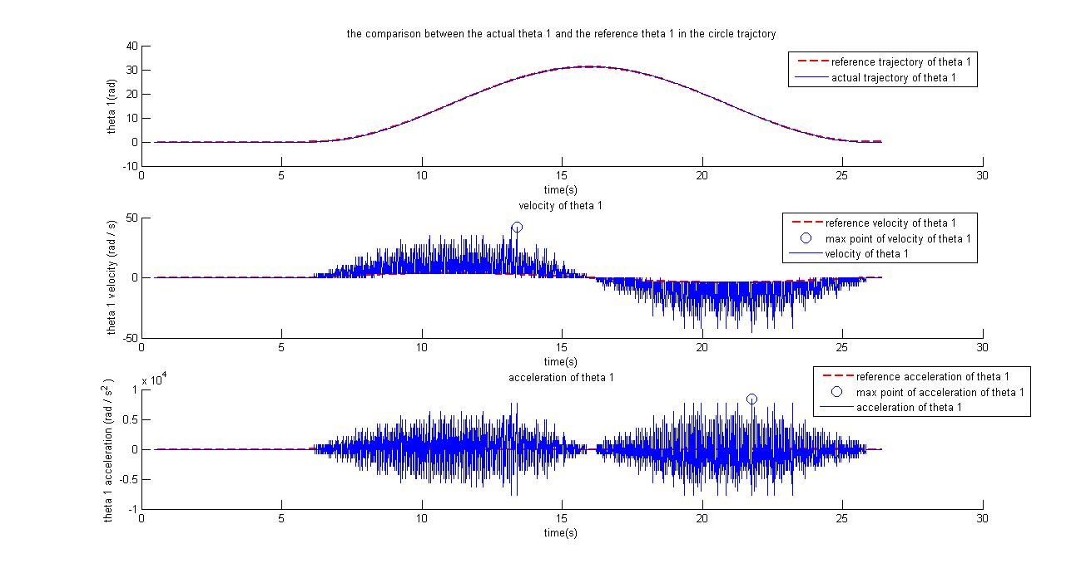

The maximum velocity of theta 1 is 41.8879 rad/s

The maximum acceleration of theta 1 is 8377.6 rad/

Theta 2:

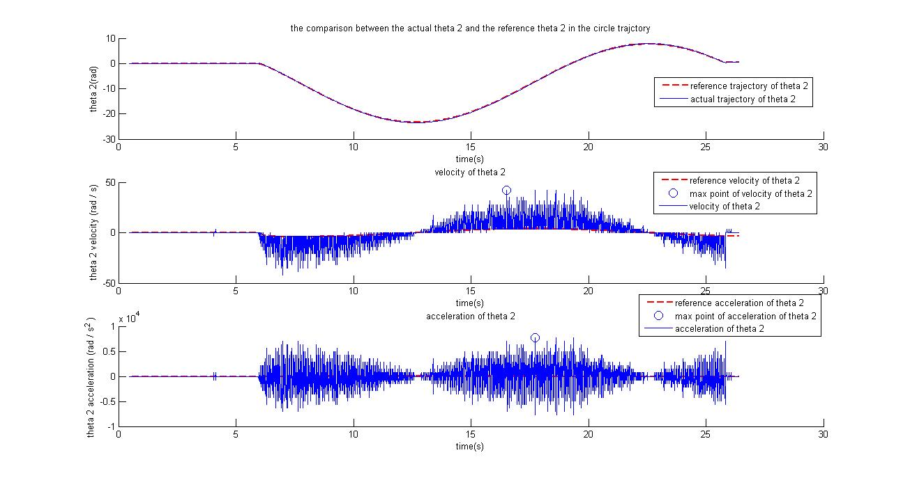

The maximum velocity of theta 2 is 41.8879 rad/s

The maximum acceleration of theta 2 is 7679.4 rad/

Theta 3:

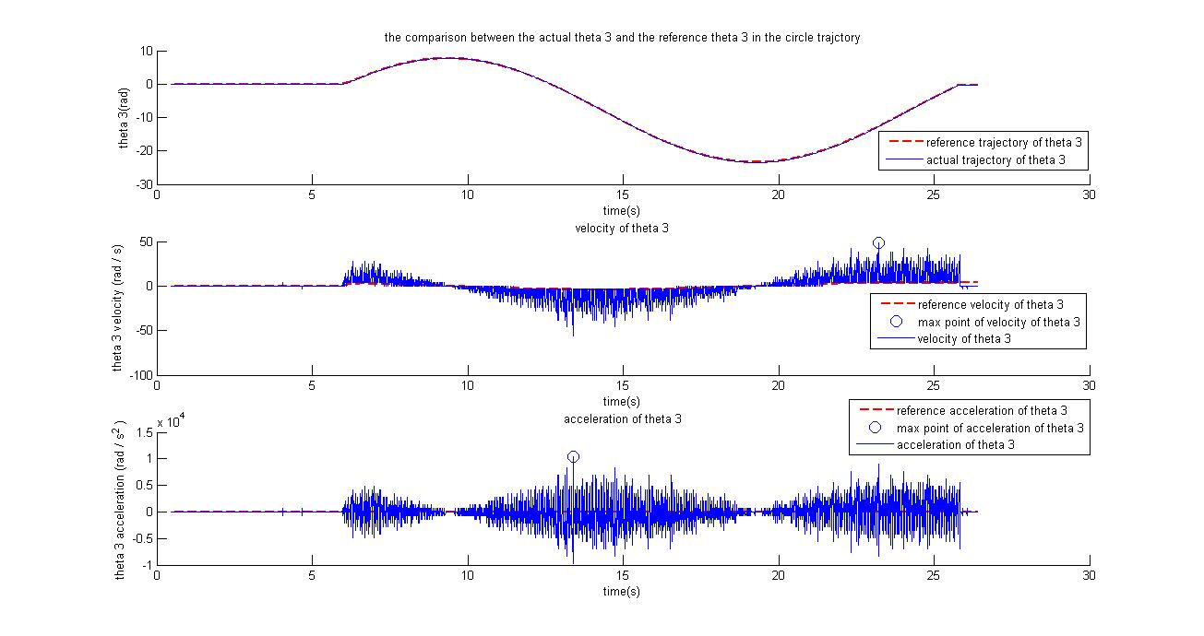

The maximum velocity of theta 3 is 48.8692 rad/s

The maximum acceleration of theta 3 is 10472 rad/

2.

Plot 4 Square trajectory:

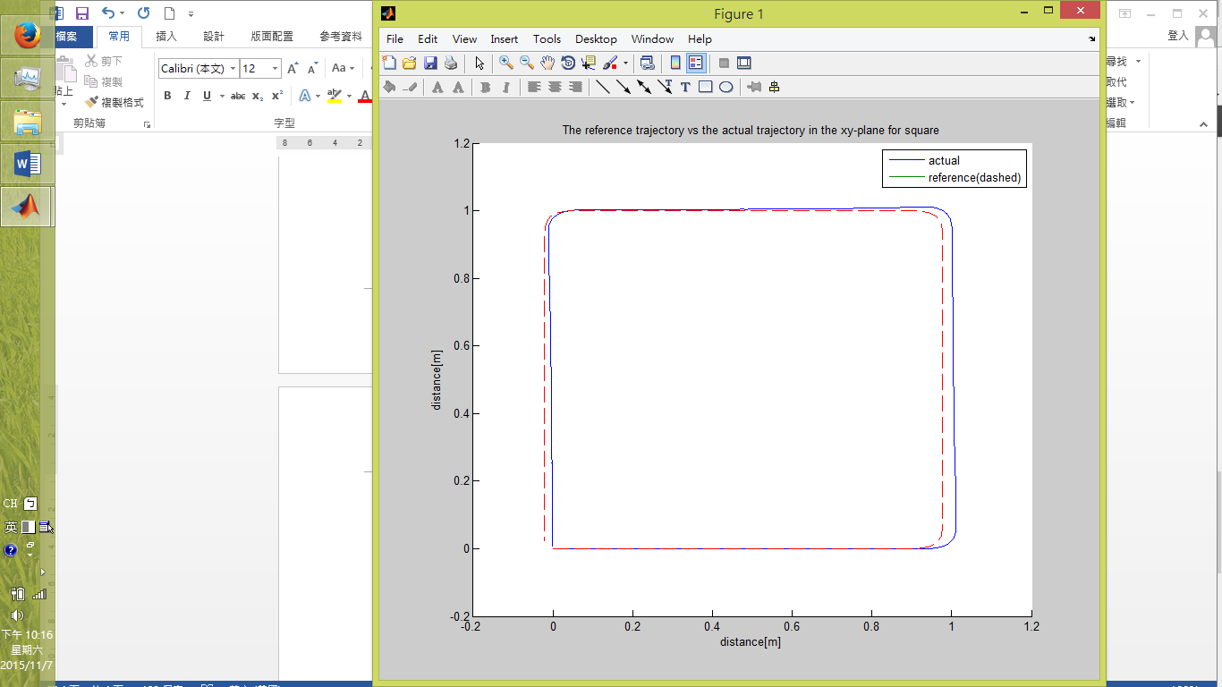

Plot 5 Circle trajectory:

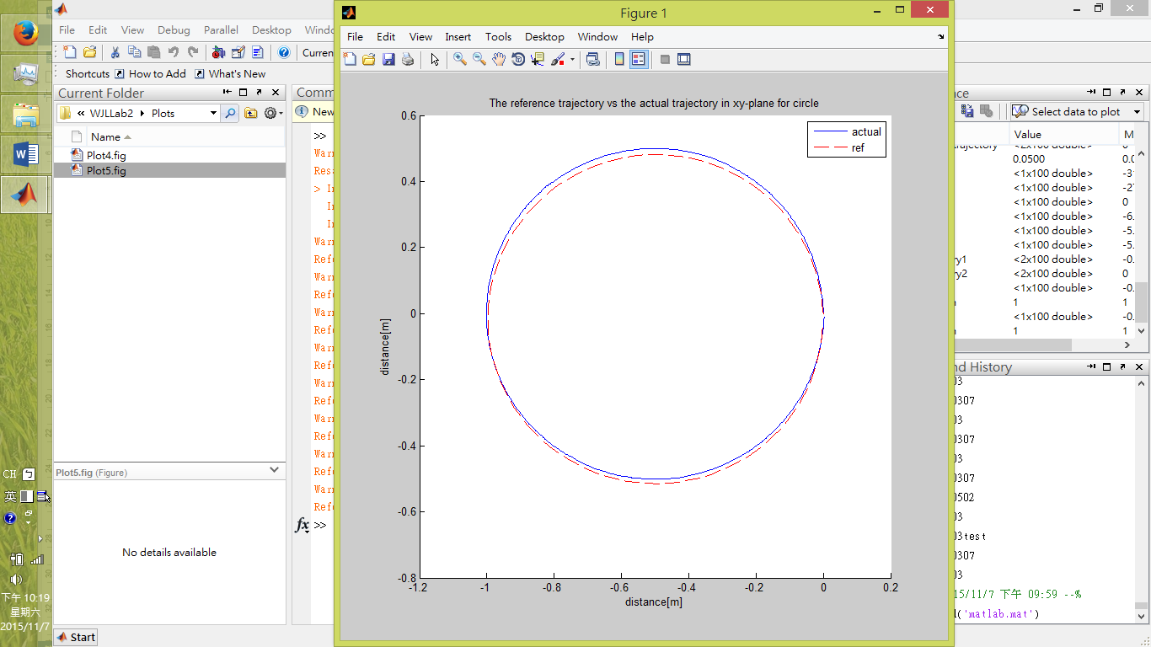

3.

For the square trajectory, before the improvement, the error is showed in the plot below:

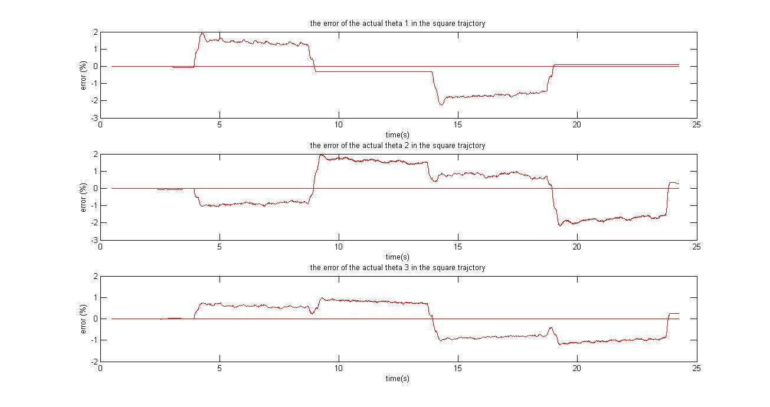

After the improvement, the error now is:

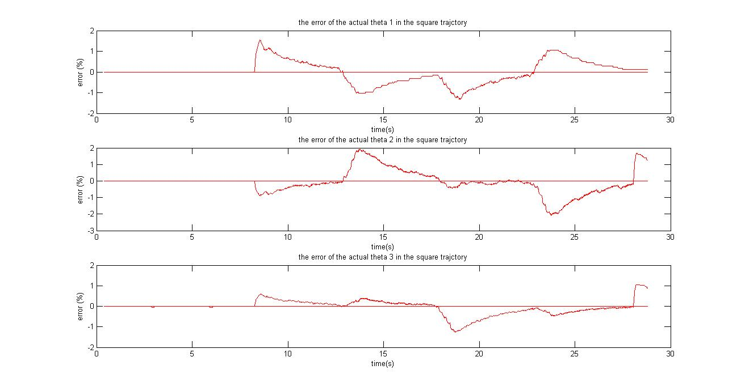

Observe that after increasing both Ki and Kp, the error decreases faster and leads to a smaller error in average.

For the circle trajectory, before the improvement:

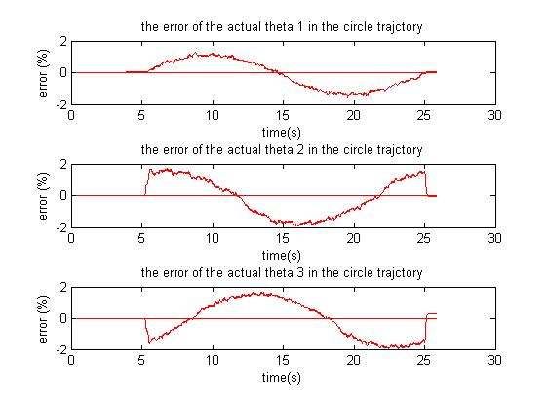

After the improvement:

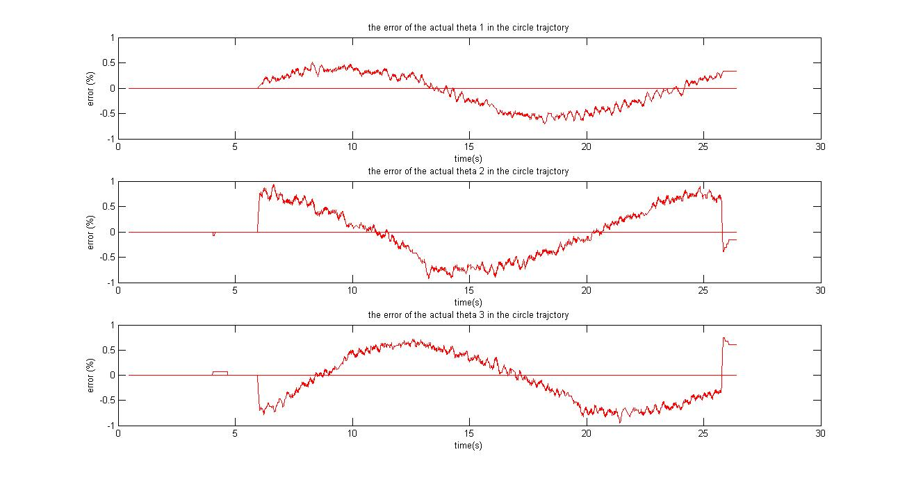

Observe that after the improvement, the magnitude of the error has actually decreased.

For both the circle and the square trajectories, the improvement was to increase Kp from 100 to 200, and Ki from 5 to 50.

The error becomes smaller after the improvement. The source of error may be the noise, and that the trajectory is not smooth enough.

Plot 6:

Square trajectory:



Circle trajectory:



**Lab 2B**

Task 1

Define phi as the angle of the laser pen in the global coordinate, define phi_b as the angle of the vehicle to the global coordinate. Then,

c = -pi*2/3;

phi = atan((Y0-Yb)/(X0-Xb));

phi_b = phi+c;

c is the offset between the laser and the angle of the vehicle as defined in the prelab.

Task 2

The plot below shows the designed trajectories in terms of x, y and phi_b. Note that phi_b is in degrees, not radians.

Plot 1

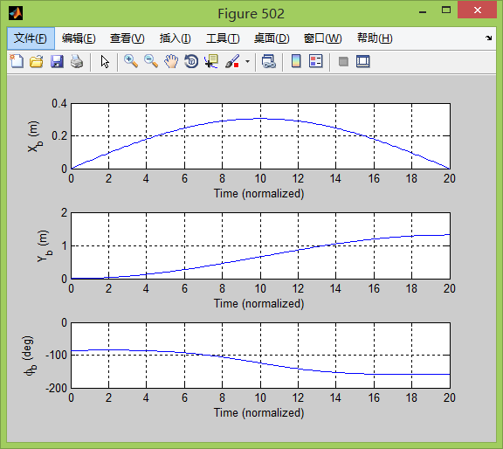

The elliptical trajectory where the horizontal axis is the x-position and the vertical axis it the y-position of the trajectory. The x-distance is roughly a foot, while the y-distance is three feet.

Plot 2

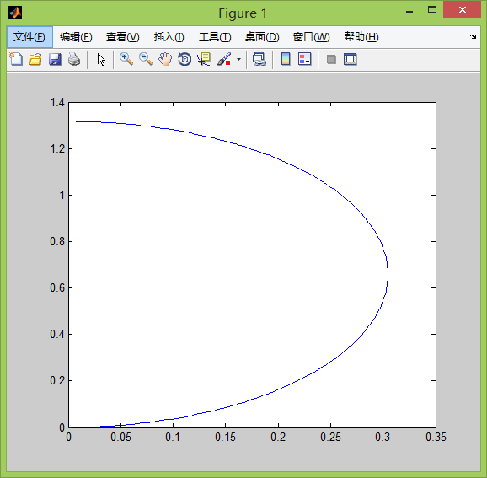

The link trajectory of the three wheels of the robot. The magnitude in the graph is in radians, while the horizontal axis is the number of points, which translates to about 10 seconds at 200.

Plot 3

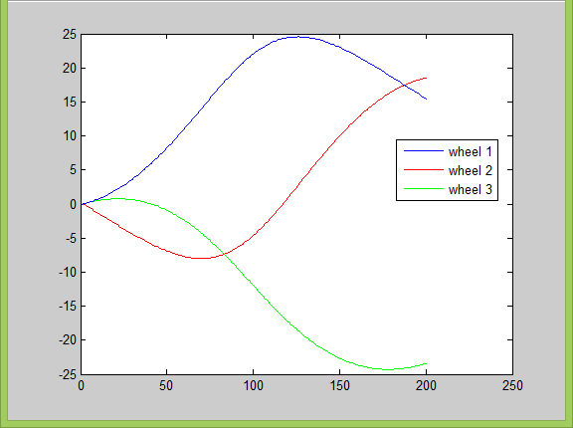

Tasks 3

The error seems to increase substantially when the motors change direction. The motors overcompensate due to the fast regulator. Robots trajectory and aiming are affected by this. Noticeable deviations and inconsistency is present. The solution to this is to adjust the controller gains and/or increase the accuracy of the model.

Plot 4

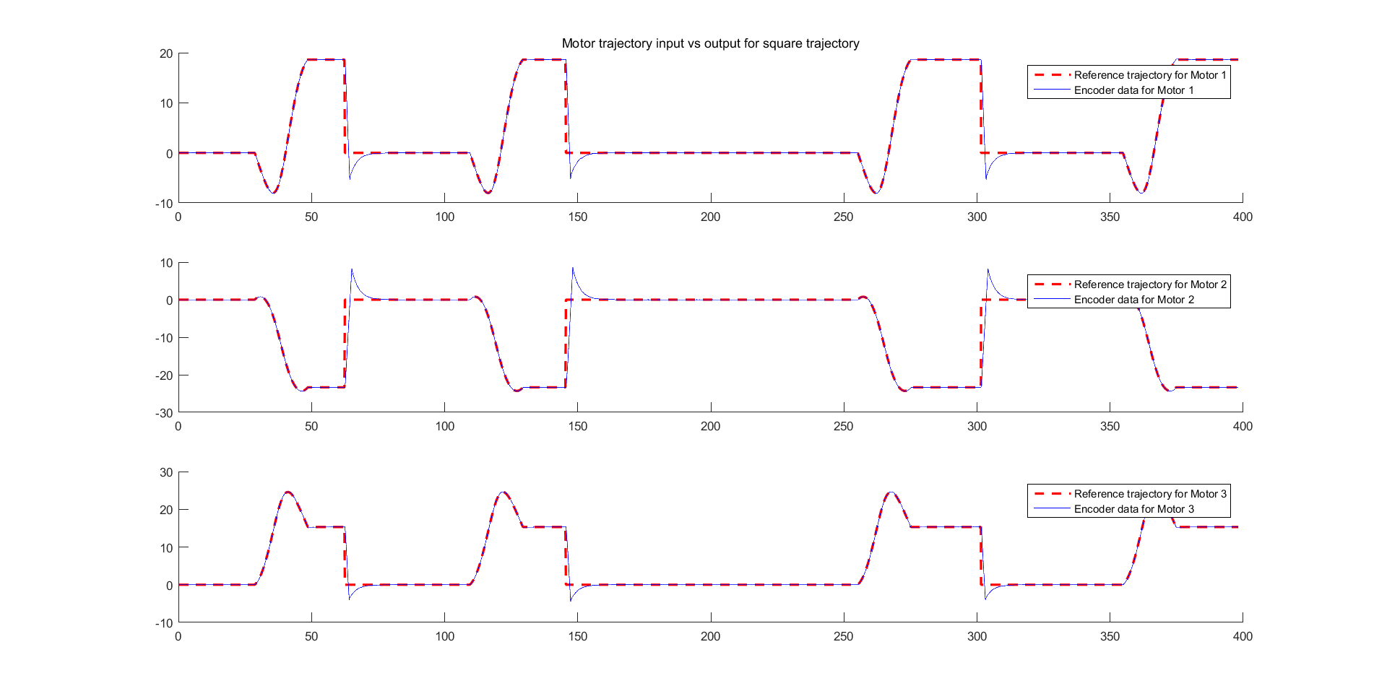

During the tests, we Kp was increased from 100 to 200 and Ki from 10 to 20 to the final value of 50. We also used several ‘smooth’ orders to prevent slipping. The adjustments made the trajectory tracing better, but the most crucial problem was in L (distance between center of body and the wheel). The value was from the prelab, which was off from the “correct” value by 150%. After finding this bug, the trajectory became almost perfect.

After some additional tuning and tweaking, the final score was the maximum one = 10.