NSCC

Assignment one
Linux Mint Install

Jeong Eun Jang (W0451032)
OSYS 1000-701
Paul Street
January 22nd, 2021
Table of Contents

- INTRODUCTION --------------------------------------------------------------- 2

- TASK 1: INTRODUCTION AND VARIANTS --------------------------- 2
2-1. FAMILY TREE OF UNIX
2-2. FAMILY TREE OF LINUX
2-3. SUMMARY

- TASK 2: INSTALLANTION OF LINUX MINT AND
BASE CONFIGURATION ------------------------------------------------------ 4
3-1. INSTALL LINUX MINT
3-2. CINNAMON DESKTOP
3-3. CREATING A ‘GOLD COPY’
3-4. CREATING A ‘TOOLBOX’
3-5. SUMMARY

- CONCULSION ------------------------------------------------------------------- 8

- REFERENCES ------------------------------------------------------------------- 9

- INTRODUCTION

Linux, a free and open-source operating system, has created multiple distributions over time. To understand Linux, we must go back to Unix first. Unix was created by Ken Thompson and Dennis Ritchie at AT&T Bell Labs in 1974. Unix supports multi-user, multi-tasks and boasts high compatibility between processes. It has many networking functions, making it suitable as an operating system for network management. Linux Kernel was developed by Linus Torvalds in 1991. With the development of the Linux-based Android operating system, Linux became a computer in the hands of people now and we can find it everywhere. Through this assignment, I would like to take a brief look through the family tree of many derives of Unix and Linux and explore Linux through installing Linux Mint and setting up a user environment.

- TASK 1: INTRODUCTION AND VARIANTS

Objective for this task is as follows:

- Through the creation of the UNIX/LINUX family tree, we learn about Unix and Linux, and the various OS terms derived from them.

  - The family tree of UNIX
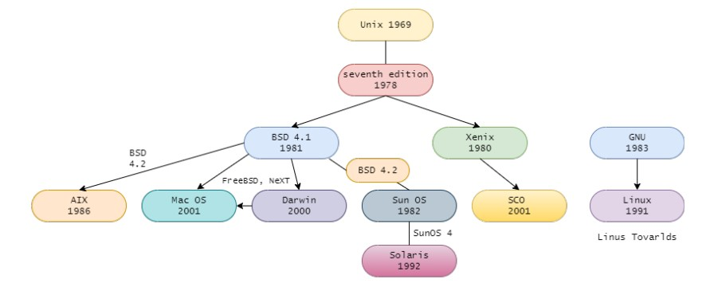

  - The family tree of LINUX
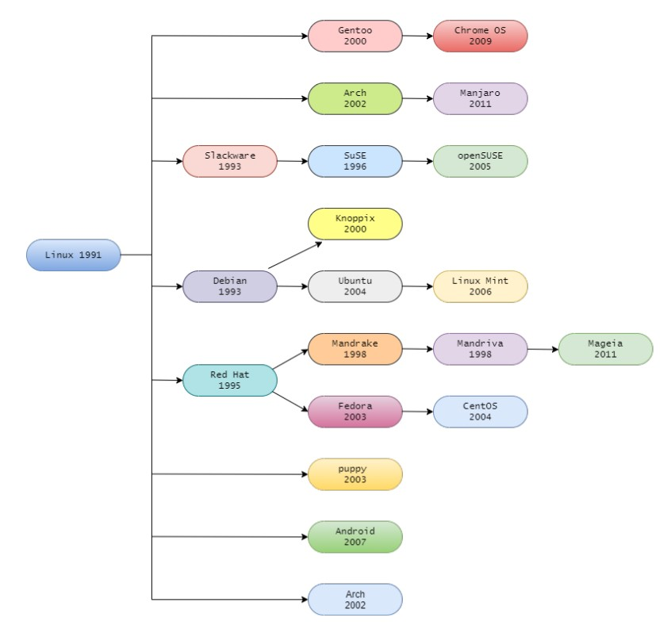

  - Summary
- Berkeley Software Distribution (BSD) is one of the Unix operating systems developed by the Computer Systems Research Group at the University of California, Berkeley from 1977 to 1995.
- Typical OS derived from the Linux kernels are Debian, Red Hat, Slackware. The Linux Mint is derived from Debian and Ubuntu.
- MacOS is a member of the BSD family and has inherited the source code from Darwin, NeXT, and FreeBSD.

- TASK 2: INSTALLANTION OF LINUX MINT AND BASE CONFIGURATION

Objectives for this task are as follows:

- Identify the features of Linux Mint through the installation process.
- Execute major commands such as sudo bash, apt-get, etc. on the terminal.
- Explore the Cinnamon desktop.
- Understand the importance of backup copies and create a backup copy.
- Create and manage a ‘toolbox’ that organizes commands to be used in Linux.

  - Install Linux Mint

    - Download the Linux Mint ISO and set my computer.
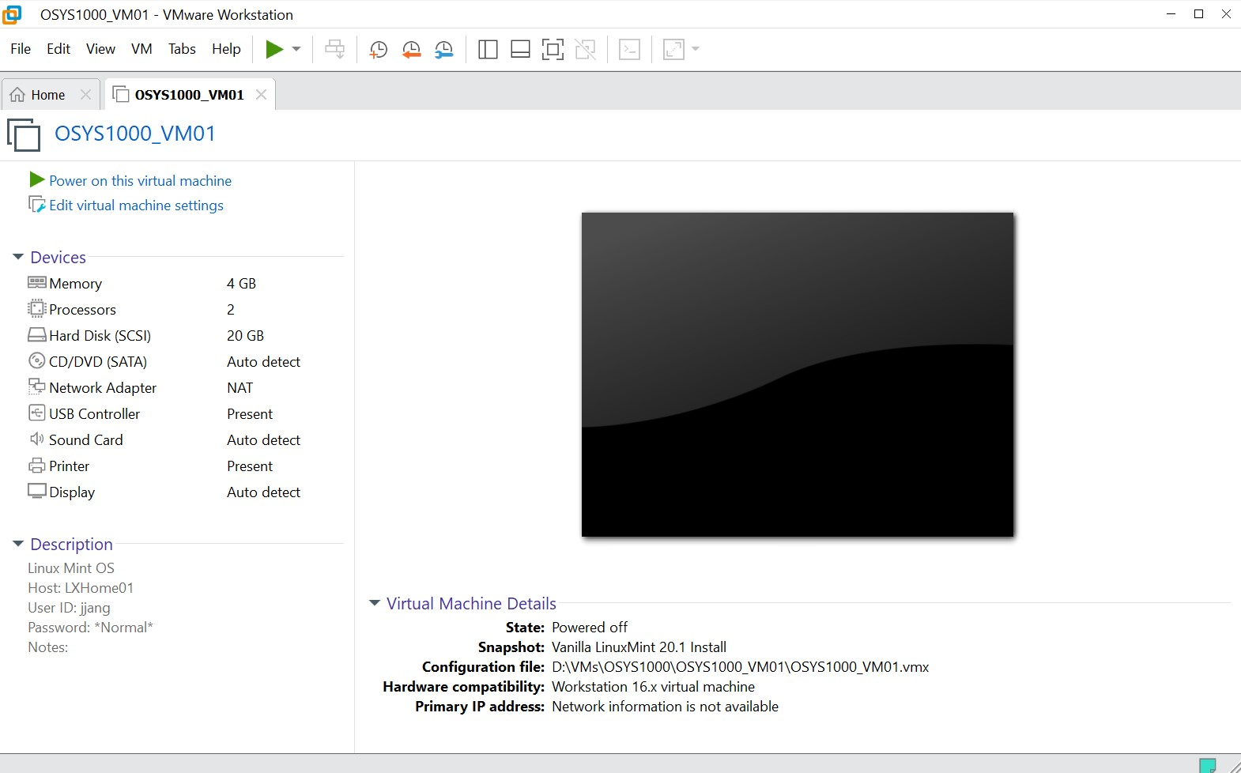
  - Cinnamon desktop

    - Setting the background
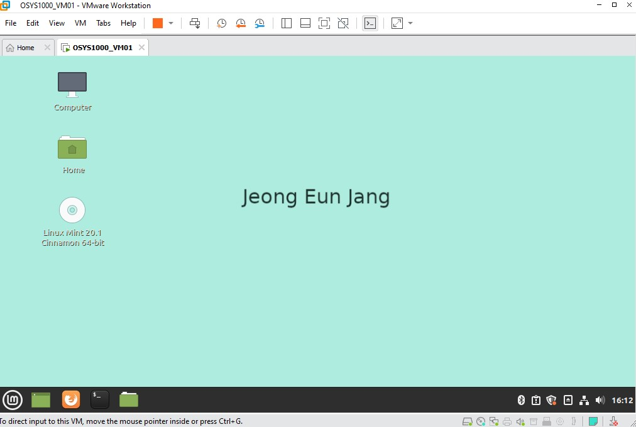
    - Create a png file in the documents folder
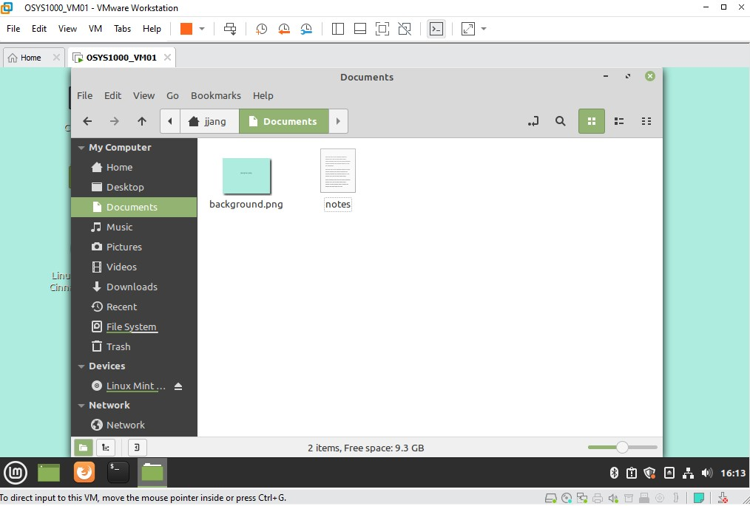
  - Creating a Gold copy
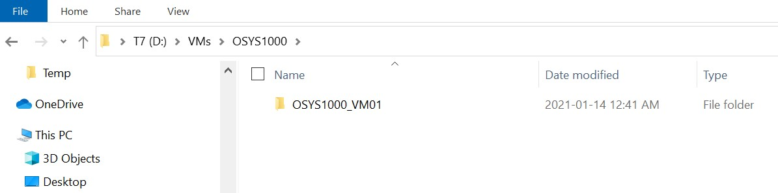
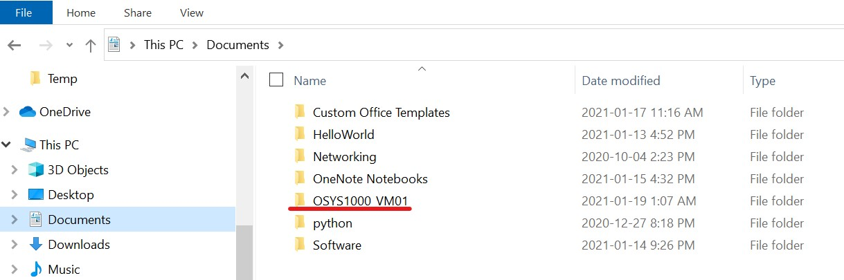

  - Creating my ‘Toolbox’
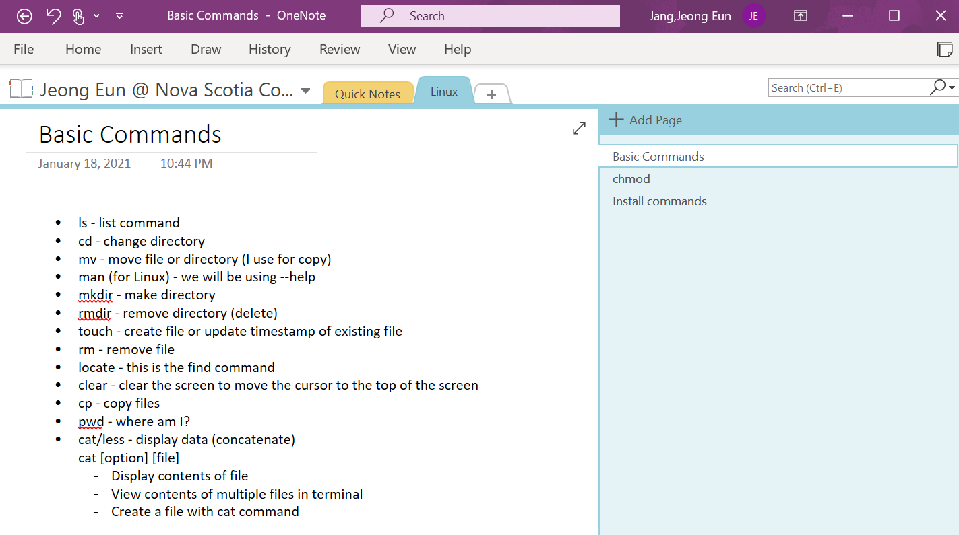

  - Summary
- Linux Mint is one of the most popular Linux distributions and it is based on Ubuntu.
- Linux Mint’s motto is “From freedom came elegance”, which features a great multimedia support.
- Linux beginners can easily use Linux Mint because the screen configuration is similar with Windows.

- CONCLUSION

Through this assignment, I learned what the operation system called Linux is and which history it has. Moreover, I became close to many operation systems derived from the Linux. Although the command line interpreter is still unfamiliar, I am happy to start a conversation with Linux using my own toolbox like OneNote. Knowing the importance of backup copies as developers and making it a habit to make backup copies is also valuable lesson learned from this assignment. Through this course, I hope to learn more about the relationship between hardware and operation system and how the computer system works.

References

Android operating system. (2021, January 20). In Wikipedia.
https://en.wikipedia.org/wiki/Android_(operating_system)

Futurist.se. (n.d.). Unix/Linux History [PNG].
https://futurist.se/gldt/wp-content/uploads/10.10/gldt1010.png

Haas, J. (2020, March 16). Unix and Linux Distributionos List.
https://www.lifewire.com/unix-flavors-list-4094248

IBM AIX. (2021, January 13). In Wikipedia.
https://en.wikipedia.org/wiki/IBM_AIX

Kiarie J. (2020, September 25). 10 Linux Distributions and Their Targeted Users.
https://www.tecmint.com/linux-distro-for-power-users/

Levenez.com (2021, January 1). Unix History.
https://www.levenez.com/unix/unix.pdf

Rund um die Welt mit Internet. (2004, July 10). Mac OS X on BSD/UNIX.
http://www.lupi.ch/Internet/unixmaclinux.html

Street, P. (2012, January). Linux Intro. [PowerPoint Slides]. Brightspace@NSCC
https://nscconline.desire2learn.com/d2l/le/content/185239/viewContent/23306
88/View

