NSCC

Final Project
Ubuntu Install

Jeong Eun Jang (w0451032)
OSYS 1000-701
Paul Street
April 16th, 2021
Table of Contents

- INTRODUCTION ----------------------------------------------------------------- 2

- TASK 1: UBUNTU 18.04.5 LTS ----------------------------------------------- 2
2-1. OBJECTIVES
2-2. CREATE A NEW VIRTUAL MACHINE AND UBUNTU 18.04
2-3. SUMMARY

- TASK 2: OPENSSH, SAMBA, LAMP STACK ------------------------------ 7
3-1. OBJECTIVES
3-2. INSTALL OPENSSH, SAMBA, LAMP STACK
3-3. SUMMARY

- GOLD COPY AND TOOLBOX --------------------------------------------------22

- CONCULSION ---------------------------------------------------------------------- 23

- REFERENCES ---------------------------------------------------------------------- 24

- INTRODUCTION

Ubuntu is one of the most popular and widely used Linux distribution. Before starting the final project of the Operating Systems course, I had many options of choice Linux distribution. I was always curious about Ubuntu after I started my Linux with Linux Mint. So, I chose Ubuntu 18.04 which has long-term support(LTS) and has been chosen by many Linux users. Ubuntu uses GNOME(GNU Network Object Model Environment) desktop environment since the 18.04 LTS version released, with file manager Nautilus as the default installation and delivery application, Firefox as the Web browser, Libre Office as the document program.

- TASK 1: UBUNTU 18.04.5 LTS

  - Objectives for this task are as follows:
: Create a new Virtual Machine with Linux Ubuntu 18.04.5 LTS 64-bit and set an environment to start it.

  - Create a ‘New’ Virtual Machine with Ubuntu 18.04.5 LTS.
- I created a new virtual machine with the name of ‘OSYS1000_VM03’ and set the machine as showing in the below screenshot.
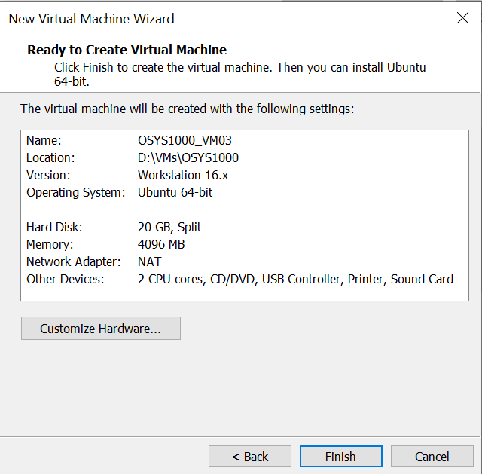
- I set the memory of the machine as 4 Gb.
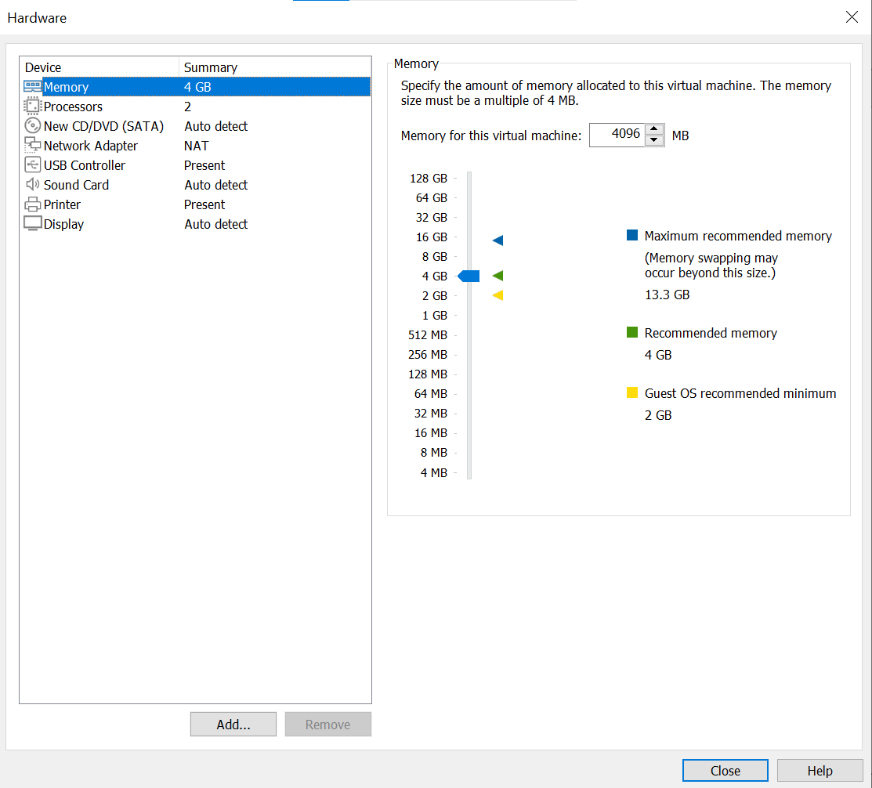
- I partitioned my virtual machine's hardware as following the instruction of the document such as 'swap 2.5 Gb' and 'data 10 Gb'.
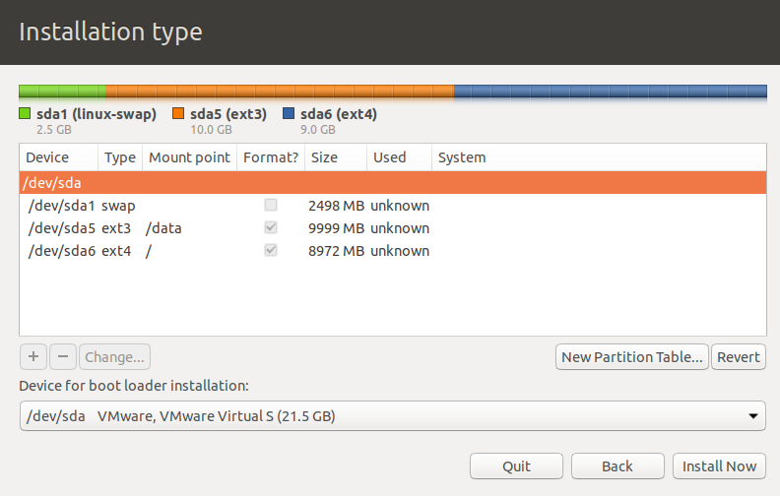
- I set the 'Language' as English/English(United States) and 'Date and Time' as Halifax.
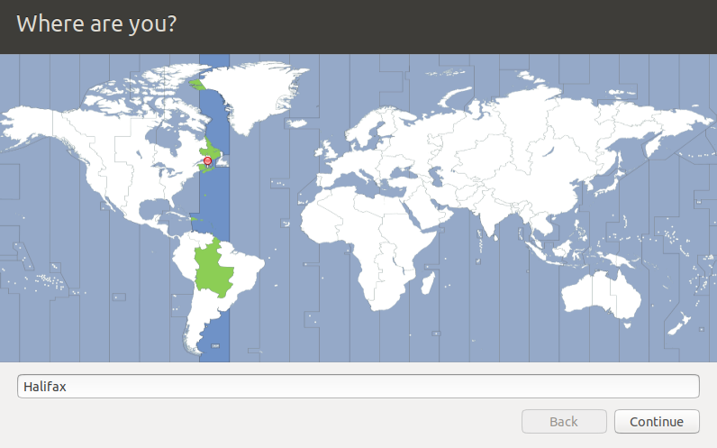
- I set my username as 'jjang' and the host name as 'LX03Ubuntu18' as following the naming convention.
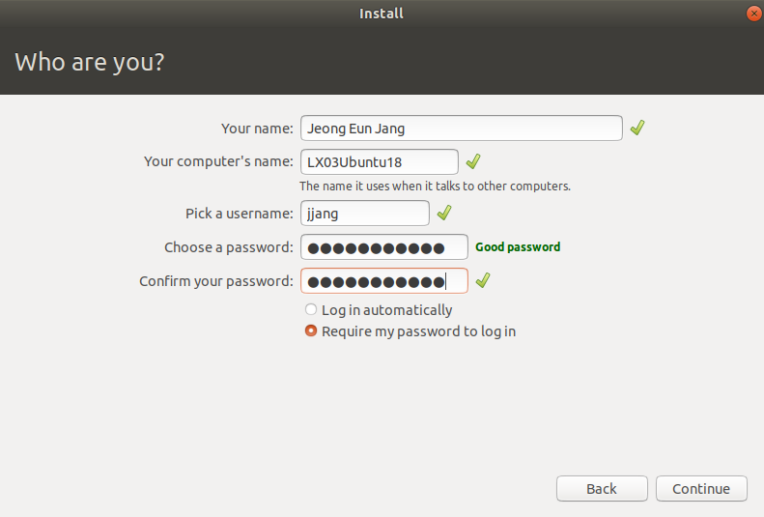

- Finally, I got my third Virtual Machine with Ubuntu18.04.5 LTS.
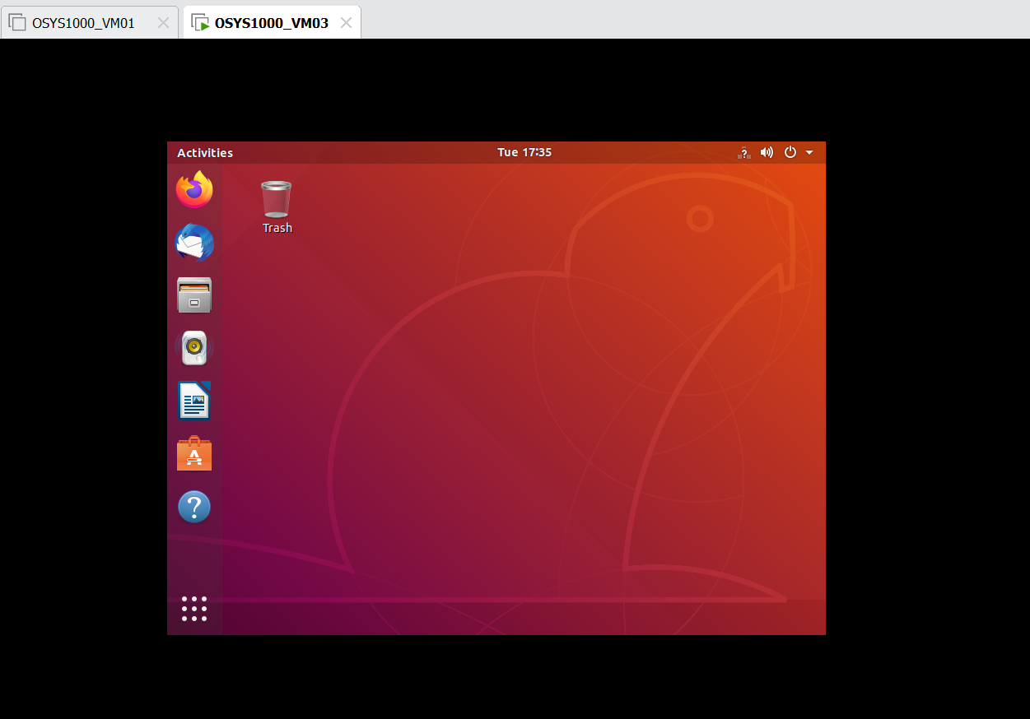
- To set up to boot into a non-graphical , multi-user run level, I used the syntax ‘sudo systemctl set-default multi-user.target’.
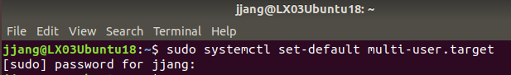
I restarted the machine, and I checked it, booted the machine with no GUI (Stack Exchange, 2019).

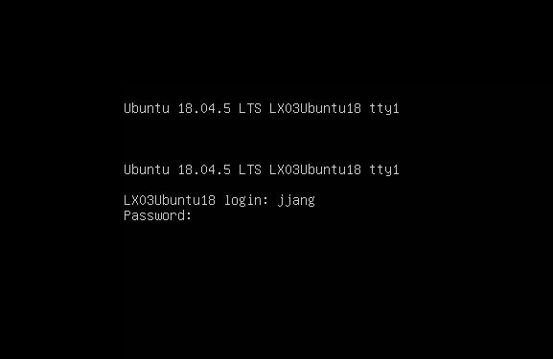
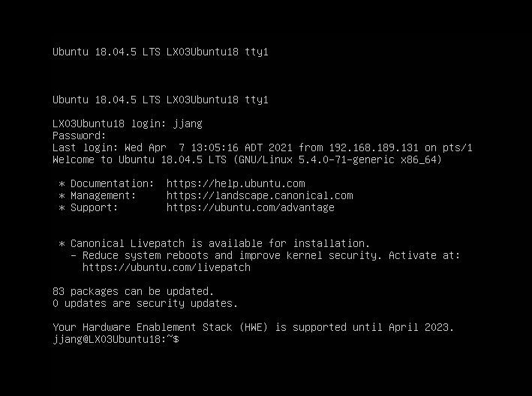
The screenshot below is my Virtual machine after I completed all set up.
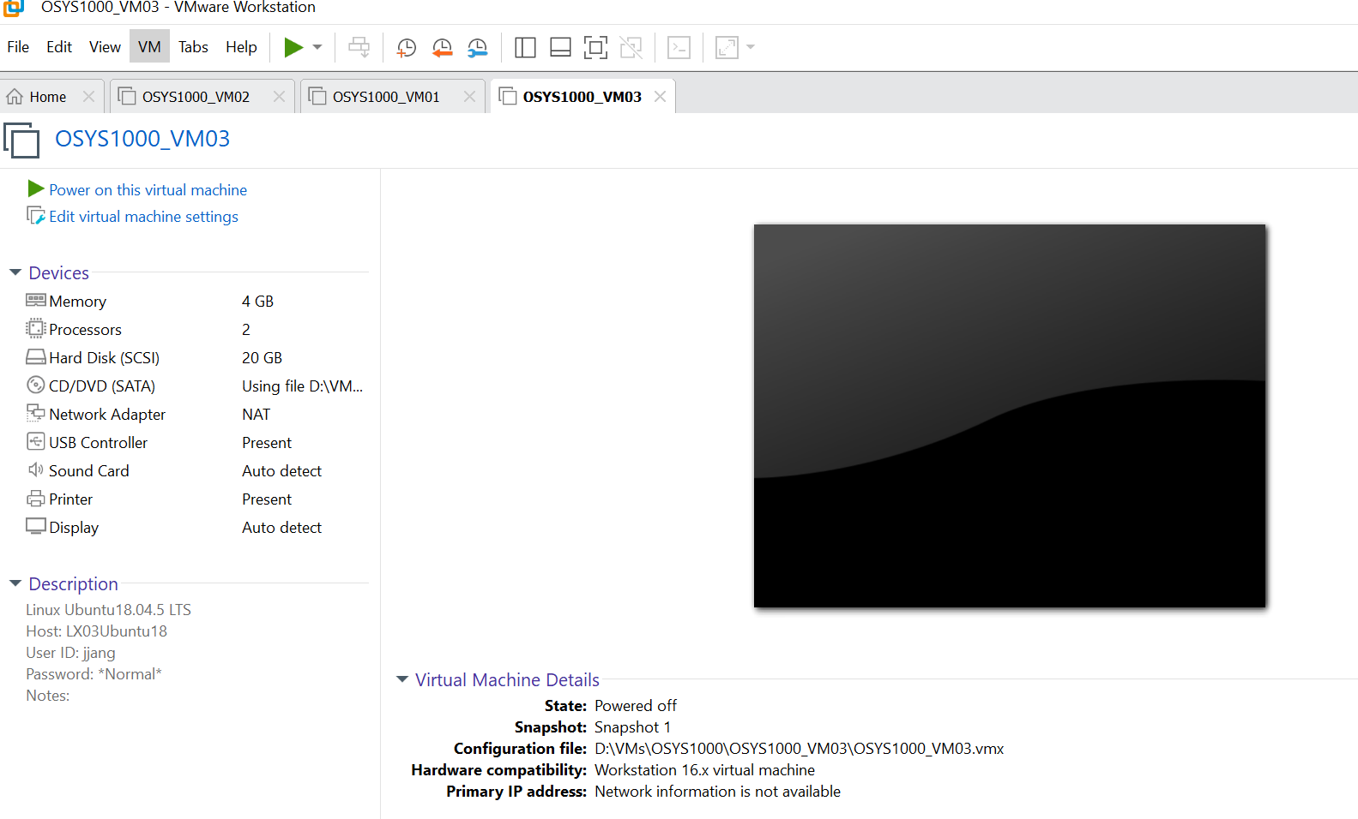

  - Summary
: Ubuntu 18.04 is one of the highly recommended releases for Linux users. This version provides a long-term support, and it has a GNOME Shell desktop.

- TASK 2: INSTALL OPENSSH, SAMBA, LAMP STACK

3.1. Objectives for this task are as follows:
: Install, properly figure out and demonstrate OpenSSH, Samba, and LAMP Stack in my new Linux environment.

  - OpenSSH
- Secure Shell (SSH) is a cryptographical network protocol used for a secure connection between a client and a server (Linuxize, 2019). Before installing SSH, I updated my system using a syntax ‘sudo apt update’ and check whether there is ‘openSSH’ in my system. I could see there was only ‘openSSH-client’ in my system.
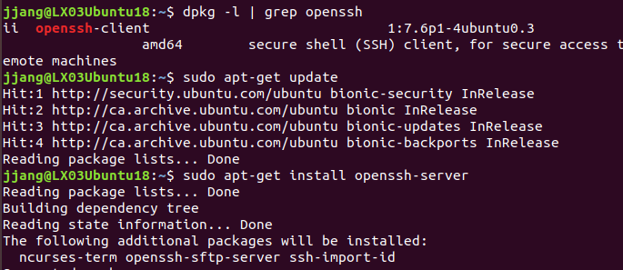
- So, I installed it using a command ‘sudo atp-get install openssh-server’ and checked the status.
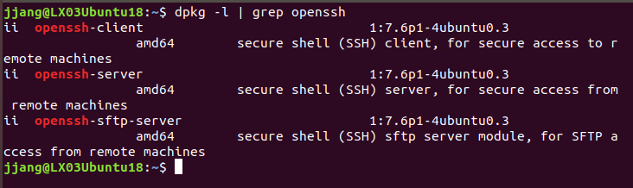
- After the installation completed, I verified the installation was successful and SSH service is running using a following command ‘sudo systemctl status ssh’. I checked the ‘Active: active (running).
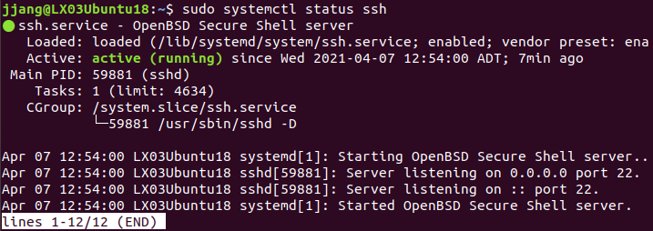
- Ubuntu comes with a firewall configuration tool called UFW. I used the command ‘sudo ufw allow ssh’ to completed setting SSH port.
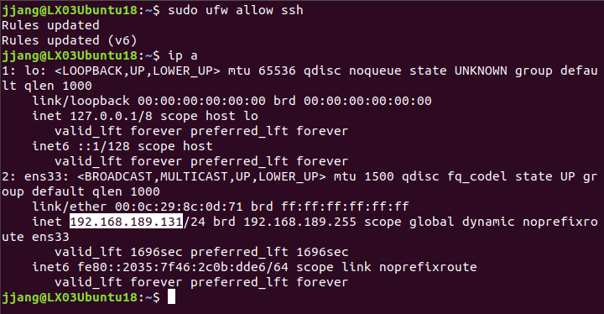
- To check my SSH connection over LAN, I found my ip address ‘192.168.189.131’. I was able to log in to remote machine by running the following ssh command (Linuxize, 2019):
$ ssh username@ip address
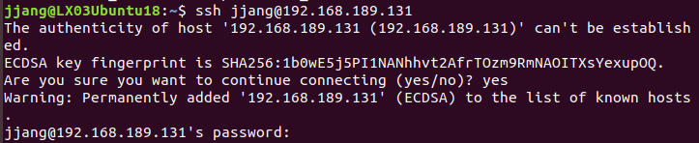
- Now, I am logged in to my Ubuntu machine after entering the password.
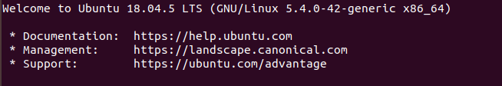

  - Samba
I followed all steps for the installation and configuration of Samba from the Linuxize article (Linuxize, 2019).
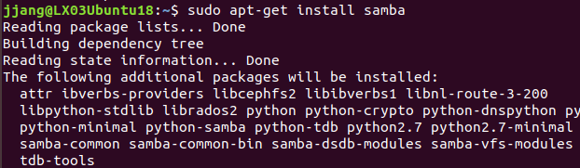
I checked whether the Samba server is running well.
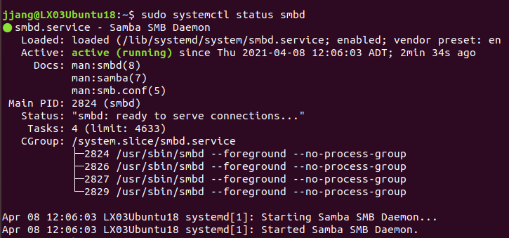
I can see that Samba has been installed and ready to be configured.
- Configuring firewall using ufw.
The Ubuntu system is using ufw to manage firewall, I opened the ports by enabling the ‘Samba’ profile with this syntax:
$sudo ufw allow ‘Samba’
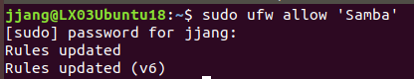
I forgot to take a screenshot, but I had created a backup of Samba before making changes to the Samba configuration file for future reference.
$sudo cp /etc/samba/smb.conf{,.backup}
I opened the default configuration file to make sure ‘server role’ was set to ‘standalone server’.
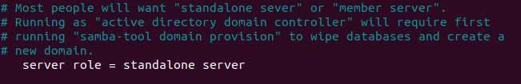
To restrict access to the Samba server only from my internal network, I remove the following two lines about interfaces and bind interfaces.
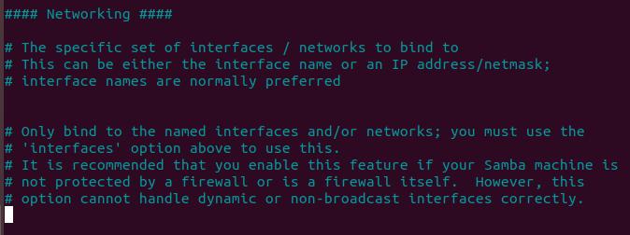
I created a new user named ‘jeong’ for practice. I used this syntax:
$sudo useradd -M -d /samba/Jeong -s /usr/sbin/nologin -G sambashare jeong
‘-M’ means ‘do not create the user’s home directory’.
‘d /samba/jeong’ means ‘set the user’s home directory to /samba/Jeong.
‘-s’ means ‘disable shell access for this user’.
‘-G’ means ‘add the user to the sambashare group’.
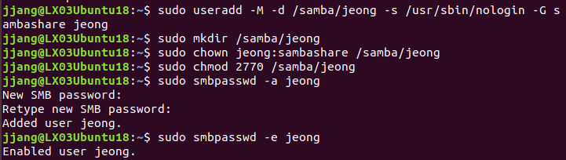
I set the permissions to 2770 and the user ‘jeong’ could read and write to this file when the sadmin user creates a new file. I set the user password as well.
- Configuring Samba Shares.
I opened the Samba configuration file and appended the sections below.
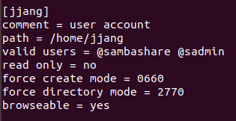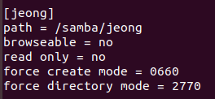
‘force directory mode’: Sets the permissions for the newly created directories in this share.
‘force create mode’: Sets the permissions for the newly created files in this share.
I restarted the Samba services with ‘sudo systemctl restart smbd’ and ‘sudo systemctl restart nmbd’.
I installed ‘smbclient’ as a tool to access Samba from the command line.
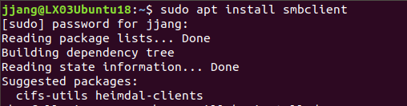
- I installed the cifs-utils package for mounting the Samba share.
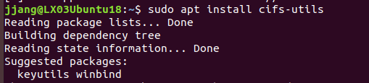
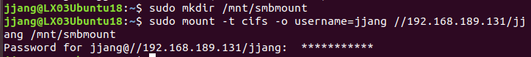
The default file manager in Gnome has built-in option to access Samba shares.
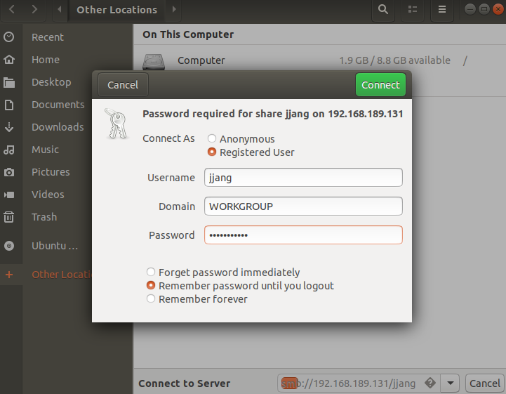
I entered the Samba share by clicking ‘Connect to Server’ with this format : smb://samba_hostname_or_server_ip/sharename. And then, I selected ‘Registered User’ and typed the username and password.
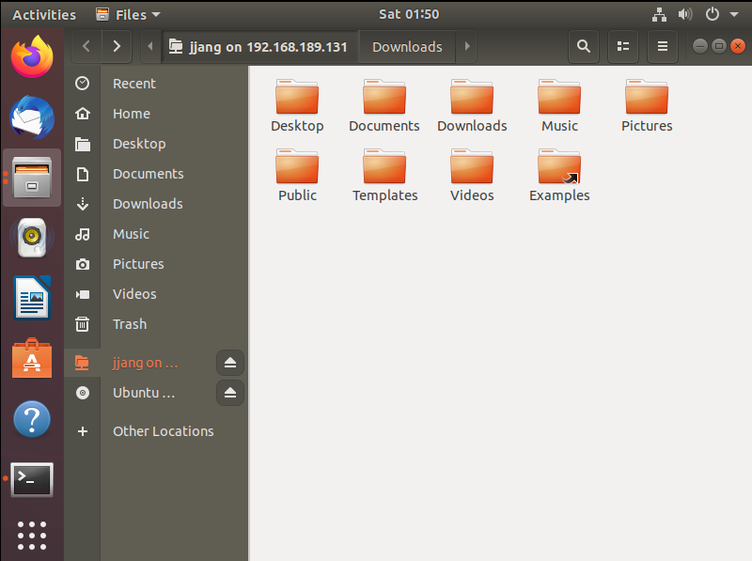

- Connecting to a Samba Share from Windows.
I opened ‘File Explorer’ -> ‘This PC’ -> ‘Choose a custom network location’ and set my network address in the following format:
\\samba_hostname_or_server_ip\sambaname
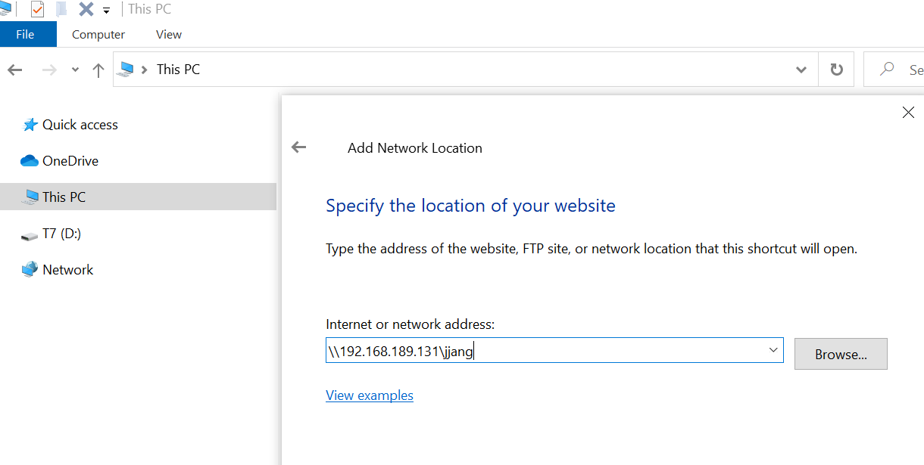
I finished the login credentials and then picked up my custom name for the network location as default one below.
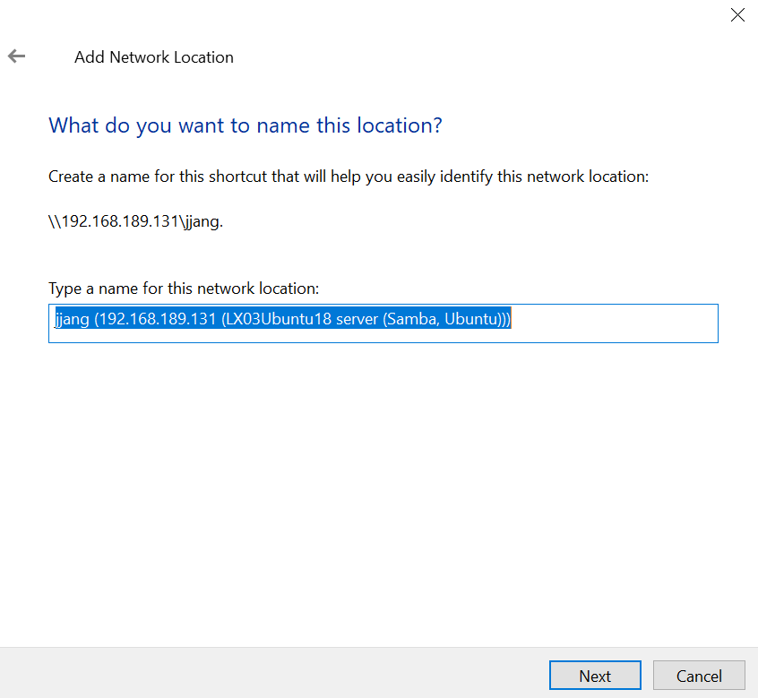
After clicking ‘Finish’, the files on the Samba server were shown.
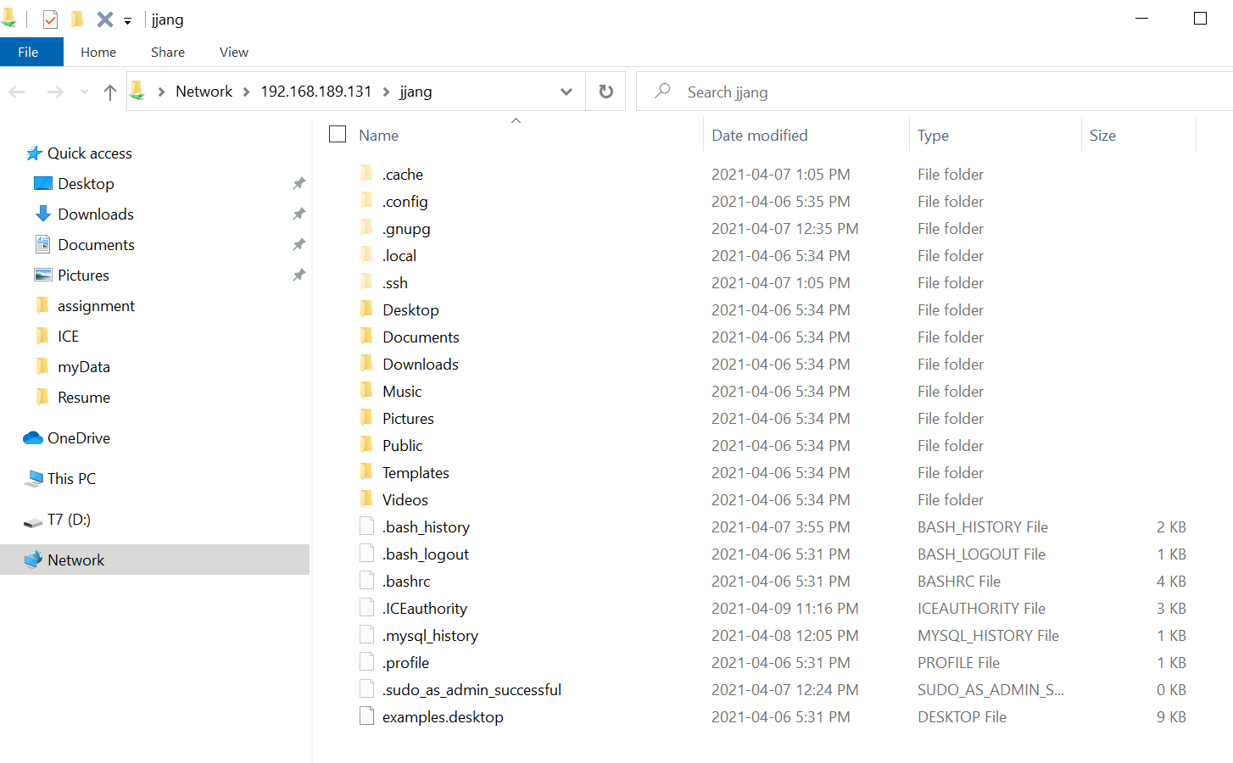
Finally, I checked the sharing was completed well.
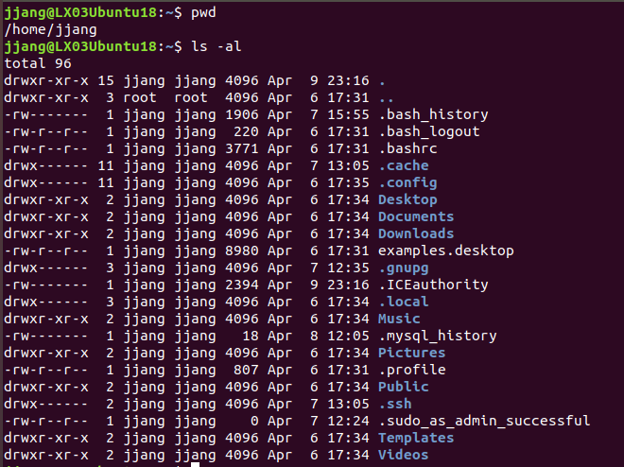

  - LAMP Stack

- A LAMP stack is a group of open-source software and the name is a combination of an acronym which represents the Linux operating system, the Apache web server, a MySQL database and PHP. They are typically installed together to experience a sever to host dynamic websites and web applications (Drake, 2018). At first, I checked the update and were ready to execute the operations with root privileges. I used the command ‘sudo apt install apache2’ to install Apache.
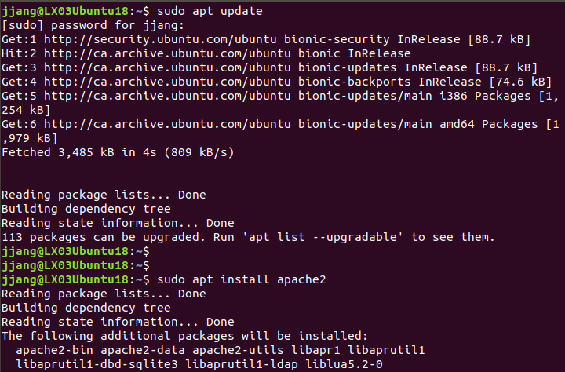
- Next, I made the UFW firewall enabled to allow web traffic.
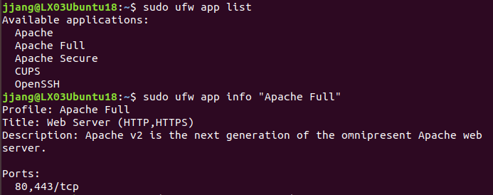
- Now, I can see my web server is correctly installed and accessible through my firewall as below screenshot.
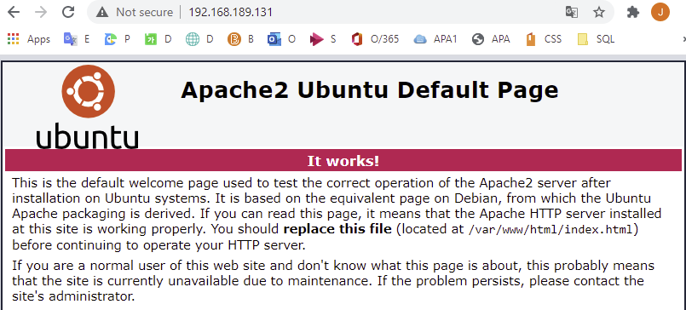

- Installing MySQL
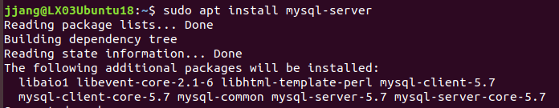
I used ‘sudo apt install mysql-server’ command to install mysql in my server.
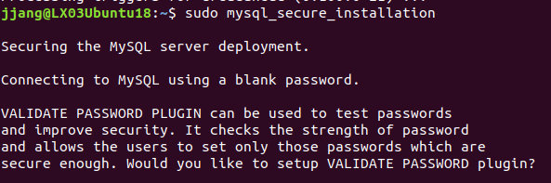
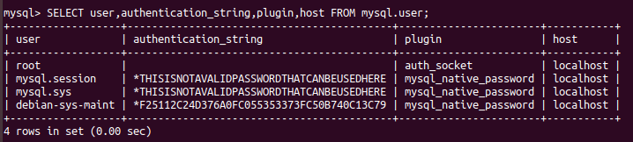
ALTER USER 'root'@'localhost' IDENTIFIED WITH mysql_native_password BY 'password';
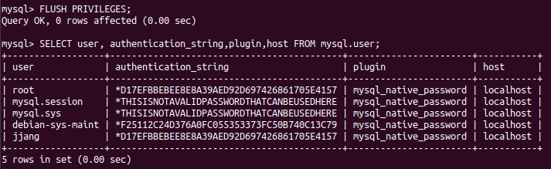

I set the root MySQL user authenticates using a password. My database system was set up and I made a new database using MySQL.
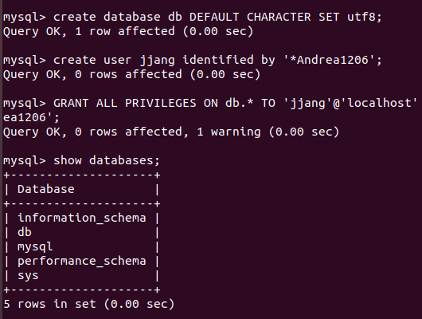
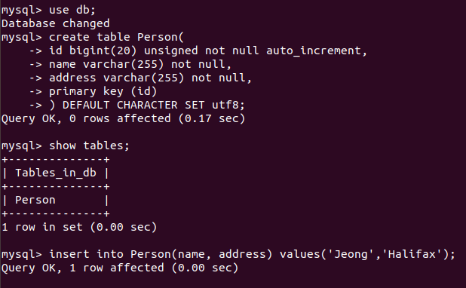
I made a table named ‘Person’ and identified each attribute.
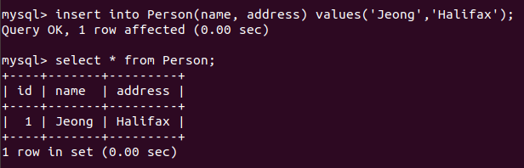

I dropped the table and finished MySQL.
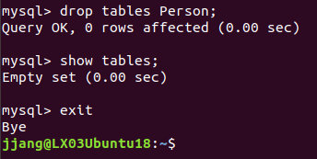
- PHP
: Most web servers support sever-side scripting such as PHP. PHP help creating dynamic web pages that are not available in simple HTML documents or modify data from databases, etc.
I installed PHP using a command ‘sudo apt install php libapche2-mod-php php-mysql’.
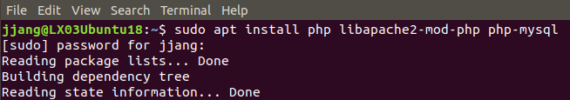
I modified the way that Apache served files to let it look for PHP files first when a directory was requested.
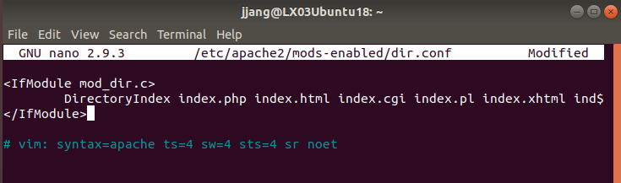
I also checked the status of the apache2 using a ‘systemctl’ command.
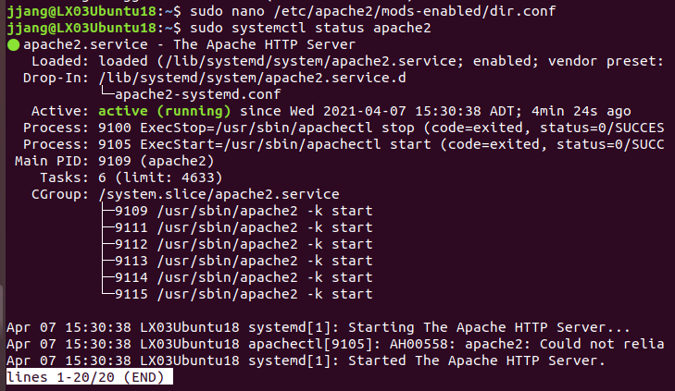
I tested that my system was configured properly for PHP by creating a basic PHP script called info.php.
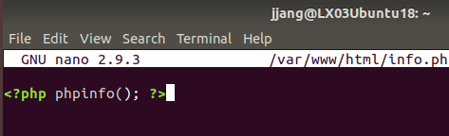
My test was successful, and I could visit the site below.
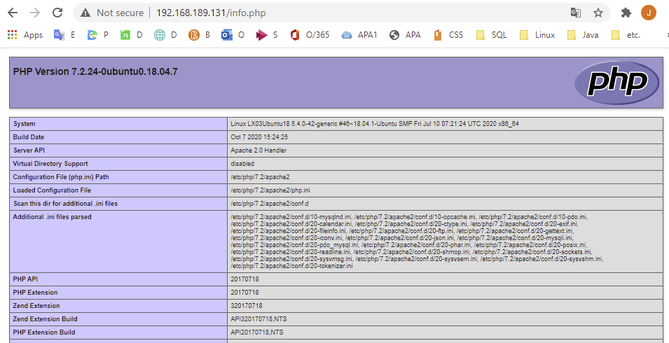

- Setting up Virtual Host
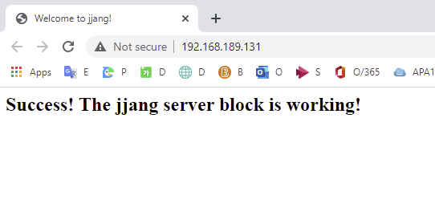
  - Summary
- I have learned how to install and enable SSH on my Ubuntu 18.04.
It means that I can now login to my machine and perform common sysadmin tasks through the command prompt. In addition, SSH listens on port 22 as default.
- I have learned how to install Samba server on Ubuntu 18.04 and created a new user. I have connected the Samba server from Linux and Widnows.
- To help manage MySQL databases from web browser, I am going to set up PHPMyAdmin.

- Toolbox & Gold copy
I made a gold copy for Ubuntu 18.04. in my ‘LinuxBackup’ folder. I encountered an error during installing mysql, but I was able to solve the problem using a gold copy. It was a valuable experience.
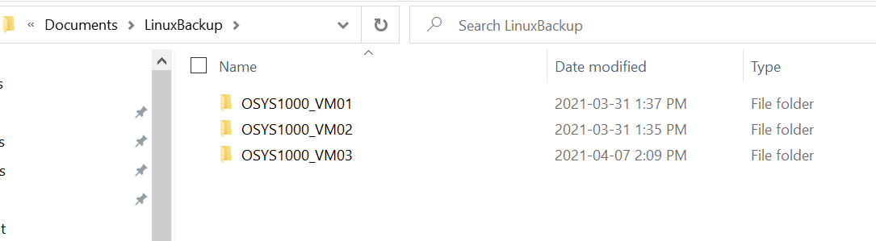
I have just added ‘Ubuntu 18.04’ page to save the different command from other Linux distribution and used commands for this assignment.
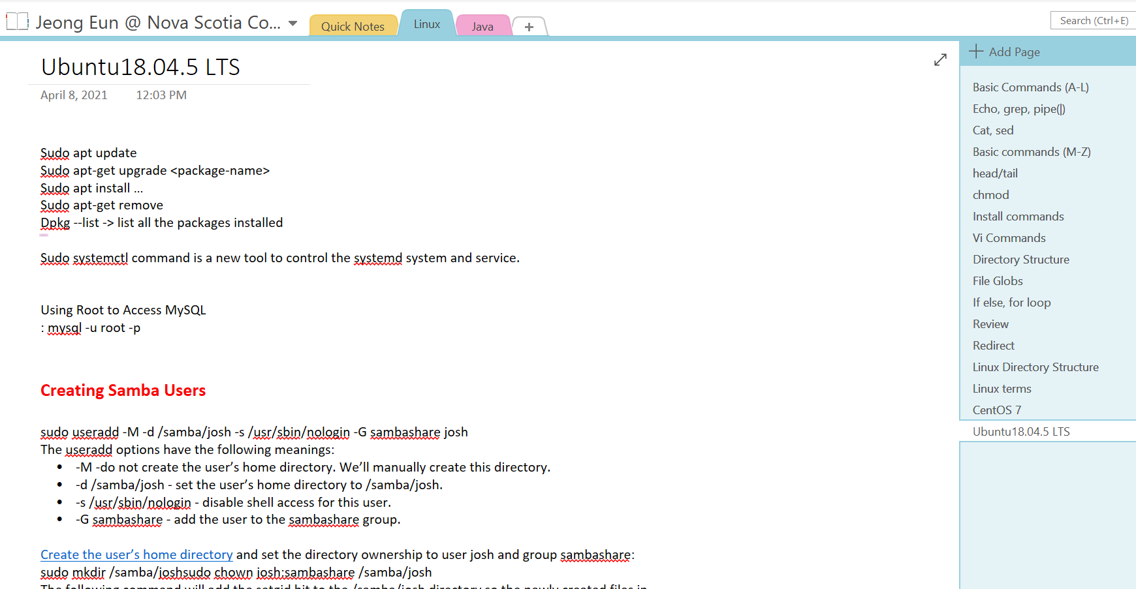

- CONCLUSION

With this third Linux distribution, my official Linux project is over. It seems like yesterday that I was unfamiliar and struggling a little, starting my first Linux, Linux Mint. Now, it has already come to the last assignment. The name of ‘Ubuntu’ has the meaning of ‘Humanity to others.’ Just like its name, it focused on user convenience more than any other Linux distribution. Because of this attribute, I could finish my last assignment with no colossal problems. My Linux distributions installed on my Virtual Machine are the result that I have worked hard. I am sure that they will be valuable assets to me as a data administrator. During this summer vacation, I plan to challenge Debian with my fourth Linux distribution.

References

Drake M. (2018, April 27). How to Install Linux, Apache, MySQL, PHP (LAMP) stack
On Ubuntu 18.04.
https://www.digitalocean.com/community/tutorials/how-to-install-linux-
apache-mysql-php-lamp-stack-ubuntu-18-04
Kumar, P. (2020, April 25). Ubuntu 18.04 LTS Desktop Installation Guide with
Screenshots
https://www.linuxtechi.com/ubuntu-18-04-lts-desktop-installation-guide-
screenshots/
Linuxize. (2019, August 2). How to Enable SSH on Ubuntu 18.04
https://linuxize.com/post/how-to-enable-ssh-on-ubuntu-18-04/
Linuxize. (2019, January 27). How to Install and Configure Samba on Ubuntu 18.04.
https://linuxize.com/post/how-to-install-and-configure-samba-on-ubuntu-18-
04/
StackExchange. (2019). How to Disable GUI on Boot in 18.04 (Bionic Beaver)?
https://askubuntu.com/questions/1056363/how-to-disable-gui-on-boot-in-18-
04-bionic-beaver

