

**Assignment 1**

*— DDL, DML —*

Jeong Eun Jang (W0451032)

DBAS 4002-700

George Campanis

February 26th, 2021

1. **Screen capture image of the MS SQL database and tables**
   1. ACCT_TRANSCACTION

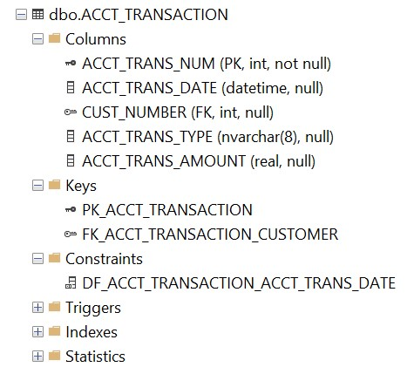

* 1. CUSTOMER

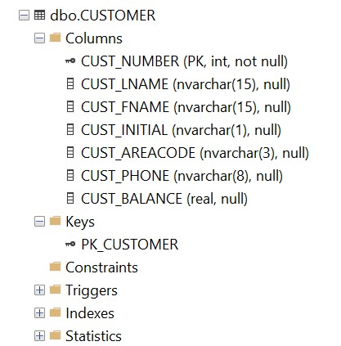

* 1. INVOICE

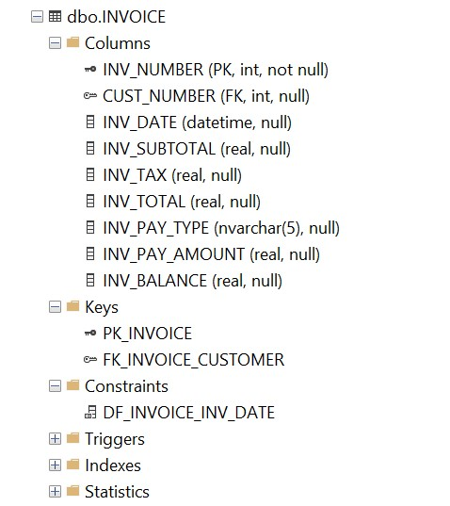

* 1. LINE

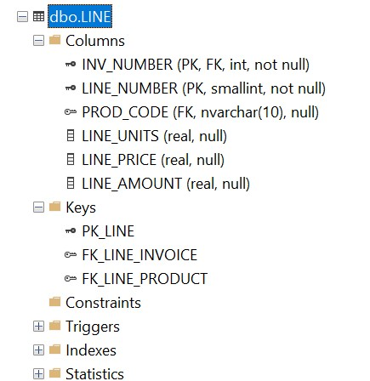

* 1. PRODUCT

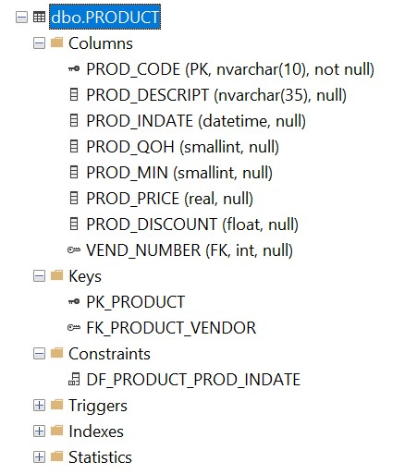

* 1. VENDOR

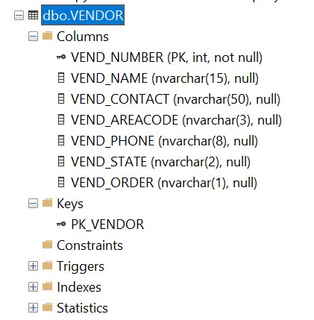

1. **Screen capture of the output of queries.**
   1. aryCustomer-Invoice-Transactions-Grouped-by-Customer

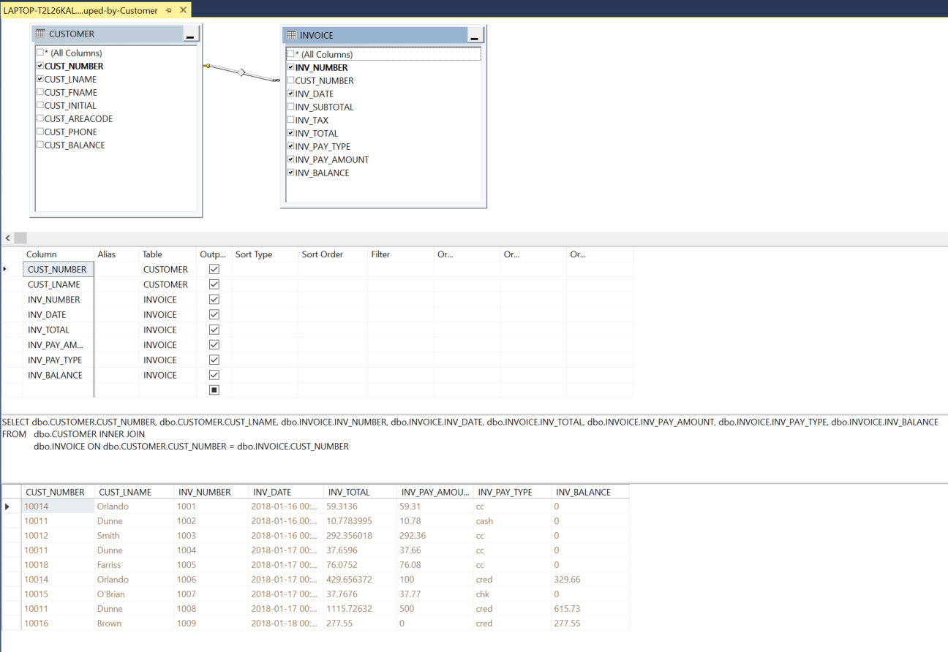

* 1. qryList-all-Purchases-and-Group-by-Customer

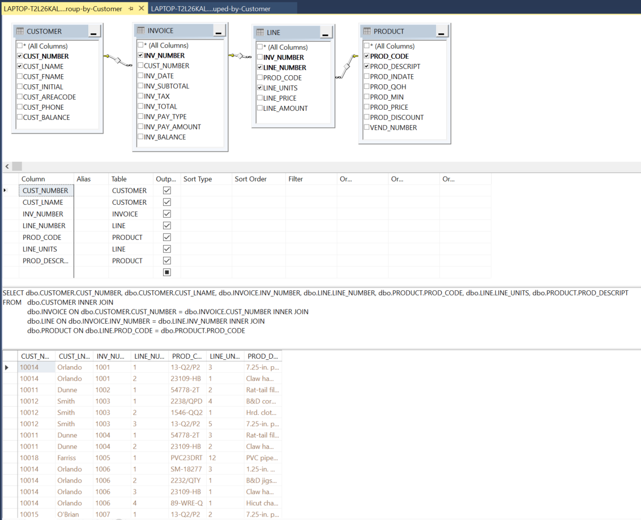

1. **A script of recreating the database.**

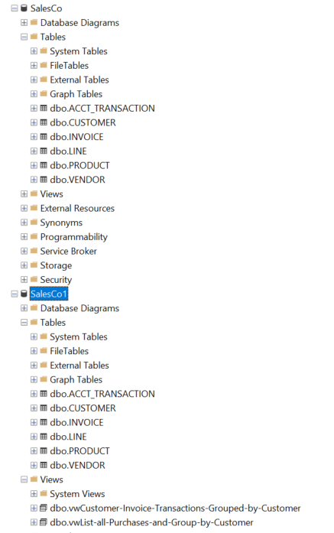

CREATE DATABASE **SalesCo1**;

1. GO
2. USE SalesCo1;
3. GO
4. CREATE TABLE [dbo].[ACCT_TRANSACTION](
5. [ACCT_TRANS_NUM] [int] NOT NULL,
6. [ACCT_TRANS_DATE] [datetime] NULL,
7. [CUST_NUMBER] [int] NULL,
8. [ACCT_TRANS_TYPE] [nvarchar](8) NULL,
9. [ACCT_TRANS_AMOUNT] [real] NULL,
10. CONSTRAINT [PK_ACCT_TRANSACTION] PRIMARY KEY CLUSTERED
11. (
12. [ACCT_TRANS_NUM] ASC
13. )WITH (PAD_INDEX = OFF, STATISTICS_NORECOMPUTE = OFF, IGNORE_DUP_KEY = OFF, ALLOW_ROW_LOCKS = ON, ALLOW_PAGE_LOCKS = ON, OPTIMIZE_FOR_SEQUENTIAL_KEY = OFF) ON [PRIMARY]
14. ) ON [PRIMARY]
15. GO
16. CREATE TABLE [dbo].[CUSTOMER](
17. [CUST_NUMBER] [int] NOT NULL,
18. [CUST_LNAME] [nvarchar](15) NULL,
19. [CUST_FNAME] [nvarchar](15) NULL,
20. [CUST_INITIAL] [nvarchar](1) NULL,
21. [CUST_AREACODE] [nvarchar](3) NULL,
22. [CUST_PHONE] [nvarchar](8) NULL,
23. [CUST_BALANCE] [real] NULL,
24. CONSTRAINT [PK_CUSTOMER] PRIMARY KEY CLUSTERED
25. (
26. [CUST_NUMBER] ASC
27. )WITH (PAD_INDEX = OFF, STATISTICS_NORECOMPUTE = OFF, IGNORE_DUP_KEY = OFF, ALLOW_ROW_LOCKS = ON, ALLOW_PAGE_LOCKS = ON, OPTIMIZE_FOR_SEQUENTIAL_KEY = OFF) ON [PRIMARY]
28. ) ON [PRIMARY]
29. GO
30. CREATE TABLE [dbo].[INVOICE](
31. [INV_NUMBER] [int] NOT NULL,
32. [CUST_NUMBER] [int] NULL,
33. [INV_DATE] [datetime] NULL,
34. [INV_SUBTOTAL] [real] NULL,
35. [INV_TAX] [real] NULL,
36. [INV_TOTAL] [real] NULL,
37. [INV_PAY_TYPE] [nvarchar](5) NULL,
38. [INV_PAY_AMOUNT] [real] NULL,
39. [INV_BALANCE] [real] NULL,
40. CONSTRAINT [PK_INVOICE] PRIMARY KEY CLUSTERED
41. (
42. [INV_NUMBER] ASC
43. )WITH (PAD_INDEX = OFF, STATISTICS_NORECOMPUTE = OFF, IGNORE_DUP_KEY = OFF, ALLOW_ROW_LOCKS = ON, ALLOW_PAGE_LOCKS = ON, OPTIMIZE_FOR_SEQUENTIAL_KEY = OFF) ON [PRIMARY]
44. ) ON [PRIMARY]
45. GO
46. CREATE TABLE [dbo].[LINE](
47. [INV_NUMBER] [int] NOT NULL,
48. [LINE_NUMBER] [smallint] NOT NULL,
49. [PROD_CODE] [nvarchar](10) NULL,
50. [LINE_UNITS] [real] NULL,
51. [LINE_PRICE] [real] NULL,
52. [LINE_AMOUNT] [real] NULL,
53. CONSTRAINT [PK_LINE] PRIMARY KEY CLUSTERED
54. (
55. [INV_NUMBER] ASC,
56. [LINE_NUMBER] ASC
57. )WITH (PAD_INDEX = OFF, STATISTICS_NORECOMPUTE = OFF, IGNORE_DUP_KEY = OFF, ALLOW_ROW_LOCKS = ON, ALLOW_PAGE_LOCKS = ON, OPTIMIZE_FOR_SEQUENTIAL_KEY = OFF) ON [PRIMARY]
58. ) ON [PRIMARY]
59. GO
60. CREATE TABLE [dbo].[PRODUCT](
61. [PROD_CODE] [nvarchar](10) NOT NULL,
62. [PROD_DESCRIPT] [nvarchar](35) NULL,
63. [PROD_INDATE] [datetime] NULL,
64. [PROD_QOH] [smallint] NULL,
65. [PROD_MIN] [smallint] NULL,
66. [PROD_PRICE] [real] NULL,
67. [PROD_DISCOUNT] [float] NULL,
68. [VEND_NUMBER] [int] NULL,
69. CONSTRAINT [PK_PRODUCT] PRIMARY KEY CLUSTERED
70. (
71. [PROD_CODE] ASC
72. )WITH (PAD_INDEX = OFF, STATISTICS_NORECOMPUTE = OFF, IGNORE_DUP_KEY = OFF, ALLOW_ROW_LOCKS = ON, ALLOW_PAGE_LOCKS = ON, OPTIMIZE_FOR_SEQUENTIAL_KEY = OFF) ON [PRIMARY]
73. ) ON [PRIMARY]
74. GO
75. CREATE TABLE [dbo].[VENDOR](
76. [VEND_NUMBER] [int] NOT NULL,
77. [VEND_NAME] [nvarchar](15) NULL,
78. [VEND_CONTACT] [nvarchar](50) NULL,
79. [VEND_AREACODE] [nvarchar](3) NULL,
80. [VEND_PHONE] [nvarchar](8) NULL,
81. [VEND_STATE] [nvarchar](2) NULL,
82. [VEND_ORDER] [nvarchar](1) NULL,
83. CONSTRAINT [PK_VENDOR] PRIMARY KEY CLUSTERED
84. (
85. [VEND_NUMBER] ASC
86. )WITH (PAD_INDEX = OFF, STATISTICS_NORECOMPUTE = OFF, IGNORE_DUP_KEY = OFF, ALLOW_ROW_LOCKS = ON, ALLOW_PAGE_LOCKS = ON, OPTIMIZE_FOR_SEQUENTIAL_KEY = OFF) ON [PRIMARY]
87. ) ON [PRIMARY]
88. GO
89. ALTER TABLE ACCT_TRANSACTION
90. ADD CONSTRAINT FK_ACCT_TRANSACTION_CUSTOMER FOREIGN KEY (CUST_NUMBER)
91. REFERENCES CUSTOMER(CUST_NUMBER)
92. ON DELETE CASCADE ON UPDATE CASCADE;
93. ALTER TABLE INVOICE
94. ADD CONSTRAINT FK_INVOICE_CUSTOMER FOREIGN KEY (CUST_NUMBER)
95. REFERENCES CUSTOMER(CUST_NUMBER)
96. ON DELETE CASCADE ON UPDATE CASCADE;
97. ALTER TABLE LINE
98. ADD CONSTRAINT FK_LINE_PRODUCT FOREIGN KEY (PROD_CODE)
99. REFERENCES PRODUCT(PROD_CODE)
100. ON DELETE CASCADE ON UPDATE CASCADE;
101. ALTER TABLE LINE
102. ADD CONSTRAINT FK_LINE_INVOICE FOREIGN KEY (INV_NUMBER)
103. REFERENCES INVOICE(INV_NUMBER)
104. ON DELETE CASCADE ON UPDATE CASCADE;
105. ALTER TABLE PRODUCT
106. ADD CONSTRAINT FK_PRODUCT_VENDOR FOREIGN KEY (VEND_NUMBER)
107. REFERENCES VENDOR(VEND_NUMBER)
108. ON DELETE CASCADE ON UPDATE CASCADE;
109. GO
110. CREATE VIEW [dbo].[vwCustomer-Invoice-Transactions-Grouped-by-Customer]
111. AS
112. SELECT dbo.CUSTOMER.CUST_NUMBER, dbo.CUSTOMER.CUST_LNAME, dbo.INVOICE.INV_NUMBER, dbo.INVOICE.INV_DATE, dbo.INVOICE.INV_TOTAL, dbo.INVOICE.INV_PAY_AMOUNT, dbo.INVOICE.INV_PAY_TYPE, dbo.INVOICE.INV_BALANCE
113. FROM dbo.CUSTOMER INNER JOIN
114. dbo.INVOICE ON dbo.CUSTOMER.CUST_NUMBER = dbo.INVOICE.CUST_NUMBER
115. GO
116. CREATE VIEW [dbo].[vwList-all-Purchases-and-Group-by-Customer]
117. AS
118. SELECT dbo.CUSTOMER.CUST_NUMBER, dbo.CUSTOMER.CUST_LNAME, dbo.INVOICE.INV_NUMBER, dbo.LINE.LINE_NUMBER, dbo.PRODUCT.PROD_CODE, dbo.LINE.LINE_UNITS, dbo.PRODUCT.PROD_DESCRIPT
119. FROM dbo.CUSTOMER INNER JOIN
120. dbo.INVOICE ON dbo.CUSTOMER.CUST_NUMBER = dbo.INVOICE.CUST_NUMBER INNER JOIN
121. dbo.LINE ON dbo.INVOICE.INV_NUMBER = dbo.LINE.INV_NUMBER INNER JOIN
122. dbo.PRODUCT ON dbo.LINE.PROD_CODE = dbo.PRODUCT.PROD_CODE
123. GO

* Inserting data in case of FK has a value of null.

