SOMA Small/Large Viewer — User Manual
  - Interactive SMPL body + IMU viewer · INTERNAL ONLY
2026-09-26
Table of contents

1. Overview
This viewer shows, interactively inside Blender, the subject’s real-shape SMPL body mesh and the RGB sensor axes at the 8 IMU locations, reconstructed from the PRISM small / large / anthro reference data. It is not a video (mp4) but a 3D scene you can orbit, play, and scrub, with two analysis features on top (dataset-run switching and per-IMU live signal plots).
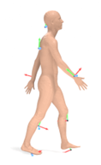
The viewer — subject SMPL body + the 8 IMU RGB axes (X=red, Y=green, Z=blue).
- Shape: an exact mesh built from the subject’s own SMPL betas.
- 8 IMU sites (sensor codes): back_T4 (upper thoracic back) · occiput (back of head) · wrist_l·wrist_r · shank_l·shank_r · foot_l·foot_r (insole).
- Axis convention: X=red, Y=green, Z=blue (computer-vision standard frame, 00_sensors.qmd spec).

2. How to run (no installation)
This viewer is Windows only.
- Double-click launch.exe in the distribution folder.
- No Python, Blender, or add-on needs to be installed on this PC — Blender, the scripts and the plotting library are all inside the folder. The data is read from this PC’s bundles, so set SOMA_DATA_ROOT first (see “Data location and adding runs” below).
- On first launch the Blender splash appears briefly, then the scene loads.

3. Screen and basic controls
In the 3D viewport:
Action | Key / mouse
Play / pause | Spacebar
Orbit | middle-mouse drag
Zoom | mouse wheel
Move frame | drag the timeline below
All features are controlled from the SOMA panel on the right. If it is hidden, press N in the 3D view to open the sidebar and select the SOMA tab.
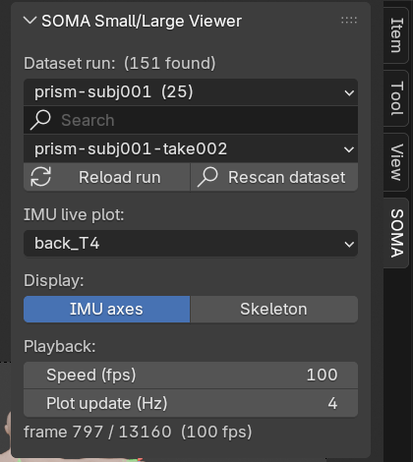
The SOMA side panel — run selector (count · Reload · Rescan) · IMU plot · display toggles · playback speed · plot update rate.

4. Features

4.1 Dataset run selector
With hundreds or thousands of runs a single list is useless, so the top of the SOMA panel narrows in three steps.
Step | Control | What it does
1 | Collection dropdown | Runs grouped by dataset and subject (e.g. prism_faithful_full/prism-subj001 (25)); the number is how many runs it holds
2 | Search box (magnifier) | Keeps only runs whose name contains what you type
3 | Run dropdown | Lists only the runs matching both
Changing the collection re-points the run list and selects its first run, rebuilding the body + IMU animation (seconds to tens of seconds for the rig). [Reload run] rebuilds the current run. If a collection holds a great many runs the list shows the first 200 and says “showing N of M”, so you can narrow further with the search box — nothing is truncated silently.
Opening a dropdown re-scans the dataset folder, so a run copied in while the viewer is running still shows up. Press [Rescan dataset] to look again immediately. The total number of runs found is shown at the top.

4.2 IMU live plot
Pick an IMU from the IMU live plot dropdown and its signals show in the adjacent image panel in three stacked plots — from top: acceleration (m/s²) · angular velocity (deg/s) · orientation (deg, roll·pitch·yaw). The three line colors (red·green·blue) in each plot are the same X·Y·Z axes as the RGB axes in the 3D view. During playback a vertical cursor tracks the current frame.
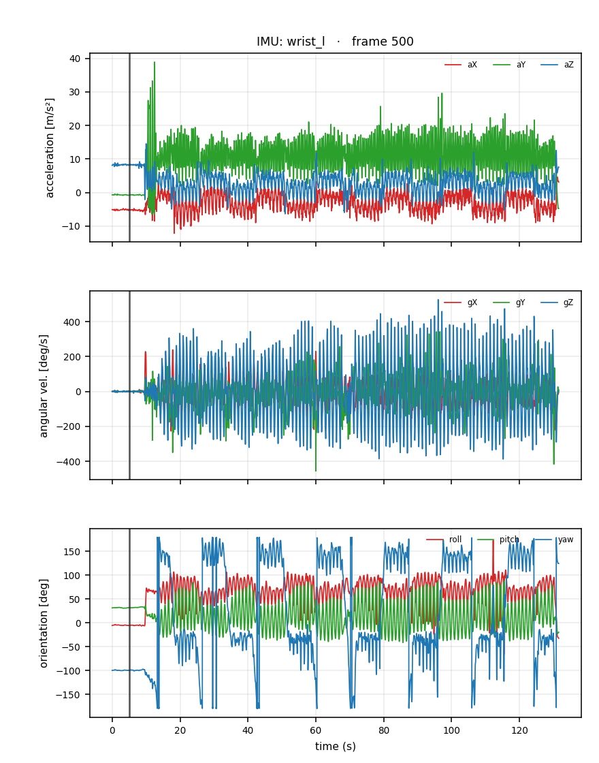
IMU live plot — acceleration, angular velocity, orientation (3 panels); the vertical line is the current frame.
The dropdown names are the small_reference.npz sensor codes directly: back_T4 (upper thoracic back) · occiput (back of head) · wrist_l·wrist_r · shank_l·shank_r · foot_l·foot_r (insole).

4.3 Display toggles
Two toggles on the Display row of the SOMA panel keep the view clean.
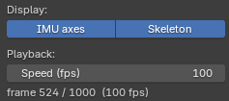
Display toggles — show/hide the IMU axes and the joint skeleton.
- IMU axes (on by default): show/hide the 8 IMU RGB axes.
- Skeleton (off by default): show/hide the SMPL joint skeleton (armature). There is one bone per joint (24 total), so it is hidden by default. Hiding it does not affect the mesh deformation.

4.4 Playback speed
The [Speed (fps)] slider sets the playback rate. The data is 100 Hz, so 100 = real time (10 s total); lower is slower (e.g. 25 → 4× slow motion), higher is faster. The scene is heavy, so if the PC cannot reach 100 fps the playback slows down — but this viewer uses frame dropping, so it skips frames it cannot draw and plays at real-time speed. If it is still slow, lower the Speed for smooth playback.

4.5 Plot update rate (3D smoothness)
The [Plot update (Hz)] slider sets how many times per second the IMU plot is redrawn during playback (default 20). Redrawing that plot is the most expensive thing happening during playback, so lowering this makes the 3D view smoother.
Value | Behaviour
20 (default) | 20 redraws/s — the cursor keeps up with playback
30 | the maximum; finest cursor, at the cost of 3D speed
4–10 | fewer redraws, 3D gets priority (4 was the previous default)
1–2 | redraws almost never
0 | no redraws during playback (only on pause/scrub) — smoothest 3D
Even at 0 the plot refreshes immediately when you pause or pick a different IMU.

5. Data location and adding runs
The viewer carries no data. It reads the bundles on the PC it runs on. Bundles stay on the PC that made them (ADR-0041), and that PC’s data root is what the SOMA_DATA_ROOT environment variable names.
<SOMA_DATA_ROOT>\
├─ runs\experimental_generation_poc_demo\
│ ├─ <bundle>\ <- the data (e.g. gaitex_unified8, hknu_unified8)
│ │ ├─ INDEX.json <- list of runs it holds; the viewer reads this to find them fast
│ │ └─ <run-id>\ ...
│ └─ _runs\ _superseded\ <- run records and evidence (the viewer does not walk them)
└─ body_models\smpl\ <- SMPL models (movable with SOMA_BODY_MODEL_DIR)
<deploy folder>\ <- this viewer (where deploy_viewer.ps1 -Dest copied it)
├─ data\SMPL_MALE_clean.npz <- when the SMPL models are shipped with the viewer
├─ scripts\ blender\ manual\
└─ launch.exe
 Important
The viewer does not scan the folders beside itself. To see bundles, set SOMA_DATA_ROOT, or name the folder to look in (item 1 of the scan order below).

When a collection ships an INDEX.json, the viewer reads that list instead of searching every folder. With thousands of runs the difference is large — a folder walk takes minutes (longer on a network drive), while reading the list is near-instant. Collections without one are searched folder by folder as before.
An entry may name its run folder in any of out_dir, relative_path, take or take_id; all four are read, so a catalog written by a different generator still works. If no entry names a folder, the viewer says so on the console and falls back to searching. The runs found are the same either way — only slower — so that line is the thing to check if filling the list suddenly takes minutes.
The viewer scans for run folders in this order and pools everything it finds into the dropdown (on a name clash the earlier root wins):
- a folder named explicitly — the Blender argument -- --folder <dir> (repeatable) or the SOMA_VIEWER_DATASET environment variable
- SOMA_DATA_ROOT\runs\experimental_generation_poc_demo\ — this PC’s bundles (the default)
- data\runs\ inside the viewer folder (for a fallback copy)
With neither SOMA_DATA_ROOT nor a named folder, the viewer says on the console what to set and stops. SMPL models are looked for in the viewer’s data\, then SOMA_BODY_MODEL_DIR, else SOMA_DATA_ROOT\body_models\smpl.
Adding a run: a bundle soma-synth run makes lands under SOMA_DATA_ROOT and appears on the next launch (or when the dropdown is opened). Runs elsewhere are shown by naming their folder as in item 1. A run folder needs small_reference.npz, large_reference.npz, and an anthro_reference.npz (older bundles: development_reference.npz) carrying the shape (betas, gender).
The body is drawn on the model matching the subject’s gender. betas live in the shape space of their own gendered model, so putting a woman’s betas on the male template does not approximate her body — it draws a different one (measured ~23 cm apart). The viewer reads gender and picks SMPL_FEMALE_clean.npz or SMPL_MALE_clean.npz. A deployment carrying only one of them falls back to it and says so on the console — the shape on screen is then not that subject’s.
Datasets prefix the joint rotation array with their own source name (smpl_global_orientation_prism_world, smpl_global_orientation_world, …). The viewer does not hard-code one name: it takes any [T,24,4] array starting with smpl_global_orientation, so any dataset following the contract opens without a code change.
It also needs a root translation — the trajectory the body follows through the world — and looks for it in this order:
- smpl_trans in anthro_reference.npz
- smpl_trans in large_reference.npz — the canonical home once it is published there
- smpl_root_translation.npz, a companion file recovered from the source recording
- trans in a *_smplx.npz in the same folder
- none of them → the take plays in place: pose and IMU frames are still exact, only the travel through the world is missing
In case 5 the panel shows “no root translation — playing in place”. It is never silent.
 Warning
Do not assume pelvis_position_world_aux is the translation. In AMASS bundles it happens to equal it; in PRISM ones it is the pelvis marker and drifts from the SMPL root by up to ~0.1 m over time. The same field name means different things per dataset, so scripts/poc/enrich_root_translation.py settles it against each run’s source recording and writes the companion file in step 3.

 Note
Long takes take longer to load: a 10 s take (1,000 frames) is a few seconds, a 2 min take (13,000 frames) about a minute before playback starts, roughly in proportion to the frame count.

6. License and distribution notice
- The body in this viewer is derived from the MPI SMPL body model (non-commercial research use, redistribution prohibited). Public or external distribution is forbidden; use it only on internal computers held by license-holders in your lab (ADR-0005: INTERNAL-ONLY).
- Blender is GPL-licensed and may be redistributed.
- You may copy the whole folder to another internal Windows PC and run it there.

