ANU TreasureMap - Sprint 6 External Testing Final Closure
Project-folder evidence pack for Sprint 6 review and handover
Field | Value
Project | ANU TreasureMap Game
Sprint | SCRUM Sprint 6, 28 Apr - 10 May
Closure status | Closed for Sprint 6 at lightweight formative / proof-of-concept level
Evidence basis | 3 informal external user tests/reviews + final Sprint 6 Jira close-out screenshots
Primary Jira items | SCRUM-108 Run External Testing and Summarise Final Playable-Slice Results; SCRUM-116 Document External Testing Reflection and Final-Version Handover
Folder location | item/testing/

1. Final close-out statement
External proof-of-concept testing is closed for Sprint 6 at a lightweight formative level. Three external users tested or reviewed the Sprint 6 playable slice. The testing was casual and qualitative rather than a formal UX study, but the feedback was consistent and useful: the slice functioned as a playable proof path, yet the first impression did not feel game-like enough and some players did not immediately know what to do. The team treated this as a real product risk rather than a cosmetic comment. The response was recorded through Jira and sprint documentation: SCRUM-108 closed the external testing summary, SCRUM-116 closed the testing reflection and handover, SCRUM-105 closed onboarding validation, and supporting UI/event/treasure/sound tasks were completed or handed over. Therefore, the external testing evidence gap is closed for Sprint 6, with richer RPG mechanics, deeper randomness, and fuller clue systems documented as future work rather than blockers for the final playable Week 1 slice.

2. Assessment framing
This evidence should be read as lightweight formative testing, not formal usability research. The notes were collected casually by a teammate and do not include a structured survey, recordings, or quantitative scoring. The value of the evidence is that the findings were consistent, documented, converted into Jira response items, and then closed or handed over.
This aligns with the Sprint Checklist expectation to conduct relevant testing, keep PBIs up to date, respond to feedback, and create/action items from review and retrospective outcomes. It also supports the Sprint Rubric areas of Execution and Quality, and Reflection and Improvement, because the team acted on the feedback instead of leaving it as an unclosed observation.

3. What was tested
- A playable Week 1 slice of ANU TreasureMap, including map navigation, early onboarding, phone/profile presentation, event/treasure interaction, and visual/game-feel cues.
- The first-impression question: whether an external player understands what to do and whether the slice feels like a game rather than a campus information guide.
- The proof-of-concept question: whether the treasure-hunting loop is engaging enough to justify future development.

4. Key findings
Finding | Summary
F1 | The strongest risk was game identity: testers did not immediately feel that the interface was game-like enough.
F2 | The second strongest risk was player guidance: players did not always know what to do next.
F3 | The map and top menu needed more visual personality and stronger game styling.
F4 | Events needed clearer transitions, animations, and outcome feedback.
F5 | The treasure loop was engaging as a hook, but deeper mechanics, descriptions, randomness, and clue logic should be developed in future work.
F6 | The in-game phone/Instagram-style UI and character-card direction were positive design anchors worth preserving.

5. Final Jira close-out evidence
The final Sprint 6 Jira screenshots supplied by the team show that the testing summary, testing reflection/handover, onboarding validation, and multiple feedback-response implementation items are now marked Done. The table below records the core Jira evidence used to close external testing.
Jira | Title | Category | Status | Closure relevance
SCRUM-45 | External Testing Follow-up from Sprint 5 | Testing & Validation | Done | Shows that previous external-testing concern was followed up in Sprint 6.
SCRUM-105 | Validate Starting Page and Onboarding Flow | Testing & Validation | Done | Addresses testers not knowing what to do.
SCRUM-108 | Run External Testing and Summarise Final Playable-Slice Results | Testing & Validation | Done | Primary external testing close-out item.
SCRUM-116 | Document External Testing Reflection and Final-Version Handover | Testing & Validation | Done | Turns testing outcome into reflection and handover evidence.
SCRUM-130 | Prioritise Onboarding First-Impression Polish Over Extra Node Events | UI / UX / Visuals | Done | Direct response to first-impression and player-guidance feedback.
SCRUM-136 | Increase Game Font Size and Add Text Background Labels | UI / UX / Visuals | Done | Improves readability after player/visual feedback.
SCRUM-138 | Implement Treasure Book UI and Collection System Evidence | UI / UX / Visuals | Done | Strengthens reward/collection feedback.
SCRUM-142 | Implement Event Animations and Image Transitions | Core Systems | Done | Direct response to animation/transition feedback.
SCRUM-143 | Implement Treasure Choice Pick-One-of-Two Interaction | Core Systems | Done | Adds clearer gameplay interaction in the treasure loop.
SCRUM-145 | Add Event Character Sprites to the Playable Event System | Art / Audio | Done | Moves event presentation away from static utility UI.
SCRUM-146 | Update Phone, Profile, and Map Icons for Final UI | Art / Audio | Done | Preserves strong phone/profile direction and improves final UI identity.
SCRUM-147 | Create Tutorial Bear Illustrations and Dialog Box Assets | Art / Audio | Done | Supports onboarding and game personality.
SCRUM-148 | Implement Go Button, Phone Click, and Event Sound Effects | Art / Audio | Done | Adds action feedback and game feel.

6. Feedback-to-response register
The register below turns the casual testing feedback into a traceable product response. This is the most important part of the close-out because it shows how the team translated user reaction into Jira work, implementation changes, and future-work boundaries.
Theme | External feedback | Team interpretation | Sprint 6 response / Jira evidence | Status
Game identity / first impression | The interface looked more like an open-week campus guide than a game; testers expected a stronger RPG or treasure-hunting feel. | The playable slice needed stronger game framing, not only functional map navigation. | Closed as a formative finding and reflected through SCRUM-130, SCRUM-136, SCRUM-145, SCRUM-146, SCRUM-147, SCRUM-148, and final presentation/handover work. Broader RPG depth remains future work. | Closed for Sprint 6; future enhancement recorded.
Player guidance / onboarding clarity | Players did not always know what to do. | The game needed clearer first-action guidance and a more readable tutorial path. | SCRUM-105 Validate Starting Page and Onboarding Flow marked Done; SCRUM-97 Finalize Starting Page, Onboarding, and Tutorial Flow marked Done; SCRUM-148 Go Button, Phone Click, and Event Sound Effects marked Done. | Closed.
Map and HUD personality | Map felt monotonous; top menu felt like a mobile app; location photos felt less game-like. | Visual styling needed to shift from utility interface toward game interface. | SCRUM-123 Finalize Map Alignment, Readability, Boundary Lines, and HUD Layout marked Done; SCRUM-136 font/background readability marked Done; SCRUM-146 phone/profile/map icon update marked Done. Full map stylisation remains a future art direction. | Partly implemented; future art polish handed over.
Event feedback and transitions | Events should use animations or image transitions; players could not always tell what had happened. | Event outcomes needed clearer feedback loops so players understand cause, outcome, and reward/no-reward state. | SCRUM-142 Implement Event Animations and Image Transitions marked Done; SCRUM-140 Integrate Week 1 Playable Event Set into Final Build marked Done; SCRUM-144 Game Ending and Credits Flow marked Done. | Closed for the slice; deeper outcome explanations remain future work.
Treasure interaction and reward clarity | Random exploration was engaging, but treasure collection could use deeper mechanics, descriptions, and clearer luck/treasure explanation. | The treasure loop worked as a hook but needed a more explicit choice/reward structure. | SCRUM-94 Implement Treasure Choice and Collect/Hint Outcome Logic Done; SCRUM-138 Treasure Book UI and Collection System Evidence Done; SCRUM-143 Pick-One-of-Two Interaction Done; SCRUM-120 Collection Board/Treasure Book/Treasure Display Support Done. | Closed for proof-of-concept; richer mechanics handed over.
Phone and character UI strengths | In-game phone/Instagram-style design was immersive; character card design was good. | The phone and character-card direction should be preserved as a successful design anchor. | SCRUM-119 Integrate Mobile Phone System and Demo-Support Flow Done; SCRUM-146 update phone/profile/map icons Done; event-character sprites and tutorial assets Done. | Closed as positive validation.
Scope boundary / deferred complexity | Testers wanted more complex mechanics, movement, randomness, and deeper clues. | These improvements point to a richer future version, but they exceed the protected Sprint 6 Week 1 proof-of-concept scope. | The final backlog screenshot shows older/deferred items remaining outside Sprint 6 closure. These are not blockers for external testing evidence; they are future-work/handover candidates. | Deferred, not a Sprint 6 blocker.

7. Closure boundary
External testing is closed for Sprint 6 because the team has evidence for feedback collection, summary, Jira response, implementation/handover decisions, and final Done status. It does not mean every possible game improvement has been completed.
The final backlog screenshot is important because it clarifies the boundary: broader mechanics, older support tasks, and feature expansion remain backlog or future-work items. They do not block the Sprint 6 external-testing closure because the sprint goal was a playable Week 1 slice with external proof-of-concept testing evidence, not a complete twelve-week RPG system.

8. Suggested Jira close-out comments

SCRUM-108
Closed. Three external formative tests/reviews were completed for the Sprint 6 playable slice. Feedback was consistent: the slice did not initially feel game-like enough and some players did not know what to do; main themes were game identity, onboarding clarity, event feedback, treasure reward clarity, map/HUD styling, and richer future mechanics. Summary and response register are now stored in item/testing/. Response items are complete or handed over through SCRUM-105, SCRUM-116, SCRUM-130, SCRUM-136, SCRUM-138, SCRUM-142, SCRUM-143, SCRUM-145, SCRUM-146, SCRUM-147, and SCRUM-148. Limitation: casual qualitative testing, no formal survey or quantitative metrics. This closes Sprint 6 external proof-of-concept testing evidence.

SCRUM-116
Closed. External testing reflection and handover completed. The key lesson is that the final slice should be framed as an onboarding-first proof of concept: the map/phone/event/treasure loop works as a demonstrable path, but future development should deepen game feel through stronger RPG framing, clearer event outcomes, richer treasure descriptions, improved map stylisation, and a more developed clue/keyword system. Remaining complex mechanics are future-work backlog items, not blockers for Sprint 6 closure.

9. Raw feedback notes
The raw notes below are preserved so that the evidence trail is transparent. They are included as informal notes, not as formal survey data.
Source type: teammate-collected casual user testing notes.
Scope: lightweight formative external testing of the Sprint 6 playable slice.
Limitations: notes were not collected through a formal survey instrument, recording protocol, or quantitative scoring method. They are treated as qualitative proof-of-concept evidence only.
1. The gameplay interface looks more like an open week campus guide than an actual game.
2. The background map feels a bit monotonous and needs a more stylized design to make it more engaging.
3. The top menu bar could use more personality - the white design feels like a mobile app.
4. The location images could use something other than photographs.
5. Events should come with animations or image transitions when they occur.
6. The in-game phone/Instagram-style design is quite immersive.
7. The character card design is also pretty good.
1. The gameplay is a bit dull - some more complex and interesting mechanics would be nice.
2. Maybe add some randomness, like dice rolls, when obtaining treasures to increase fun.
3. When events happen at a location, it is unclear what actually occurred - there should be some way to show whether it is because there is no treasure there or just bad luck.
4. Could there be more interesting ways to handle character movement on the map?
5. The clues in the phone have not been fully realized - the keyword system has potential and should be developed further.
6. The random exploration and treasure-hunting mechanics are engaging - the treasure descriptions could be written in more depth.
I have done 3 user tests and the feedback is consistent: it does not feel like a game and players do not know what to do. The latest tester expected an RPG style with treasure hunting.

10. Jira screenshot appendix
The following screenshots are included in the project-folder pack under item/testing/jira-closeout-screenshots/. They provide visual evidence for the final Jira closure state.

Figure 1. Sprint 6 goal and initial Done items
Shows the Sprint 6 goal: playable Week 1 slice including external proof-of-concept testing evidence, with early Sprint 6 tasks marked Done including SCRUM-45 External Testing Follow-up from Sprint 5.
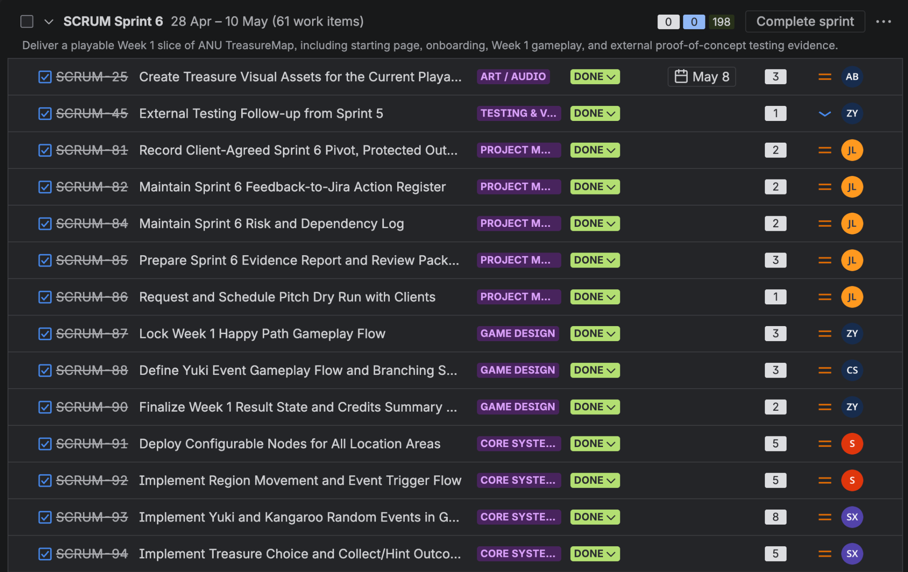
01_sprint6_goal_and_initial_done_items.png (2048 x 1291)

Figure 2. Sprint 6 top close-out view
Shows the Sprint 6 backlog section expanded with completed project-management, game-design, and core-system work items.
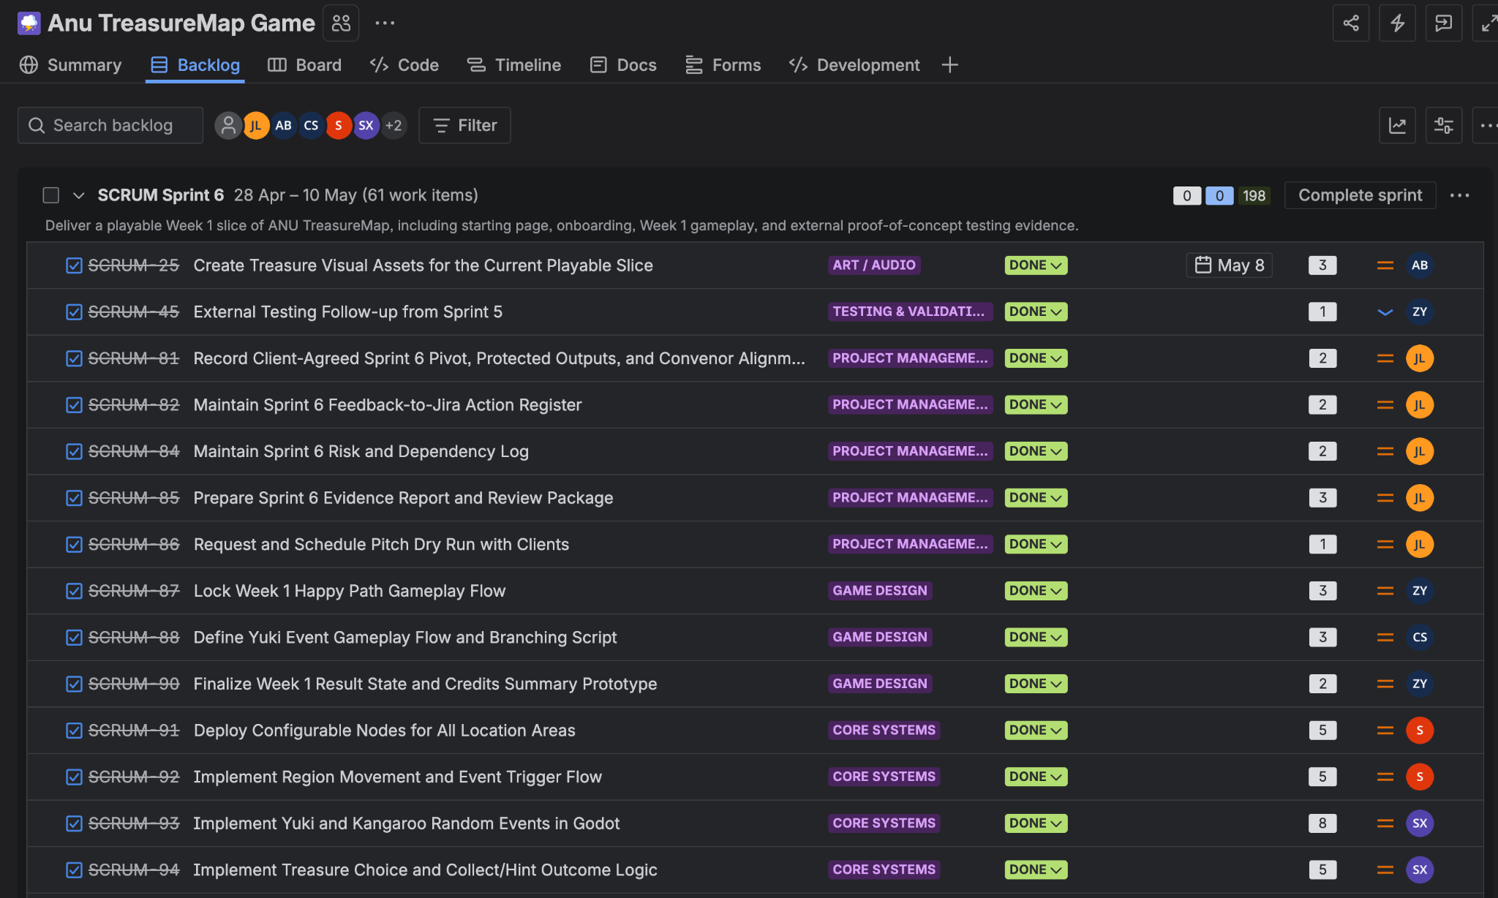
02_sprint6_full_top_closeout_view.png (2048 x 1228)

Figure 3. Testing and validation closure view
Shows SCRUM-105 Validate Starting Page and Onboarding Flow, SCRUM-108 Run External Testing and Summarise Final Playable-Slice Results, and SCRUM-116 Document External Testing Reflection and Final-Version Handover marked Done.
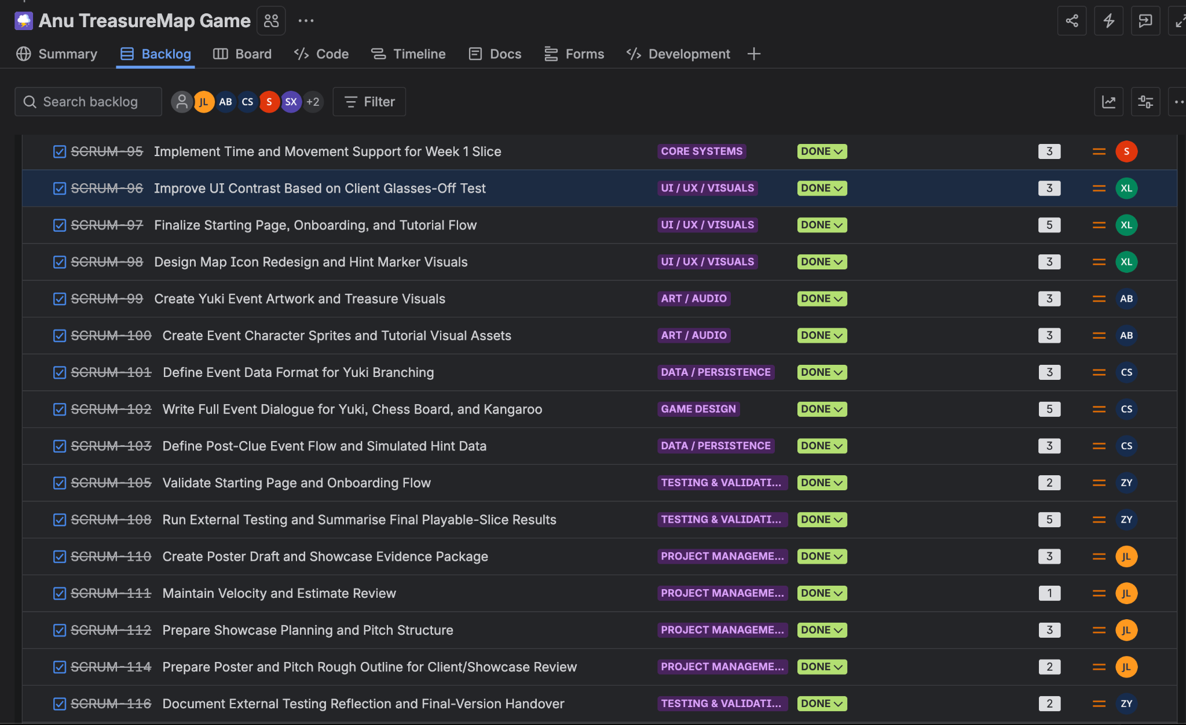
03_testing_validation_and_external_testing_done.png (2048 x 1254)

Figure 4. Final delivery and response items
Shows final delivery work marked Done, including collection/treasure display, final map/HUD layout, documentation, and handover tasks that support the tested playable slice.
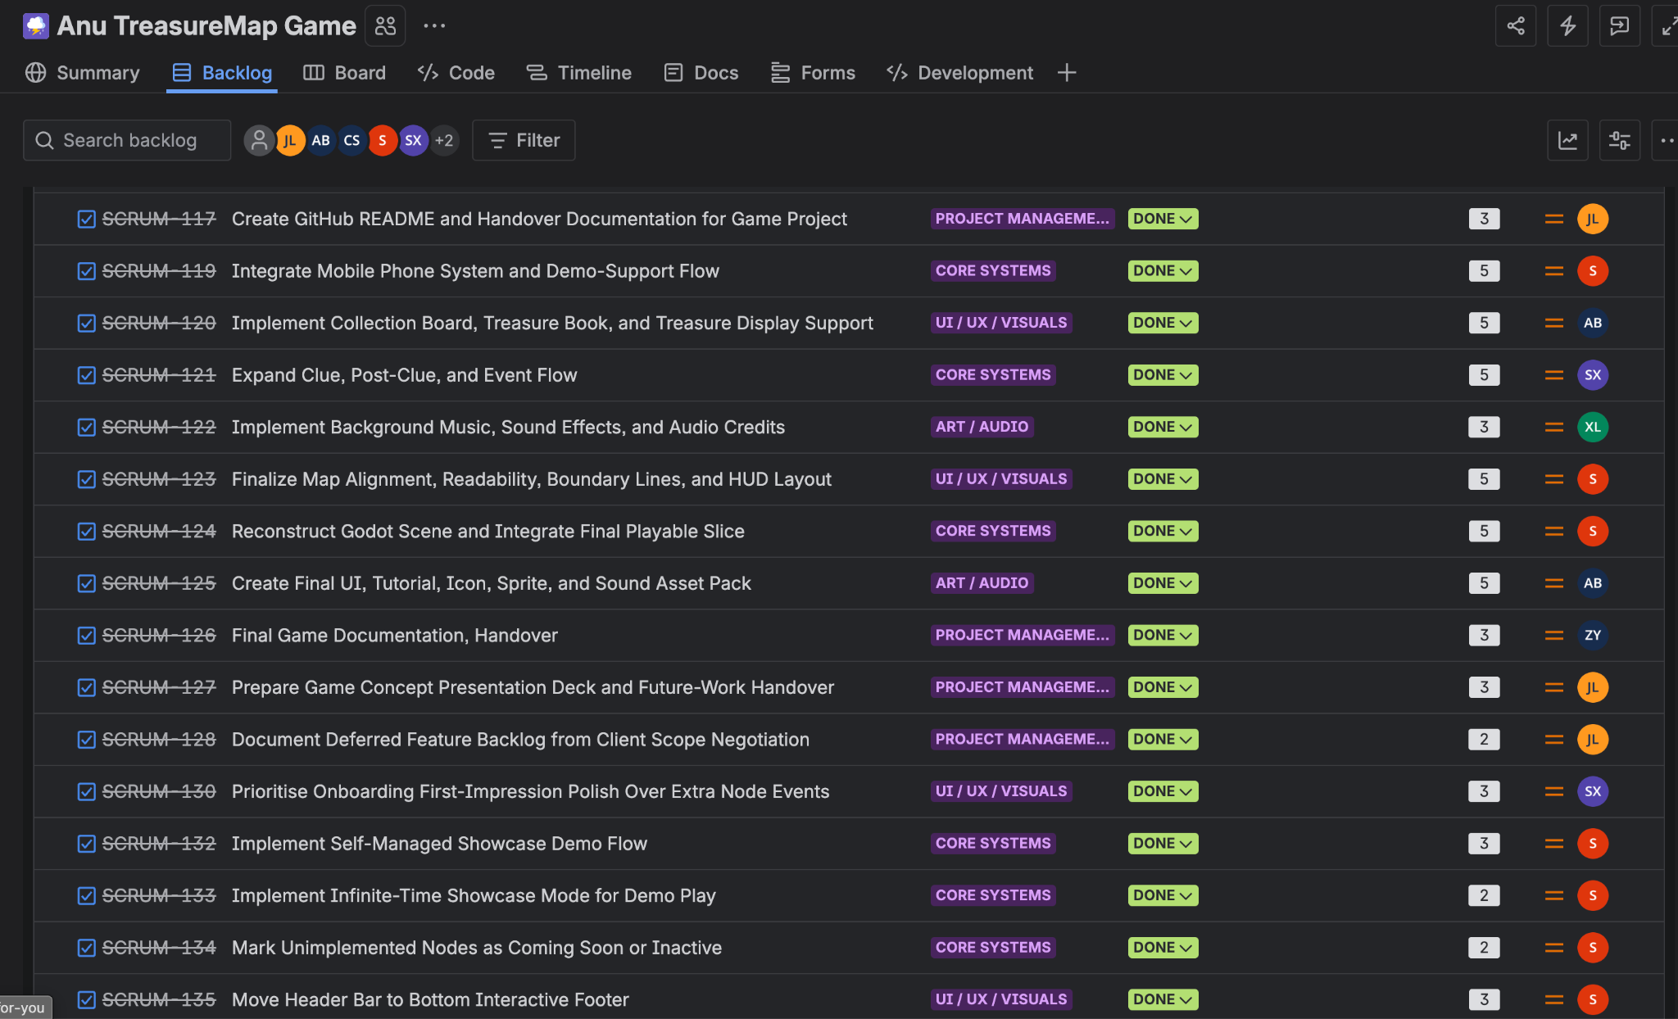
04_final_delivery_response_items_done.png (2048 x 1244)

Figure 5. Event, UI, and audio response items
Shows late Sprint 6 polish and feedback response items marked Done, including font/readability changes, treasure-book evidence, Week 1 event integration, event animations/image transitions, choice interaction, character sprites, icons, tutorial assets, and sound effects.
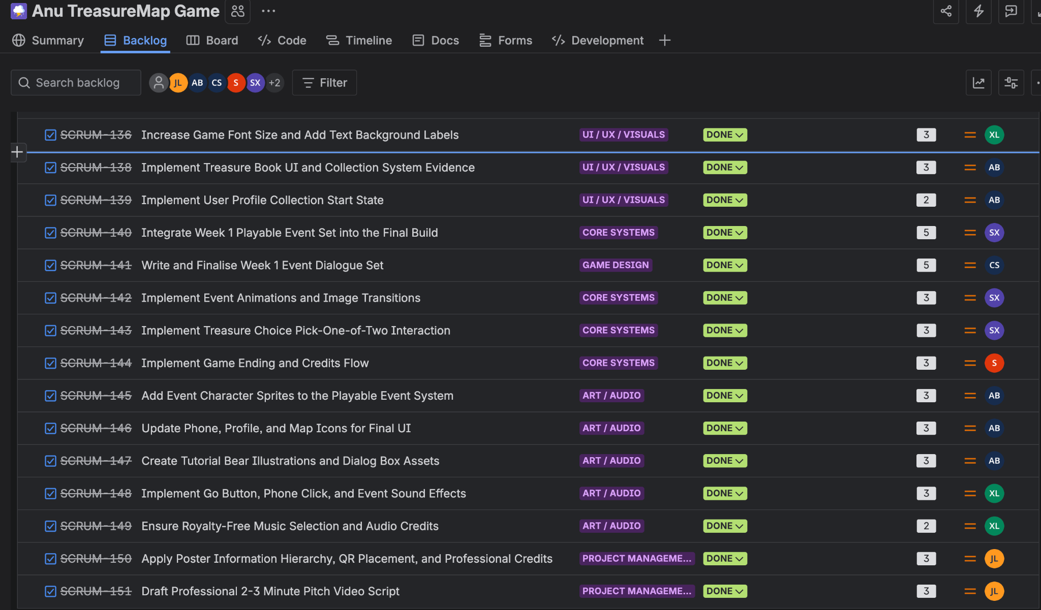
05_event_visual_ui_and_audio_response_items_done.png (2048 x 1201)

Figure 6. Deferred backlog evidence
Shows the separate backlog with non-Sprint-6 or deferred work items. This supports the closure boundary: broader mechanics and older open tasks remain future/backlog work, not blockers for Sprint 6 external proof-of-concept testing closure.
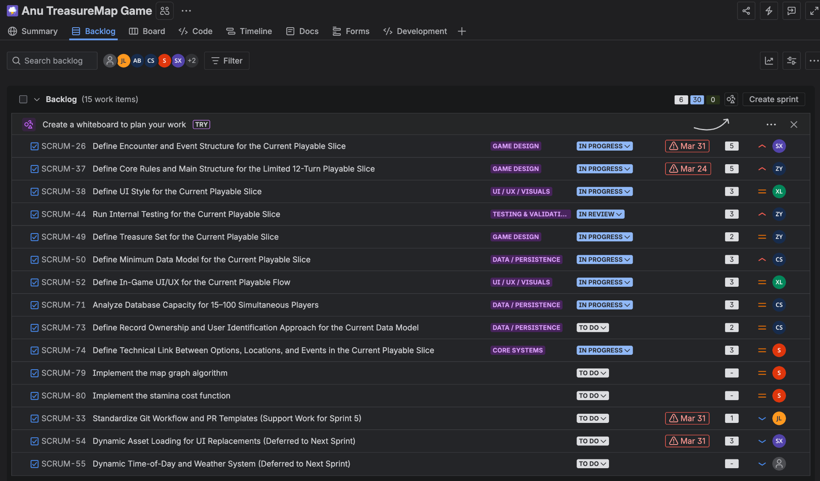
06_deferred_backlog_not_sprint6_closure_blockers.png (2048 x 1201)

