ANU TreasureMap
Sprint 6 Review Report
Single-file evidence report aligned to the TechLauncher Sprint Checklist and Marking Rubric

Project | ANU TreasureMap | External stakeholder team | Godot
Sprint focus | Final delivery: playable Week 1 slice from starting page through onboarding, Week 1 gameplay, event/treasure loop, and proof-of-concept testing evidence
Sprint scope | Week 7 to Week 9; evidence-cleaned report refreshed on 2026-05-06 AEST
Tools | Jira for task management; GitHub for version control, PRs, commits, and CI workflows
Team members | Jeongjoon Lee, Wing Sze Shing, Suya Xie, Zijun Yang, Xiyin Li, Anlin Bai, Shaoming Qin

Purpose
This report consolidates Sprint 6 evidence for ANU TreasureMap into a single reviewable DOCX. It follows the evidence-forward style of the HD sample report while translating the content to this team's tools, product, and sprint context. Sprint 6 is treated as the final product delivery sprint: the team is presenting a client-agreed playable Week 1 slice from starting page through onboarding, Week 1 gameplay, event/treasure interaction, and proof-of-concept testing evidence. Because the final submission is a single DOCX, the key Jira, GitHub, meeting, code, and product evidence is embedded directly as images rather than relying on external links.
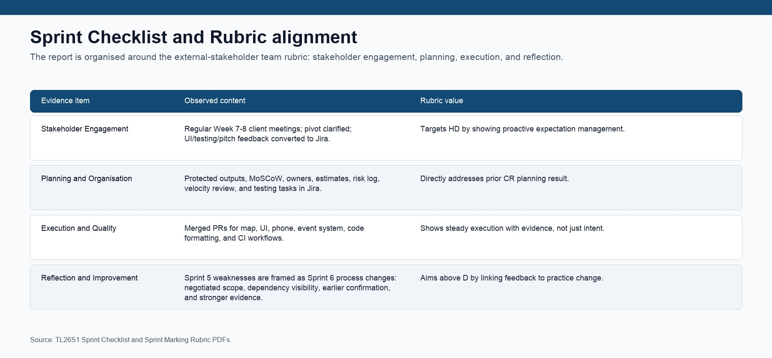
Figure 1. Sprint Checklist and marking rubric alignment used to structure the report.

Executive Summary
Sprint 6 should be read as both a recovery-and-quality sprint and the project's final deliverable sprint. Sprint 5 produced strong stakeholder and reflection evidence, but planning and execution were marked at Credit because the team had not yet translated the pivoted game concept into a tightly protected, implementation-ready, testable slice. In Sprint 6 the team responded by narrowing the target to a playable Week 1 vertical slice and by turning client feedback into explicit Jira work items, GitHub implementation evidence, and test preparation.
- Stakeholder engagement remained a strength: the team used Week 7, Week 8, and Week 9 client meetings to clarify a negotiated pivot, define the final deliverable shape, sharpen onboarding-first polish, and convert specific feedback into tasks.
- Planning improved materially: the report-scoped Jira register now shows 38 Sprint 6 issues, 27 Done, and 11 In Review after evidence cleanup, with live Jira screenshots embedded for verification.
- Execution evidence is stronger than Sprint 5: PRs #46-64 show map, UI, phone interaction, event data, Godot event logic, CI, a game-facing README, Sprint 6 evidence docs, checklist closure, and event-visual feedback closure.
- Testing is now planned as explicit work; the remaining In Review items clearly list the Week 9 demo/testing evidence that must be supplied before the final evidence-closed submission.

Rubric area | Sprint 6 evidence | Grade case | Evidence status
Stakeholder | Week 7-9 client meetings; feedback-to-Jira register; new SCRUM-113 to SCRUM-118 cleanup actions. | HD/D | Final testing/demo evidence still requested.
Planning | 38 report-scoped Jira issues; 27 Done and 11 In Review after SCRUM-110 and SCRUM-118 were closed with build/event evidence. | HD-leaning | Actual Jira board/issue screenshots embedded.
Execution | PRs #46-64; PR #61 merged; PR #64 opened; live Godot map screenshot; Yuki/event visual evidence; CI workflows. | D/HD-leaning | Full demo-flow screenshots still requested.
Reflection | Sprint 5 lessons converted into negotiated scope, evidence-backed Done policy, dependency-management practice, checklist closure, and explicit Week 9 evidence list. | HD-leaning | Individual reflections still requested later.

1. Stakeholder Engagement
The strongest Sprint 6 stakeholder evidence is the feedback-to-action chain. Client meetings did not only confirm attendance; they clarified the negotiated pivot, protected the Week 1 vertical-slice goal, and converted UI, demo, testing, pitch, onboarding-first polish, and event-visual concerns into Jira work. This directly addresses the risk that the team could be seen as changing scope without structure.
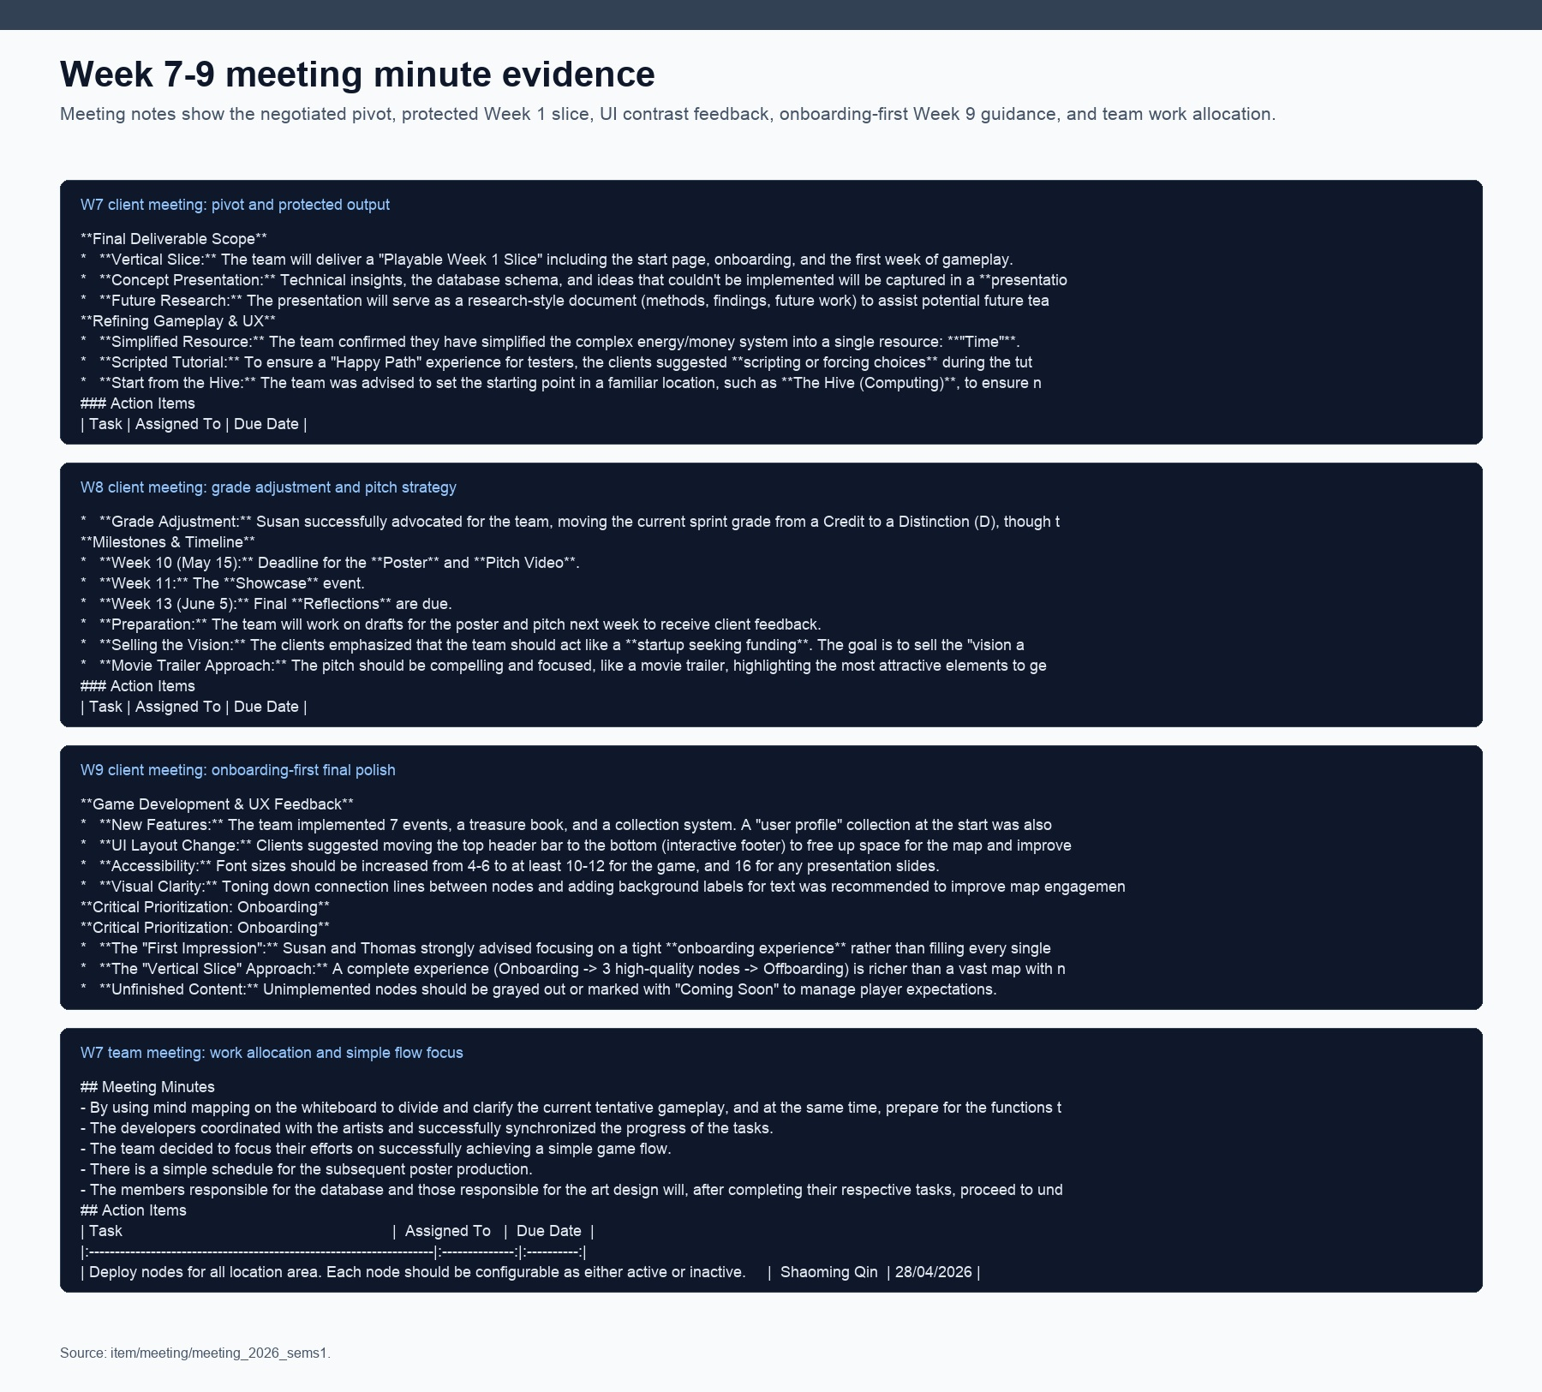
Figure 2. Week 7-9 meeting evidence showing client feedback, negotiated pivot, onboarding-first guidance, and internal task allocation.
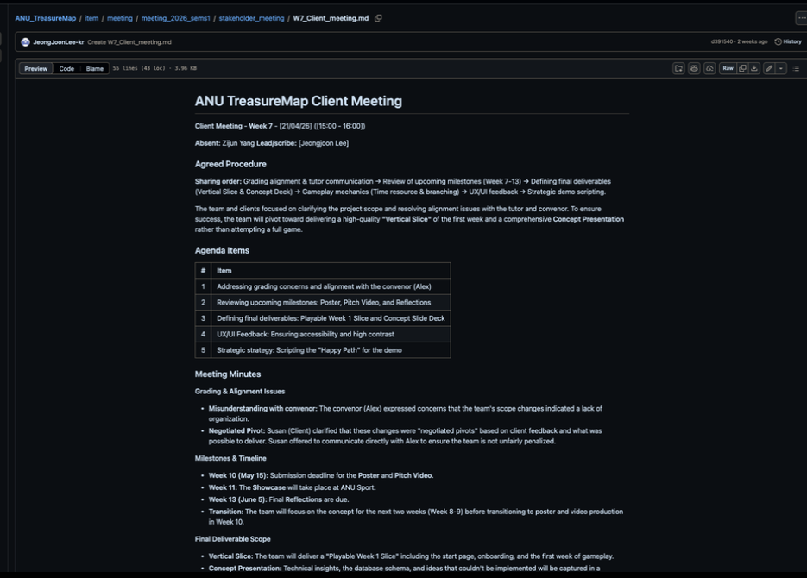
Figure 2A. Actual GitHub screenshot of W7_Client_meeting.md showing the negotiated pivot, playable Week 1 slice, UI contrast feedback, and happy-path strategy.
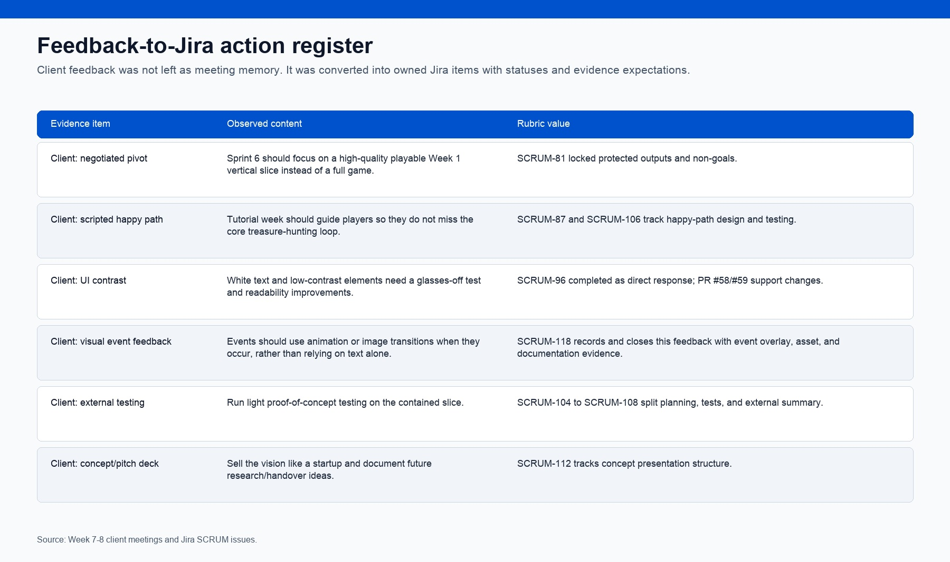
Figure 3. Feedback-to-Jira action register showing client feedback converted into owned Jira tasks.
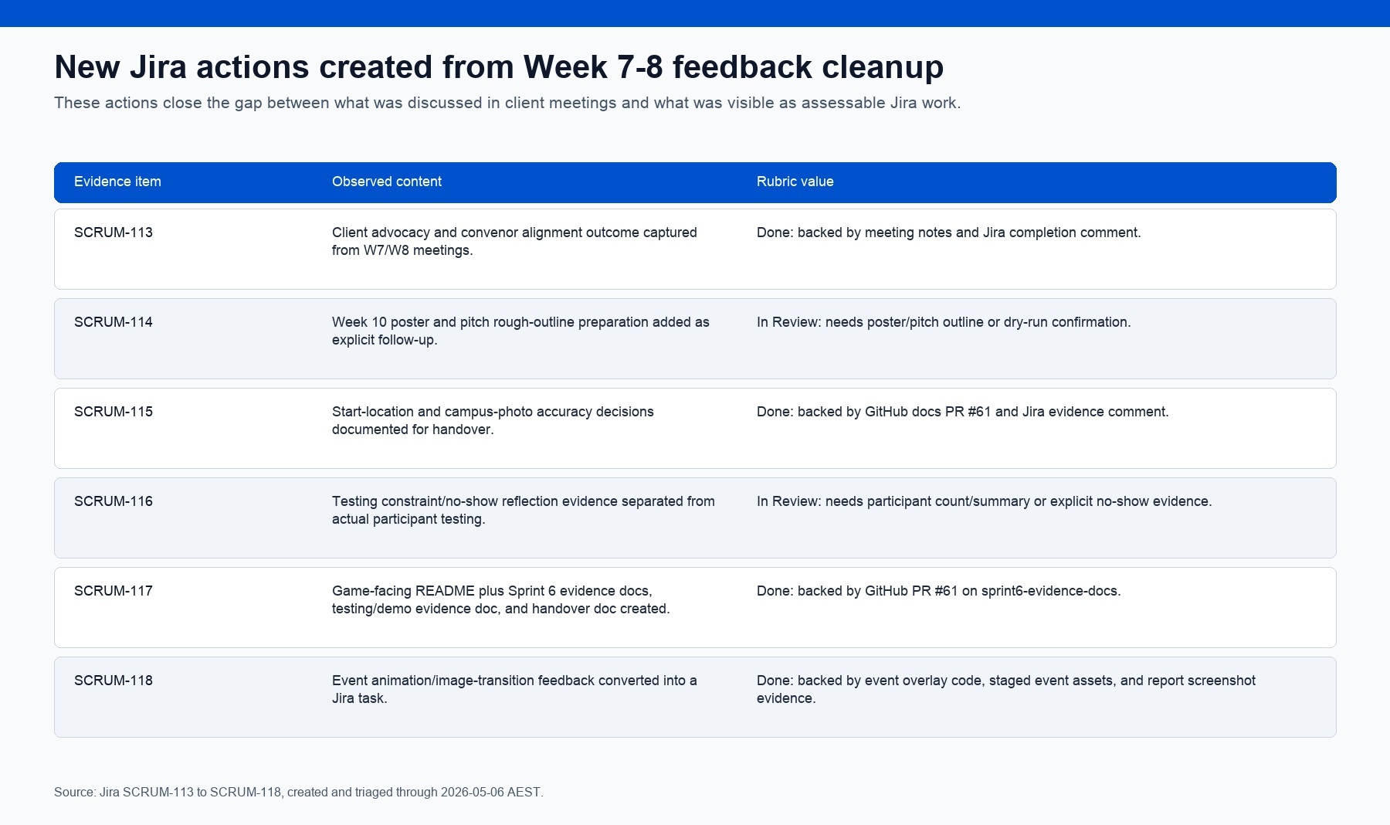
Figure 4. New Jira actions created from Week 7-8 client feedback that was not previously explicit enough in Jira.
The client also helped clarify that the scope change should be understood as a negotiated pivot rather than a sign of disorganisation. That is important evidence because it connects stakeholder management with assessment risk management: the team was not simply reducing ambition; it was protecting a higher-quality, demonstrable slice with client support.

2. Planning and Organisation
Planning in Sprint 6 is substantially stronger than in Sprint 5 because the team created a more explicit operating model around Jira. The backlog is not a loose task list: it shows protected outputs, owners, estimates, MoSCoW priority, risk/dependency tracking, test tasks, build evidence tasks, and a velocity review. After cleanup, report-scoped evidence-backed work is Done, while user-dependent demo/testing/pitch evidence remains clearly separated as In Review. The live Jira board still shows some sprint-board work open, so the report treats those items as visible Week 9/evidence dependencies rather than pretending the board is fully closed.
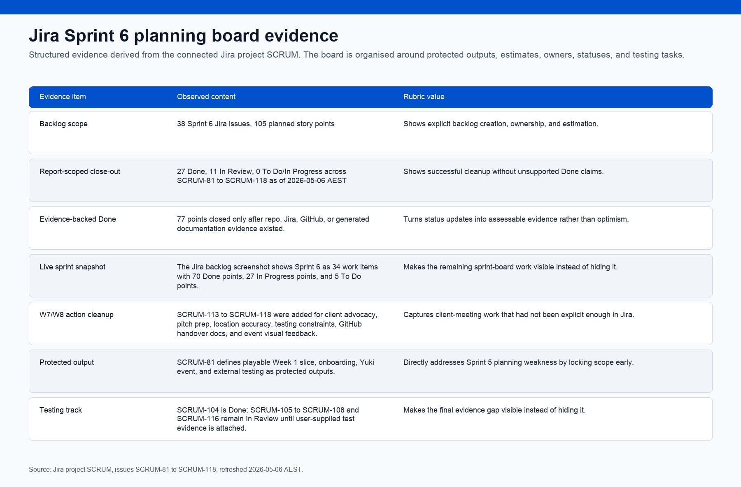
Figure 5. Jira planning summary showing protected output, estimates, owners, and final evidence-cleaned status.
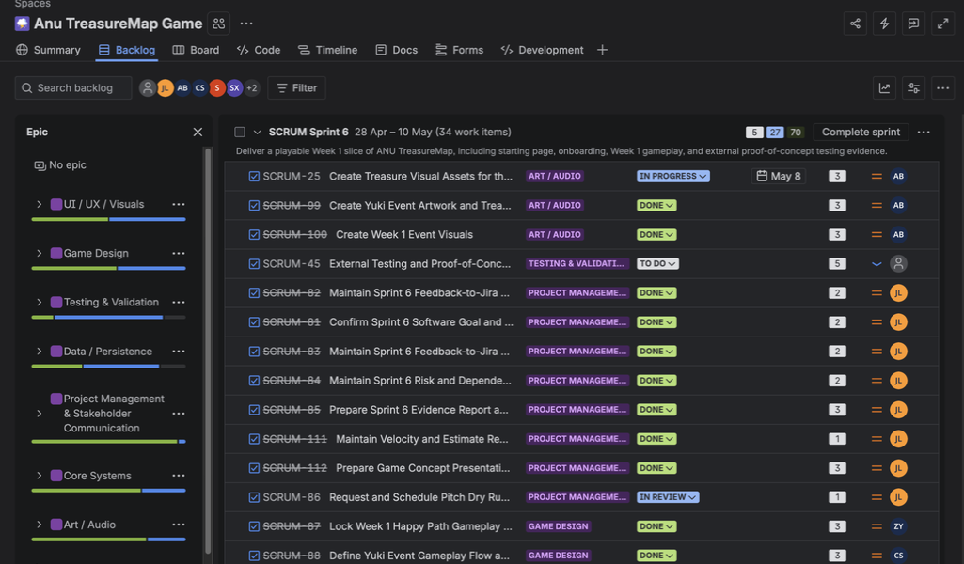
Figure 6. Actual Jira Sprint 6 backlog screenshot showing sprint dates, work-item count, point status, owners, estimates, and issue statuses.
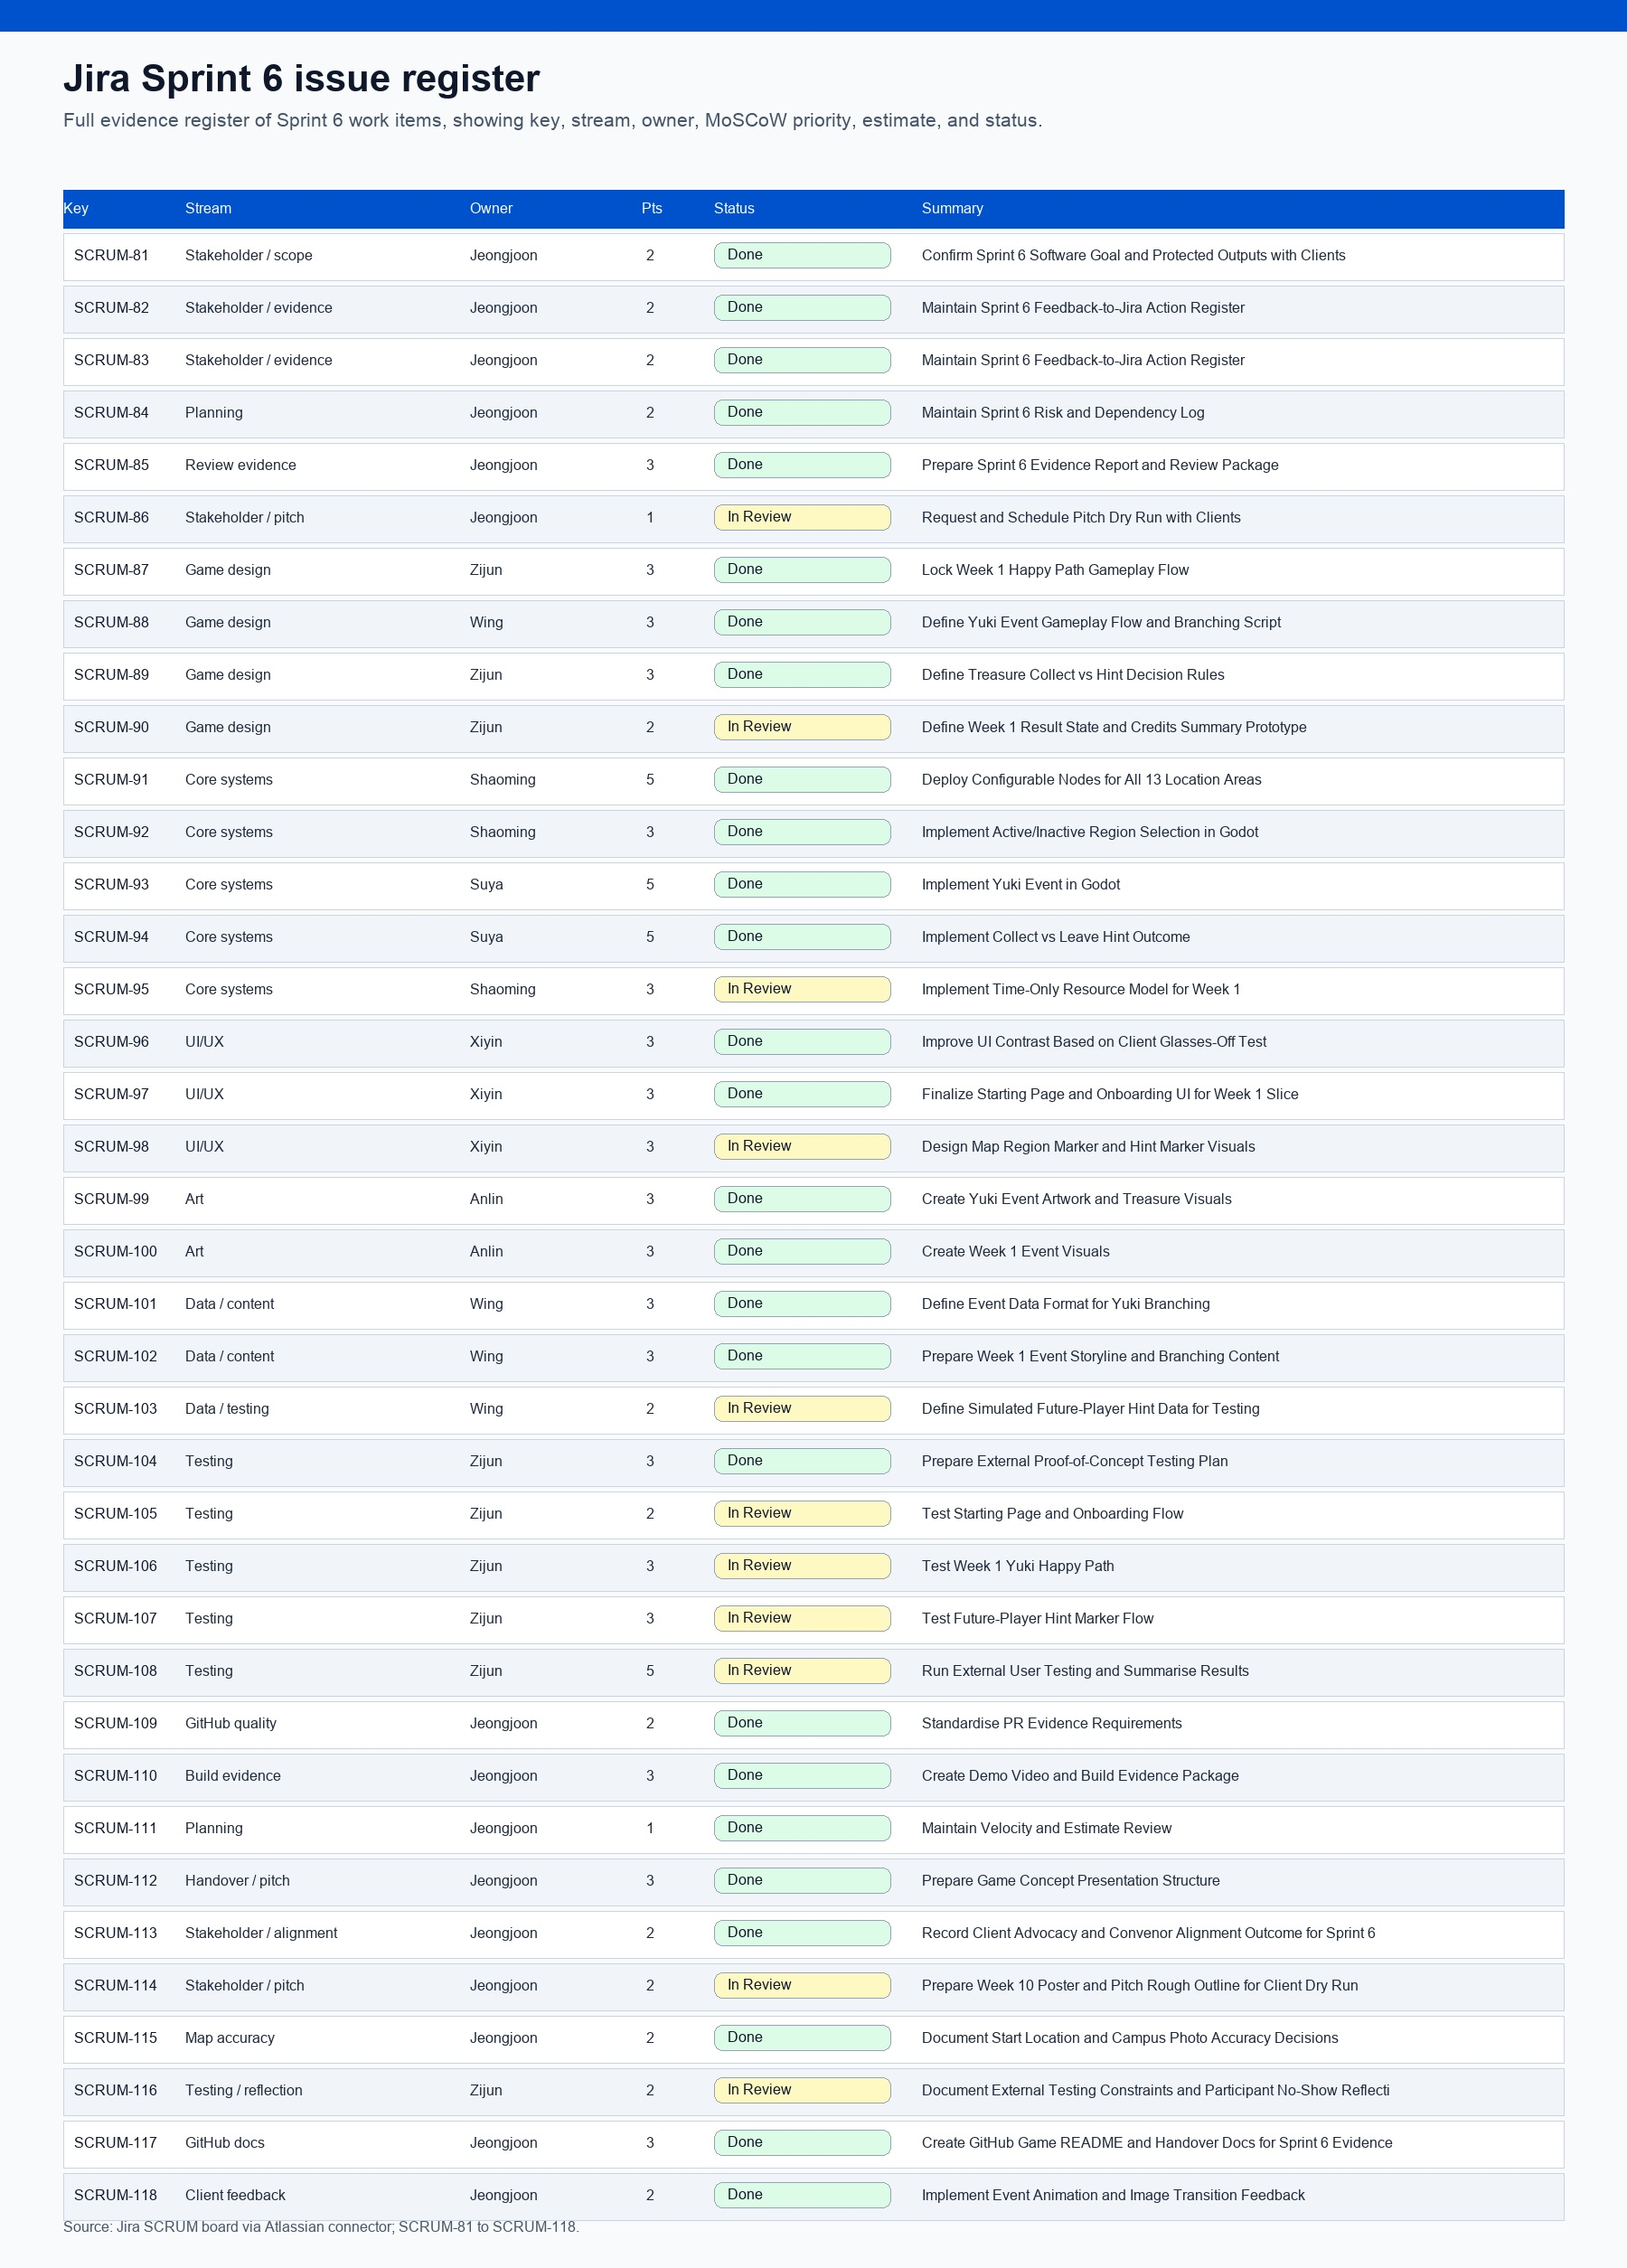
Figure 7. Full Sprint 6 Jira issue register embedded for single-file evidence review.
The key planning improvement is that Sprint 6 explicitly separates what must be protected from what can be documented as future work. The protected output is the playable Week 1 slice: start page, onboarding, Week 1 map flow, Yuki event, collect-or-hint decision, and light external testing. The broader ideal version is captured through concept and handover work rather than being allowed to destabilise the implementation sprint.
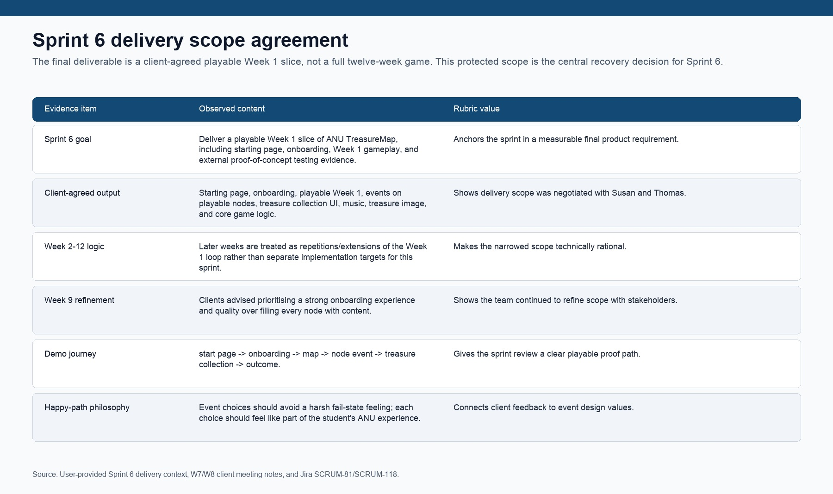
Figure 7A. Client-agreed Sprint 6 delivery scope: playable Week 1 slice and repeatable Week 2-12 logic.
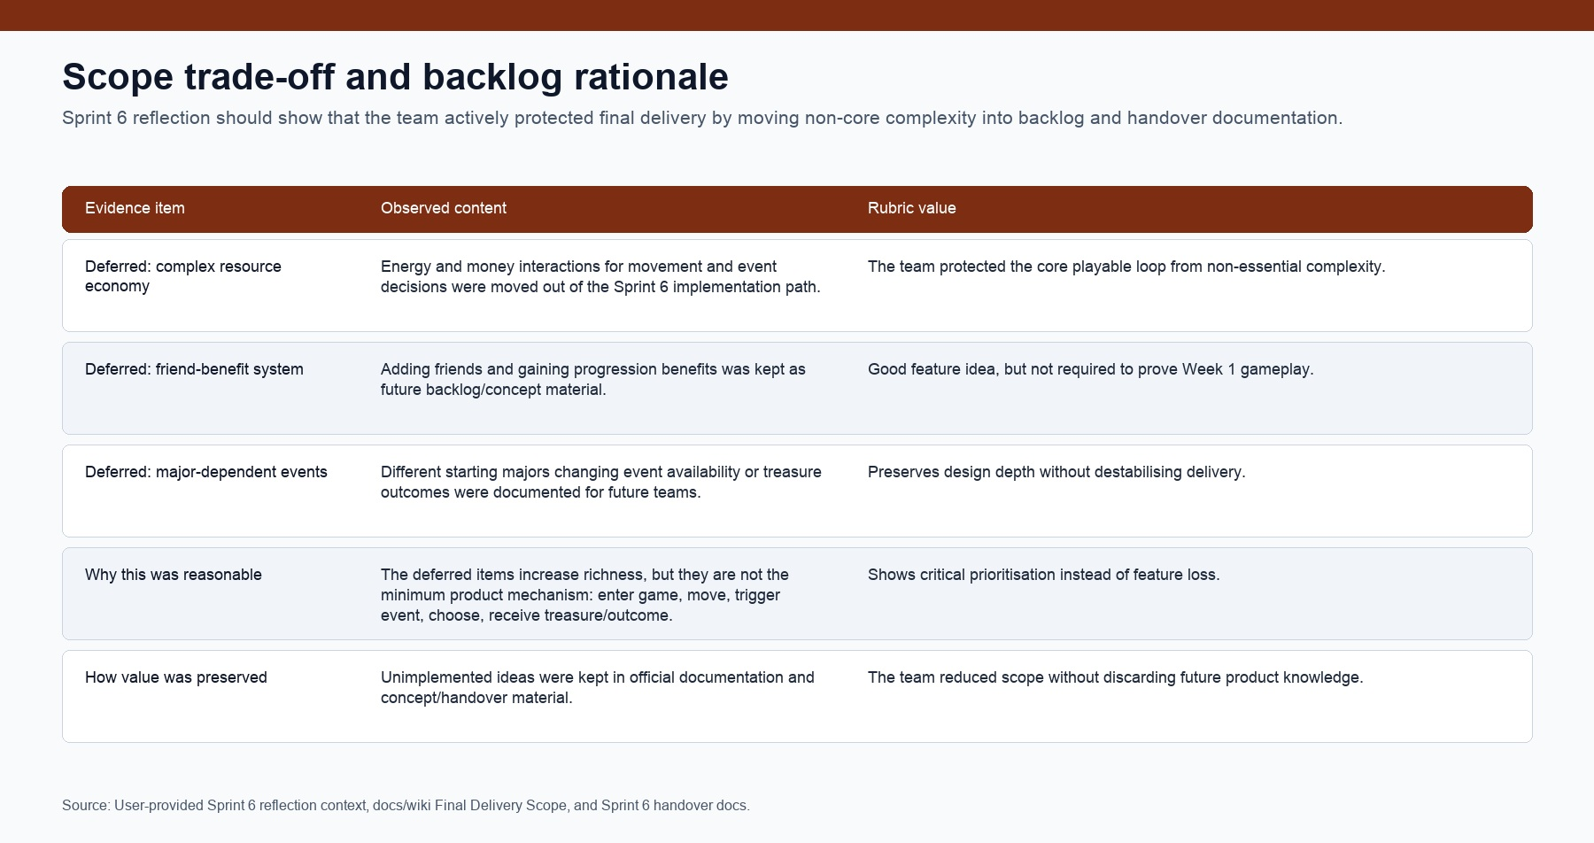
Figure 7B. Scope trade-off evidence showing why complex resource, friend, and major-dependent systems were moved to backlog/handover.

3. Execution and Quality
Execution evidence is strongest in GitHub and the running Godot build. The Sprint 6 period includes merged PRs for map and location work, UI contrast and font adjustments, phone interaction, event content, Yuki/Kangaroo random event logic, meeting-note evidence, and ongoing format/quality workflow activity. PR #61 is now merged for the game-facing README and Sprint 6 evidence docs, while PR #64 adds the item-by-item checklist closure matrix.
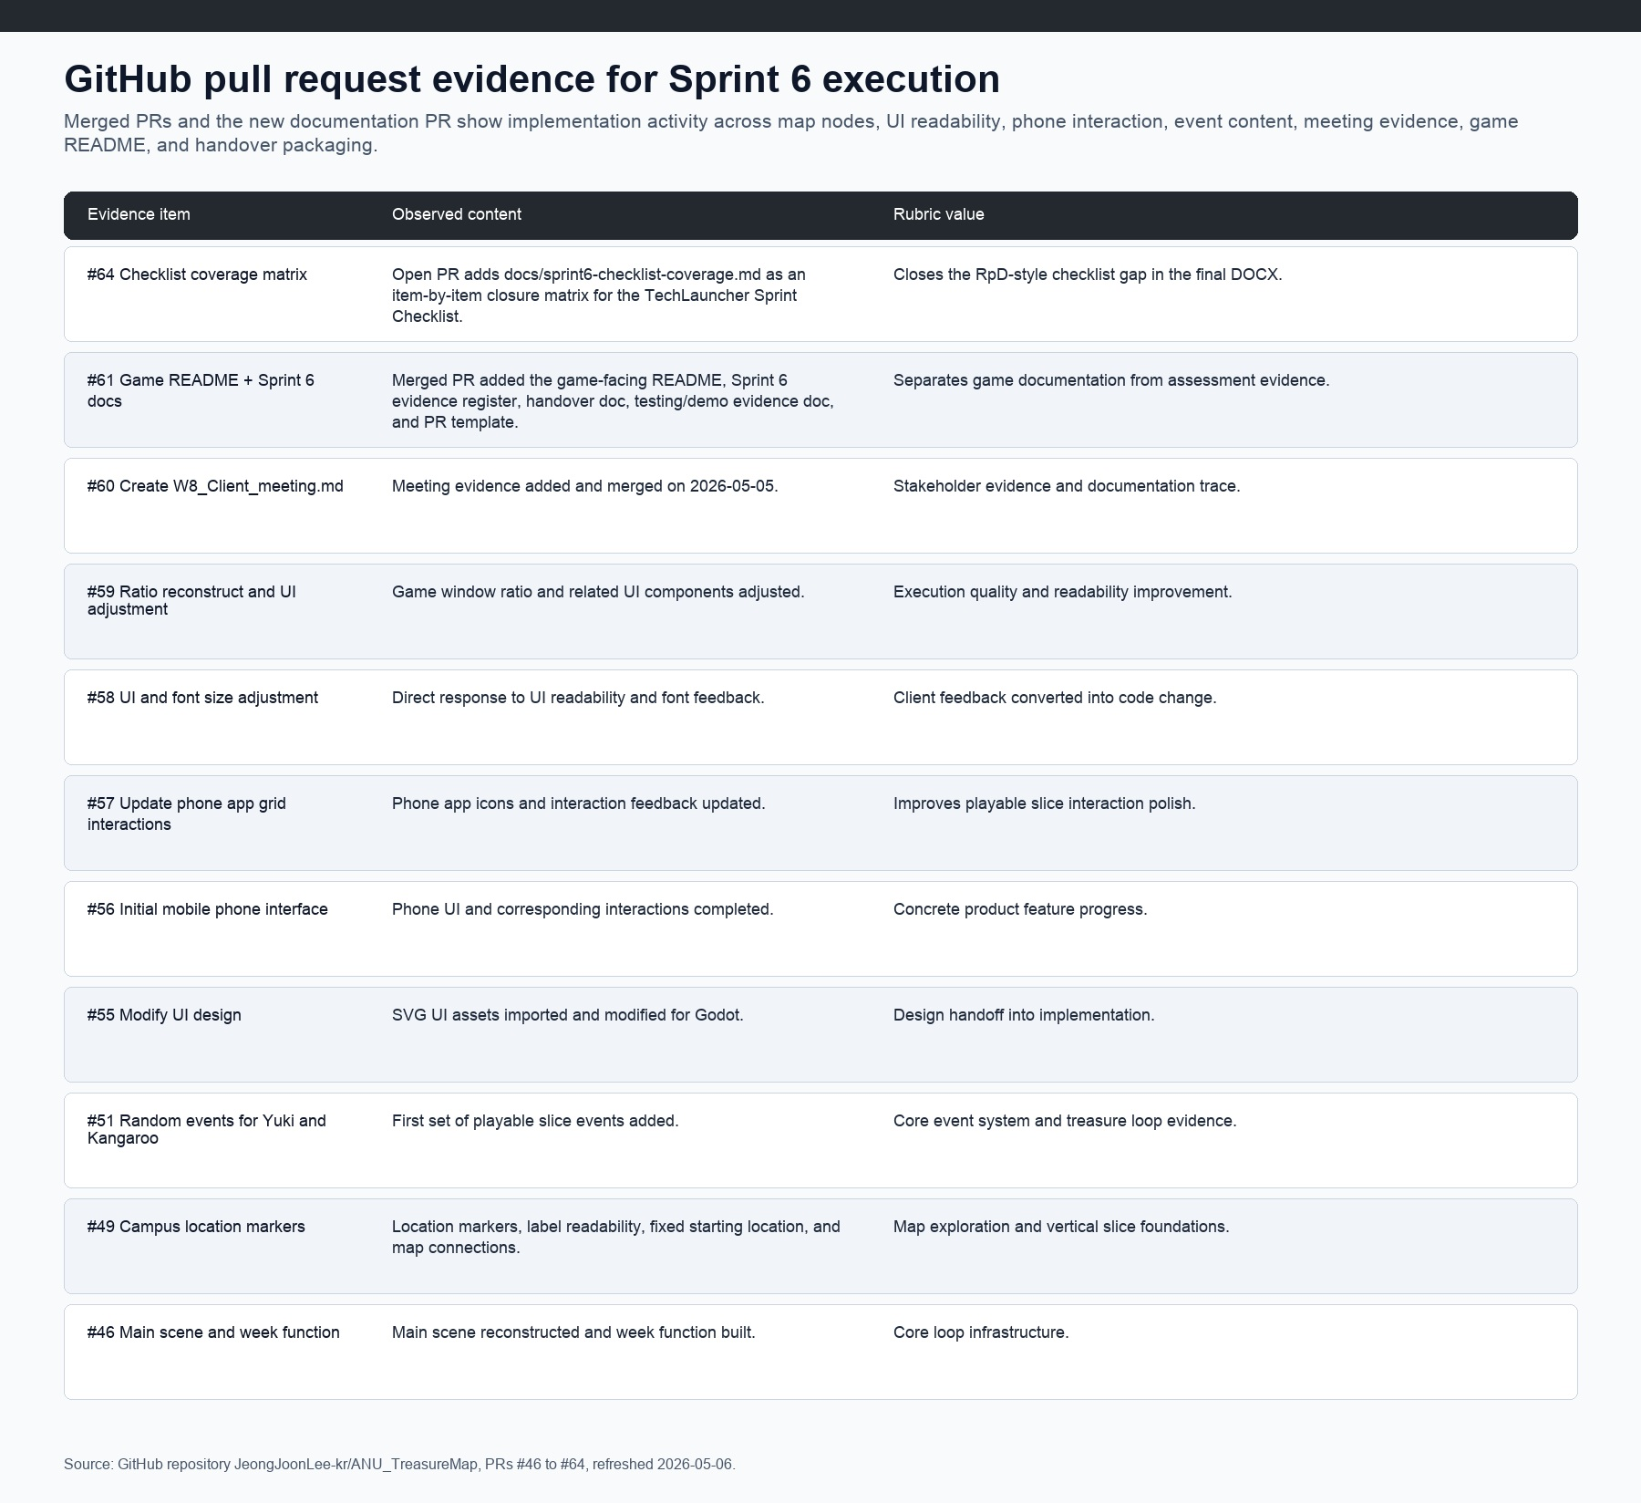
Figure 8. GitHub PR evidence showing Sprint 6 execution across map, UI, phone, event, documentation, and checklist work.
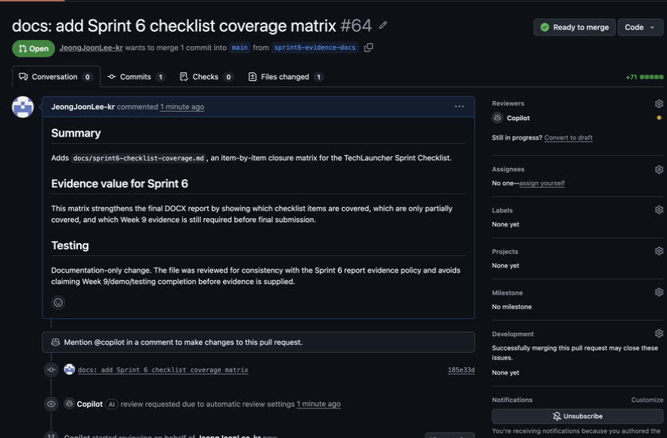
Figure 9. Actual GitHub PR #64 screenshot showing the Sprint 6 checklist coverage matrix PR ready for review/merge.
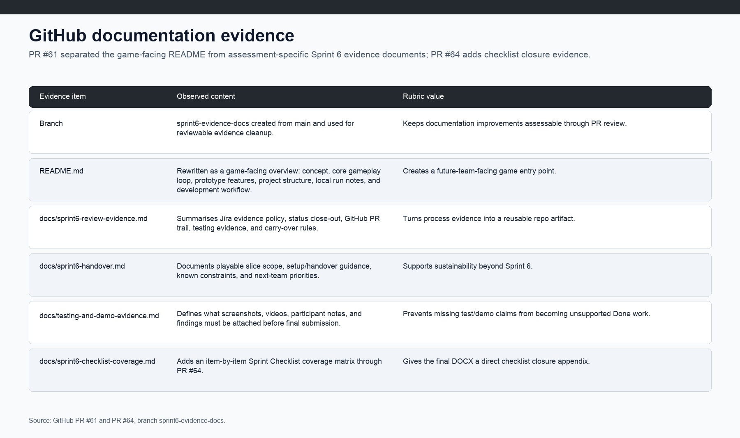
Figure 10. GitHub documentation evidence showing the game-facing README separated from Sprint 6 evidence documents.
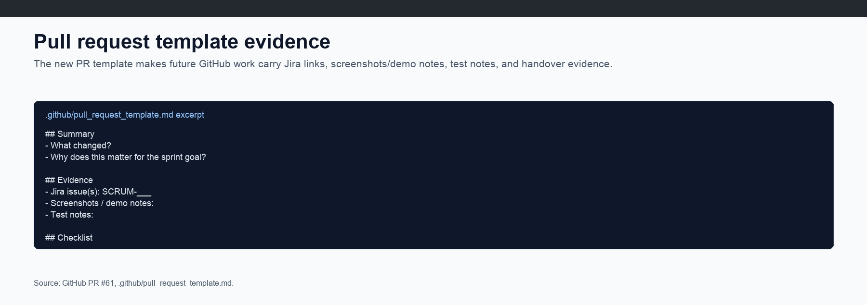
Figure 11. Pull request template evidence requiring Jira links, screenshots/demo notes, tests, and handover updates.
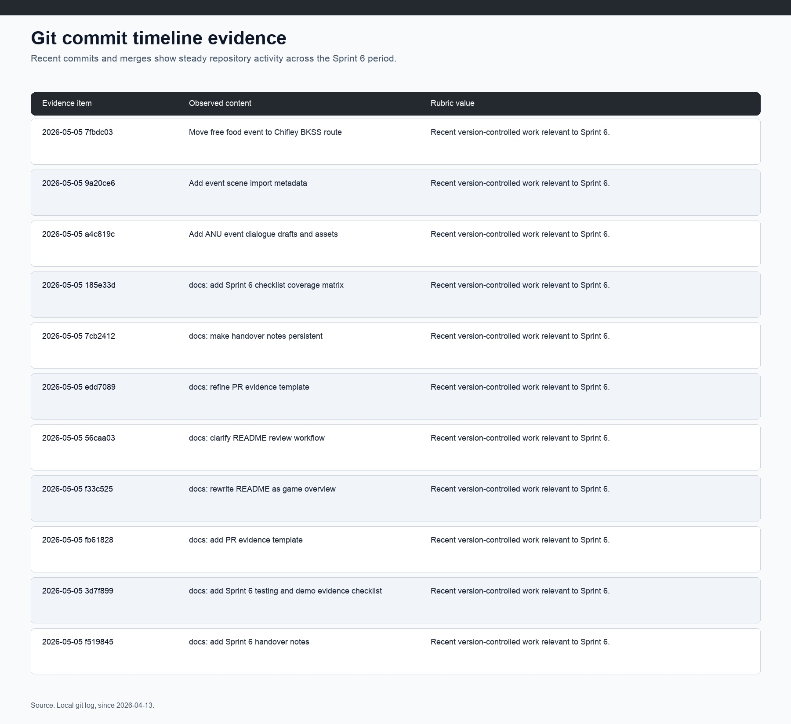
Figure 12. Git commit timeline for recent Sprint 6 repository activity.
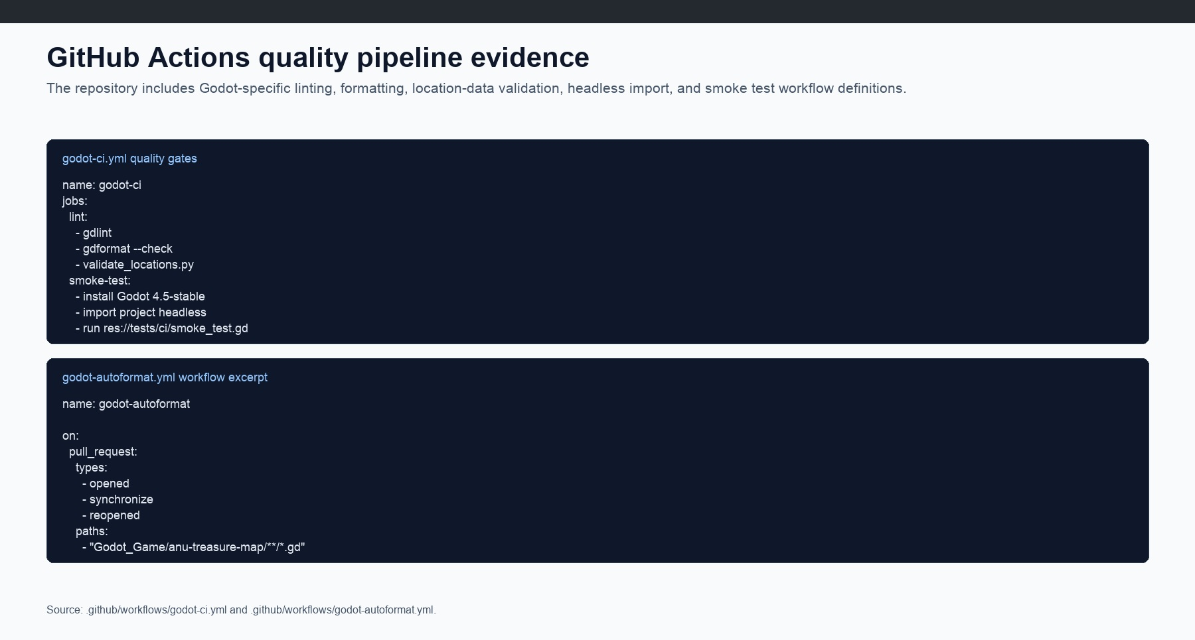
Figure 13. GitHub Actions workflow evidence for lint, formatting, location validation, and smoke testing.
A live product screenshot is now available: Computer Use captured the running Godot debug build with the Week 1 map, status HUD, location network, Bruce Hall marker, and Next Week control. This is real build evidence, not a mock-up. It does not yet replace the Week 9 demo-flow evidence still needed for start page, onboarding, Yuki choice, collect/hint choice, and outcome state.
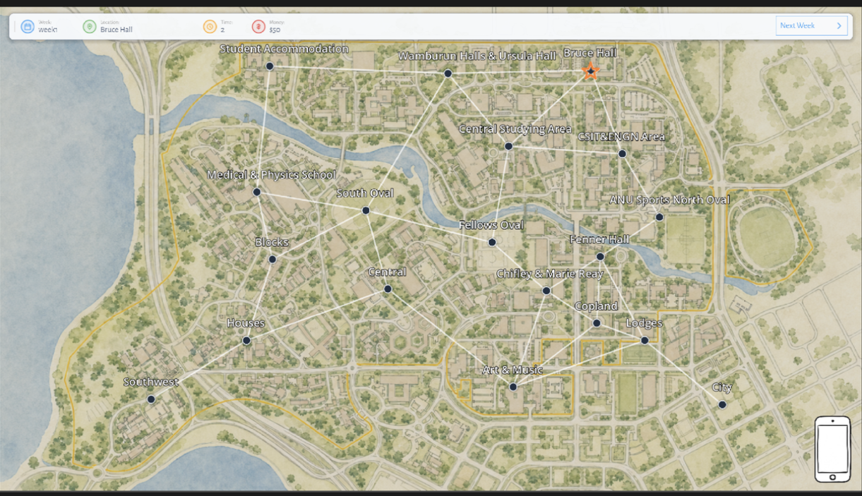
Figure 14. Actual running Godot debug build screenshot showing the playable Week 1 ANU campus map slice.
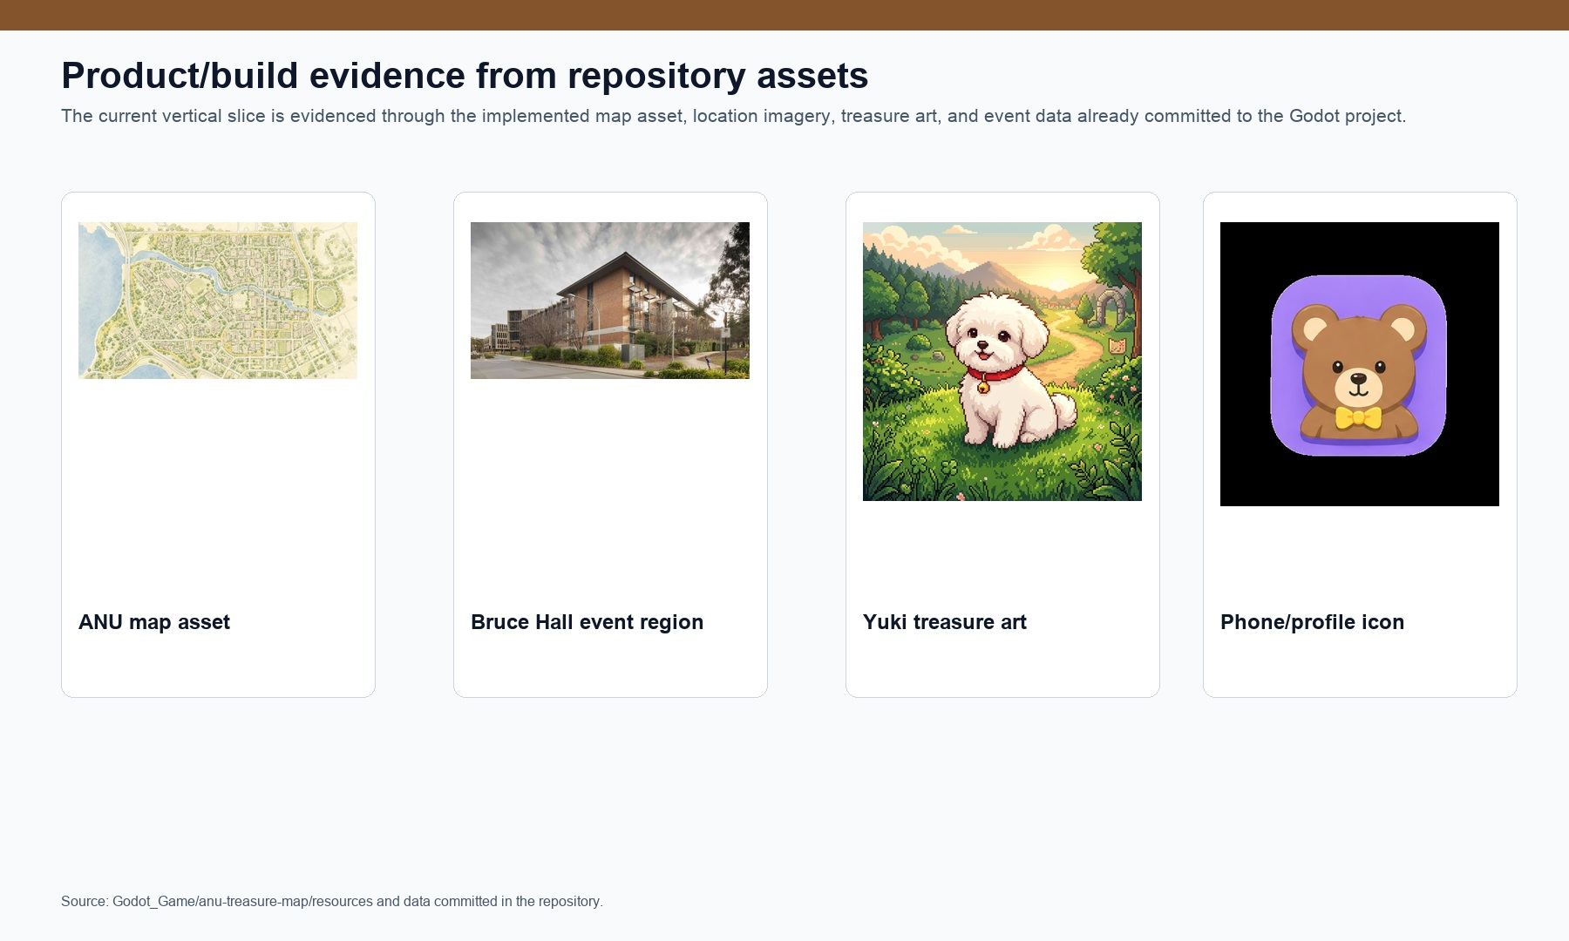
Figure 15. Repository product/build evidence from committed Godot assets.
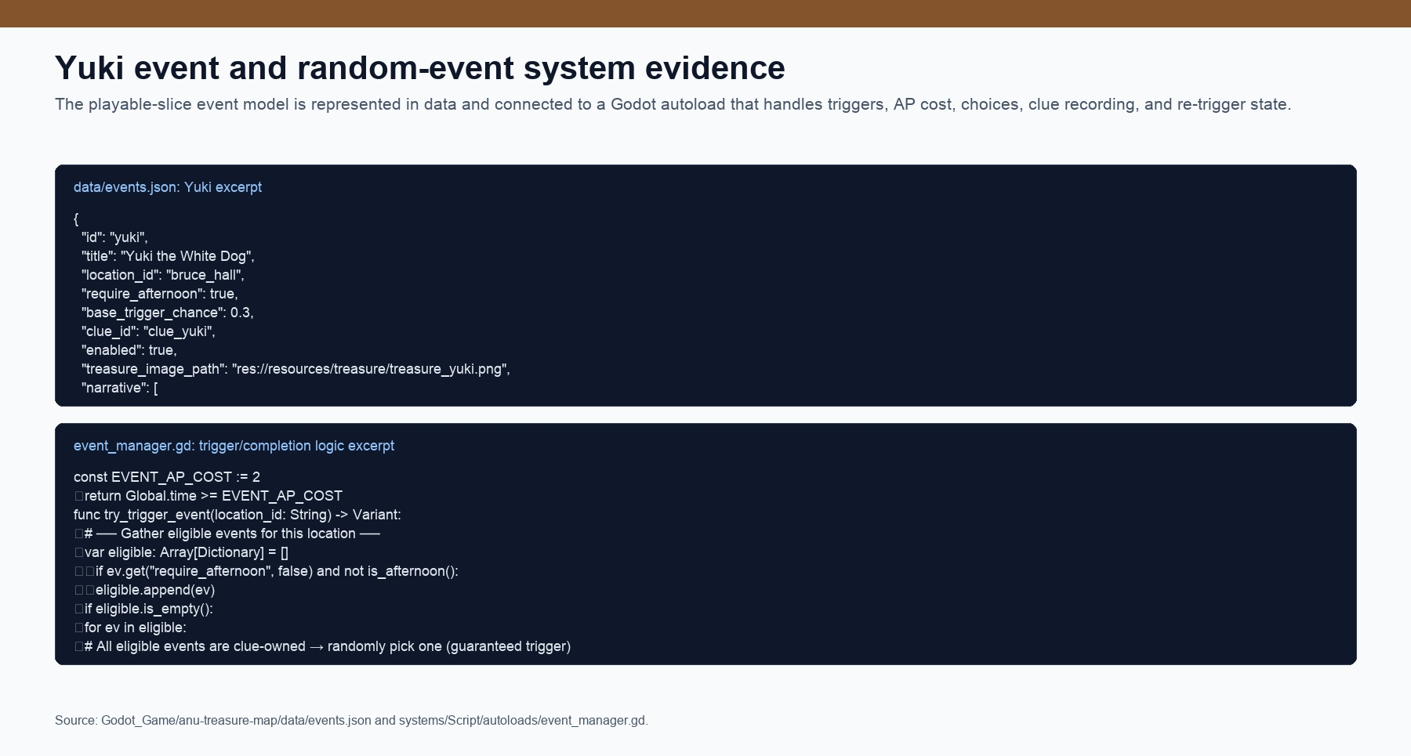
Figure 16. Yuki event data and EventManager implementation evidence.
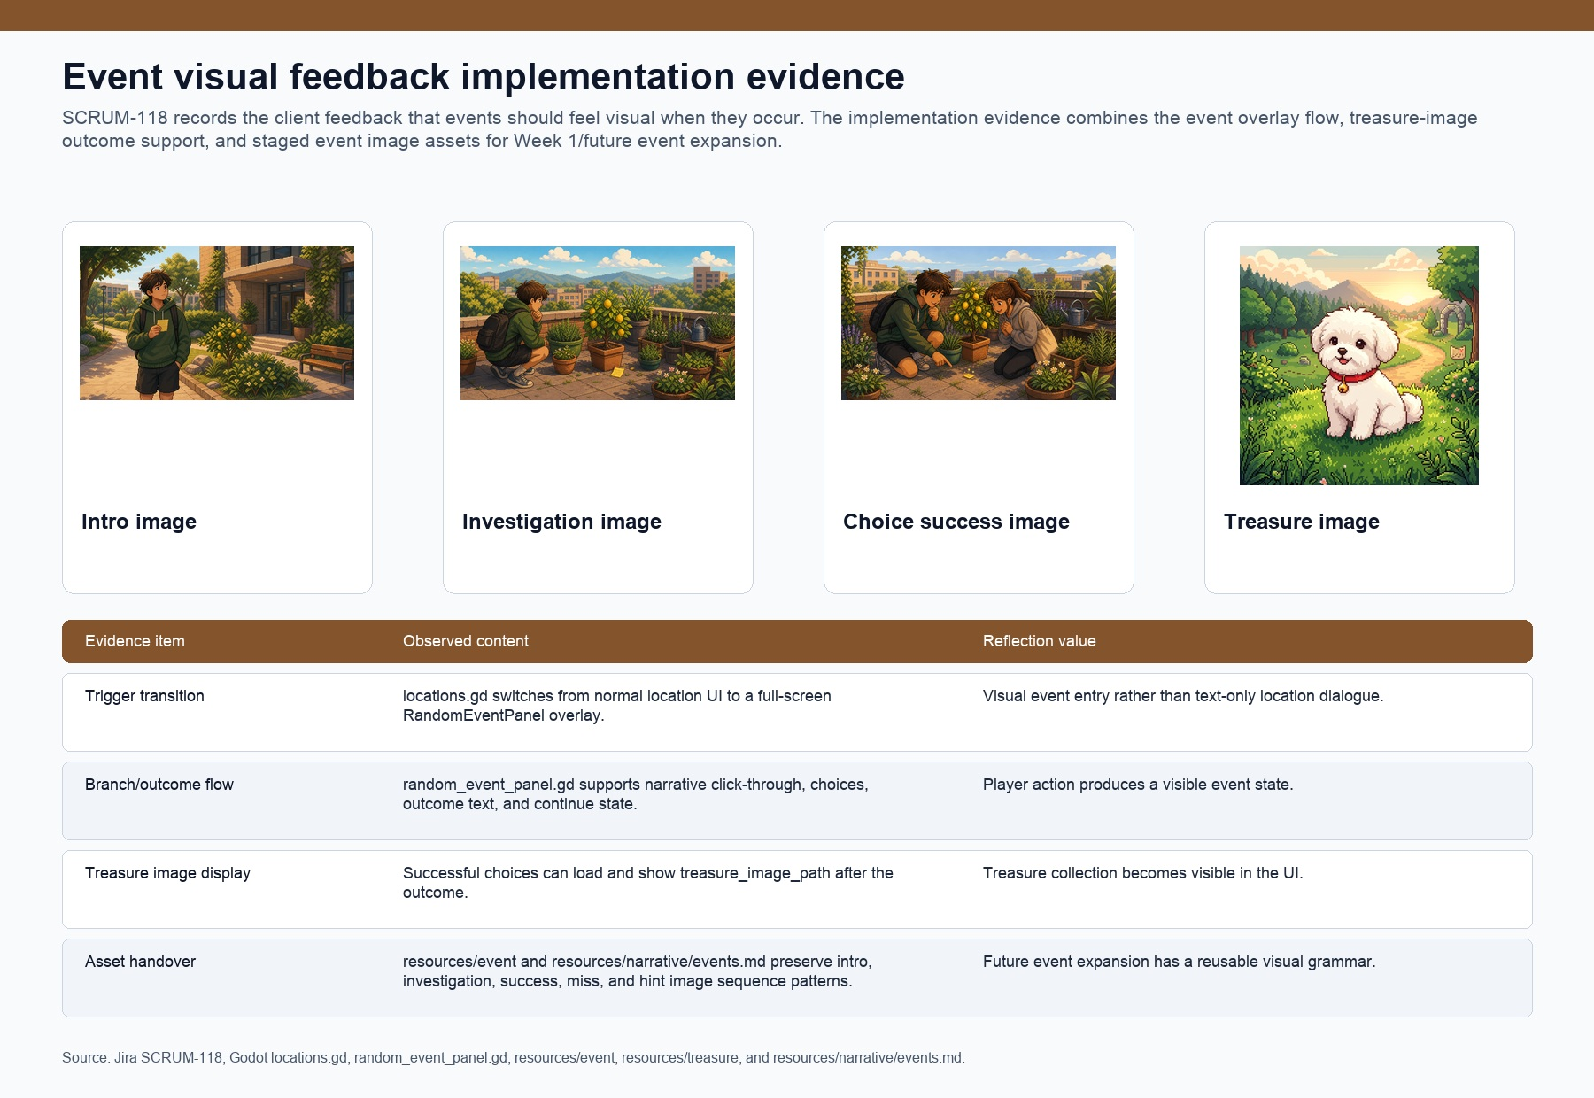
Figure 16A. Event visual feedback evidence connecting SCRUM-118 to overlay flow, image sequence assets, and treasure image display.
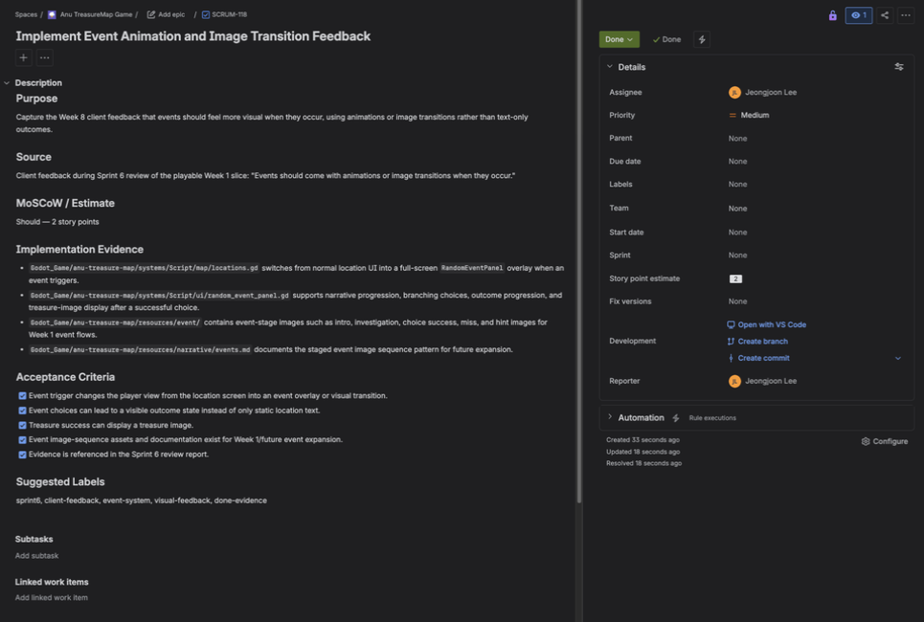
Figure 16B. Actual Jira screenshot showing SCRUM-118 Done with acceptance criteria and implementation evidence.

4. Reflection and Improvement
The reflection story for Sprint 6 is not that the team suddenly avoided all uncertainty. It is that the team learned how to convert uncertainty into negotiated scope, visible Jira work, and a playable proof path. Sprint 5 was difficult because the project pivot and the client's paper-prototype expectation placed real pressure on the team's limited resources. The important reflective point is that the scope reduction was not decided privately by the team; the W7 client evidence records it as a negotiated pivot based on client feedback and what was possible to deliver.
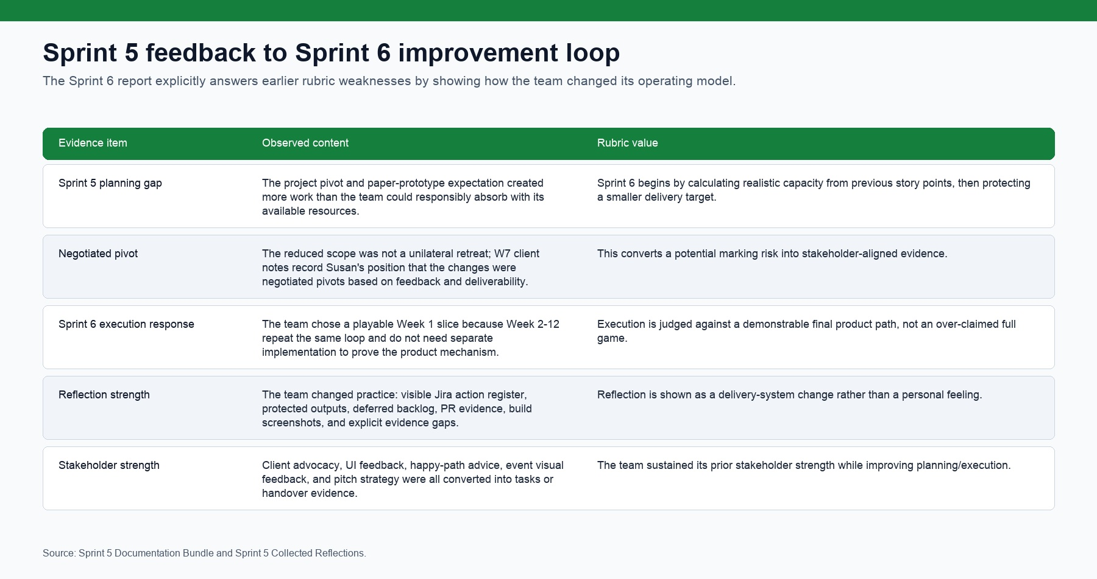
Figure 17. Sprint 5 feedback mapped to Sprint 6 process improvements.
At the start of Sprint 6, the team listed the work that would be required for the sprint, compared it with the story-point load the team had actually managed in the previous period, and used that capacity estimate to prioritise Must and Should work. The team then presented the realistic delivery plan to the clients. This changed the planning pattern: instead of beginning with a broad ideal product and cutting late, Sprint 6 began with a protected Week 1 slice that the clients accepted as a meaningful final delivery path.
The Week 1 focus was decided in the Week 7 internal planning discussion after the team considered realistic workload and cross-functional dependencies. This decision mattered because Week 2 through Week 12 use the same gameplay logic as Week 1. By proving Week 1 well, the team could demonstrate the product mechanism without forcing twelve weeks of duplicated content into a three-week sprint. Features such as energy/money interaction complexity, friend-based benefits, and major-dependent event paths were moved into backlog and concept documentation because they increase richness but are not required to prove the core loop.
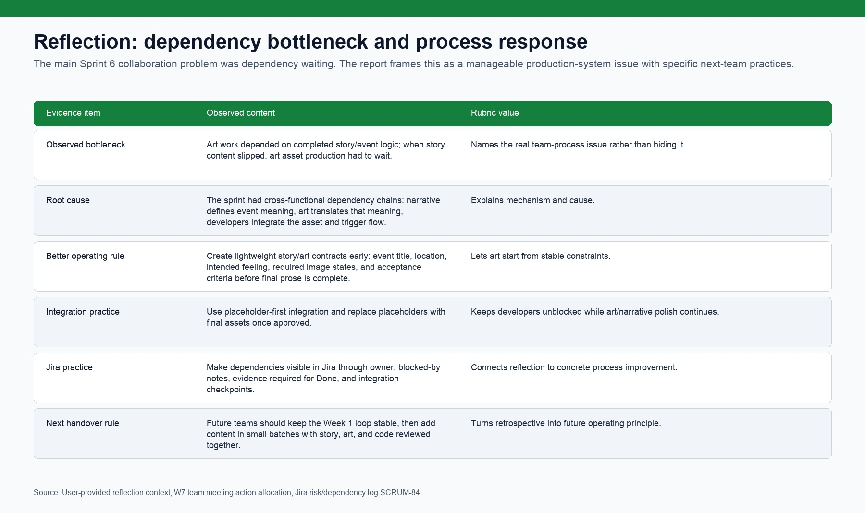
Figure 18. Dependency bottleneck reflection and future operating practices.
The major collaboration challenge was dependency waiting. Art production depended on story and event logic being clear enough to guide image generation; when narrative decisions moved slowly, art could not confidently start. The strongest rubric response is not to blame one stream, but to show the production mechanism and the process change: future work should use early story/art contracts, placeholder-first integration, explicit blocked-by notes in Jira, and short integration checkpoints so narrative, art, and code can move in parallel.
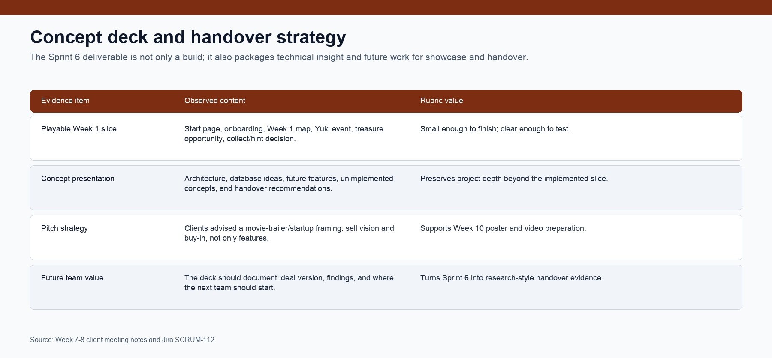
Figure 19. Concept deck and handover strategy preserving the broader project vision.
This is why the Sprint 6 grade case can aim above the previous planning and execution result. The team is not asking for credit on aspiration alone: the evidence shows a changed process, narrower scope control, more explicit ownership, direct feedback-to-Jira conversion, and a stronger trail between client feedback and deliverable work. Individual reflection evidence is still expected later, but the team-level reflection now has the mechanism, cause, response, and future rule that the HD sample uses well.

Appendix: Full Evidence Pack
This appendix is included because the final submission is expected to stand alone as a single DOCX. The images below are deliberately embedded so the marker can assess the evidence without opening Jira, GitHub, or the repository.
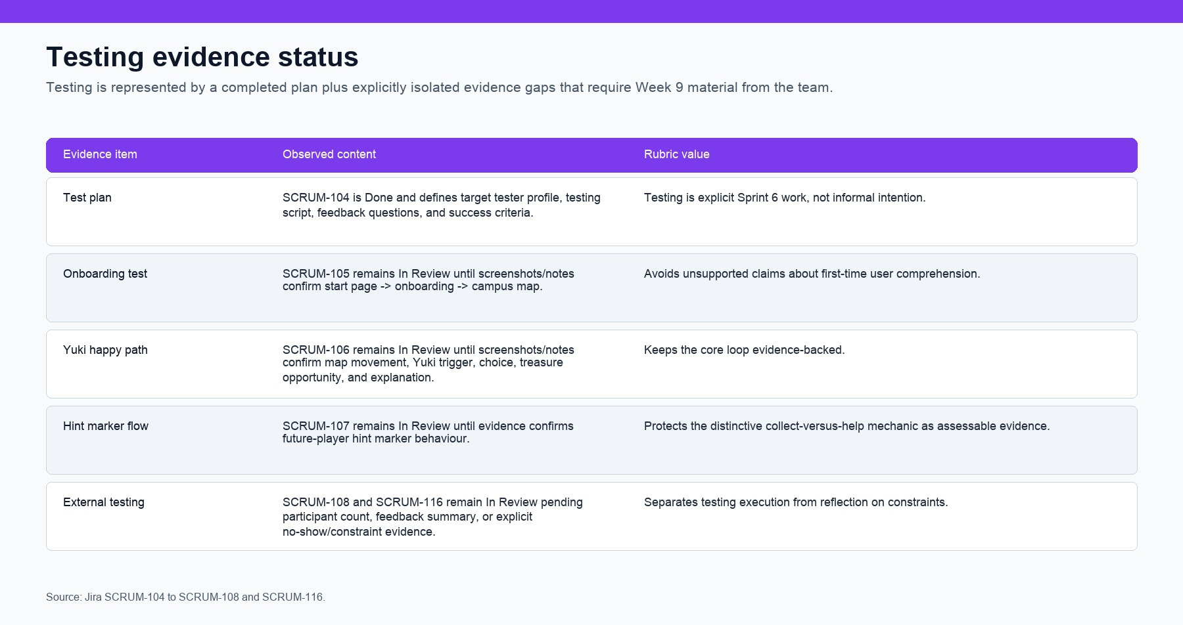
Figure 20. Testing plan and Week 9 external proof-of-concept evidence status.
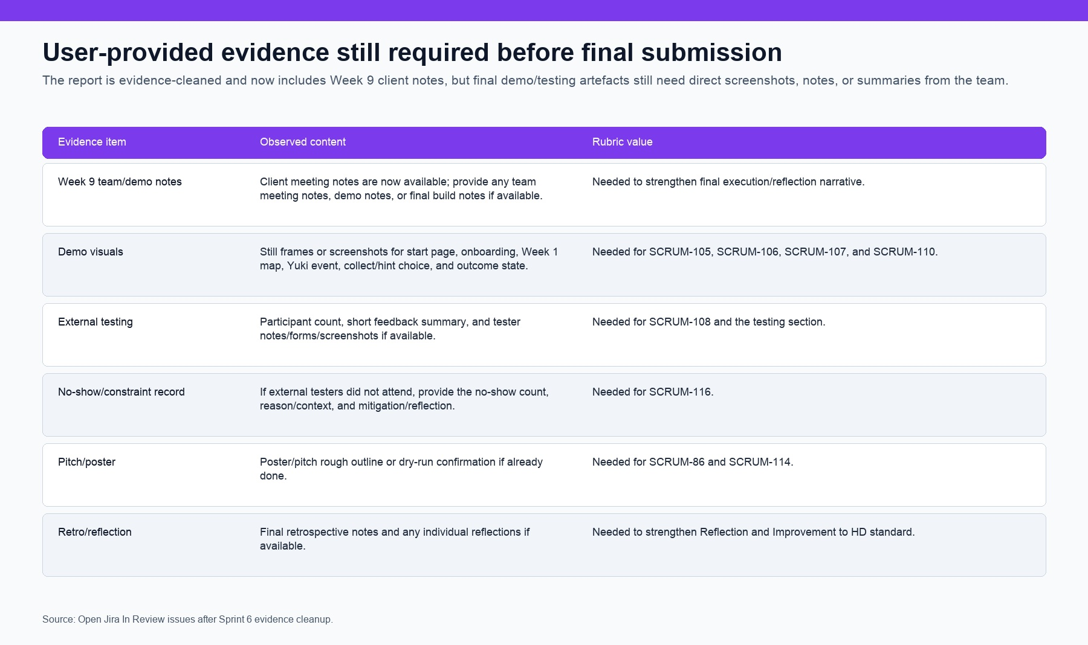
Figure 21. User-provided evidence still required before the report can be treated as fully evidence-closed.

Checklist Item Closure Matrix
The following four figures close the TechLauncher Sprint Checklist directly, item by item. This mirrors the HD sample's habit of making the marker's checklist work easy: each item is either Covered, Partially covered, or left as Week 9/user evidence.
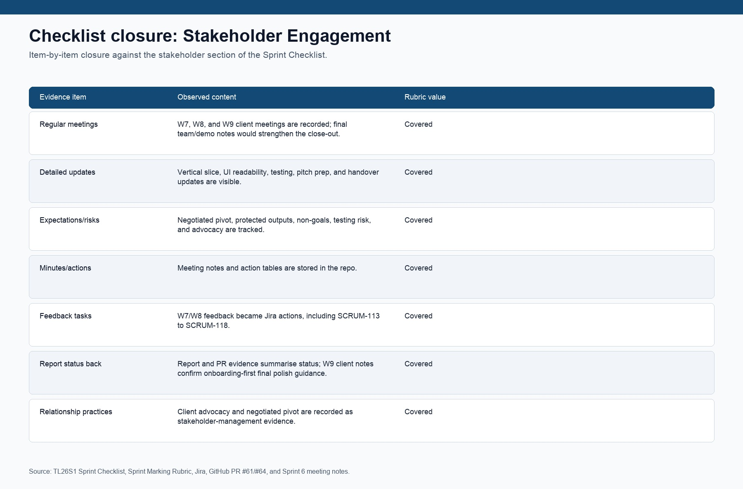
Figure 22. Stakeholder Engagement checklist closure matrix.
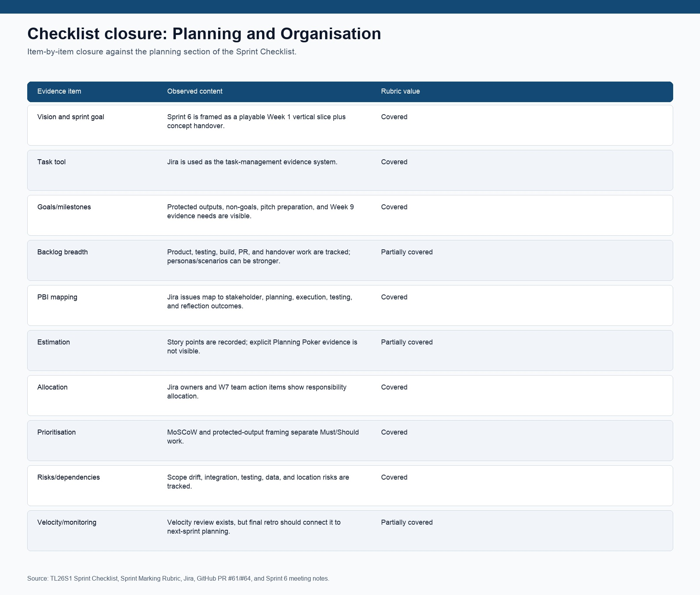
Figure 23. Planning and Organisation checklist closure matrix.
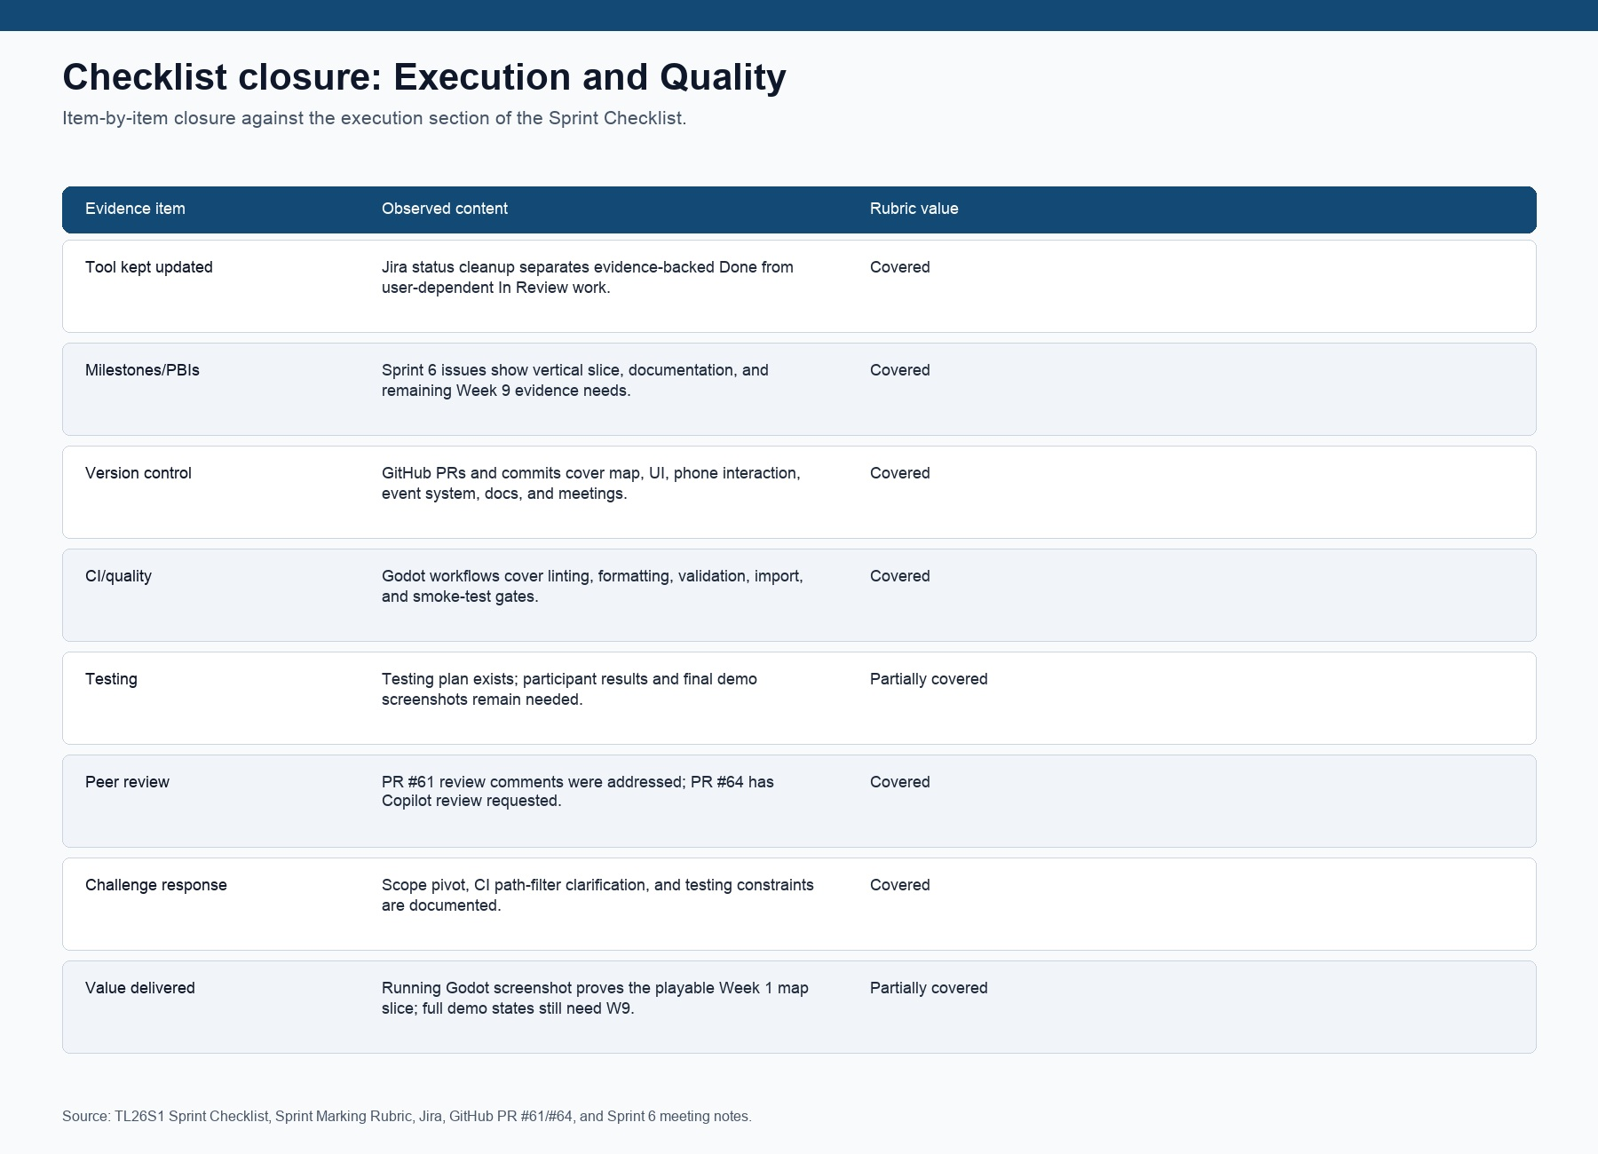
Figure 24. Execution and Quality checklist closure matrix.
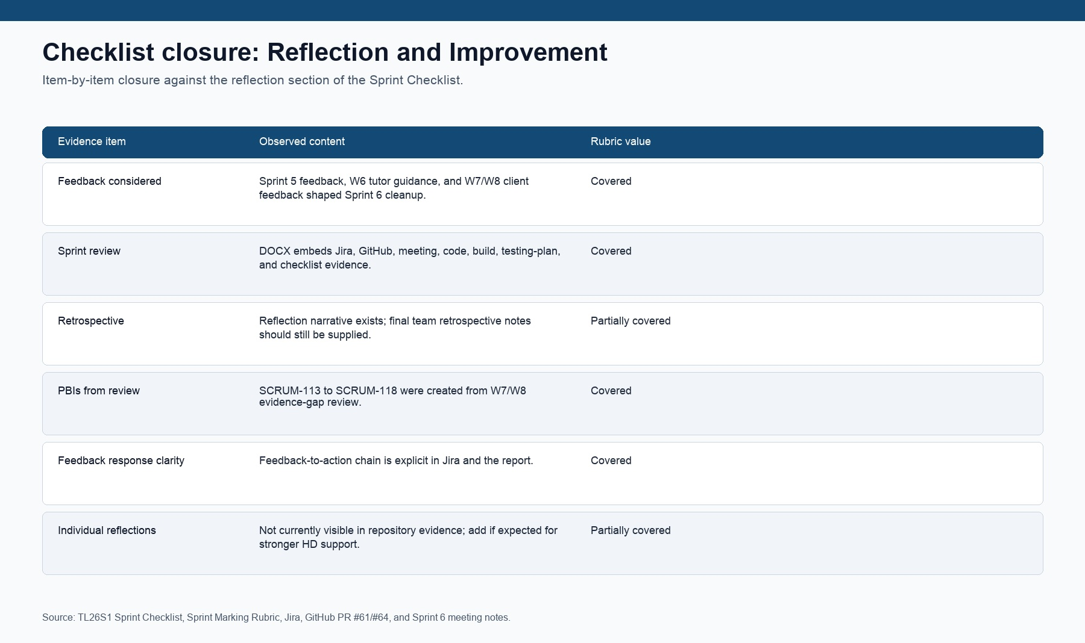
Figure 25. Reflection and Improvement checklist closure matrix.

Final Evidence Close-Out Status
This report now reflects the Jira and GitHub cleanup requested for Sprint 6: missing Week 7-8 feedback actions were created, Week 9 client notes were added to the evidence base, evidence-backed Jira issues were closed, SCRUM-110 was closed after a real Godot build screenshot was captured, SCRUM-118 was created and closed for event animation/image-transition feedback, unsupported testing/pitch work was left In Review, PR #61 was merged for the game README and Sprint evidence documentation, and PR #64 was opened for checklist closure. The remaining evidence gap is deliberately narrow and user-dependent: full demo screenshots or video frames, external-testing results or no-show reflection, pitch/poster confirmation, and final retrospective/individual reflections. Those items should be inserted as final embedded evidence before submission.

