**Deep Learning Project 1**

**2018320260**

**컴퓨터학과 류정주**

1. About My Code

-> In forward pass part, I implemented Relu using for loop, not np.maximum. I also implemented Exponential to scores, make softmax matrix, Log likelihood loss and total loss with L2 regularization Loss.

In backward pass, I found gradient W1, W2, b2, b1 using chain rule.

In training, exploit size 200 batch from toy_data, update weight and bias using gradient above.

In predict , store the result of prediction of my model to y_pred.

2. Result

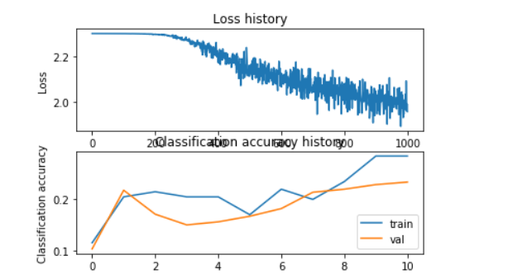

**+)** **Inline Question**

**Answer: 1,3**

**Explanation** : if we add more hidden units, the model will be more complex, causing ‘overfitting’ problem, but large dataset can make the model more accurate, and increasing regularization strength can prevent the overfitting problem.

3. Discussion

-> I have used python in artificial intelligence class, but This is the first time I have used numpy, so It is hard to understand the systax, function of numpy. But putting many time in this project, I have been adopted at numpy more than before.