Assignment 1

2017113547 이정근

소스코드 : rotation_bw.py

import cv2

import numpy as np

def transform(img, angle): # forward transformation

height, width = img.shape

result = np.zeros((height, width), np.uint8) # result image

affine = np.array([[np.cos(np.radians(angle)), -np.sin(np.radians(angle)), 0],

[np.sin(np.radians(angle)), np.cos(np.radians(angle)), 0],

[0, 0, 1]]) # Affine transformation matrix

for x in range(width):

for y in range(height):

p = affine.dot(np.array([x, y, 1]))

xp = int(p[0])

yp = int(p[1])

if 0 <= yp < height and 0 <= xp < width:

result[yp, xp] = img[y, x]

return result

def backward_map(in_image, out_image, angle):

height, width = out_image.shape

result = np.zeros((height, width), np.uint8)

affine = np.array([[np.cos(np.radians(angle)), -np.sin(np.radians(angle)), 0],

[np.sin(np.radians(angle)), np.cos(np.radians(angle)), 0],

[0, 0, 1]]) # Affine transformation matrix

inverse_affine = np.linalg.inv(affine)

for x in range(width):

for y in range(height):

if out_image[y][x] == 0:

p = inverse_affine.dot(np.array([x,y,1]))

xp = int(p[0])

yp = int(p[1])

if 0 <= yp < height and 0 <= xp < width:

result[y, x] = in_image[yp][xp]

else:

result[y][x] = out_image[y][x]

return result

in_image = cv2.imread('dgu_gray.png', 0) # img2numpy

out_image = transform(in_image, 20)

backward_mapped_image = backward_map(in_image, out_image, 20)

cv2.imshow('Input Image', in_image)

cv2.imshow('Result Image', out_image)

cv2.imshow('Backward Mapped Image', backward_mapped_image)

cv2.imwrite('dgu_gray_rotate.png', out_image) # save result img

cv2.imwrite('dgu_gray_backward_mapped.png', backward_mapped_image)

cv2.waitKey()

결과 사진

dgu_gray_backward_mapped.png

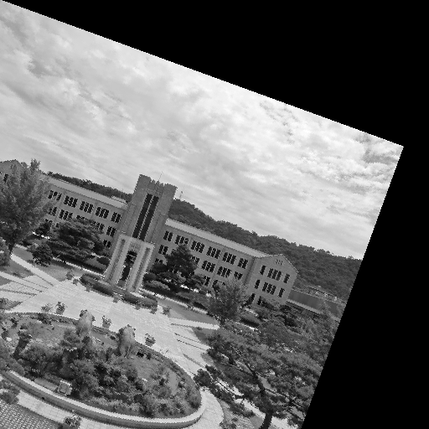

dgu_gray.png

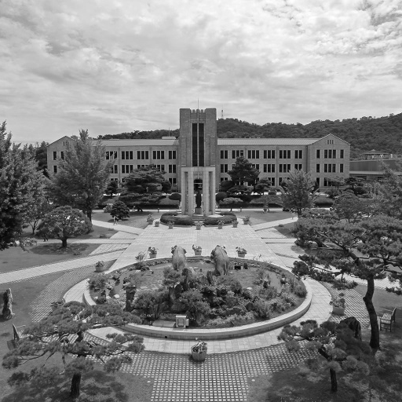

dgu_gray_rotate.png

