Multimedia Image Processing

Assignment 2

2017113547 이정근

Source Code :

#Equalization.py

import cv2

import numpy as np

NUM_INTENSITY = 256

def HistogramEqualize(img):

height, width = img.shape

num_pixels = height*width

# making histogram

histogram = np.zeros((NUM_INTENSITY,))

for y in range(height):

for x in range(width):

histogram[img[y, x]] = histogram[img[y, x]] + 1

# normalizing histogram

normalized_histogram = np.divide(histogram, num_pixels)

# making cdf

cdf = np.zeros((NUM_INTENSITY,))

cdf[0] = normalized_histogram[0]

for k in range(1, NUM_INTENSITY, 1):

cdf[k] = cdf[k-1] + normalized_histogram[k]

# finding output gray level

output_gray_level = np.multiply(NUM_INTENSITY-1, cdf)

output_gray_level = np.round(output_gray_level)

# convert image to equalized image

result = np.zeros((height, width), np.uint8) # result image

for y in range(height):

for x in range(width):

result[y, x] = output_gray_level[img[y, x]]

return result

in_image = cv2.imread('dgu_night.png', 0) # img2numpy

out_image = HistogramEqualize(in_image)

cv2.imshow('Input Image', in_image)

cv2.imshow('Result Image', out_image)

cv2.imwrite('dgu_night_histogram_equalized.png', out_image) # save result img

cv2.waitKey()

Result Image: dgu_night_histogram_equalized.png

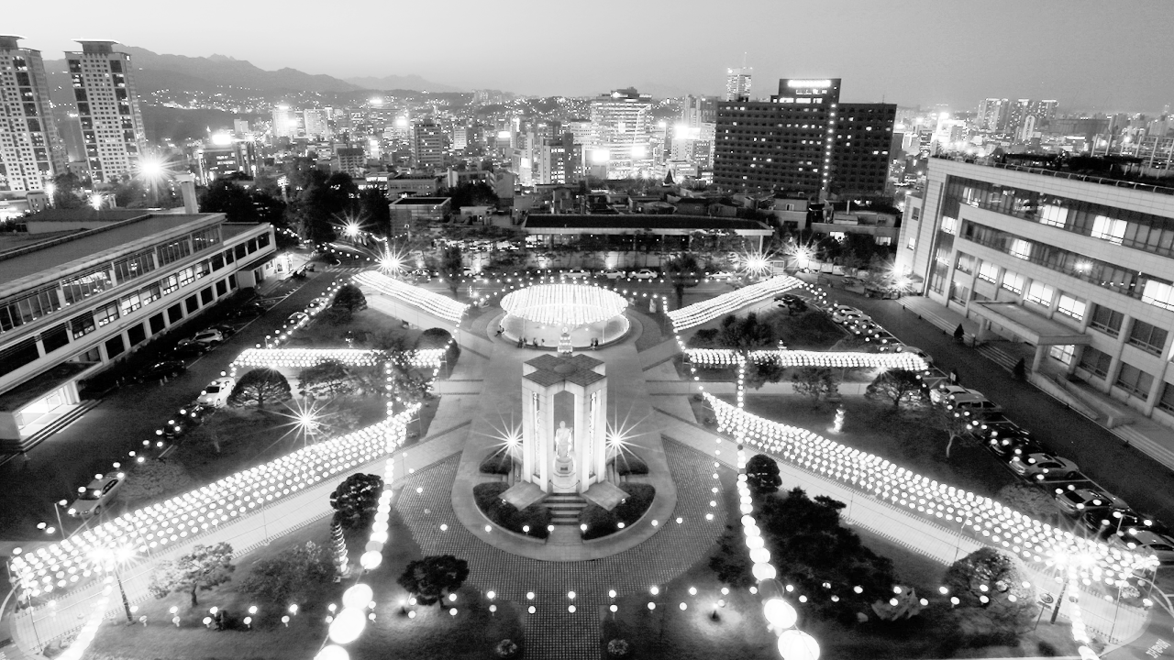

Source Image: dgu_night.png

