Assignment 4

2017113547 이정근

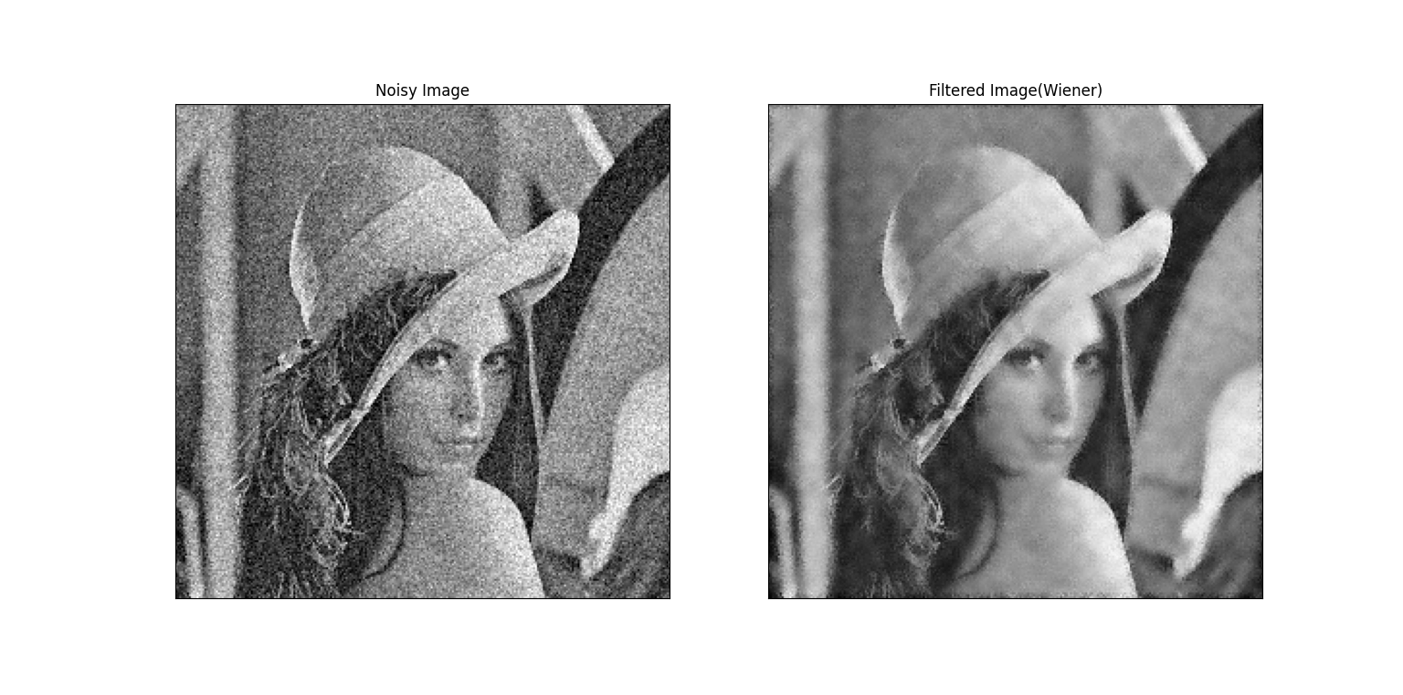

WienerFilter.py

import cv2

import numpy as np

from numpy import fft

import matplotlib.pyplot as plt

def add_gaussian(image, sigma):

noise = np.random.normal(0, sigma, image.shape)

# Add the Gaussian noise to the image

output = np.clip(image + noise, 0, 255)

output = output.astype('uint8')

return output

in_image_lena = cv2.imread('lena_gray.png', 0)

noisy_image = add_gaussian(in_image_lena, 0.1*255)

height, width = in_image_lena.shape

recovered_image = np.zeros((height, width))

padded_image = np.pad(noisy_image, ((3, 3), (3, 3)), 'constant')

height, width = padded_image.shape

vn = np.var(noisy_image)

for i in range(3, height-3):

for j in range(3, width-3):

m = np.mean(padded_image[i-3:i+4, j-3:j+4])

vg = np.var(padded_image[i-3:i+4, j-3:j+4])

recovered_image[i-3, j-3] = m + vg/(vg+vn)*(padded_image[i][j]-m)

plt.subplot(121), plt.imshow(noisy_image, cmap='gray')

plt.title('Noisy Image'), plt.xticks([]), plt.yticks([])

plt.subplot(122), plt.imshow(recovered_image, cmap='gray')

plt.title('Filtered Image(Wiener)'), plt.xticks([]), plt.yticks([])

plt.show()

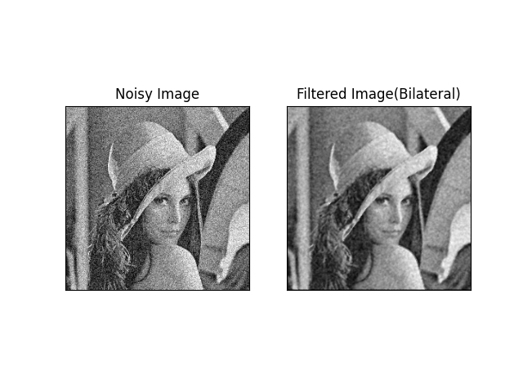

BilateralFilter.py

import cv2

import numpy as np

from numpy import fft

import matplotlib.pyplot as plt

def add_gaussian(image, sigma):

noise = np.random.normal(0, sigma, image.shape)

# Add the Gaussian noise to the image

output = np.clip(image + noise, 0, 255)

#output = output.astype('uint8')

return output

in_image_lena = cv2.imread('lena_gray.png', 0)

noisy_image = add_gaussian(in_image_lena, 0.1*255)

height, width = in_image_lena.shape

recovered_image = np.zeros((height, width))

padded_image = np.pad(noisy_image, ((1, 1), (1, 1)), 'constant')

height, width = padded_image.shape

def pre_weight(x, y, k, l, sigmaX, sigmaY, sigmaR, g):

return np.exp(-(x-k)**2/(2*(sigmaX**2))-(y-l)**2/(2*(sigmaY**2))-(g[x,y]-g[k,l])**2/(2*(sigmaR**2)))

def sum_pre_weight(x, y, sigmaX, sigmaY, sigmaR, g):

sum =0

for k in range(x-1, x+2):

for l in range(y-1, y+2):

sum += pre_weight(x, y, k, l, sigmaX, sigmaY, sigmaR, g)

return sum

def weight(x, y, k, l, sigmaX, sigmaY, sigmaR, g):

return pre_weight(x, y, k, l, sigmaX, sigmaY, sigmaR, g)/sum_pre_weight(x, y, sigmaX, sigmaY, sigmaR, g)

sigmaX = 100

sigmaY = 100

sigmaR = 100

for i in range(1, height-1):

for j in range(1, width-1):

recovered_image[i - 1, j - 1] = \

np.sum(np.multiply(padded_image[i-1:i+2, j-1:j+2],

np.array([[weight(i, j, k, l, sigmaX, sigmaY, sigmaR, padded_image)

for k in range(i-1, i+2)] for l in range(j-1, j+2)])))

plt.subplot(121), plt.imshow(noisy_image, cmap='gray')

plt.title('Noisy Image'), plt.xticks([]), plt.yticks([])

plt.subplot(122), plt.imshow(recovered_image, cmap='gray')

plt.title('Filtered Image(Bilateral)'), plt.xticks([]), plt.yticks([])

plt.show()