**toms pipes**

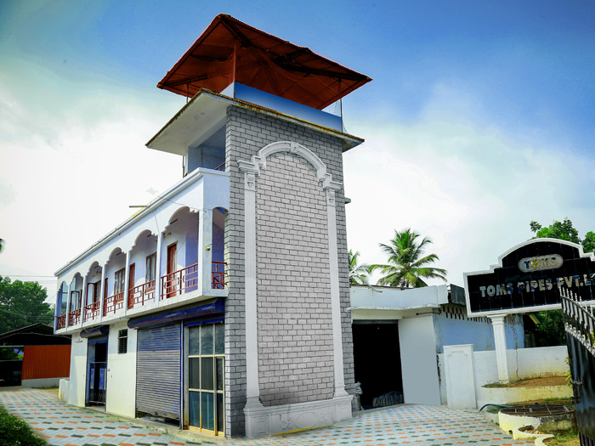

**civil enginnering assignment**

**a visit to toms pipes**

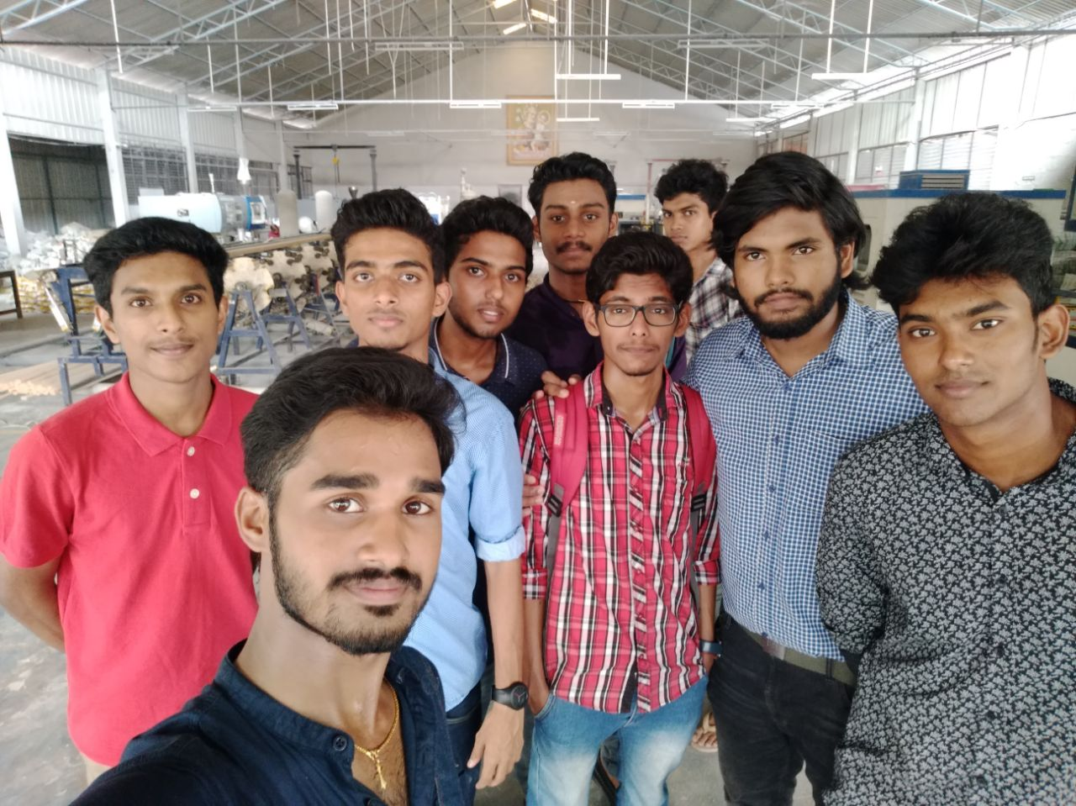

TOMS PIPES

We a group of nine students had visited the industry TOMS PIPES, industrial nagar, changanacherry. It is at heart part of changanacherry at about 7kms from our college. It is constructed in approx. 5 acres. 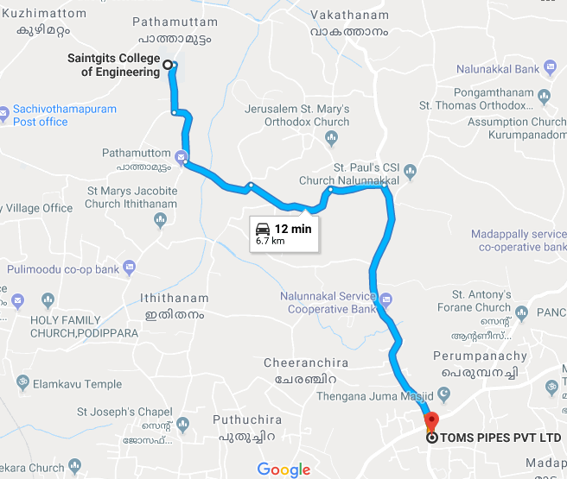

**About 25 years back, Mr.Tomy C.Vadayil, the Managing director of Toms Pipes had a humble beginning in his business. He started a Small Scale Industrial unit, manufacturing PVC fittings such as Elbow, Tee, Junction Box, Saddle, coupling, Bend etc., in the Brand Name of "TOMS" to cater to the requirements of Electrical Wiring. He marketed the same through outlets of various districts.**

The industrial building consist of

1. Raw materials mixing area

In this part of the building the raw materials of the polymer are mixed and moved to production unit for the production of PVC products.

This part of building is entirely covered with clothes so as to absorb the polymer resin particles that gets scattered in air to absorb. The exhaust fans are provided to move the heat out.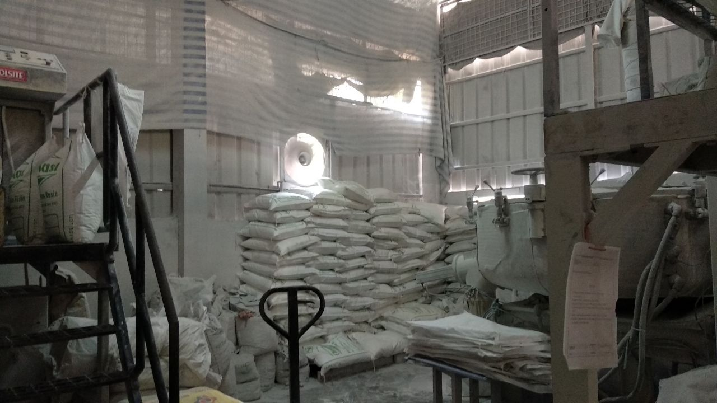

1. Production unit

The main part of the building where the raw materials are manufactured into the desired PVC product. This part of building has roofs as roofing sheets. The sheets are provided with ventilators fans that reduces the heat inside the building.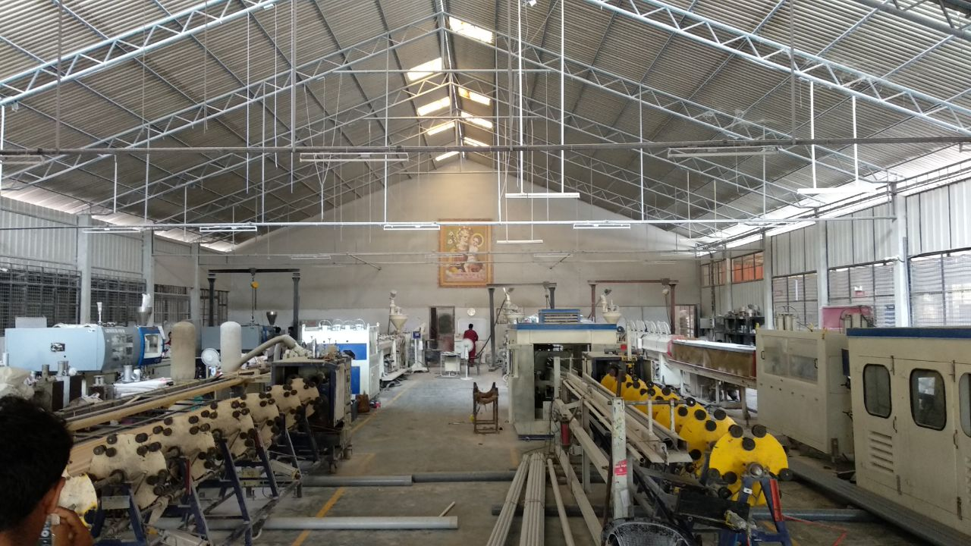

1. Storage area

The produced pvc products are stored in an open area of industry which made the transportation easier. There are three storage units separately for storing large & small blocks of pipes.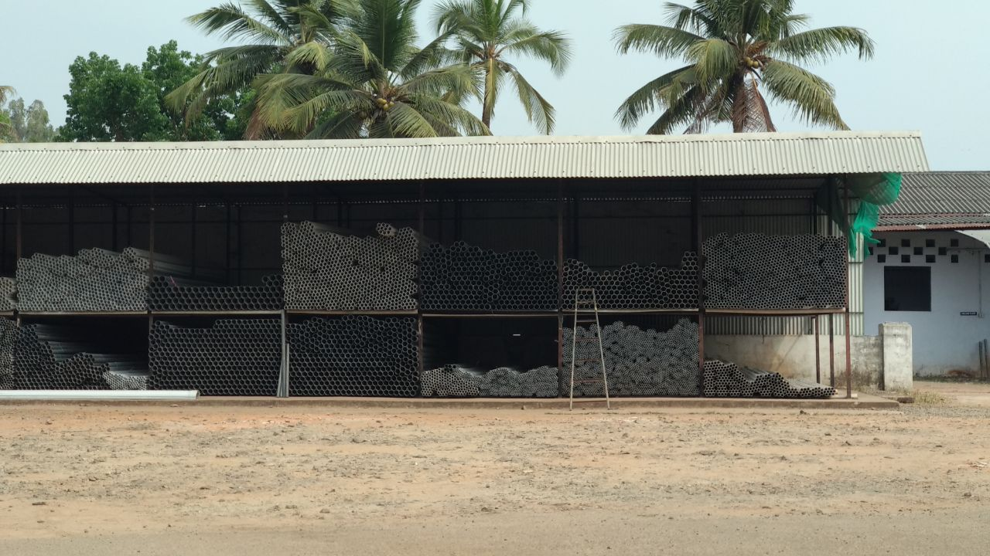

**FEATURES OF THE BUILIDING**

* IT IS **‘G’** TYPE BUILDING WHICH COMES UNDER ‘G1’ CATEGORY
* THIS BUILDING IS TALL AND WIDE ENOUGH TO ACCOMMODATE ADVANCED MACHINES AND LABOURING UNITS
* THE WALLS ARE MADE WITH HOLLOW BRICKS WHICH PROVIDES THERMAL STABILITY INSIDE THE BUILDING
* THE ROOFS ARE MADE OF HIGH QUALITY STAINLESS STEEL WITH EXHAUST FANS
* THE BUILDING MAKES USE OF THE MAXIMUM NATURAL VENTILATION
* IT IS AWAY FROM EDUCATIONAL BUILDING AND RESIDENTIAL AREA.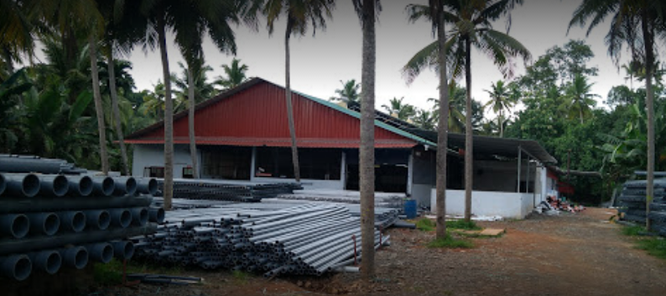

Industry – DEFECTS

* Poor drainage system
* Low height chimneys

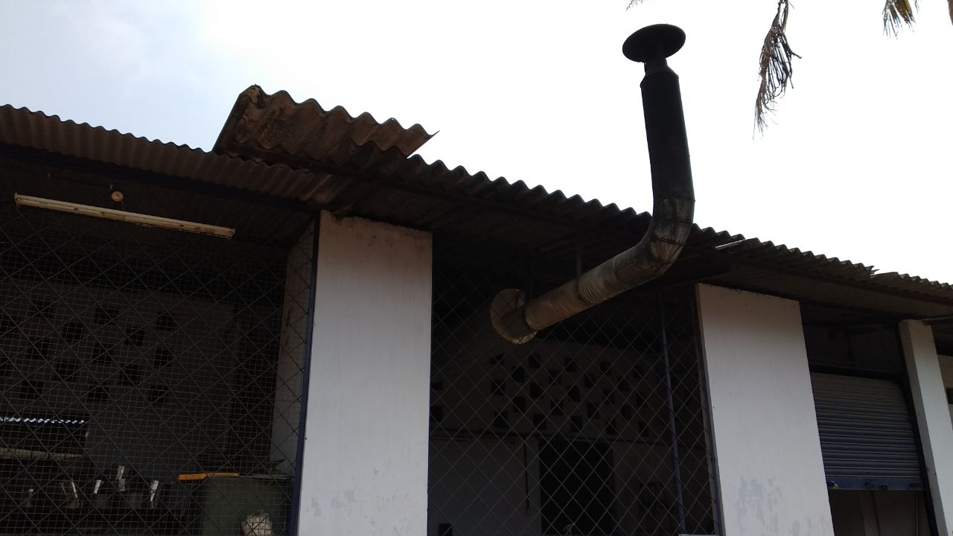

* Improper waste disposal, harmful to trees nearby.

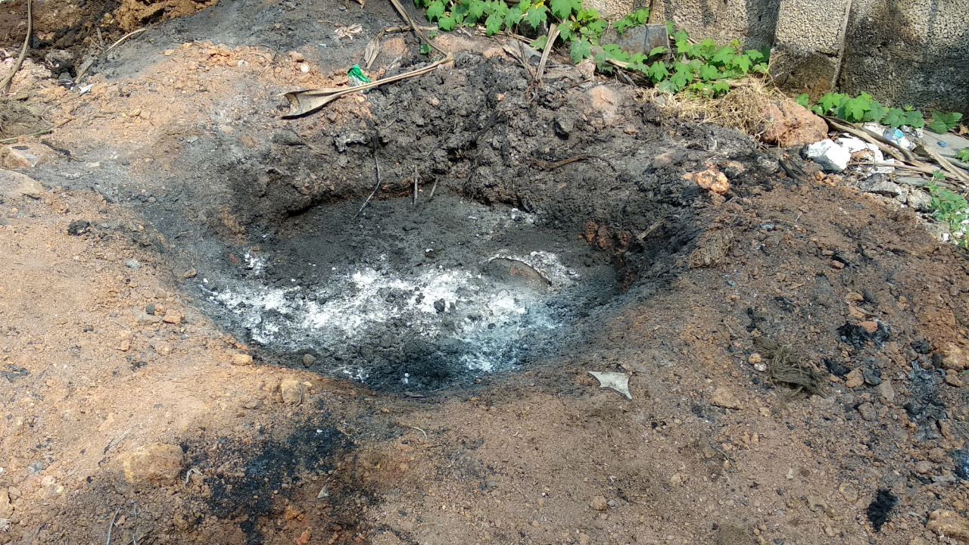

* The waste and oils is dumped nearby well in industry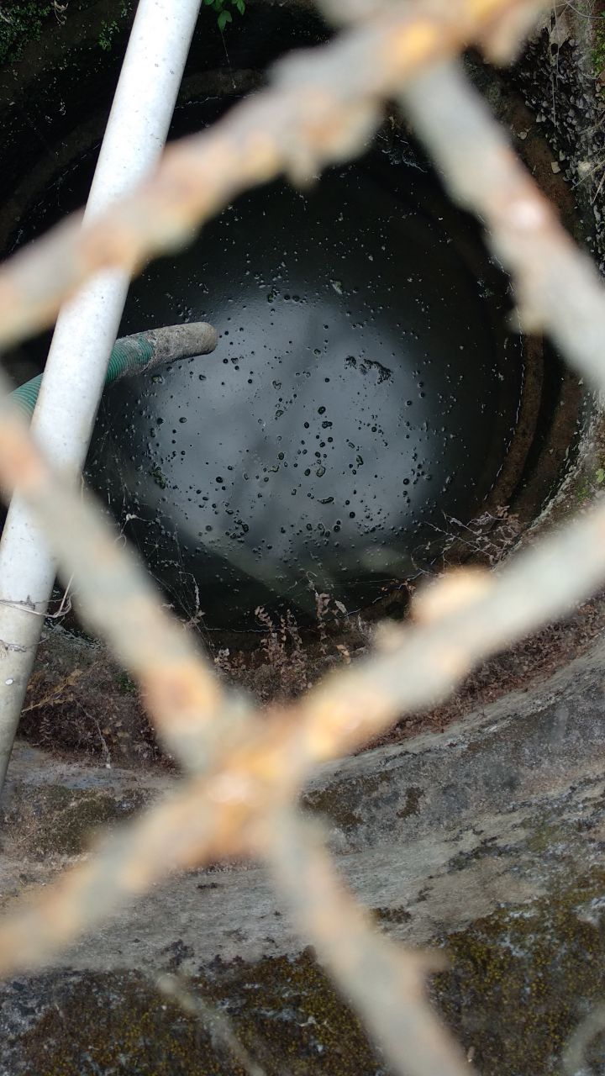

Conclusion

Thanking all the faculties for giving an oppurtunity to visit the industry and learn more about the industrial bulidings and their infrastructure.