

Indian Institute of Management Kashipur
Uttarkhand, 244713

MBA Analytics 2025-27
DSML Group Project Report

Predicting Regions With High Electric Vehicle Adoption In India
Predictive Analytics for Charging-Infrastructure Planning

Group Members
Name | Roll No.
Abhijay Kumar Jayant | MBAA25004
Anjali | MBAA25008
Bhavika Garua | MBAA25017
Jeptha H Lalawmpuia | MBAA25024
Nandini Talwar | MBAA25035
Vaidehee Ghorpade | MBAA25073
Shruthi G Bhosle | MBAA25160

Contents
Analytical Questions 5
What the figure shows 17
What it means 17
Why it matters for the project 17
What the matrix shows 20
What the pattern means 21
Why this model 28
How it works 29
Implementation 29
Results 29
Interpretation 29
Strengths and weaknesses here 29
Why this model 30
How it works 30
Implementation 30
Results 31
Interpretation 31
Strengths and weaknesses here 32
Why this model 32
How it works 32
Implementation 32
Results 33
Interpretation 33
Strengths and weaknesses here 34
Why this model 34
Implementation 34
Results and interpretation 34
Strengths and weaknesses here 35
Why regression at all 35
Implementation 35
Interpretation 35
Why regression is weaker than classification here 36
Why this was added 36
Implementation 37
Interpretation 39
Strengths and weaknesses here 40
Reading these numbers honestly 41
What each metric contributes 42
Interpretation 45
A caution about reading importance 45
What the figure shows 49

1. Executive Summary
India is undergoing a rapid transformation in its automotive energy landscape. Electric vehicles have moved from policy talking points to a visible share of new vehicle registrations within a remarkably short window. Analysis of Vahan registration data shows EV registrations increased from 0.68% of all registrations in 2019 to approximately 6.85% in the January–May 2024 period a tenfold increase in five years. However, this growth is geographically uneven. Goa records an adoption rate above 16%, while several northeastern states and smaller union territories remain below 1%. This geographic unevenness creates a critical planning problem: charging infrastructure is capital-intensive, requires long commissioning timelines, and is typically deployed by state agencies and utilities. Infrastructure investment decisions cannot rely on national averages; they require region-specific forecasts. The core insight is that registration data offers both the evidence base (it already exists, is published at fine geographic grain, and is continuously refreshed) and the analytical opportunity (historical patterns can predict near-term adoption trends). This project tests whether machine learning can extract actionable signals from historical registration records to guide charging-infrastructure investment.

2. Problem Statement
Current charging-infrastructure deployment in India follows demand rather than anticipating it. States and utilities invest after visible congestion appears, which means regions with the potential to grow fastest are often last to receive infrastructure support. This reactive posture creates a self-reinforcing cycle: regions without charging infrastructure face range anxiety and adoption lags, while regions with early infrastructure attract more buyers and attract more investment. A transparent, repeatable method for identifying promising regions before adoption accelerates would break this cycle and enable more efficient resource allocation.

Analytical Questions
- Can we predict which regions will have high EV adoption (top 25%) based on historical data through 2023?
- What is the predicted continuous adoption rate for each region, and how certain can we be?
- Which historical EV indicators are the strongest predictors of future adoption?
- Which machine-learning model performs best for this prediction task, and how stable are its results across different data splits?
- Can regions be grouped into meaningful EV-adoption profiles that support portfolio-level planning?
3. Dataset Description
3.1 Source and scope
The analysis uses Vahan vehicle-registration data published by India's Ministry of Road Transport & Highways. The dataset contains 418,372 monthly records spanning January 2019 through May 2024, representing vehicle registrations at the registration office (RTO) level, disaggregated by fuel type. The complete dataset covers 34 states and union territories, 1,414 distinct registration offices (1,314 unique office codes), and 22 fuel-type categories. Critically, the dataset contains zero missing values and no duplicate rows, indicating good data integrity at the collection level. Each record specifies the date (first day of month), state, office, fuel type, and registration count for that combination. The definition of an electric vehicle relies on the fuel_type field containing "electric," which identifies the Electric(Bov) category, capturing 55,305 rows and 17,524,732 registrations. This single category dominates the electric registrations; two other potential categories (Pure Ev with 47,790 registrations and Plug-In Hybrid Ev with 2 registrations) represent less than 0.3% of the electric total and were excluded for consistency with the notebook implementation.
Table 3.1. Dataset at a glance
Property | Value
Rows (observations) | 418,372
Columns (variables) | 9
Date coverage | January 2019 to May 2024 (65 monthly periods)
States / union territories | 34
Registration offices (by name) | 1,414
Registration office codes | 1,314
Distinct fuel types | 22
Missing values | None in any column
Duplicate rows | None, with or without the id column
Total registrations recorded | 771,822,033
The gap between 1,414 office names and 1,314 office codes indicates that some office names appear under more than one code, or that the same code serves offices recorded under slightly different names. We did not attempt to reconcile them because the analysis operates at state level, but anyone extending this work to office level would need to resolve that mapping first.
3.2 Variables in the raw file
Table 3.2. Variable description for the raw dataset
Variable | Data type | Description | Role in analysis
id | Integer | Sequential row identifier running from 0 to 418,371 | Not used; carries no information
date | Text, parsed to date | First day of the reporting month, supplied as DD-MM-YYYY | Source of the year variable used for all aggregation
state_name | Text | Name of the state or union territory (34 distinct values) | Unit of analysis; grouping key
state_code | Integer | Numeric code for the state, ranging from 1 to 38 | Identifier only; not modelled
office_name | Text | Registration office or RTO (1,414 distinct values) | Used to count active offices per state-year
office_code | Text | RTO code such as MH15 (1,314 distinct values) | Identifier only; reserved for future office-level work
fuel_type | Text | Fuel or powertrain category (22 distinct values) | Used to flag electric registrations
category | Text | Constant value "Fuel" in every row | Dropped; no variation
registrations | Integer | Count of registrations for that office-month-fuel combination | Numeric measure aggregated into every feature

3.3 Distribution of the registration counts
The registrations column is heavily right-skewed. The median row records 26 registrations while the mean is 1,844.82, and the standard deviation of 55,819.84 is thirty times the mean. The largest single row records 15,988,691 registrations. Half the rows sit below 26 and 90% below 829, but the top of the distribution stretches into the millions.
Table 5.3. Distribution of the registrations variable across all 418,372 rows
Statistic | Value
Minimum | 1
25th percentile | 5
Median | 26
75th percentile | 170
90th percentile | 829
99th percentile | 5,659
99.9th percentile | 261,960
Maximum | 15,988,691
Mean | 1,844.82
Standard deviation | 55,819.84
Skew of this kind is normal in administrative data, since a metropolitan RTO handles vastly more volume than a district office in a small state. The extreme upper tail, however, is not explained by that, and Section 6.5 examines it in detail.
3.4 Fuel types and the definition of an electric vehicle
The fuel_type column contains 22 categories, of which four reference electric powertrains in some form. The notebook identifies an EV by testing whether the fuel type contains the string "electric", which matches exactly one category, Electric(Bov). That category alone covers 55,305 rows and 17,524,732 registrations, and it is by a wide margin the dominant electric category in the file.
Table 3.4. Registration volume by fuel type (top categories and all electric-related categories)
Fuel type | Rows | Registrations | Treated as EV?
Petrol | 82,094 | 641,613,521 | No
Diesel | 81,597 | 83,917,468 | No
Electric(Bov) | 55,305 | 17,524,732 | Yes
Petrol/Cng | 43,149 | 11,795,314 | No
Cng Only | 23,074 | 5,534,760 | No
Petrol/Hybrid | 59,219 | 5,212,921 | No
Not Applicable | 22,206 | 2,670,391 | No
Pure Ev | 1,462 | 47,790 | No - not matched by the filter
Strong Hybrid Ev | 1,470 | 16,758 | No - hybrid, correctly excluded
Plug-In Hybrid Ev | 2 | 2 | No - not matched by the filter
Fuel Cell Hydrogen | 6 | 22 | No
Checking this against the raw file showed that the string filter misses two categories that arguably belong in an EV definition. Pure Ev contributes 47,790 registrations and Plug-In Hybrid Ev contributes 2. Together they represent about 0.27% of the electric total, so including them would not move any of the state-level results reported here. Strong Hybrid Ev is a conventional hybrid and its exclusion is correct. We have kept the original definition for consistency with the notebook and the presentation, but the omission is documented here because a stricter replication should widen the filter.

3.5 The modelling dataset
The raw file is not the dataset the models see. After aggregation and reshaping, the analytical dataset has 34 rows, one per state or union territory, and 15 columns before the target label is added. This is a very small sample by machine-learning standards, and it constrains almost every conclusion in the later sections. Table 5.5 describes the eleven features that were built and the three outcome-period columns.
Table 3.5. Variables in the state-level modelling dataset (n = 34)
Variable | Data type | Description | Role
state_name | Text | Name of the state or union territory | Identifier
ev_adoption_rate_2021 | Numeric | EV share of all registrations in 2021 | Feature
ev_adoption_rate_2022 | Numeric | EV share of all registrations in 2022 | Feature
ev_adoption_rate_2023 | Numeric | EV share of all registrations in 2023 | Feature
ev_registrations_2023 | Numeric | Absolute count of EV registrations in 2023 | Feature
total_registrations_2023 | Numeric | Absolute count of all registrations in 2023 | Feature
office_count_2023 | Numeric | Number of distinct offices reporting in 2023 | Feature
ev_share_avg_2021_23 | Numeric | Mean of the 2021, 2022 and 2023 adoption rates | Feature
ev_share_change_22_23 | Numeric | 2023 adoption rate minus 2022 adoption rate | Feature
ev_reg_growth_22_23 | Numeric | Year-on-year growth in EV registrations, 2022 to 2023 | Feature
total_reg_growth_22_23 | Numeric | Year-on-year growth in total registrations, 2022 to 2023 | Feature
ev_cagr_21_23 | Numeric | Two-year compound growth rate of EV registrations | Feature
ev_adoption_rate_2024 | Numeric | EV share of registrations, January to May 2024 | Regression target
ev_registrations_2024 | Numeric | Absolute EV registrations, January to May 2024 | Reported alongside output
total_registrations_2024 | Numeric | All registrations, January to May 2024 | Denominator of the target
high_adoption | Binary (0/1) | 1 when the 2024 adoption rate is at or above the 75th percentile | Classification target

3.6 Descriptive statistics of the modelling variables
Table 3.6. Descriptive statistics across the 34 regions
Variable | Mean | Std. dev. | Min | Median | Max
ev_adoption_rate_2021 | 0.0153 | 0.0133 | 0.0000 | 0.0146 | 0.0562
ev_adoption_rate_2022 | 0.0386 | 0.0299 | 0.0000 | 0.0416 | 0.1208
ev_adoption_rate_2023 | 0.0526 | 0.0386 | 0.0000 | 0.0490 | 0.1376
ev_share_avg_2021_23 | 0.0355 | 0.0264 | 0.0000 | 0.0336 | 0.1037
ev_share_change_22_23 | 0.0139 | 0.0156 | -0.0097 | 0.0121 | 0.0670
ev_reg_growth_22_23 | 0.5379 | 0.7599 | -0.9841 | 0.4516 | 3.6111
total_reg_growth_22_23 | 0.0209 | 0.2805 | -0.9800 | 0.1106 | 0.2087
ev_cagr_21_23 | 1.0574 | 0.8886 | -0.8155 | 1.1361 | 3.7958
ev_registrations_2023 | 138,352 | 383,142 | 0 | 23,582 | 1,719,657
total_registrations_2023 | 2,164,450 | 5,998,158 | 5,150 | 602,561 | 27,047,144
office_count_2023 | 38.32 | 35.56 | 1 | 27 | 146
ev_adoption_rate_2024 | 0.0575 | 0.0421 | 0.0002 | 0.0620 | 0.1644
ev_registrations_2024 | 44,369 | 138,540 | 3 | 11,502 | 810,834
A few things stand out. The adoption-rate variables climb steadily year on year at every point of the distribution, so the national trend is not being driven by a handful of leaders. The growth variables are far noisier than the level variables: EV registration growth ranges from a 98% decline to a 361% increase, and the total-registration growth variable includes a 98% fall, which is not a plausible real-world movement and points back to reporting inconsistencies in the underlying file. The volume variables are extremely dispersed, with standard deviations larger than their means, which is the direct consequence of the outlier rows discussed in Section 6.5.
3.7 Class distribution of the target
Applying the 75th-percentile rule to the 2024 adoption rate gives a threshold of 7.99%. Nine regions meet or exceed it and twenty-five fall below, a 26.5% to 73.5% split. The class imbalance is mild by the standards of most classification problems, but the absolute numbers are the real constraint: nine positive cases in total means that any test split contains only a handful of them.
Table 3.7. The nine regions labelled high adoption (2024 rate ≥ 7.99%)
Region | 2024 EV adoption rate | 2024 EV registrations
Goa | 16.44% | 5,754
Chandigarh | 13.87% | 2,450
Tripura | 12.29% | 3,243
Delhi | 11.99% | 34,343
Kerala | 11.35% | 35,344
Karnataka | 9.10% | 72,539
Assam | 8.65% | 25,062
Uttar Pradesh | 8.26% | 130,189
Maharashtra | 8.11% | 94,227
The table already illustrates the tension that runs through the rest of the report. Goa tops the list on percentage but registers fewer than six thousand electric vehicles in the period, while Uttar Pradesh sits near the bottom of the high-adoption group and registers more than twenty times as many. A charging-infrastructure decision that ranks purely on this percentage would prioritise the wrong places.
4. Data Preprocessing and Preparation
The raw file arrived in reasonable shape, so the work in this section is less about repair than about restructuring. The dataset is at office-month-fuel level and the question is at state-year level, so most of the effort went into aggregation, reshaping and feature construction rather than cleaning.
4.1 Missing values and duplicates
Checking every column returned zero missing values across all 418,372 rows, so no imputation strategy was needed. We also tested for duplicate records both including and excluding the id column, and found none in either case. This matters because the id column is sequential and would mask genuine duplicates if it were left in the comparison; removing it and re-testing confirmed that no office-month-fuel combination is recorded twice.
4.2 Type conversion and derived time variables
The date column arrived as text in DD-MM-YYYY format. Parsing it with day-first interpretation converted all 418,372 values successfully with no failures, which confirms the format is consistent throughout. From the parsed date we extracted year and month. Year became the backbone of the entire analysis, since every feature is defined over an annual window.
Reading the date field also revealed the coverage pattern that shapes the whole project. The years 2019 through 2023 each contain twelve monthly periods, while 2024 contains only five, from January to May. That asymmetry does not distort the adoption rate itself, because the rate is a ratio and both numerator and denominator cover the same five months. It does mean that the 2024 EV registration counts are not comparable in level to earlier years, and we have been careful to describe them as five-month figures wherever they appear.
Table 4.1. Records and reporting periods per year
Year | Rows in file | Monthly periods | Coverage
2019 | 67,910 | 12 | Full year
2020 | 63,141 | 12 | Full year
2021 | 70,511 | 12 | Full year
2022 | 79,708 | 12 | Full year
2023 | 93,296 | 12 | Full year
2024 | 43,806 | 5 | January to May only

4.3 Flagging electric vehicles
A boolean indicator was created by testing whether the fuel_type string contains "electric", case-insensitively. This flags 55,305 of the 418,372 rows. Every EV measure in the project is built by summing the registrations column where this flag is true. The choice is discussed in Section 5.4; the practical effect is that the analysis measures battery-electric registrations as recorded under the Electric(Bov) label.
5. Exploratory Data Analysis
The exploratory work had three jobs: establish whether EV adoption is actually growing, establish where it is concentrated, and establish whether the historical variables we planned to build have any relationship with the outcome we planned to predict.
5.1 National EV adoption over time
Table 7.1. National registrations and EV adoption rate by year
Year | Total registrations | EV registrations | EV adoption rate
2019 | 24,682,018 | 168,619 | 0.68%
2020 | 388,239,508 | 2,595,149 | 0.67%
2021 | 132,371,219 | 2,316,128 | 1.75%
2022 | 130,931,340 | 6,232,335 | 4.76%
2023 | 73,591,315 | 4,703,953 | 6.39%
2024 (Jan–May) | 22,006,633 | 1,508,548 | 6.85%
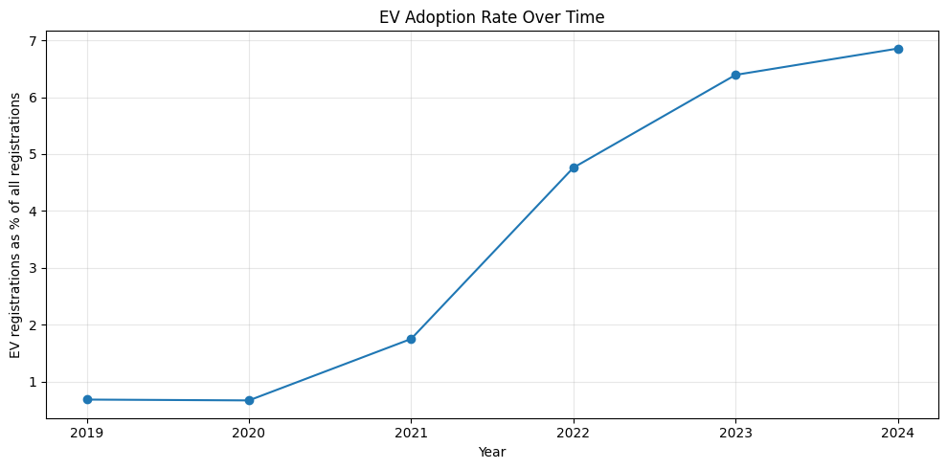
Figure 1. National EV adoption rate, 2019 to the January–May 2024 period. The rate is EV registrations expressed as a percentage of all recorded registrations.

What the figure shows
The curve is flat between 2019 and 2020 at roughly 0.68%, then rises sharply from 2021 onwards, reaching 4.76% in 2022, 6.39% in 2023 and 6.85% in the 2024 window. The steepest single-year jump is 2021 to 2022, when the rate roughly triples.

What it means
EV adoption in India is in a rising phase, and the acceleration begins around 2021 rather than at the start of the series. The flat 2019-to-2020 segment is consistent with the electric share being negligible before subsidy schemes and product availability improved. The apparent flattening between 6.39% in 2023 and 6.85% in the 2024 window should not be read as a slowdown, since 2024 covers only five months and the comparison is not like for like.

Why it matters for the project
A rising national trend is a precondition for the whole exercise. If EV share were stagnant, predicting future high-adoption regions would be a matter of reading off the current ranking. The trend also justifies treating recent years as more informative than distant ones, which is why the feature set leans on 2021 to 2023 rather than reaching back to 2019.
The total-registrations column in Table 7.1 is worth flagging separately. The 2020 figure of 388 million is not credible against 24.7 million in 2019, and it is a direct consequence of the extreme rows described in Section 6.5. This is the point in the analysis where the data-quality problem first becomes visible, and it is why we went back to the raw file to investigate.
5.2 Which regions lead on adoption
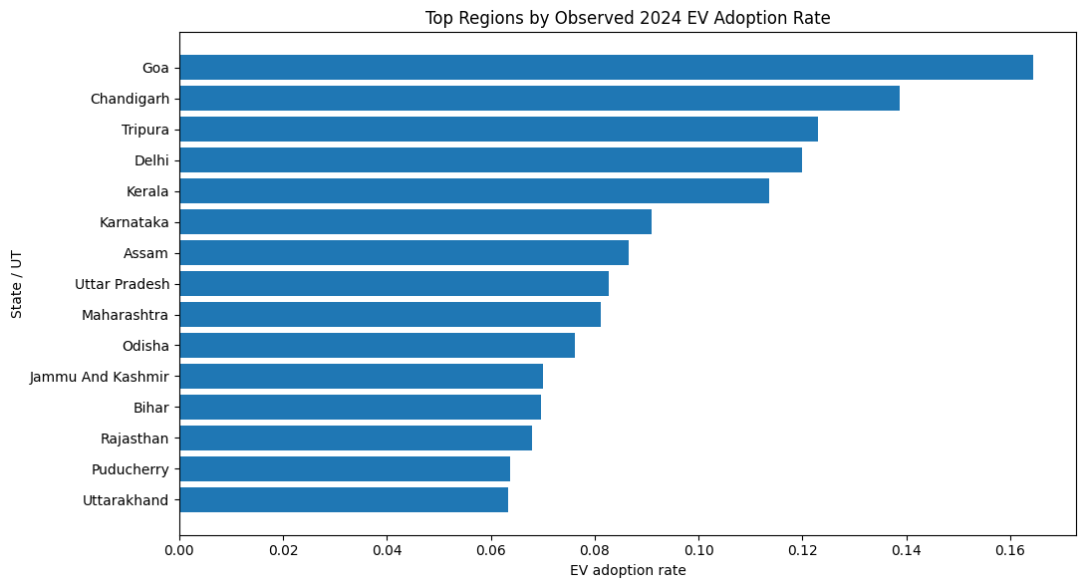
Figure 2. Top 15 states and union territories by observed EV adoption rate in the January–May 2024 period.
What the figure shows
Goa leads at 16.44%, followed by Chandigarh at 13.87%, Tripura at 12.29%, Delhi at 11.99% and Kerala at 11.35%. Below that the values decline gradually rather than dropping off, with Karnataka at 9.10%, Assam at 8.65%, Uttar Pradesh at 8.26% and Maharashtra at 8.11%, and the rest of the top fifteen clustered between 6% and 8%.
What pattern is visible
The leaders are a mix of three quite different kinds of region. Small, compact, high-income territories appear at the top: Goa, Chandigarh and Delhi all have short average trip distances and dense urban form, which suits current EV range and charging patterns. States with strong policy positions appear next: Kerala and Karnataka have both pursued EV incentives and public-transport electrification. Then there are entries that are harder to explain from first principles, particularly Tripura and Assam, which suggests that two-wheeler and three-wheeler electrification is doing more of the work than passenger cars in some regions.
Why it matters
The gradual decline rather than a sharp break is what makes the 75th-percentile threshold a reasonable but somewhat arbitrary cut. Maharashtra at 8.11% and Odisha at 7.63% are separated by less than half a percentage point, yet one is labelled high adoption and the other is not. Any classification result has to be read with that in mind, because the model is being asked to reproduce a boundary that the data itself does not draw sharply.
5.3 Composition of electric registrations
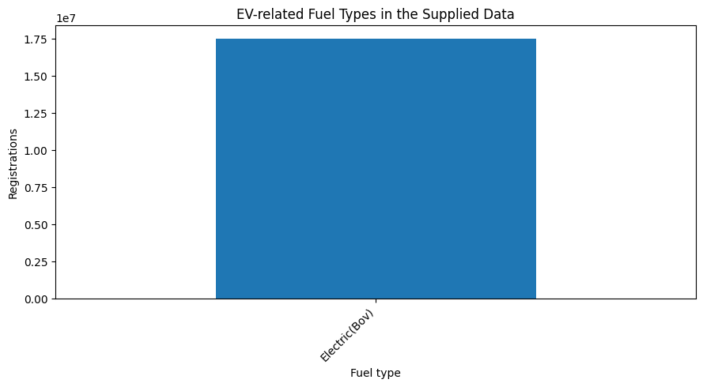
Figure 3. Registrations captured by the electric-vehicle filter, by fuel-type label.
This chart is the simplest in the report and the most useful as a check on our own method. It shows a single bar, because the string filter matches only the Electric(Bov) category, which carries all 17,524,732 registrations counted as electric. Seeing one bar rather than several told us that the EV definition rests entirely on one label, and prompted the check reported in Section 5.4 that identified Pure Ev and Plug-In Hybrid Ev as categories the filter misses. The practical conclusion is that the measure is dominated by battery-electric registrations under a single reporting label, and that any change in how Vahan classifies electric vehicles would break the series.
7.4 Relationships between historical indicators and the outcome
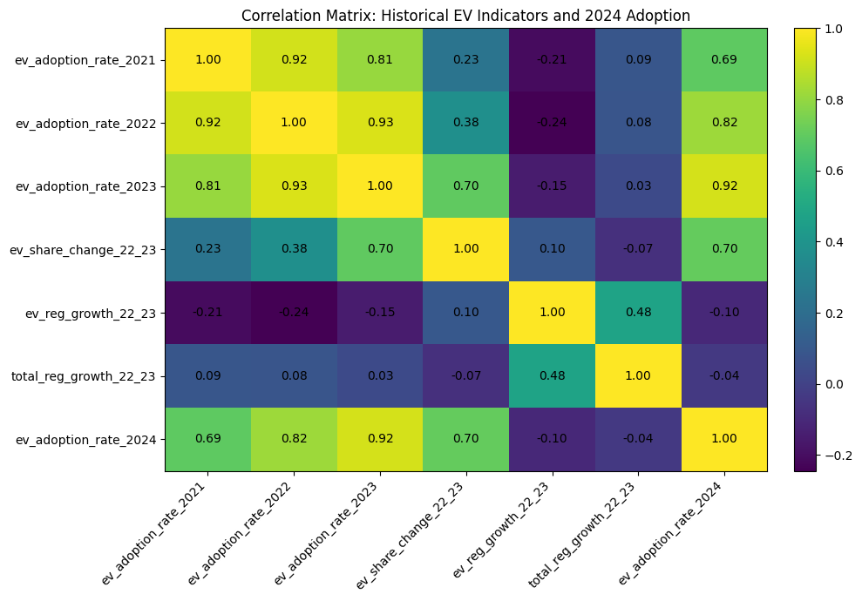
Figure 4. Correlation matrix of historical EV indicators and the 2024 adoption rate across the 34 regions.
Table 7.2. Pearson correlations with the 2024 EV adoption rate
Variable | Correlation with 2024 adoption rate
ev_adoption_rate_2023 | 0.92
ev_adoption_rate_2022 | 0.82
ev_share_change_22_23 | 0.70
ev_adoption_rate_2021 | 0.69
ev_reg_growth_22_23 | -0.10
total_reg_growth_22_23 | -0.04

What the matrix shows
The level variables correlate strongly with the outcome and the correlation gets stronger the more recent the year: 0.69 for 2021, 0.82 for 2022 and 0.92 for 2023. The change in share between 2022 and 2023 also correlates at 0.70. The two growth-rate variables are effectively uncorrelated with the outcome, at -0.10 and -0.04.

What the pattern means
EV adoption is highly persistent. A region's share this year is the best available guide to its share next year, and recency matters. The contrast between the change variable at 0.70 and the growth variable at -0.10 is instructive, because both are meant to capture momentum. The difference is that ev_share_change_22_23 is an arithmetic difference between two shares, so a region already at a high level and still climbing scores highly, whereas ev_reg_growth_22_23 is a percentage change in raw counts, which rewards small regions moving off a tiny base. A state going from 40 EVs to 160 posts 300% growth and contributes nothing to national charging demand.
8. Feature Engineering and Feature Selection

8.1 Design principle
The governing rule for the feature set was that nothing from the outcome period could enter it. The 2024 adoption rate, the 2024 EV count and the 2024 total are used only as targets and as reporting columns. Every explanatory variable is built from data dated 2023 or earlier. This makes the exercise a genuine forward prediction rather than a description of the same period on both sides of the equation, and it is the reason we can claim the models are being tested on information they did not see.
8.2 The features and why each was built
Table 8.1. Constructed features and their rationale
Feature | How it was built | Why it was included
ev_adoption_rate_2021 / 2022 / 2023 | EV registrations divided by all registrations, for each year separately | Captures the level of adoption and how it has moved. Keeping three separate years lets a model weight recency for itself
ev_share_avg_2021_23 | Arithmetic mean of the three annual rates | Smooths out a single unusual year, which matters for small regions where one month can swing the rate
ev_share_change_22_23 | 2023 rate minus 2022 rate, in percentage points | Measures momentum in a way that is comparable across regions of different sizes
ev_reg_growth_22_23 | 2023 EV count divided by 2022 EV count, minus one | Intended to capture acceleration in absolute uptake
total_reg_growth_22_23 | Same calculation on all registrations | Controls for whether the overall vehicle market in a region is expanding or contracting
ev_cagr_21_23 | Two-year compound growth rate of EV registrations | A less volatile growth measure than a single year-on-year figure
ev_registrations_2023 | Sum of EV registrations in 2023 | Brings market size into the model, since adoption share alone ignores absolute volume
total_registrations_2023 | Sum of all registrations in 2023 | Proxy for the overall size of the regional vehicle market
office_count_2023 | Count of distinct offices reporting in 2023 | Rough proxy for administrative reach and reporting completeness

8.3 Variables deliberately excluded
Three columns from the raw file play no part in the models. The id column is a row index with no information content. The category column takes the value "Fuel" in all 418,372 rows and therefore has zero variance, so it cannot help any model. The state_code and office_code columns are identifiers; encoding a state code as a numeric feature would invite a model to treat the arbitrary ordering of codes as meaningful.
The 2019 and 2020 adoption rates were also left out, even though they were available. Adoption was close to zero for most regions in those years, so the variables carry little discriminating information, and including them would have added two more highly correlated columns to an already small dataset.
8.4 Feature selection
No formal selection procedure was applied. All eleven engineered features were passed to every model. With 34 observations and 11 features the ratio is already uncomfortable, and we considered running a correlation-based or model-based reduction, but chose instead to let the tree ensembles reveal which features matter and to interpret their importance directly.
With hindsight, this is defensible for the trees but weak for the linear models. The correlations of 0.92 and 0.93 between consecutive adoption-rate variables mean that Logistic and Linear Regression coefficients are being estimated on nearly redundant inputs, and their individual values are unstable. Dropping to a single level variable plus a momentum variable, or applying regularisation with a tuned penalty, would have produced coefficients that could be interpreted more confidently. The feature-importance results in Section 11.3 effectively perform this selection after the fact, showing that three of the eleven features carry roughly 95% of the signal.

9. Machine Learning Methodology
The workflow moves from the raw registration file to a scored list of regions in eight steps: load and inspect the data, restructure it to state-year level, explore it, engineer features from pre-2024 information, split into training and test sets, train the candidate models, evaluate and compare them, and finally refit the selected models on all available regions to score every state.
9.1 Type of problem
Two supervised problems were framed on the same feature matrix, plus one unsupervised layer.
Track | Type | Target | Purpose
Classification | Supervised, binary | high_adoption (0 or 1) | Answers the planning question directly: does this region belong on the shortlist?
Regression | Supervised, continuous | ev_adoption_rate_2024 | Gives a numeric estimate so regions can be ranked rather than only sorted into two groups
Clustering | Unsupervised | None | Groups regions into adoption profiles for portfolio-level planning

9.2 Train and test design
Both supervised tracks use the same 75/25 split with a fixed random seed, giving 25 training regions and 9 test regions. Fixing the seed means the comparison between models is fair, since all of them see identical training and test data. The classification split is stratified on the target so that the class proportions are preserved: the training set holds 18 normal and 7 high-adoption regions, and the test set holds 7 normal and 2 high-adoption regions. The regression split is not stratified, since the target is continuous.
A test set of nine observations is far too small to give a stable performance estimate on its own, and we knew this when we designed the split. The alternative was to shrink the test set further, which would have been worse. To compensate, all classification results were re-checked with five-fold stratified cross-validation over all 34 regions, so that every region appears in a validation fold exactly once.
9.3 Preprocessing pipeline
Scaling was attached to the linear and logistic models through a pipeline rather than applied to the full dataset in advance. The distinction matters: fitting a scaler on the whole dataset before splitting lets information about the test set's mean and variance leak into the training process. Inside a pipeline, the scaler is refitted on the training portion of every split and every cross-validation fold. Tree-based models were fitted on unscaled features, since threshold splits are unaffected by scale.
9.4 Validation strategy
Cross-validation used a stratified five-fold scheme with shuffling and a fixed seed, scored on ROC-AUC. Stratification is necessary here because with only nine positive cases, an unstratified fold could easily contain zero positives, which makes ROC-AUC undefined for that fold. Five folds rather than ten was chosen because ten folds on 34 observations would put roughly three regions in each validation set.
9.5 Hyperparameters
Hyperparameters were set by hand rather than tuned with a search, and the choices were made to constrain model complexity given the sample size rather than to maximise a score. No grid search or randomised search was run. This is a genuine gap in the methodology, though it is partly excused by the fact that every model reached the ceiling on the classification task, leaving nothing for tuning to improve.
Table 9.1. Model configurations used
Model | Configuration | Reasoning
Logistic Regression | Standardised inputs, maximum 1,000 iterations, default L2 regularisation | Regularisation helps with the correlated feature set; scaling makes the penalty apply evenly
Decision Tree (classifier) | Maximum depth 3, minimum 2 samples per leaf | Depth was capped hard because an unrestricted tree on 25 training rows would memorise them
Random Forest (classifier) | 300 trees, 70% of features per split, minimum 2 samples per leaf | Many shallow-ish trees with feature subsampling to reduce variance on a small sample
Gradient Boosting (classifier) | 150 stages, depth 2, learning rate 0.05 | Shallow stumps and a low learning rate to slow the fit and limit overfitting
Linear Regression | Standardised inputs, no regularisation | Transparent baseline for the continuous target
Random Forest (regressor) | 300 trees, 70% of features per split, minimum 2 samples per leaf | Same reasoning as the classifier version
Gradient Boosting (regressor) | 150 stages, depth 2, learning rate 0.05 | Same reasoning as the classifier version
K-Means | k from 2 to 6 compared, 20 initialisations each | Multiple restarts guard against a poor random start; k selected on silhouette score

9.6 Evaluation metrics
Classification was evaluated on accuracy and ROC-AUC, supported by a confusion matrix and a full precision, recall and F1 report for the Random Forest. Accuracy is easy to communicate to a non-technical audience but is misleading under class imbalance, since predicting "normal" for every region would score 73.5%. ROC-AUC was therefore treated as the primary metric because it evaluates the ranking of predicted probabilities and is unaffected by where the decision threshold is placed.
Regression was evaluated on R², RMSE and MAE. R² states the share of variation in the 2024 adoption rate that the model explains. RMSE is in the same units as the target, so an RMSE of 0.028 means typical errors of about 2.8 percentage points of adoption share. MAE reports the average absolute error and is less sensitive to a single large miss, so comparing it against RMSE indicates whether errors are evenly spread or concentrated in a few regions.

10. Machine Learning Models
Seven supervised models were fitted in total, four for classification and three for regression, along with a K-Means segmentation. Each is described below with its rationale, implementation and results.
10.1 Logistic Regression (classification)

Why this model
Logistic Regression was the natural starting point because it produces a calibrated probability rather than a bare label, and because its coefficients can be inspected. For a public-sector planning application that matters: an official who has to justify why one state was shortlisted over another needs to be able to see what drove the decision.

How it works
The model fits a weighted linear combination of the input features and passes it through a logistic function that maps any value onto the range 0 to 1, which is read as the probability of the high-adoption class. Weights are estimated by maximising the likelihood of the observed labels, with an L2 penalty that shrinks large coefficients.

Implementation
Fitted inside a pipeline with standardisation, on the 25 training regions, with the iteration limit raised to 1,000 to guarantee convergence.

Results
Accuracy of 1.00 and ROC-AUC of 1.00 on the nine test regions. Mean cross-validated ROC-AUC of 1.00 with a standard deviation of 0.00 across five folds. When refitted on all 34 regions for final scoring, the largest standardised coefficients belong to the 2023 adoption rate (0.97), the 2022-to-2023 change in share (0.94), the three-year average share (0.86) and the 2022 rate (0.77).

Interpretation
The coefficient pattern is consistent with the correlation analysis: recent adoption level and recent momentum push a region towards the high-adoption class, while volume and office-count variables contribute little. Because the level variables are correlated with each other at above 0.9, the individual coefficient values should be read as a group rather than as separate independent effects. The direction is trustworthy; the precise magnitudes are not.

Strengths and weaknesses here
The main strength is that it produces graded probabilities, which turned out to be more useful than the binary labels. In the final scoring, Logistic Regression assigns Maharashtra a probability of 0.38 while Random Forest assigns 0.80, and that disagreement is itself informative for a planner. The main weakness is that the multicollinearity in the feature set makes the coefficients unstable, and with 25 training rows and 11 features the model has very little data per parameter.
10.2 Decision Tree (classification)

Why this model
A tree was included specifically because its output is a rule that a planning committee can read without any statistical background. If the tree performs comparably to the ensembles, the rule itself becomes the deliverable.

How it works
The algorithm searches for the feature and threshold that best separate the two classes, measured by reduction in Gini impurity, splits the data there, and repeats within each branch until a stopping rule is reached.

Implementation
Depth capped at 3 and a minimum of 2 samples per leaf, fitted on the same 25 training regions.
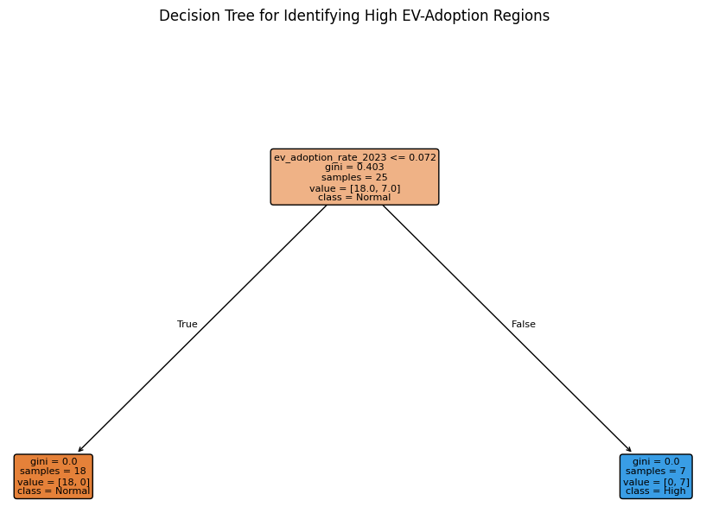
Figure 5. Fitted decision tree for identifying high EV-adoption regions. Although a depth of 3 was permitted, the tree required only one split.

Results
Accuracy of 1.00 and ROC-AUC of 1.00 on the test set, with a mean cross-validated ROC-AUC of 0.98 and a fold-to-fold standard deviation of 0.04. The fold scores were 1.00, 1.00, 1.00, 0.90 and 1.00.
The fitted tree is a single rule. The root node holds all 25 training regions with a Gini impurity of 0.403 and a class split of 18 normal to 7 high. One split on the 2023 EV adoption rate at a threshold of 7.2% separates them completely: 18 regions fall below and are all normal, 7 fall above and are all high adoption. Both leaves have a Gini impurity of zero.

Interpretation
This is the single most revealing result in the project. The tree was allowed to grow to depth 3 and chose not to, because one threshold on one variable already separates the training data perfectly. Translated into plain language, the rule is: if a region's EV share exceeded roughly 7% in 2023, expect it to be a high-adoption region in 2024. That is a finding a planning department can act on immediately, and it does not require a model to implement.

Strengths and weaknesses here
The transparency is genuine and valuable. The weakness is equally clear: a single-split tree is brittle. It has no way to express that a region just below the threshold with strong momentum might be worth watching, and its cross-validation standard deviation of 0.04 is the highest of the four classifiers, which reflects that a hard threshold is sensitive to which regions land in the training fold.
10.3 Random Forest (classification)

Why this model
Random Forest was included to test whether combining many trees would capture interactions that a single tree misses, and because its feature-importance output speaks directly to the diagnostic question of which historical signals matter.

How it works
Many trees are grown on bootstrap resamples of the training data, with each split considering only a random subset of features. Averaging the trees reduces the variance that makes an individual tree unstable, and the feature subsampling stops every tree from splitting on the same dominant variable.

Implementation
300 trees, 70% of features available at each split, minimum 2 samples per leaf.
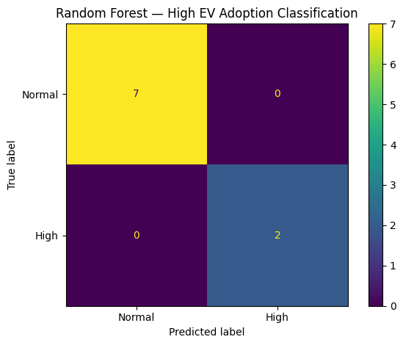
Figure 6. Confusion matrix for the Random Forest classifier on the nine held-out test regions.

Results
Accuracy of 1.00, ROC-AUC of 1.00, and a mean cross-validated ROC-AUC of 1.00 with zero standard deviation. The confusion matrix shows 7 true negatives, 2 true positives and no errors of either kind. Precision, recall and F1 are all 1.00 for both classes, on supports of 7 and 2.
Table 10.1. Random Forest classification report on the test set
Class | Precision | Recall | F1-score | Support
Normal adoption | 1.00 | 1.00 | 1.00 | 7
High adoption | 1.00 | 1.00 | 1.00 | 2
Overall accuracy |  |  | 1.00 | 9

Interpretation
Perfect scores on nine test observations, two of which are positive, carry very little information. Getting both positives right when the separating rule is a single threshold is not evidence of a sophisticated model. What is more informative is the cross-validated result, which stays at 1.00 with zero variation across folds, meaning that whichever regions are held out, the model still separates them. That consistency is real, but it reflects how cleanly separable the problem is rather than how good the model is.

Strengths and weaknesses here
The forest gives well-behaved probability estimates and a usable importance ranking, and it is more robust to a single odd region than the tree. Against that, it is opaque, its importance scores are known to favour continuous high-cardinality features, and with 34 observations the bootstrap samples overlap heavily, so the trees are less diverse than they would be on a larger dataset.
10.4 Gradient Boosting (classification)

Why this model
Boosting builds trees sequentially, with each one focusing on the cases the previous ones got wrong. It was included to test whether that sequential correction could pick up structure among the regions near the classification boundary, which is exactly where a bagged forest tends to be weakest.

Implementation
150 boosting stages, a maximum depth of 2, and a learning rate of 0.05. The shallow depth and slow learning rate were chosen because boosting is the most overfitting-prone of the four classifiers on a sample this size.

Results and interpretation
Accuracy of 1.00, ROC-AUC of 1.00, and a mean cross-validated ROC-AUC of 1.00 with zero standard deviation. Identical to Random Forest and Logistic Regression on every metric recorded. The extra complexity bought nothing, which is the expected outcome when a single threshold already separates the classes.

Strengths and weaknesses here
Boosting is usually the strongest of these four on tabular data with a few thousand rows and genuine non-linear structure. Neither of those conditions holds here. On 25 training rows with a linearly separable target, it is the least appropriate choice of the four, and its results give no reason to prefer it.
10.5 Regression models for the continuous adoption rate

Why regression at all
A binary label loses information. Two regions can both be flagged high adoption while sitting at 16.4% and 8.1%, which are very different planning situations. Estimating the rate directly lets regions be ranked and lets planners see how far a region sits from the threshold.

Implementation
Linear Regression with standardised inputs, Random Forest and Gradient Boosting with the same settings as their classification counterparts, all fitted on the same 25 training regions and evaluated on the same 9 test regions. Predictions were clipped at zero, since a negative adoption share is impossible.
Table 10.2. Regression performance on the nine held-out test regions
Model | R² | RMSE | MAE
Random Forest | 0.6658 | 0.0283 | 0.0222
Gradient Boosting | 0.6072 | 0.0307 | 0.0245
Linear Regression | 0.5991 | 0.0310 | 0.0211

Interpretation
Random Forest explains about 67% of the variation in the 2024 adoption rate, with typical errors of 2.8 percentage points. Given that the observed rates run from 0.02% to 16.44% with a standard deviation of 4.2 percentage points, an error of 2.8 points is substantial. A model of this accuracy can reasonably say that a region is in the high group or the low group, but it cannot reliably distinguish a region at 8% from one at 10%.
The clipping at zero is worth noting because it was not cosmetic. Linear Regression produced negative predictions for two test regions, Rajasthan and Sikkim, which were floored at zero. A model that predicts a physically impossible value is telling you something about how well it fits the extremes of this data.
The comparison between MAE and RMSE is also informative. Linear Regression has the lowest MAE at 0.0211 but the highest RMSE at 0.0310, which means its errors are usually small but occasionally very large. Random Forest has a slightly higher MAE but the lowest RMSE, so its errors are more evenly distributed. For a planning application that wants no region badly misjudged, the more even error profile is preferable, which supports Random Forest as the better regression choice despite the mixed MAE result.

Why regression is weaker than classification here
The gap between near-perfect classification and modest regression is not a contradiction. Sorting regions into two groups separated by a clear threshold is a much easier task than pinning down where each one sits on a continuous scale. The models can tell that Goa belongs at the top; they cannot tell that it belongs at 16.44% rather than 11%.
10.6 K-Means clustering and PCA (unsupervised)

Why this was added
Classification splits the country into two groups, which is a blunt instrument for planning. Segmentation groups regions by the shape of their adoption history rather than by a single threshold, so that regions with similar trajectories can be handled with similar policy instruments.

Implementation
Six historical variables were standardised and clustered with K-Means, comparing k from 2 to 6 with 20 initialisations at each value. Silhouette score was used to choose k. PCA reduced the six standardised variables to two components for plotting.
Table 10.3. Silhouette scores by number of clusters
k | Silhouette score
2 | 0.3998
3 | 0.4712
4 | 0.4475
5 | 0.4777
6 | 0.4718
The highest score is at k = 5, at 0.4777, but the differences are small. Three, five and six clusters score within 0.007 of each other, so the choice of five is only weakly supported by the metric. All the scores sit below 0.5, which indicates moderate rather than strong cluster structure. We proceeded with five because the resulting groups are interpretable, not because the silhouette evidence is decisive.
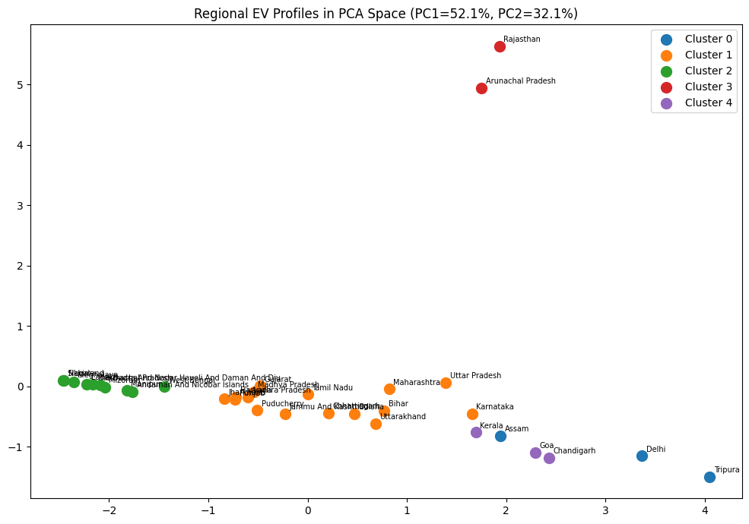
Figure 7. Regional EV profiles projected onto the first two principal components. Together PC1 and PC2 account for 84.2% of the variance in the six standardised historical indicators.
Table 10.4. Cluster profiles (means of the historical indicators and the 2024 outcome)
Cluster | n | 2021 rate | 2022 rate | 2023 rate | EV regs 2023 | Total regs 2023 | 2024 rate
0 | 3 | 4.77% | 10.09% | 11.42% | 49,540 | 470,127 | 10.98%
1 | 16 | 1.54% | 4.31% | 5.69% | 74,269 | 1,182,115 | 6.32%
2 | 10 | 0.38% | 0.44% | 0.69% | 2,339 | 129,897 | 1.27%
3 | 2 | 1.78% | 4.82% | 6.37% | 1,625,981 | 25,537,299 | 3.45%
4 | 3 | 1.94% | 6.03% | 11.23% | 30,559 | 297,845 | 13.89%
Table 10.5. Cluster membership
Cluster | Character | Regions
0 | Established high adoption | Tripura, Delhi, Assam
1 | Broad middle market | Karnataka, Uttar Pradesh, Maharashtra, Odisha, Jammu and Kashmir, Bihar, Puducherry, Uttarakhand, Chhattisgarh, Punjab, Andhra Pradesh, Tamil Nadu, Madhya Pradesh, Gujarat, Haryana, Jharkhand
2 | Low adoption | West Bengal, Meghalaya, Mizoram, Dadra and Nagar Haveli and Daman and Diu, Manipur, Himachal Pradesh, Andaman and Nicobar Islands, Ladakh, Sikkim, Nagaland
3 | Volume outliers | Rajasthan, Arunachal Pradesh
4 | Fast-accelerating adoption | Goa, Chandigarh, Kerala

Interpretation
Four of the five clusters describe recognisable adoption profiles. Cluster 0 contains regions that were already at high adoption by 2021 and have stayed there. Cluster 4 contains regions that started lower and climbed much faster, ending 2024 with the highest average rate of any group at 13.89%, and its members are the three regions with the steepest share increase between 2022 and 2023. Cluster 1 is the broad middle of the country, sixteen states averaging 6.32% in 2024. Cluster 2 is the low-adoption group, ten regions averaging 1.27%.
Cluster 3 is different in kind. It contains only Rajasthan and Arunachal Pradesh, and what separates them is not their adoption behaviour but their registration volumes: average 2023 total registrations of 25.5 million against 1.2 million for the next largest cluster. In the PCA plot these two sit alone at the top, separated almost entirely along the second component. This cluster is an artefact of the extreme registration rows documented in Section 6.5 rather than a real behavioural segment, and it is useful mainly as independent confirmation that the data-quality problem is large enough to distort an unsupervised analysis.

Strengths and weaknesses here
The segmentation adds a dimension the classifiers cannot provide, since it distinguishes established leaders from fast climbers, which is a genuinely different policy situation. Its weaknesses are that K-Means assumes roughly spherical clusters of similar size, which is a poor fit for a dataset containing a two-member outlier group, that the silhouette evidence for k = 5 is weak, and that with 34 points the clusters are small enough that moving a single region between groups would change the profile means noticeably.

11. Model Evaluation and Comparison

11.1 Classification results
Table 11.1. Classification performance and cross-validation
Model | Test accuracy | Test ROC-AUC | Mean CV ROC-AUC | CV std. dev. | Assessment
Logistic Regression | 1.00 | 1.00 | 1.00 | 0.00 | Perfect and stable; interpretable coefficients make it the most defensible choice
Decision Tree | 1.00 | 1.00 | 0.98 | 0.04 | Perfect on the test split but least stable across folds; yields the clearest rule
Random Forest | 1.00 | 1.00 | 1.00 | 0.00 | Perfect and stable; best feature-importance output
Gradient Boosting | 1.00 | 1.00 | 1.00 | 0.00 | Perfect and stable; added complexity with no measurable gain

Reading these numbers honestly
Four different algorithms with very different inductive biases all reached the same ceiling on both the held-out split and cross-validation. When a linear model and a boosted ensemble agree perfectly, the usual explanation is that the problem is easy, not that all four models are excellent.
Examining the actual test split confirms this. The nine test regions are Kerala and Karnataka, both labelled high adoption, together with Rajasthan, West Bengal, Punjab, Himachal Pradesh, Mizoram, Ladakh and Haryana, all labelled normal. Kerala's 2023 adoption rate is 9.99% and Karnataka's is 8.74%. The highest 2023 rate among the seven negatives is Rajasthan's at 6.36%. A single threshold anywhere between 6.4% and 8.7% classifies all nine correctly, and that is precisely the rule the Decision Tree found at 7.2%. Any model that learns the same threshold, and all four do, will score perfectly.
This does not mean the models are worthless. It means their perfect scores measure the separability of the target rather than model quality, and that the honest headline finding is about the data: the 2023 EV adoption rate predicts 2024 high-adoption status almost deterministically in this sample.

What each metric contributes
Accuracy of 1.00 means all nine test regions were labelled correctly. Because 73.5% of regions are negative, a model that predicted "normal" for everything would score 0.735, so 1.00 is meaningfully above the naive baseline, but on nine observations the gap corresponds to correctly identifying two positives.
ROC-AUC of 1.00 means every high-adoption region received a higher predicted probability than every normal region. This is more informative than accuracy because it does not depend on the 0.5 cut-off, and it is what makes the graded probabilities in the final scoring table usable for ranking.
Precision of 1.00 for the high-adoption class means no region was wrongly shortlisted, and recall of 1.00 means no genuinely high-adoption region was missed. For infrastructure planning these two errors have very different costs. A false positive means chargers installed where demand arrives later than expected, which wastes capital. A false negative means a growing region is left without infrastructure, which suppresses adoption and is harder to reverse. If this model were ever deployed, we would want the decision threshold set below 0.5 to favour recall, accepting more false positives to avoid missing an emerging region.
The cross-validation column is the most useful part of Table 11.1. It shows the Decision Tree dropping to 0.90 in one of five folds, which is exactly the brittleness a single-threshold rule would predict, while the other three models hold at 1.00 in every fold.
11.2 Regression results
Table 11.2. Regression model comparison
Model | R² | RMSE | MAE | Assessment
Random Forest | 0.6658 | 0.0283 | 0.0222 | Best overall; lowest RMSE and most evenly distributed errors
Gradient Boosting | 0.6072 | 0.0307 | 0.0245 | Middle on every metric; no advantage over the forest
Linear Regression | 0.5991 | 0.0310 | 0.0211 | Lowest MAE but highest RMSE, and produced impossible negative predictions
The three models are separated by less than seven percentage points of R², which on a nine-observation test set is not a decisive gap. The ordering is plausible rather than proven, and a different random seed could reorder them. What can be said with more confidence is that all three land in the same broad range, explaining somewhere around 60% to 67% of the variation, and none of them approaches the accuracy the classification track appears to show.
Overfitting is a reasonable concern across the regression track. Every model has 11 features and 25 training rows, which is close to the point where a flexible model can fit the training data almost exactly. The modest test R² alongside that ratio is consistent with models that are fitting training noise, which is another reason to treat the continuous estimates as indicative only.
11.3 Which features the models rely on
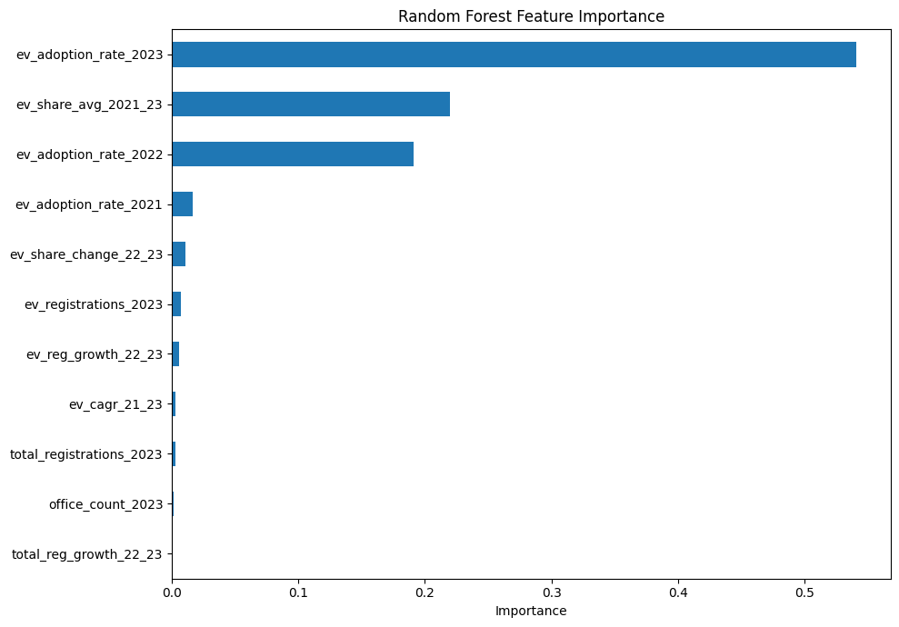
Figure 8. Random Forest feature importance for the high-adoption classification.
Table 11.3. Random Forest feature importance
Feature | Importance | Share
ev_adoption_rate_2023 | 0.5413 | 54.13%
ev_share_avg_2021_23 | 0.2201 | 22.01%
ev_adoption_rate_2022 | 0.1913 | 19.13%
ev_adoption_rate_2021 | 0.0162 | 1.62%
ev_share_change_22_23 | 0.0104 | 1.04%
ev_registrations_2023 | 0.0071 | 0.71%
ev_reg_growth_22_23 | 0.0057 | 0.57%
ev_cagr_21_23 | 0.0031 | 0.31%
total_registrations_2023 | 0.0030 | 0.30%
office_count_2023 | 0.0011 | 0.11%
total_reg_growth_22_23 | 0.0008 | 0.08%

Interpretation
Three features carry 95.3% of the total importance, and all three are adoption-share levels. The 2023 rate alone accounts for more than half. Everything else together, including all four growth and volume variables, accounts for under 3%.
Two conclusions follow. The first is that recent adoption level is the signal, and momentum measures add almost nothing on top of it. That is a slightly deflating result for the feature-engineering effort, since six of the eleven features turned out to be close to redundant, but it is a clean answer to one of the questions the project set out to ask. The second is that market size does not help predict adoption share, which is expected given that the target is a ratio, but it reinforces why the final output has to report volume separately rather than relying on the model to surface it.

A caution about reading importance
Feature importance describes what the model used, not what causes EV adoption. The 2023 adoption rate does not cause the 2024 rate. Both are driven by underlying conditions the dataset does not contain: charging availability, state incentive schemes, income levels, fleet composition and urban density. The correct reading is that the 2023 rate is a good proxy for those unobserved conditions, which is exactly why it predicts well and also why it would stop predicting well if a state changed its policy sharply. The importance ranking is also affected by the strong correlations among the three level variables, since correlated predictors share importance between them in ways that make individual values hard to compare.
11.4 Choosing a model
On metrics alone there is nothing to choose between Logistic Regression, Random Forest and Gradient Boosting. Since the metrics do not separate them, the decision falls to what the models offer beyond their scores.
The project's final scoring step uses two models rather than one, which we think is the right call. Logistic Regression is retained because it produces graded, interpretable probabilities and its coefficients can be explained to a non-technical stakeholder. Random Forest is retained because it handles non-linearity if any exists and provides the importance ranking. Requiring both to agree before a region is flagged gives a consensus rule that is more conservative than either model alone, and the one region where they disagree, Maharashtra, is a genuinely borderline case that deserves human judgement rather than an automated label.
Gradient Boosting was dropped from the final scoring because it duplicates Random Forest's behaviour without adding interpretability. The Decision Tree is not used for scoring either, but its single rule is arguably the most useful output of the whole classification exercise for communication purposes.
For the regression track, Random Forest is the better model on RMSE and error distribution, but with an R² of 0.6658 on nine test points, we would not present its point estimates as forecasts. Its role is to provide a rough ordering, not a number to plan against.

12. Final Scored Output and Planning View

12.1 How the final scores were produced
For the deliverable, Logistic Regression and Random Forest were refitted on all 34 regions rather than on the 25-region training split. Using the full sample for the final fit is standard once model selection is complete, since the earlier split has already served its purpose of giving an unbiased estimate of performance. The trade-off is that the probabilities these models assign to regions they were trained on are optimistic, and the scores in Table 12.1 should be read as fitted values rather than as out-of-sample predictions.
Each region received two probabilities, one from each model. A region carries the priority flag when both models assign at least 0.50. Requiring agreement rather than averaging is a deliberately conservative rule: it means a region only gets flagged when a linear and a non-linear view of the data both support it.
12.2 The shortlist
Table 12.1. Regions flagged by both models (consensus priority list)
Region | 2024 EV registrations | 2024 adoption rate | Logistic probability | Random Forest probability
Goa | 5,754 | 16.44% | 95.3% | 98.4%
Karnataka | 72,539 | 9.10% | 78.7% | 98.2%
Chandigarh | 2,450 | 13.87% | 97.8% | 97.0%
Tripura | 3,243 | 12.29% | 99.7% | 96.5%
Assam | 25,062 | 8.65% | 81.1% | 96.2%
Delhi | 34,343 | 11.99% | 97.9% | 94.0%
Uttar Pradesh | 130,189 | 8.26% | 64.6% | 89.6%
Kerala | 35,344 | 11.35% | 94.0% | 85.7%
Eight of the nine regions labelled high adoption appear on the consensus list. The exception is Maharashtra, where Random Forest assigns 80.5% but Logistic Regression assigns only 37.5%, so the agreement rule excludes it. The disagreement is worth understanding rather than dismissing. Maharashtra's 2023 adoption rate of 7.58% falls just below the tree's 7.2% threshold region and below the level that makes the linear model confident, while its large absolute EV volume and non-linear feature combination push the forest towards a positive call. In practice this is the kind of case a planning team should look at manually, since a state registering more than 94,000 electric vehicles in five months is not a marginal market by any operational measure.
The list is also a good illustration of why the models alone cannot make the decision. Goa and Chandigarh top the probability rankings but register 5,754 and 2,450 electric vehicles respectively, while Uttar Pradesh sits last on logistic probability and registers 130,189. Ranked by probability the order is one thing; ranked by the number of vehicles that will actually need charging it is almost reversed.
12.3 Adoption rate against volume
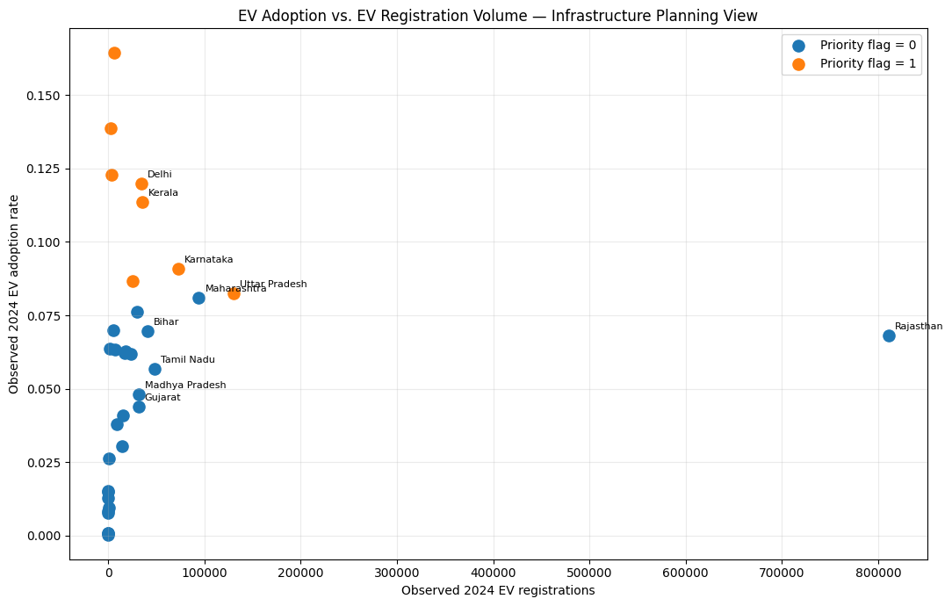
Figure 9. Observed 2024 EV adoption rate against observed 2024 EV registrations. Flagged regions are shown separately from unflagged ones.

What the figure shows
Most regions sit crowded against the left axis, with fewer than 50,000 EV registrations. The flagged regions spread up the vertical axis but stay mostly to the left, meaning they combine high adoption rates with modest absolute volumes. Uttar Pradesh and Karnataka are the exceptions, appearing both flagged and relatively far right. Maharashtra sits just below the flagged group at a similar volume. Rajasthan is a lone point at the far right with 810,834 EV registrations at a 6.80% adoption rate, an order of magnitude beyond every other region on the horizontal axis.
13. Key Findings
13.1 What the data showed
- National EV adoption rose from 0.68% of recorded registrations in 2019 to 6.85% in the January–May 2024 window, with the acceleration beginning around 2021 rather than at the start of the series.
- Adoption is very unevenly distributed. The 2024 rate ranges from 0.02% to 16.44% across the 34 regions, with a mean of 5.75% and a standard deviation of 4.21 percentage points.
- The leading regions are a mixture of compact urban territories (Goa, Chandigarh, Delhi), states with active EV policy (Kerala, Karnataka) and north-eastern states (Tripura, Assam) whose position is harder to explain from the dataset alone.
- Adoption rate and adoption volume are close to independent. The highest-percentage region registers about 5,754 electric vehicles in the period while a lower-percentage region registers 130,189.
- The electric measure rests entirely on one fuel-type label, Electric(Bov), which accounts for 17,524,732 registrations. Two smaller electric categories are missed by the filter but represent only about 0.27% of the electric total.

13.2 Statistical relationships
- The 2023 adoption rate correlates with the 2024 rate at 0.92, the 2022 rate at 0.82 and the 2021 rate at 0.69. Adoption is strongly persistent and recency matters.
- The change in adoption share between 2022 and 2023 correlates with the 2024 rate at 0.70, so momentum measured in percentage points carries real signal.
- Percentage growth in EV registrations correlates with the outcome at -0.10, essentially no relationship. Growth measured off a small base is dominated by regions whose absolute numbers are negligible.
- The three annual adoption-rate variables correlate with each other between 0.81 and 0.93, so they carry heavily overlapping information rather than three independent signals.

13.3 What the models revealed
- All four classifiers achieved accuracy and ROC-AUC of 1.00 on the held-out test set. Three of the four held a mean cross-validated ROC-AUC of 1.00 across five folds; the Decision Tree reached 0.98.
- The fitted Decision Tree used a single split: regions with a 2023 EV adoption rate above 7.2% were classified as high adoption, and this separated all 25 training regions perfectly.
- Random Forest importance concentrated 95.3% of its weight in three adoption-level features, with the 2023 rate alone at 54.13%. All growth and volume features together accounted for under 3%.
- Regression performance was far more modest. The best model, Random Forest, reached an R² of 0.6658 with an RMSE of 0.0283, meaning typical errors of about 2.8 percentage points against a target with a standard deviation of 4.2 points.
- Examining the test split showed why classification looks perfect: the two positive test regions have 2023 rates of 9.99% and 8.74% while the highest negative is at 6.36%, so any threshold in between classifies all nine correctly.
- K-Means with k = 5 produced four interpretable adoption profiles plus a two-member cluster containing Rajasthan and Arunachal Pradesh that is separated by registration volume rather than adoption behaviour.
16. Recommendations
16.1 Use adoption rate and EV volume together, never rate alone
What: any priority ranking for charging infrastructure should combine the adoption rate with the absolute number of electric vehicles registered, using something like the four-quadrant framework in Section 12.4.
Why: the two measures identify different regions, and infrastructure serves vehicles rather than percentages.
Support: Figure 9 shows no strong relationship between the two axes. Goa leads on rate with 5,754 registrations while Uttar Pradesh sits at the bottom of the high-adoption group with 130,189, more than twenty times as many.
16.2 Adopt the previous-year share threshold as an operational screening rule
What: use a rule of the form "flag regions whose EV share exceeded roughly 7% last year" as a first-pass screen, refreshed annually.
Why: it is simple, transparent, requires no modelling infrastructure and reproduces the classifier's decisions on this data.
Support: the fitted Decision Tree separated all 25 training regions with a single split at 7.2% on the 2023 adoption rate, and Random Forest assigned 54.13% of its importance to that one variable.
17. Future Scope
17.1 Fix the sample-size problem with a panel design
The single most valuable change would be to move from 34 cross-sectional rows to a state-year panel. Predicting each year from the two preceding years across 2021 to 2024 would yield roughly a hundred training observations instead of twenty-five, which is enough to support hyperparameter tuning and a proper validation set. It would also let the models learn how adoption trajectories evolve rather than only where they currently sit.
17.2 Add external variables
Registration history is a proxy for conditions the dataset does not observe. Population and vehicle ownership per capita, urbanisation, per-capita income, electricity distribution capacity, highway density, existing charging-station locations, state incentive schemes and commercial fleet activity would all plausibly carry independent signal. With those variables the models could begin to explain adoption rather than only extrapolate it, and feature importance would become genuinely informative rather than a restatement of persistence.
18. Conclusion
We set out to find whether public vehicle-registration data alone could tell planners which Indian states and union territories are heading towards high EV adoption, so that charging infrastructure could be positioned ahead of demand rather than behind it. After building a state-level dataset from 418,372 registration records, engineering eleven historical features, and comparing seven supervised models and a clustering layer, the answer is a qualified yes with an important twist.
19. References
The project used one dataset and the standard Python scientific stack. No external literature was cited in the notebook or the presentation, and none has been added here.
Type | Reference
Dataset | Ministry of Road Transport & Highways, Government of India. Vahan vehicle registrations by fuel type. File used: vahan-vehicle-registrations-by-fuel-type-nmiqeb.csv, covering January 2019 to May 2024.
Software | Python, with pandas and NumPy for data handling, Matplotlib and Seaborn for visualisation, and scikit-learn for all modelling, cross-validation, clustering and evaluation.

