Lab 3.3 Lab Digital Signatures & Digital Certificates

Lab Objectives
By the end of this lab, you should be able to:
- Inspect and interpret digital certificates using a web browser
- Identify different types of certificate trust problems
- Verify a digital signature using Adobe Acrobat Reader
- Explain how digital signatures detect tampering
- Explain why PKI and Certificate Authorities are necessary

Part A – Inspecting a Trusted Certificate
In this section, you will examine the Digital Certificates of several websites.
To examine the Digital Certificates on most browsers:
- Click on the icon in the address bar that is just to the left of the address of the site you are visiting. In most browsers, the icon is a padlock.
- In the menu that opens, click on “Connection is Secure” or similar.
- This step varies from browser to browser. Below are instructions for MS Edge and Chrome:
  - Edge – click on the certificate icon on the top right of the prompt.
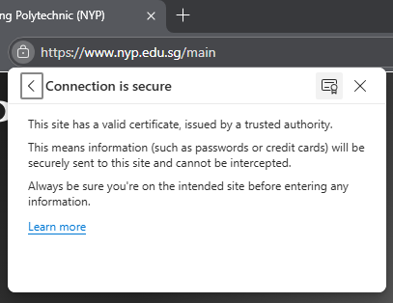
  - Chrome – click on “Certificate is valid”.
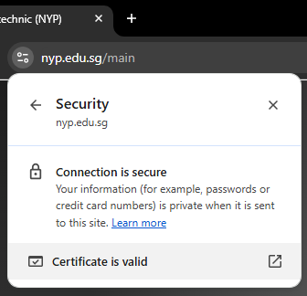
  - Other browsers – it should be quite intuitive. Search on the web if necessary or ask your classmates or tutor for help.

Website A (Trusted Certificate)
Instructions
- Open https://www.google.com in your browser.
- View the digital certificate.
- Examine the certificate details carefully and complete the table below.
Field | Observation
Website URL | https://nyplms.polite.edu.sg/content/enforced/839477-25S2-IT1922/2025s2/Lab/Lab%203.3/original_document_signed.pdf?isCourseFile=true&ou=839477
Subject (Issued To) | nyplms.polite.edu.sg
Issuer (Certificate Authority) | Amazon RSA 2048 M04
Valid From | Saturday, October 25, 2025 at 8:00:00 AM
Valid Until | Monday, November 23, 2026 at 7:59:59 AM
Browser Trust Status (delete accordingly) | Trusted

Concept Check
Q1. Why does your browser trust this certificate?
The certificate contains a digital signature from an intermediate CA

Part B – Identifying Certificate Problems (40 minutes)
In this section, you will inspect four different websites, each with a specific certificate issue.

Website B1 – Self-Signed Certificate
Instructions
- Attempt to visit https://self-signed.badssl.com.
- Observe the browser warning.
- View the certificate details (if allowed).
Observation | Answer
Browser warning shown | Connection isn’t private
Issuer | No shown
Subject | Not shown
Are Issuer and Subject the same? (Yes/No) | Not shown
Trust Status (delete accordingly) | Trusted / Not Trusted

Concept Question
Q2. Why is this certificate not trusted?
It is self-signed

Website B2 – Expired Certificate
https://expired.badssl.com
Observation | Answer
What is wrong with the validity period? | Expired
Browser warning shown | Yes
Certificate status (delete accordingly) | Expired

Concept Question
Q3. Which stage of the certificate lifecycle failed?
Expiry

Website B3 – Wrong Hostname
https://wrong.host.badssl.com
Observation | Answer
Domain you visited | Cant go
Domain listed in certificate | no
Do they match? (Yes/No) | no
Browser warning shown | yes

Concept Question
Q4. What security risk does a hostname mismatch indicate?
Attackers might try to steal your information

Website B4 – Untrusted Root Certificate
https://untrusted-root.badssl.com
Observation | Answer
Issuer | BadSSL
Is the issuer trusted by your system? (Yes/No) | No
Browser warning shown | Yes

Concept Question
Q5. Why does an untrusted root break the entire trust chain?
If the root is untrusted it connect sign any certificate which thus doesn’t allow anyone to be signed

Important Reflection
Q6. Are these connections encrypted even though they are not trusted? Explain your answer briefly:
No I think. There is just warning shown that the connection isn’t private

Part C – Digital Signature Verification Using Adobe Acrobat

Files Provided
- Digitally signed PDF (original) – Download “original_document_signed.pdf” from LMS
- Modified version of the same PDF – Download “original_document_modified.pdf” from LMS.
This modified document is the modified version of the original digitally signed document. The modifications were made after signing.

Instructions
- Open the original signed PDF in Adobe Acrobat. Use the school lab PC if you do not have Acrobat on your personal PC.
- Click Signature Panel. It should be a bar above the document in Acrobat.
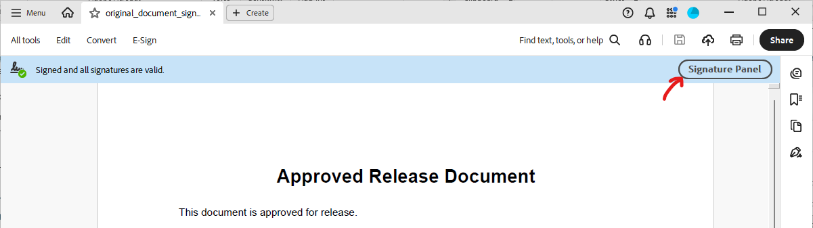
- Check the signature status. (i.e. is it valid?)
- Record the results in the table below.
- Open the modified PDF.
- Check the signature status again.

Record Your Results
File | Signature Status (delete accordingly)
Original signed PDF | valid
Modified PDF | Invalid

Concept Questions
Q7. Why did the signature fail after the file was modified?
Some information is changed

Q8. Which security property does a digital signature primarily protect?
- Confidentiality
- Integrity
- Availability
Answer: ___
Q9. Does a digital signature hide or encrypt the document contents?
- Yes
- No
Answer: ___

Part D – Exit Question (10 minutes)
Answer in 2–3 sentences.
Why does Public Key Infrastructure (PKI) rely on trusted Certificate Authorities, and what happens if that trust is broken?
oAs there are billions of devices and it is impossibke to verify single website.The CA acts as a third party that bridge the gap .If the trust is broken attackers can steal sensitive information of users.

Key Takeaway (Read This Before You Leave)
- Digital certificates establish trust.
- Digital signatures detect tampering.
- Encryption protects secrecy — not identity.
~ End ~

