User guide for “XRD_NREL.py”

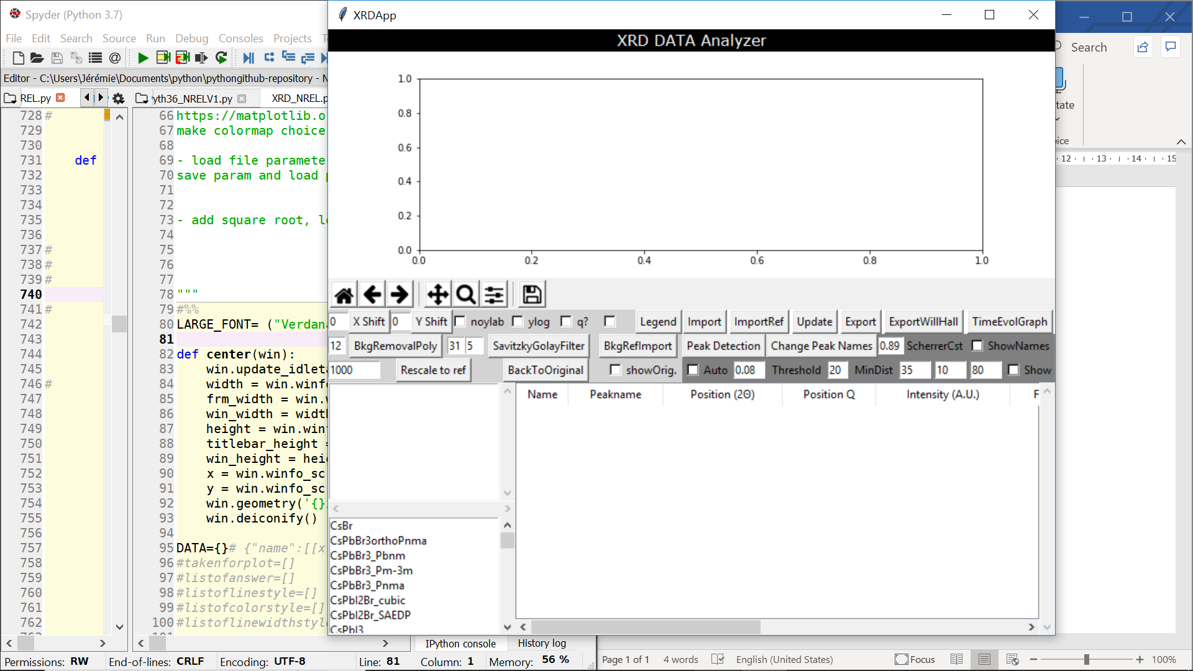

2

5

4

3

1

1. Graph
2. Control buttons panel
3. Selectable sample names after import
4. Database of theoretical and reference experimental data
5. Table showing the results of the peak detection algorithm

# Button descriptions

## BackToOriginal

Removes all modifications done to the data and reinitialize it to the original imported data (only to the selected samples)

## BkgRefImport

Will ask to open a reference file, will read it, interpolate the data, and subtract it from the selected samples: Ynew = Yorig – f(Xorig), where f is the interpolated function of the ref. background data just imported.

## BkgRemovalPoly

It will remove the “base” of the selected samples. The base is detected with the function *peakutils.baseline*, which takes in entry the y data of the sample and the polynomial degree that we entered in the text entry (default is 12). This base is then simply subtracted from the y data of the sample.

## Change Peak Names

User can give specific names to the detected peaks, and then use the ShowNames check box to show them on the graph.

## Export

Export the graph, a text file with its raw data in tabulated columns, and a text file with the results from the peak detection table associated with the plotted samples.

## ExportWillHall

## Import

## ImportRef

To import 2-columns text files and add the data to the reference listbox.

## Legend

Allows to change the legend: names, linestyle, color, line width.

## Noylab

Well… obvious I guess.

## Peak Detection

## q?

if checked, graph is plotted in q space coordinates. If not, in 2theta degree.

## Rescale

Enter a value (default is 1000). The y data will be normalized to this value, taking the maximum intensity as this value.

## SavitzkyGolayFilter

Apply a Savitzky Golay filter to the selected samples, with the aim to remove noise. For a description of this filter: <https://en.wikipedia.org/wiki/Savitzky%E2%80%93Golay_filter>   
it takes 2 parameters that the user can define in the adjacent text entry boxes: left is the window size, right is the polynomial order.  
*Important*: 1) the SG window-size must be larger than the SG order, positive and odd. 2) this filter should be used with caution. It can deform the original peak shape, size, intensity… good practice is to overlay it with the original data and apply some good judgment.

## Show

Shows in black overlay the peak fitting, baseline, and FWHM lines. This is meant as a cross-check for the accuracy of the peak detection algorithm and its defined parameters.

## ShowNames

Insert texts in the graph next to the peaks that were given a name by the user.

## TimeEvolGraph

## Update

Updates the graph…

## X Shift

Enter a number (integer or double, positive or negative). The selected sample(s) x data will be shifted by the entered value.

## Y Shift

Same principle as X Shift, but for the y data.

## Ylog

If checked, the graph will be a semilogy plot. If not, linear. Note that doing a background removal before can lead to sometimes strange log plot…