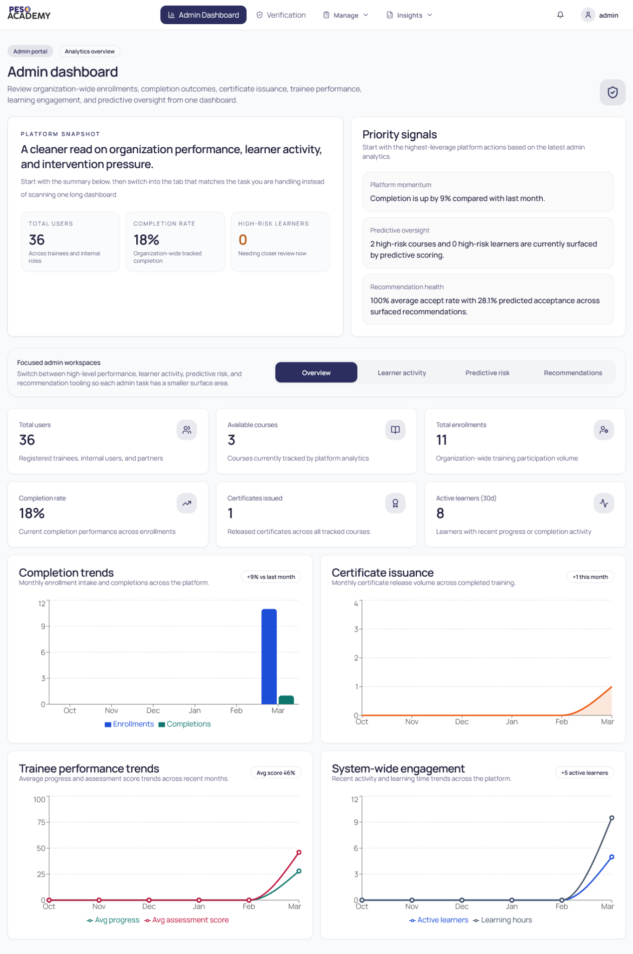
Figure 2: Admin Dashboard

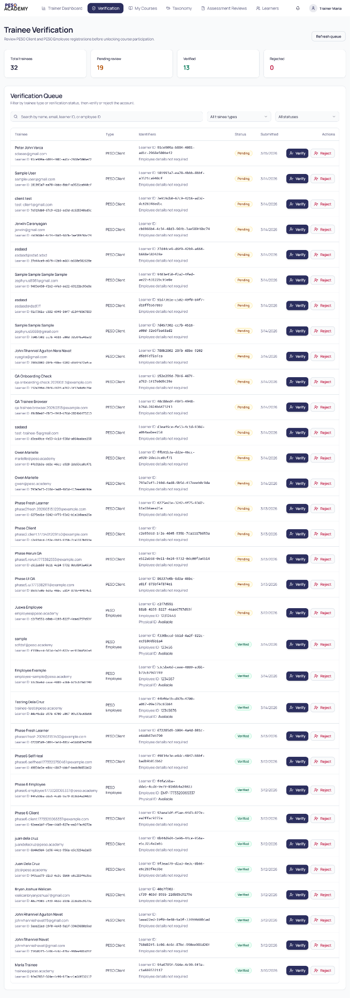
Figure 2: Admin - Account Verification
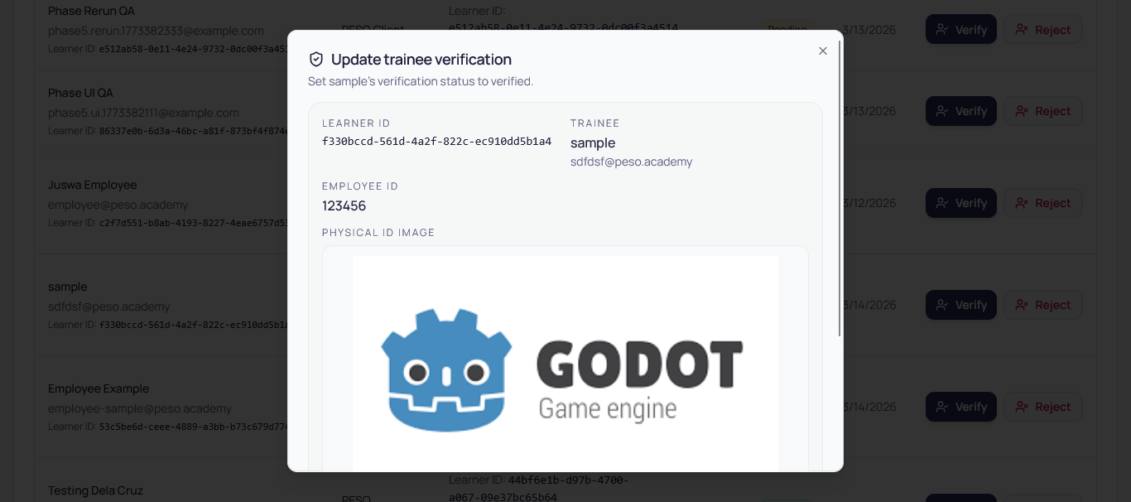
Figure 2.1: Admin - Verifying an account
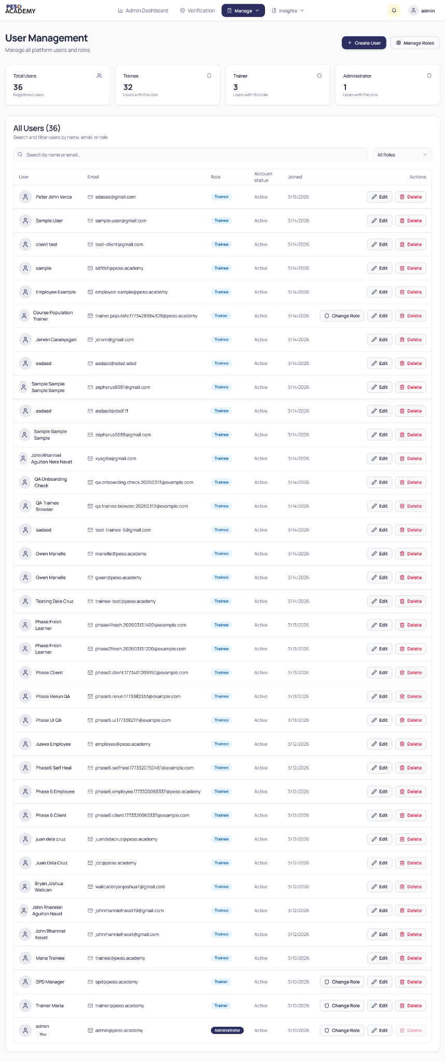
Figure 3: Admin - User Management
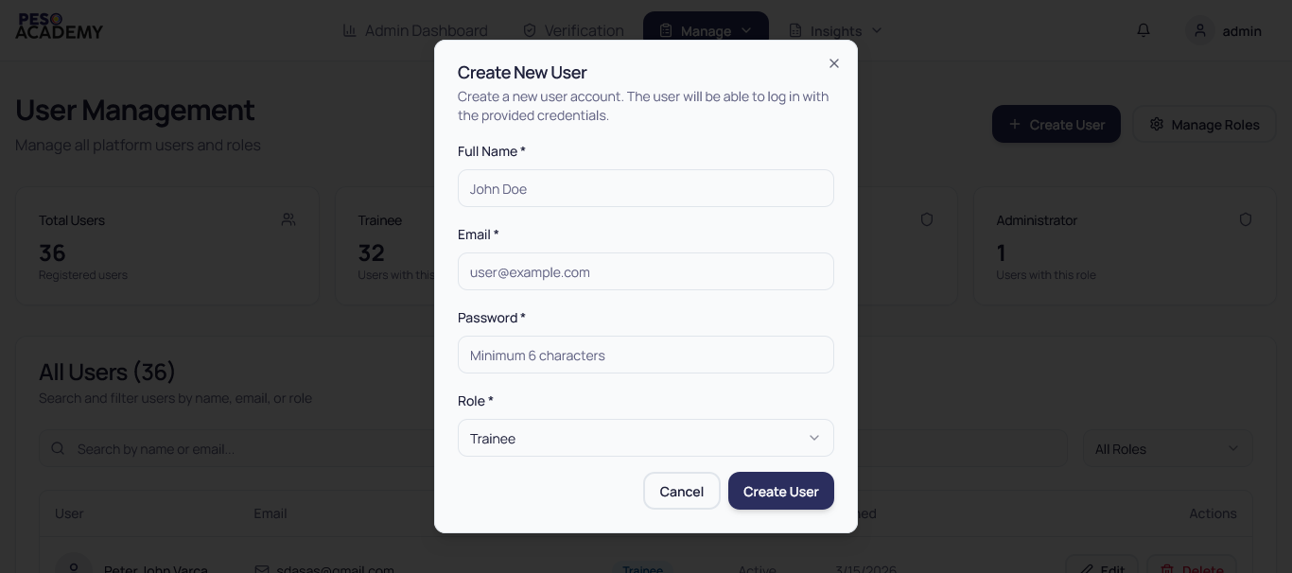
Figure 3.1: Admin - Creating a user
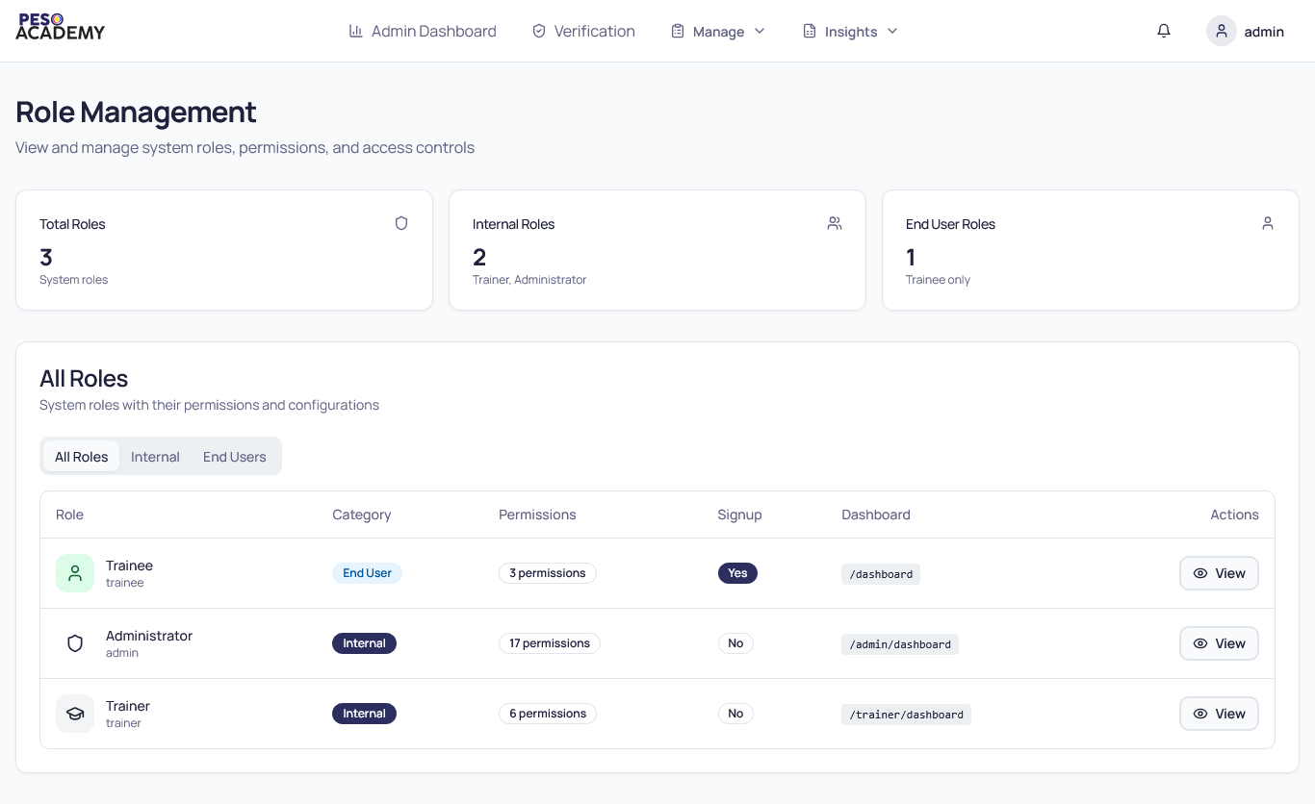
Figure 3.2: Admin - Role Management
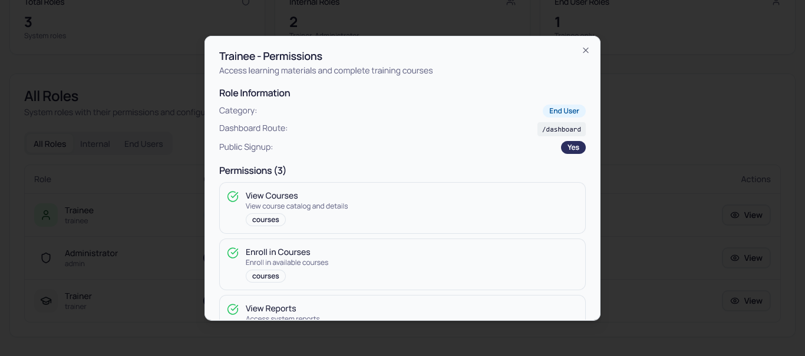
Figure 3.3: Admin - Viewing Role Permission
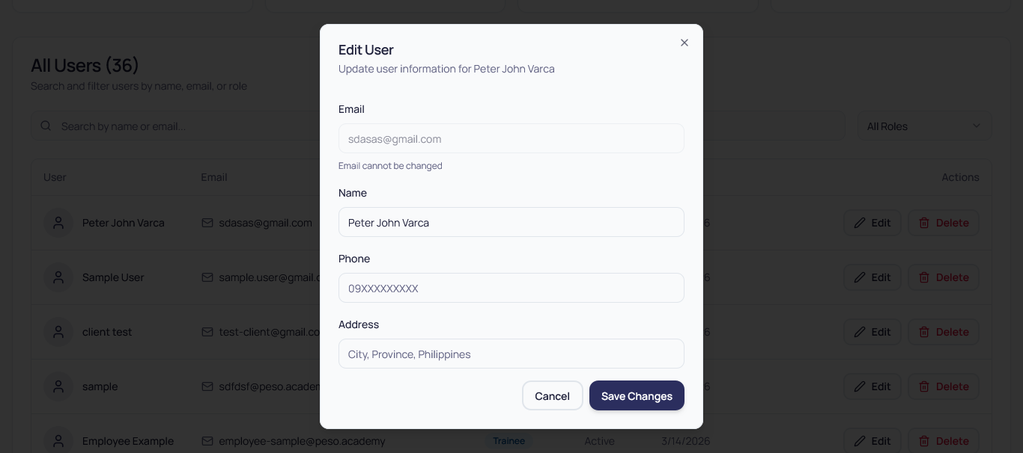
Figure 3.4: Admin - Editing a User Basic Information
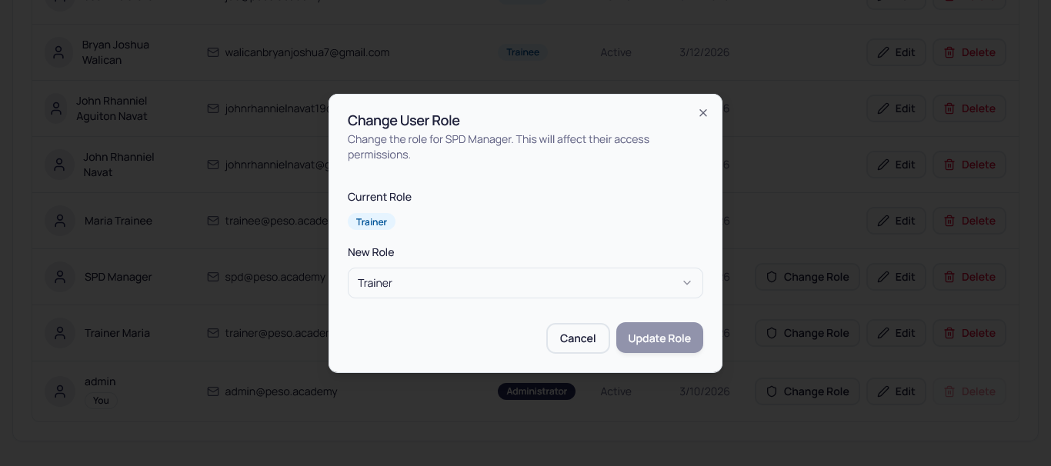
Figure 3.5: Admin - Changing a User Role

Figure 4: Admin & Trainer - Course Management
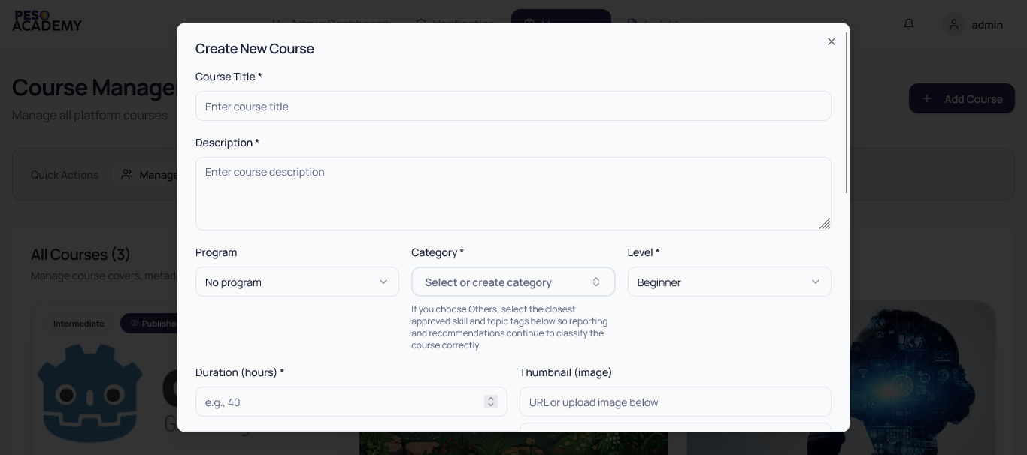
Figure 4.1: Admin & Trainer - Course Creation Modal
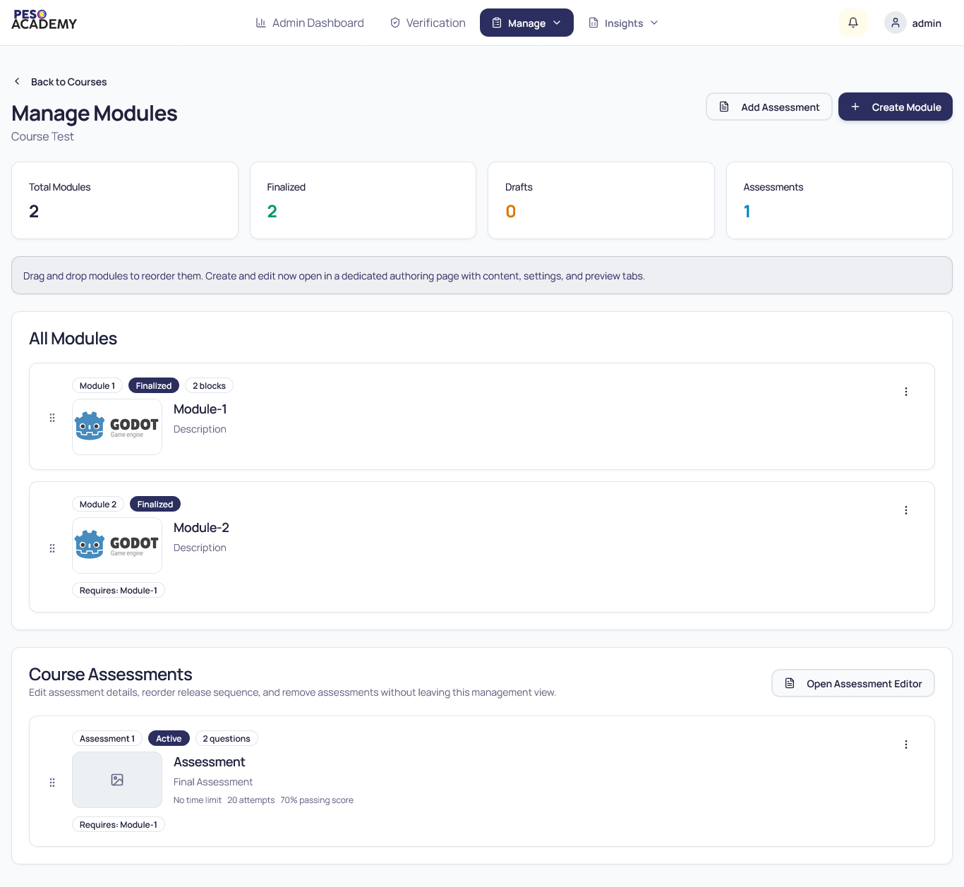
Figure 5: Admin & Trainer - Module Management
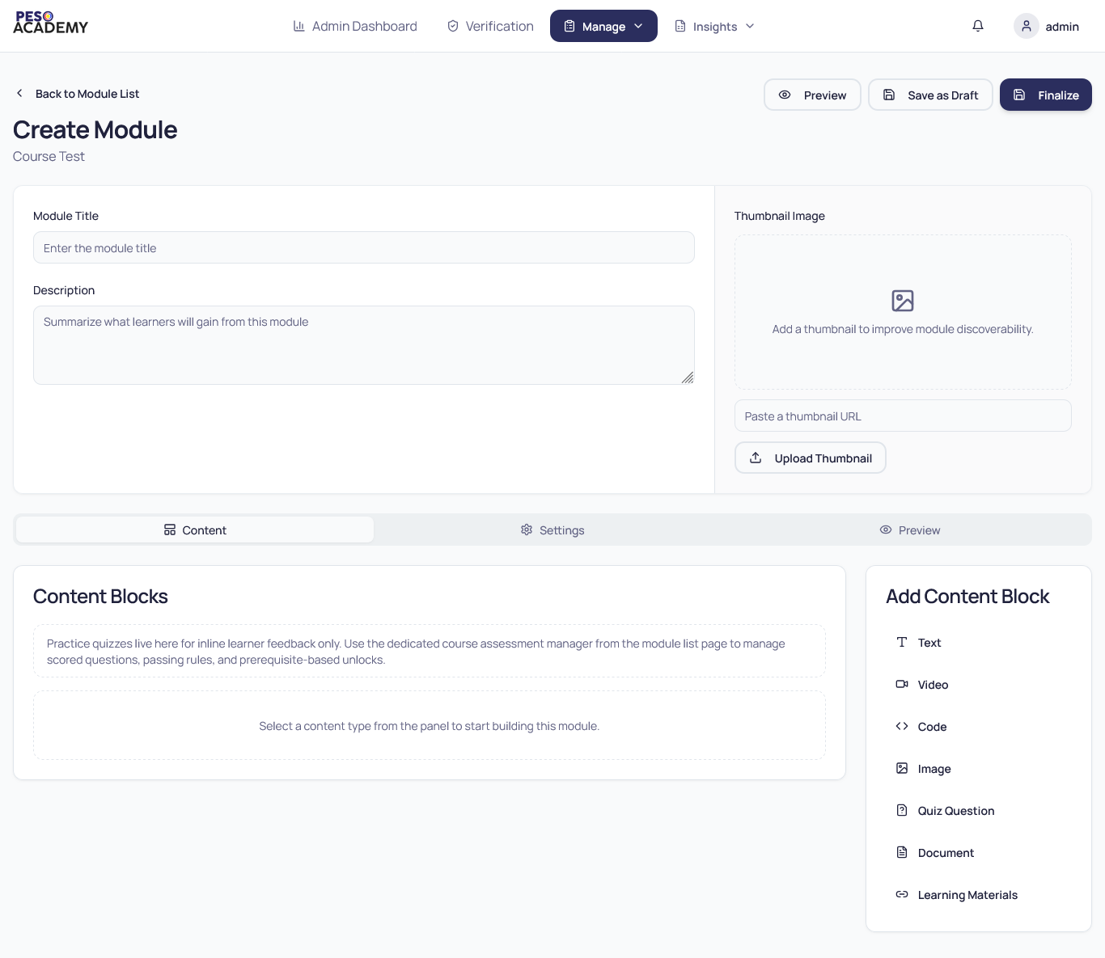
Figure 5.1: Admin & Trainer - Module Creation and Editing
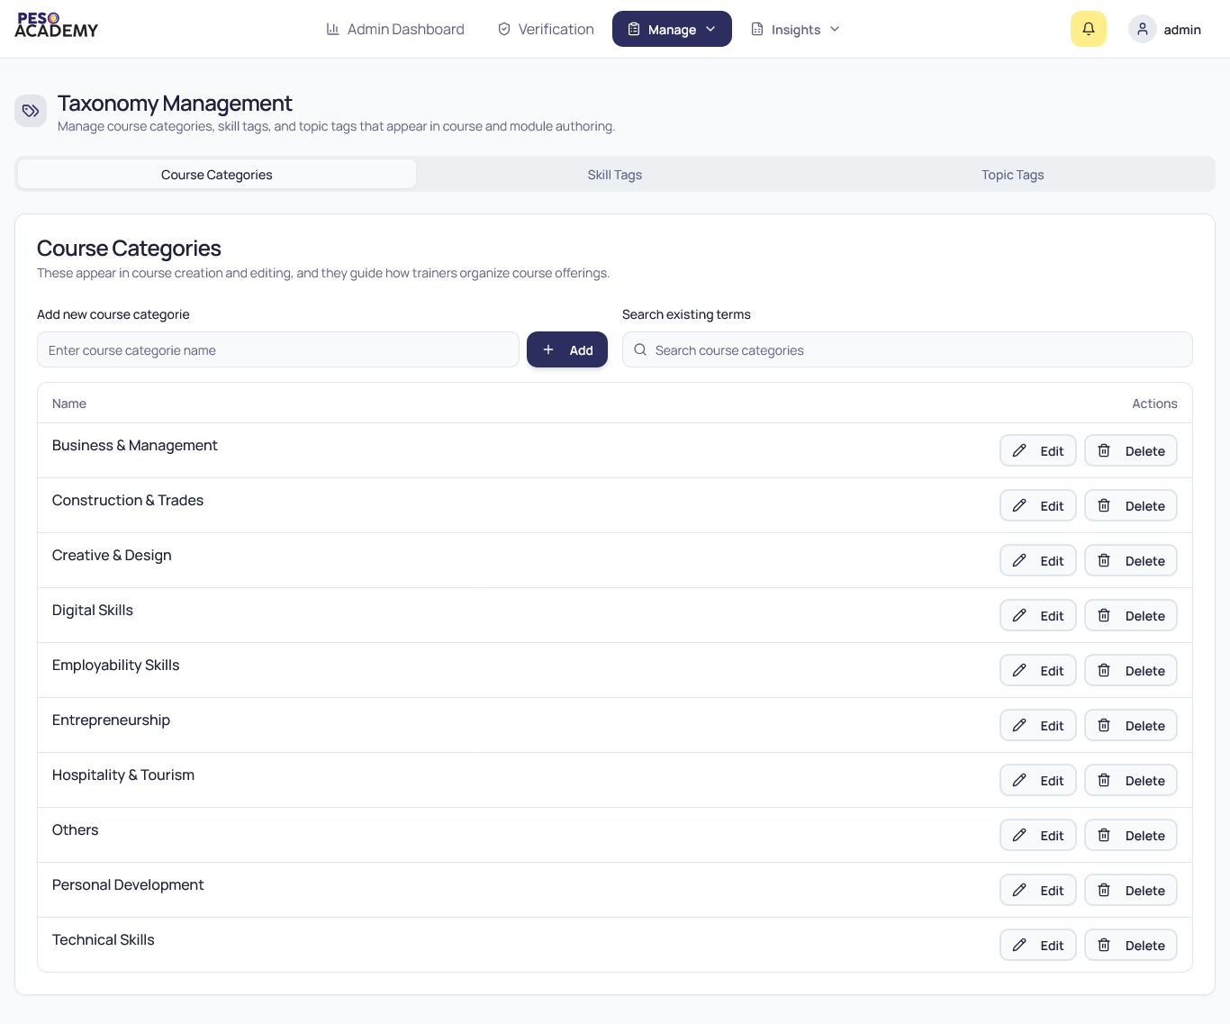
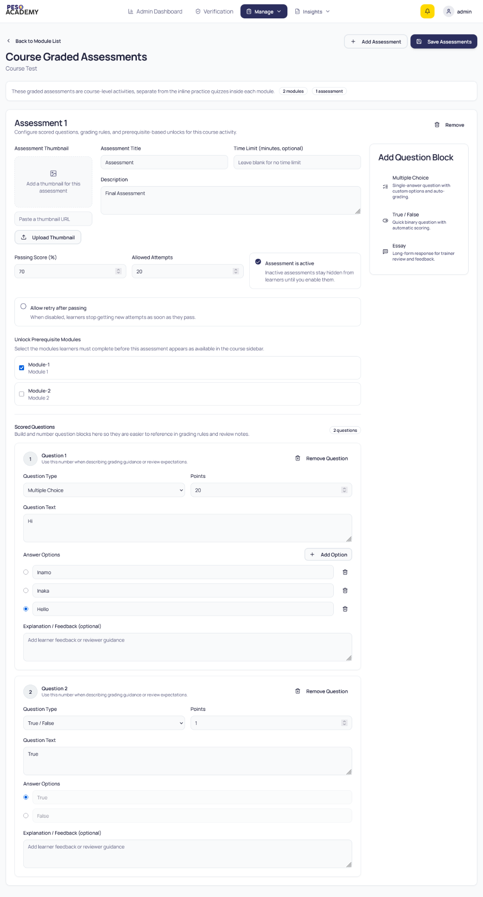
Figure 5.2: Admin & Trainer - Assessment Creation and Editing

Figure 5.1: Admin & Trainer - Taxonomy Management

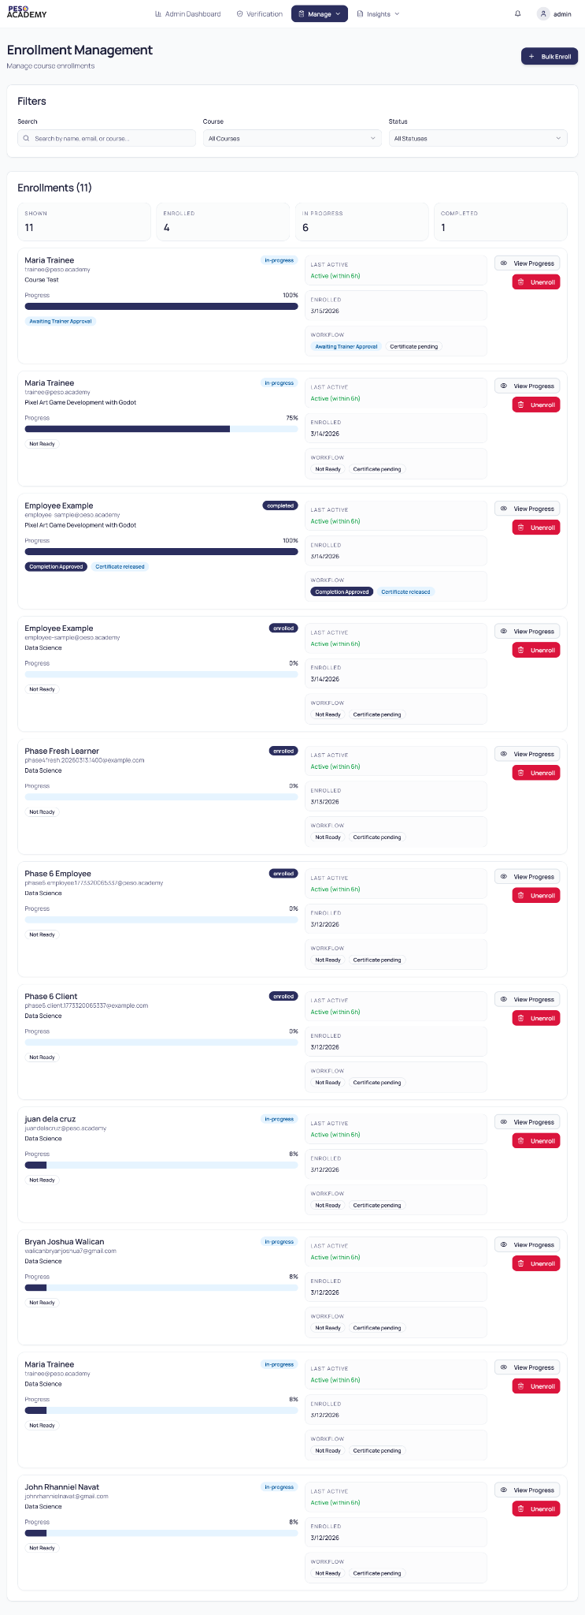
Figure 5.1: Admin - Enrollment Management
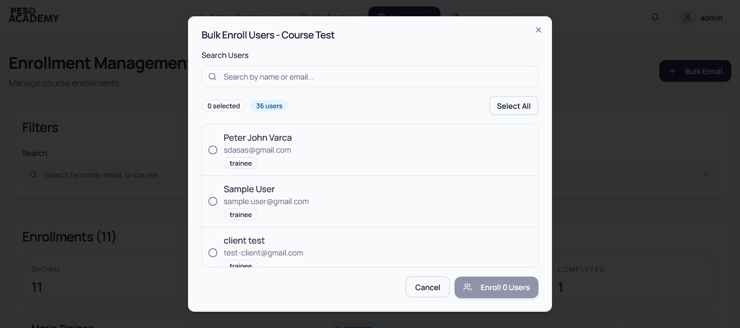
Figure 5.1: Admin - Bulk Enroll Modal
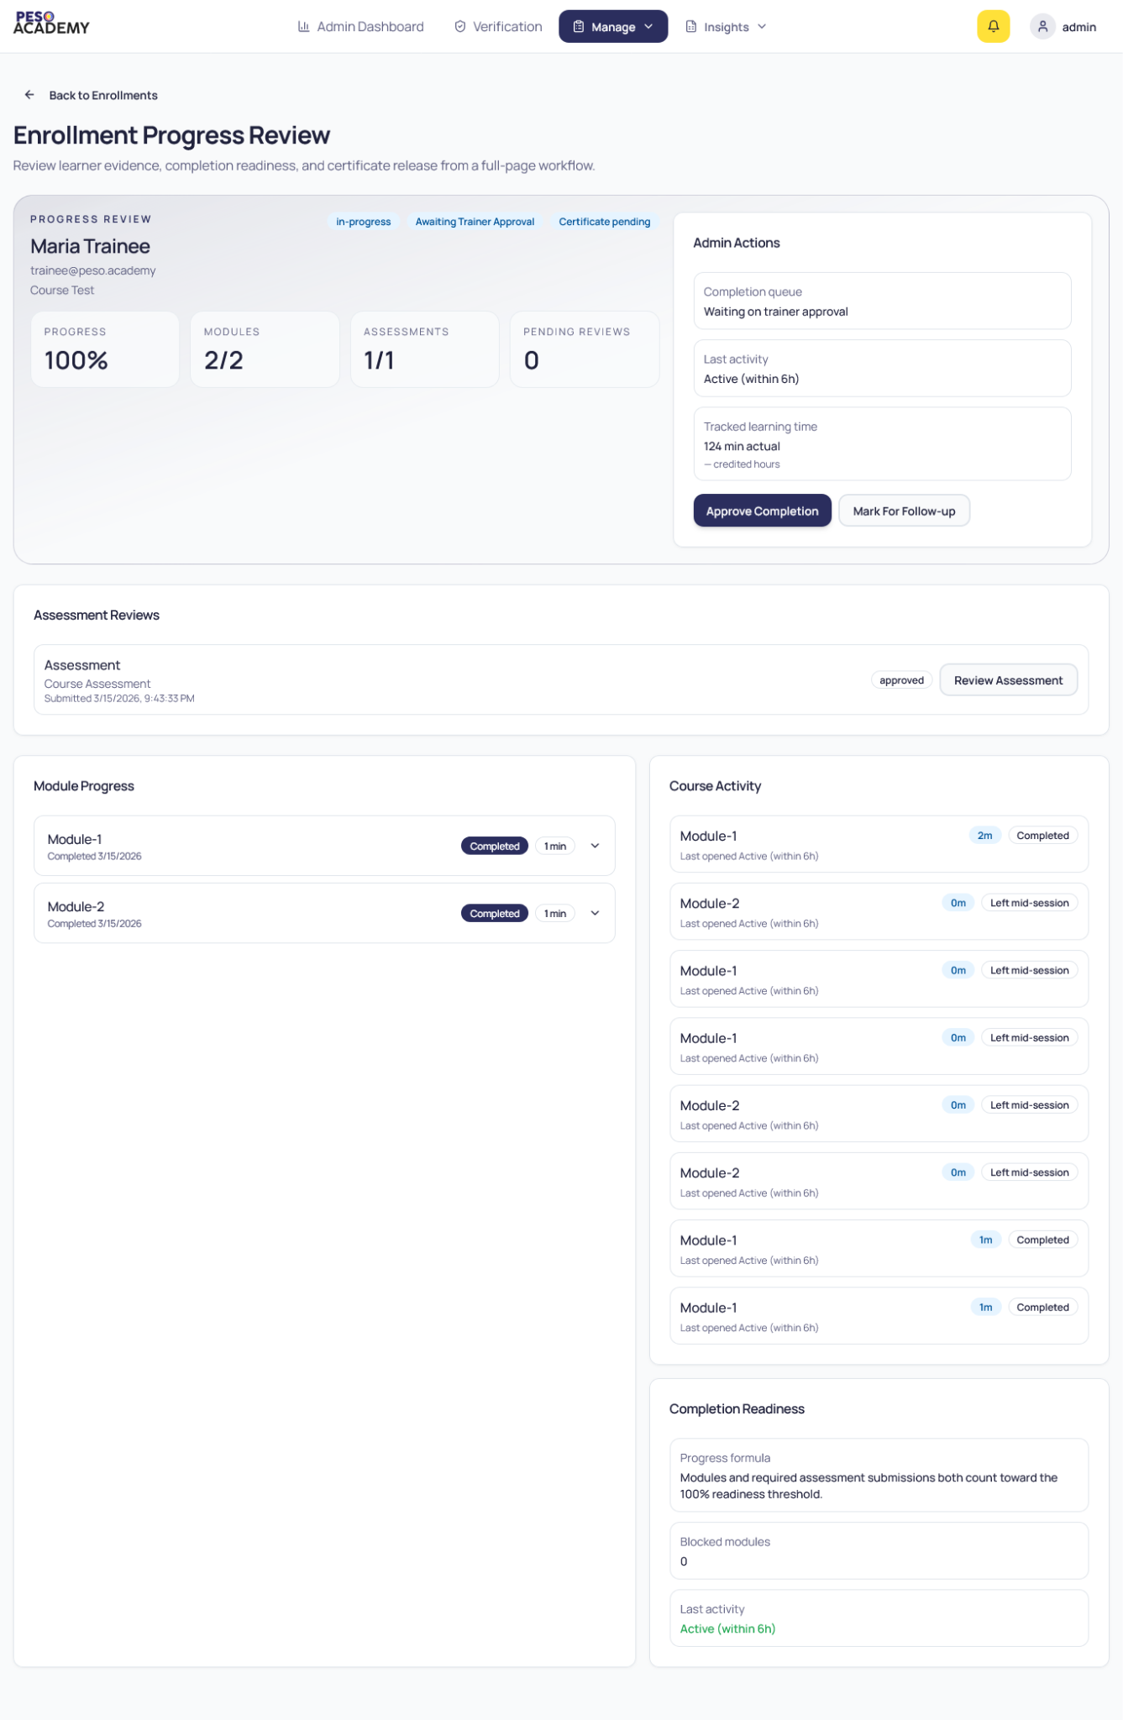
Figure 5.1: Admin & Trainer - Viewing Learner’s Progress
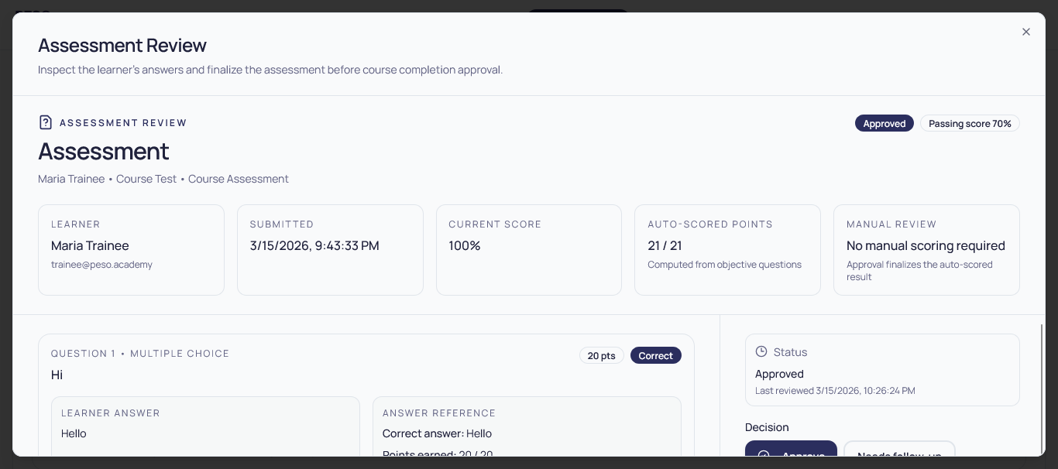
Figure 5.1: Admin & Trainer - Assessment Review Modal
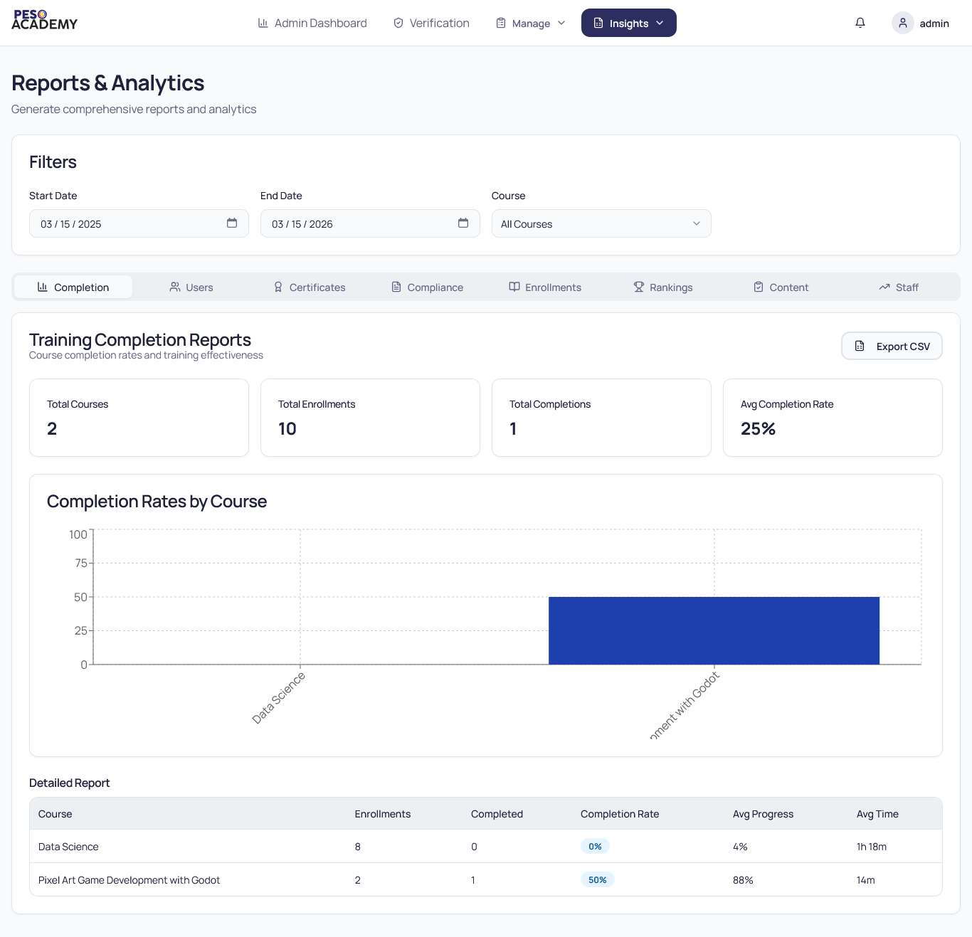
Figure 5.1: Admin - Reports
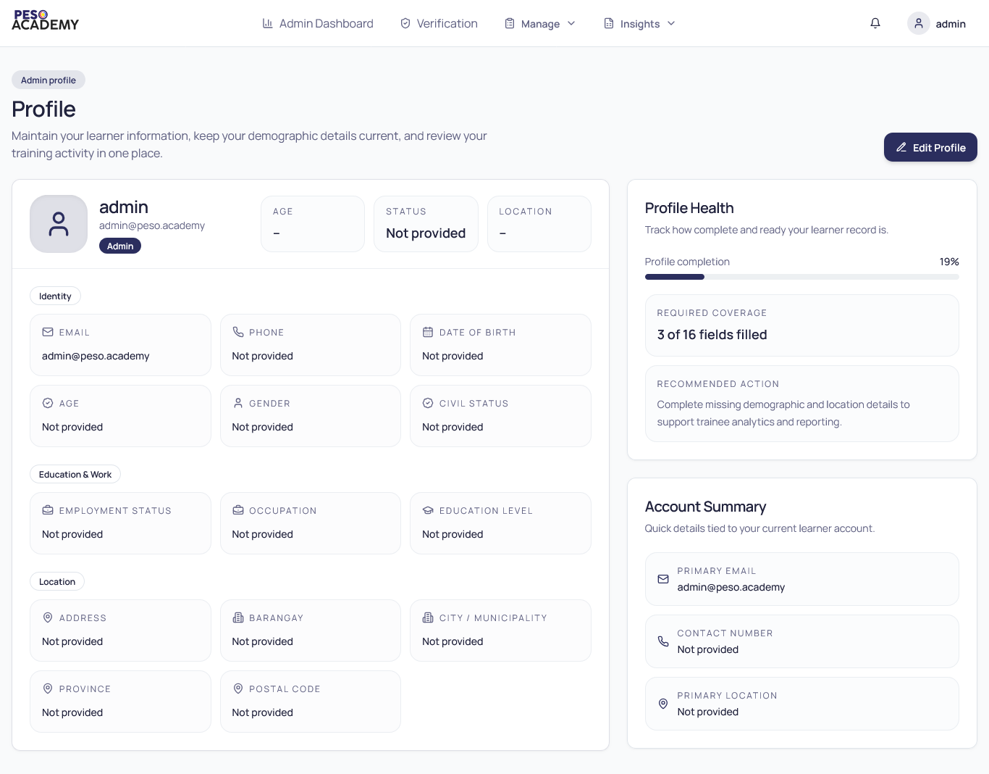
Figure 5.1: Admin, Training Officer, and Learner - Profile
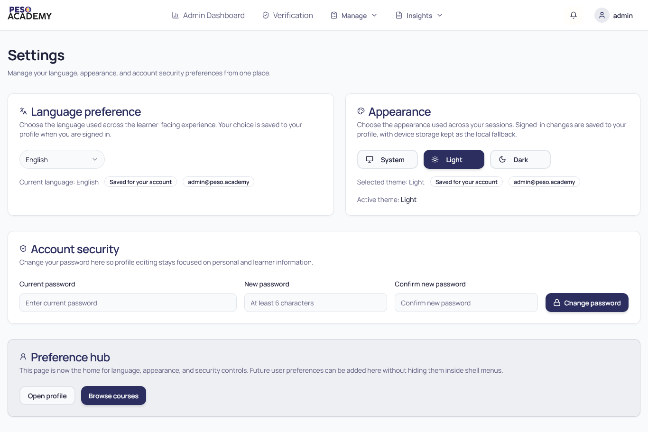
Figure 5.1: Admin, Training Officer, and Learner - Settings

