SmartCare v0.3 - Domain Model Workbook
Week 6 student resource

Requirement-to-Concept Trace
Requirement | Concept | State/behaviour | Decision
FR-01: Create a patient record | Patient | Stores patient information | Include Patient
FR-02: Search for a patient record | Patient | Patient can be identified/searchable | Include Patient
FR-03: Update patient information | Patient | Patient information can be updated | Include Patient
FR-04: Create an appointment | Appointment | Stores appointment details and links patient/practitioner | Include Appointment
FR-05: View practitioner appointments | Practitioner, Appointment | Practitioner has scheduled appointments | Include both
FR-06: Prevent double booking | Practitioner, Appointment | Appointment time is checked against existing practitioner appointments | Include both
FR-07: Change appointment status | Appointment | Appointment has a changeable status | Include Appointment
FR-08: Cancel appointment | Appointment | Appointment can be cancelled | Include Appointment
FR-09: Retain appointment history | Appointment | Appointment records are retained | Include Appointment
FR-10: View practitioner availability | Practitioner | Stores/views practitioner availability | Include Practitioner

CRC Cards

Patient
Responsibilities  Store appointment date and time; link a patient with a practitioner; store appointment status; allow appointment status to be changed; support appointment cancellation; maintain appointment history; check for conflicting appointments for a practitioner. | Collaborators  Patient, Practitioner

Practitioner
Responsibilities  Store appointment date and time; link a patient with a practitioner; store appointment status; allow appointment status to be changed; support appointment cancellation; maintain appointment history; check for conflicting appointments for a practitioner. | Collaborators  Patient, Practitioner

Appointment
Responsibilities  Store appointment date and time; link a patient with a practitioner; store appointment status; allow appointment status to be changed; support appointment cancellation; maintain appointment history; check for conflicting appointments for a practitioner. | Collaborators  Patient, Practitioner

Optional class
Responsibilities  Store appointment date and time; link a patient with a practitioner; store appointment status; allow appointment status to be changed; support appointment cancellation; maintain appointment history; check for conflicting appointments for a practitioner. | Collaborators  Patient, Practitioner

UML Class Diagram
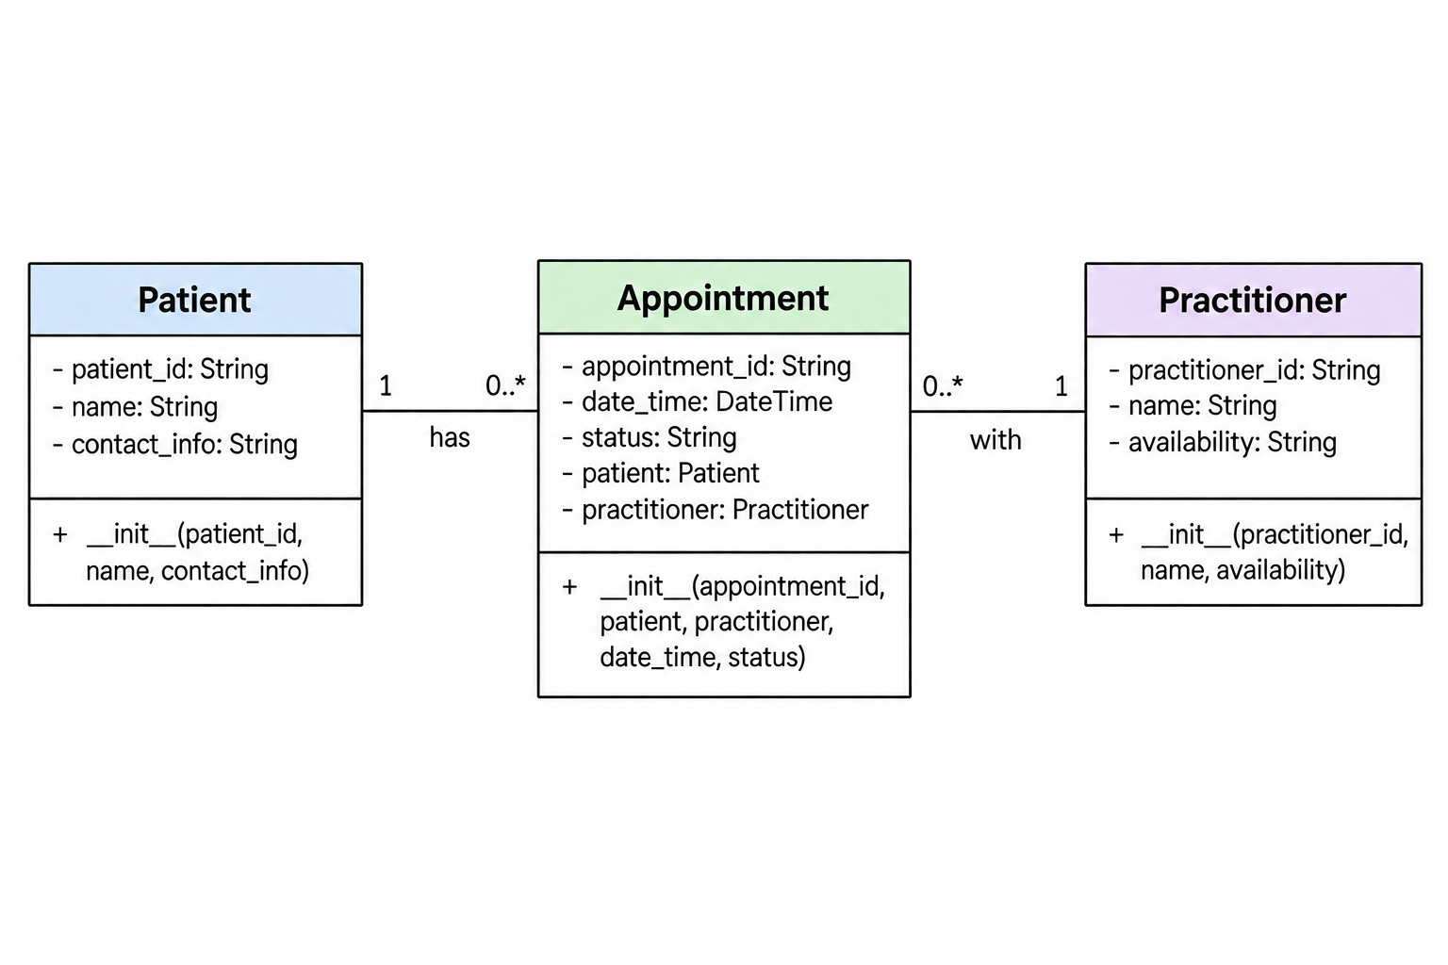
Relationship rule:
Each Appointment is associated with one Patient and one Practitioner.
A Patient and Practitioner can each have zero or many Appointments.
A Practitioner cannot have two Appointments at the same date and time.

Design Rationale
The model contains Patient, Practitioner and Appointment because these are the main concepts supported by the SmartCare requirements. Patient stores patient information, Practitioner stores practitioner information and availability, and Appointment records the relationship between a patient and practitioner, including date/time and status.
Appointment is the connecting class because each appointment is associated with one patient and one practitioner. A patient and practitioner can each have zero or many appointments.
Clinic, Database, Cancellation and Status were not modelled as separate classes because the requirements do not establish them as independent domain entities.

AI Design Review Record
AI suggestion | Evidence | Decision | Reason | Model change
AI suggested Patient, Practitioner and Appointment as the core domain classes. | FR-01–FR-10 require patient, practitioner and appointment management. | Accepted | These three concepts are directly supported by the confirmed requirements. | Patient, Practitioner and Appointment included.
AI suggested a separate Database class. | No confirmed requirement requires Database as a domain entity. | Rejected | Database is an implementation detail rather than a confirmed domain concept. | No Database class added.
AI suggested Appointment as the class connecting Patient and Practitioner. | FR-04 and FR-05 require appointments involving patients and practitioners. | Accepted | The relationship is directly supported by the requirements. | Appointment links Patient and Practitioner.
AI suggested separate manager/controller classes. | No confirmed requirement requires manager or controller classes. | Rejected | They would add complexity without supporting requirements. | No manager/controller classes added.

Consistency Check
The Python skeleton is consistent with the domain model. Patient contains patient_id, name and contact_info; Practitioner contains practitioner_id, name and availability; Appointment contains appointment_id, patient, practitioner, date_time and status. The Appointment class connects Patient and Practitioner, matching the UML relationships. Full booking, cancellation and double-booking behaviour has not been implemented because this stage only requires class skeletons.

