SmartCare v0.5 - Architecture and Refactoring Workbook
Week 8 student resource

Current Architecture Problems
Problem | Evidence | Impact | Refactoring
No separate service/workflow layer | v0.4 contains only domain classes and no service class. | Workflow coordination has no dedicated location. | Introduce AppointmentService for use-case coordination.
No repository abstraction | v0.4 has no repository contract. | Data access would have no defined boundary. | Add a small AppointmentRepository contract.
No persistence layer | v0.4 contains no persistence implementation. | Storage concerns are not separated. | Add a persistence implementation of AppointmentRepository.
No presentation layer | v0.4 contains no presentation code. | User interaction is not separated from application logic. | Create a simple presentation layer.

Layer Responsibilities
Layer | Responsibilities | Must not contain
Presentation | User input and displaying results. | Domain rules, repository operations, persistence/database details.
Service | Coordinate application use cases and call domain/repository operations. | Direct SQLite/database implementation and presentation formatting.
Domain | Patient, Practitioner, Appointment and appointment business rules. | UI input/output and database access.
Repository | Define the small appointment-data operations required by services. | Database implementation details and presentation logic.
Persistence | Implement the repository contract and handle storage. | Business rules and UI logic.

Architecture Diagram
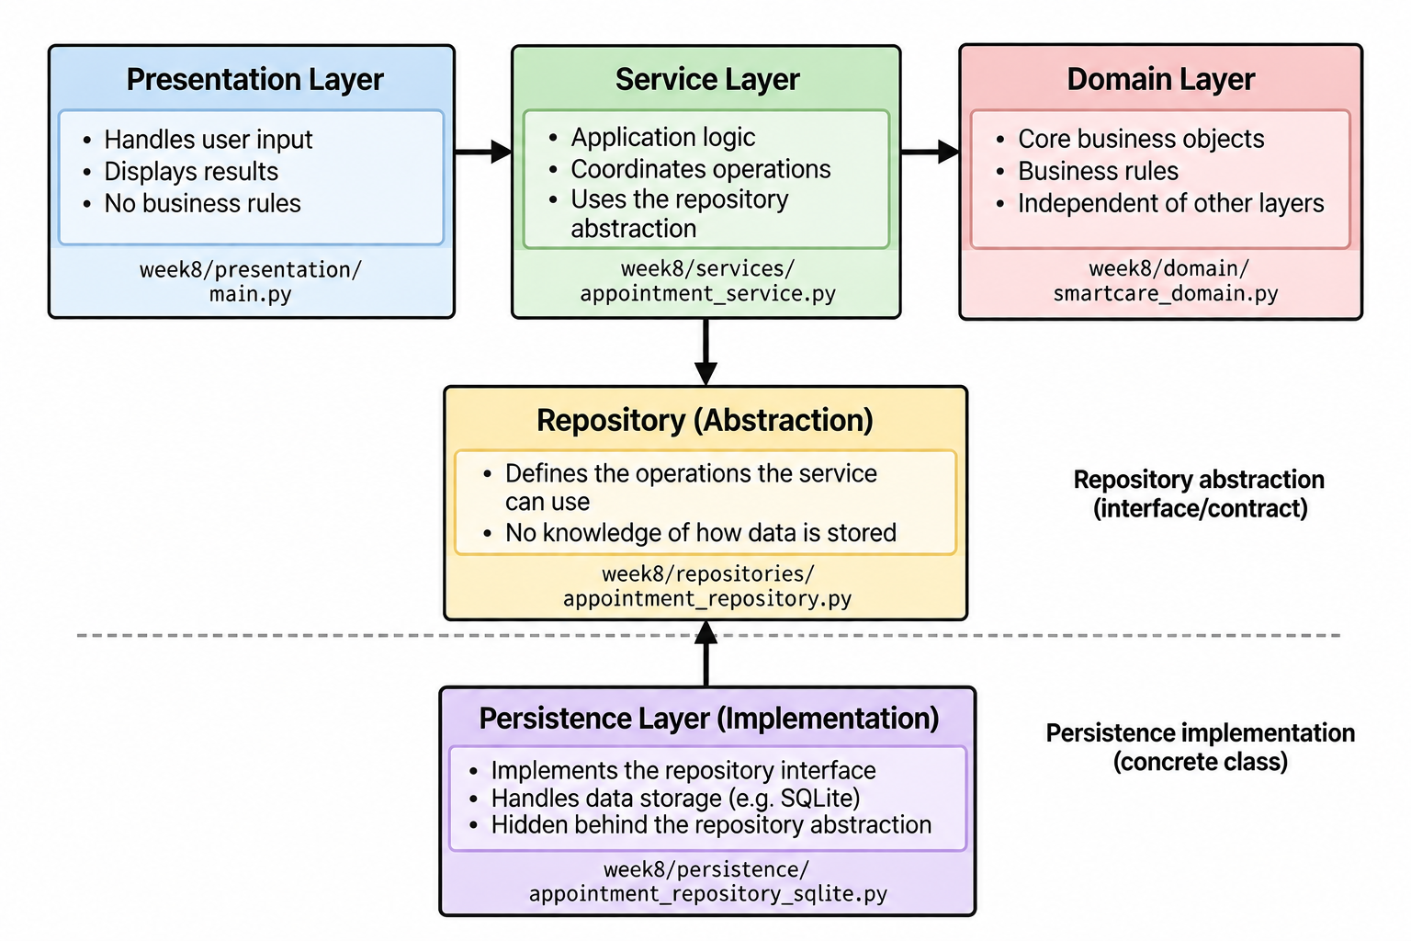)

SOLID Review
Principle | Relevant? | Evidence | Decision
SRP | Yes | Each layer has a focused responsibility: presentation, workflow, domain, repository contract, or persistence. | Keep responsibilities separated across the layers.
OCP | Limited relevance | The repository abstraction allows persistence implementations to vary without changing service coordination. | Keep the repository contract small and stable.
LSP | Relevant | Persistence implementations should honour the AppointmentRepository contract. | SQLiteAppointmentRepository follows the repository operations.
ISP | Yes | The repository contract contains only find_by_id and save, matching the current service needs. | Do not add unrelated repository methods.
DIP | Yes | AppointmentService depends on AppointmentRepository rather than a concrete persistence class. | Keep the service dependent on the abstraction.

AI Architecture Review
AI suggestion | Observed problem? | Decision | Reason | Verification
Introduce AppointmentService | Yes | Workflow coordination was missing from v0.4. | Accepted | Provides a focused service without moving Appointment's cancellation rule.
Service should depend on repository abstraction | Yes | Direct persistence dependency would increase coupling. | Accepted | AppointmentService uses AppointmentRepository.
Add microservices/event bus/framework | No | Current requirements do not justify this complexity. | Rejected | The lab asks for the simplest justified refactoring.
Create many additional manager/controller classes | No | No current requirement supports them. | Rejected/Deferred | Would add unnecessary complexity.
Architecture remains limited to the required layers.

Week 8 Verification and Reflection
The refactoring separates the domain model from workflow coordination, repository abstraction, persistence and presentation. Appointment retains responsibility for its cancellation rule, while AppointmentService coordinates the cancellation use case. The service depends on the AppointmentRepository abstraction rather than a concrete persistence implementation. The architecture review rejected unnecessary frameworks, microservices and additional interfaces because the current requirements do not justify them.

