GradNavi
AI-Powered Career Guidance System
User Guide
COIT20273 Software Design and Development Project, Term 2 2026
WBS 8.11 User Guide Finalisation
Prepared by Joyee Chakraborty (Member 2)
Version 1.0, October 2026

Contents
Contents 2
1. Introduction 3
1.1 Who this guide is for 3
1.2 Accessing GradNavi 3
1.3 Before you start 3
2. Getting Started 4
2.1 Create an account 4
2.2 Log in 5
2.3 Forgot your password 6
2.4 Log out 7
3. Student Dashboard 8
4. Student Profile 9
4.1 Add or edit skills 9
4.2 Set your career goal 9
5. Career Recommendations 10
6. Skill Gap Analysis 11
7. Career Roadmap 12
8. Learning Resources 13
9. Job Matching 14
10. Resume Builder 15
11. Cover Letter Builder 17
12. Interview Preparation 19
13. Settings and Mobile Use 21
13.1 Settings 21
13.2 Using GradNavi on a phone 21
14. Administrator Guide 23
14.1 Admin Dashboard 23
14.2 Users 23
14.3 Careers 23
14.4 Skills 24
14.5 Learning Resources 25
14.6 Reports 25
14.7 Audit Records 25
15. Troubleshooting and FAQ 26

1. Introduction
GradNavi is a web application that helps university students and recent graduates understand which careers fit their profile, what skills they are missing, and how to prepare applications. It combines structured, rule-based scoring with AI-generated explanations, so every score stays visible and the AI explains the result rather than changing it.

1.1 Who this guide is for
- Students and graduates: sections 2 to 13 explain how to build a profile and use each career guidance tool.
- Administrators: section 14 explains how to manage users, careers, skills, learning resources, resource reports and audit records.

1.2 Accessing GradNavi
- Open https://www.gradnavi.site in a web browser.
- Supported browsers: current versions of Google Chrome, Microsoft Edge and Mozilla Firefox.
- GradNavi works on desktop, tablet and mobile screens. On small screens the menu is opened with the menu (☰) button at the top right.

1.3 Before you start
Most features use the information saved in your Student Profile. The more complete your profile is (skills, education, experience and career goal), the more useful your recommendations, skill gaps and documents will be.

2. Getting Started
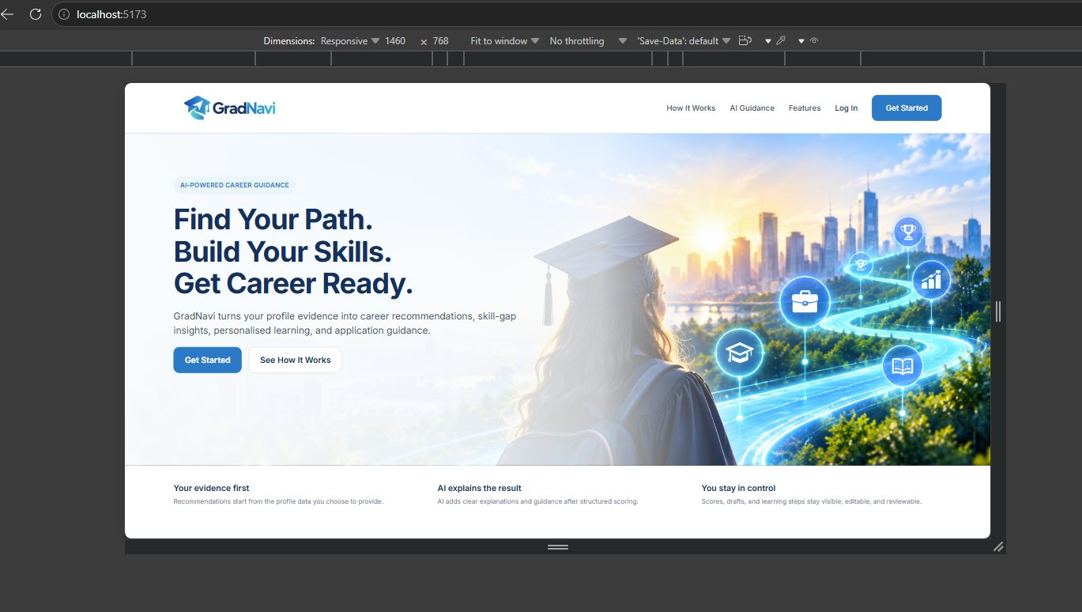
Figure 1: GradNavi homepage

2.1 Create an account
- On the homepage, select Get Started, or select Create an account on the login page.
- Enter your first name, last name and email address.
- Create a password and enter it again in Confirm password. Select Show to see what you typed.
- Select Create Account. You are signed in and taken to your Student Dashboard.
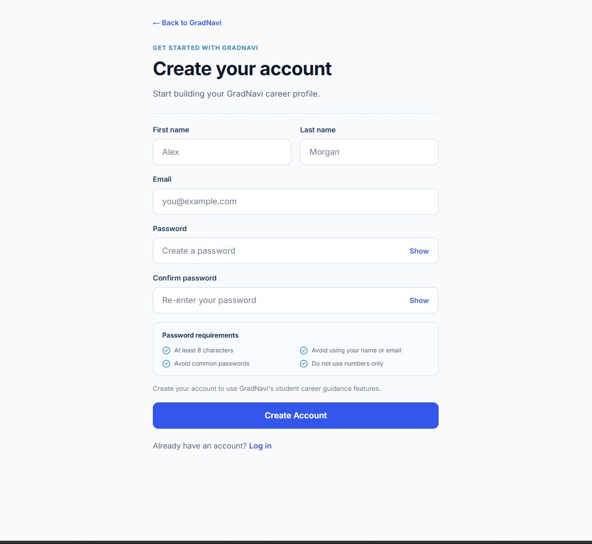
Figure 2: Create your account page
Your password must meet these requirements:
- At least 8 characters.
- Not a common password.
- Does not use your name or email.
- Not numbers only.

2.2 Log in
- Select Log In at the top of the homepage.
- Enter your email and password, then select Log In.
- Students are taken to the Student Dashboard. Administrators are taken to the Admin Dashboard.
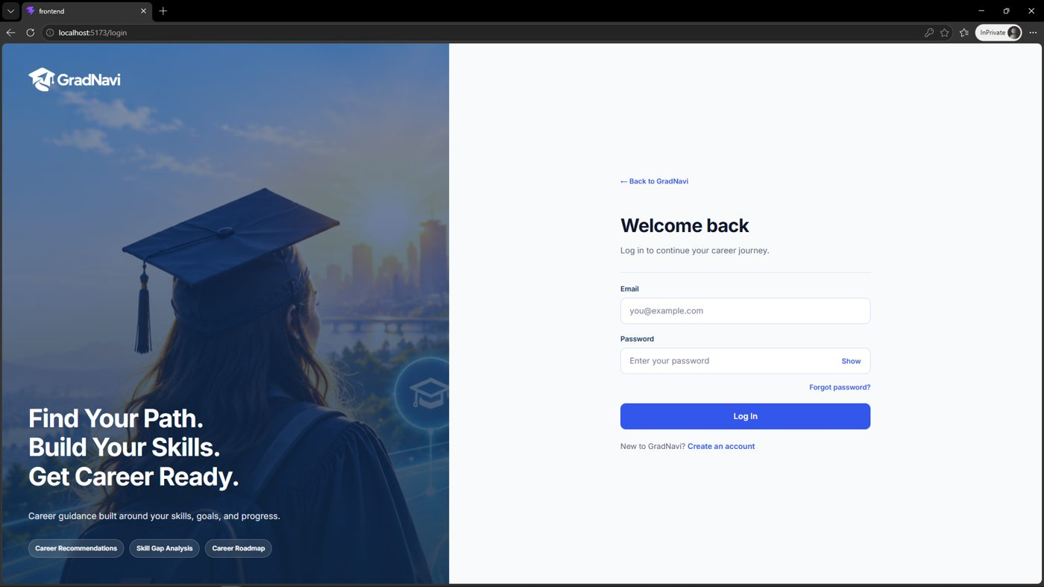
Figure 3: Login page
If the email or password is wrong, GradNavi shows the message “Email or password is incorrect” and you stay on the login page.
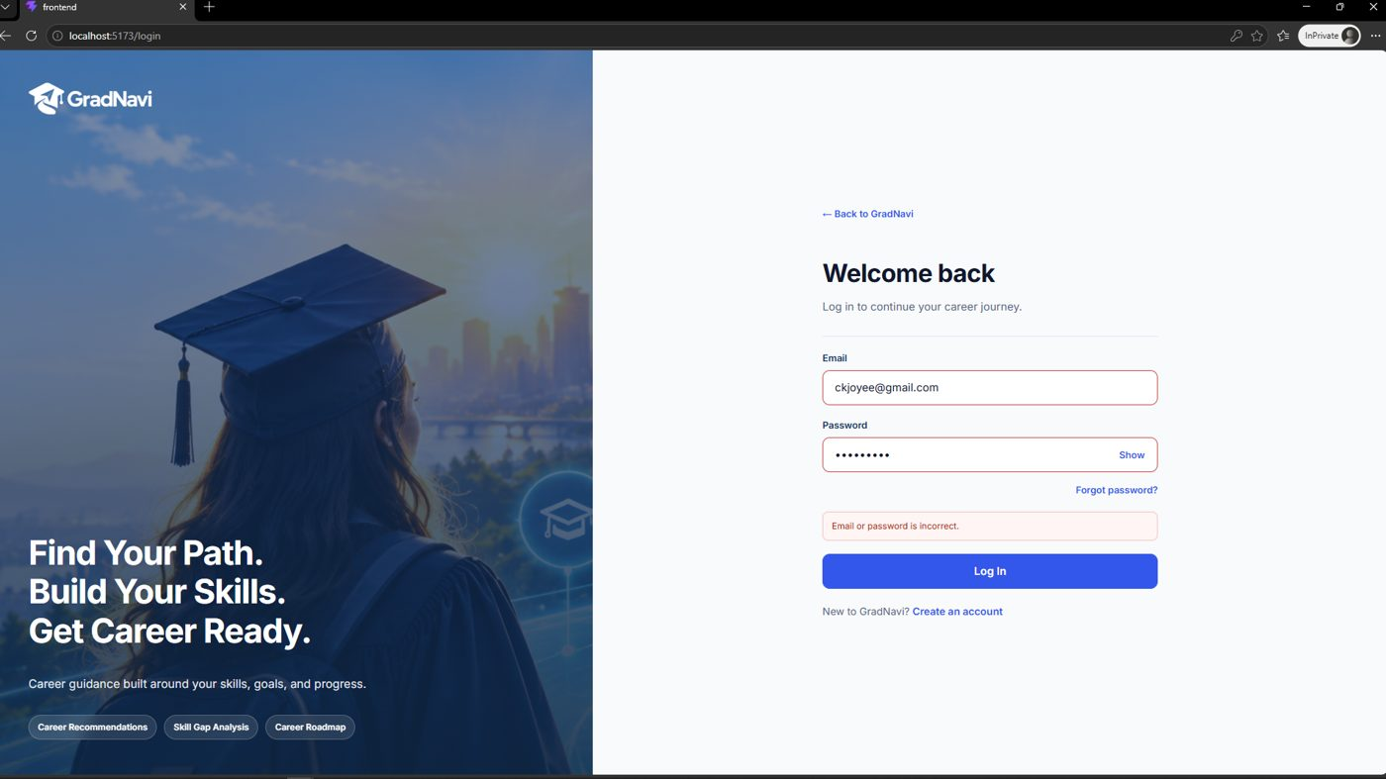
Figure 4: Message shown after an incorrect password

2.3 Forgot your password
- On the login page, select Forgot password?.
- Enter the email address you signed up with.
- Select Send Reset Instructions, then follow the instructions sent to your email to set a new password.
- Select Back to Log In to return to the login page.
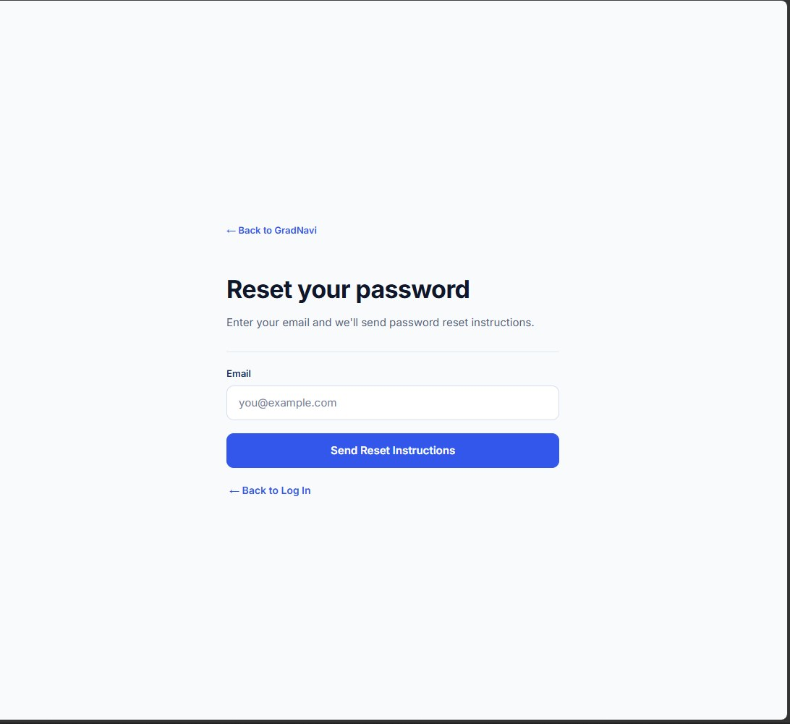
Figure 5: Reset your password page

2.4 Log out
Select Log Out at the bottom of the left menu. If you open a protected page while signed out, GradNavi sends you to the login page.

3. Student Dashboard
The dashboard is your home page after signing in. It shows your primary career, your current readiness, a summary of your progress and the next action worth taking.
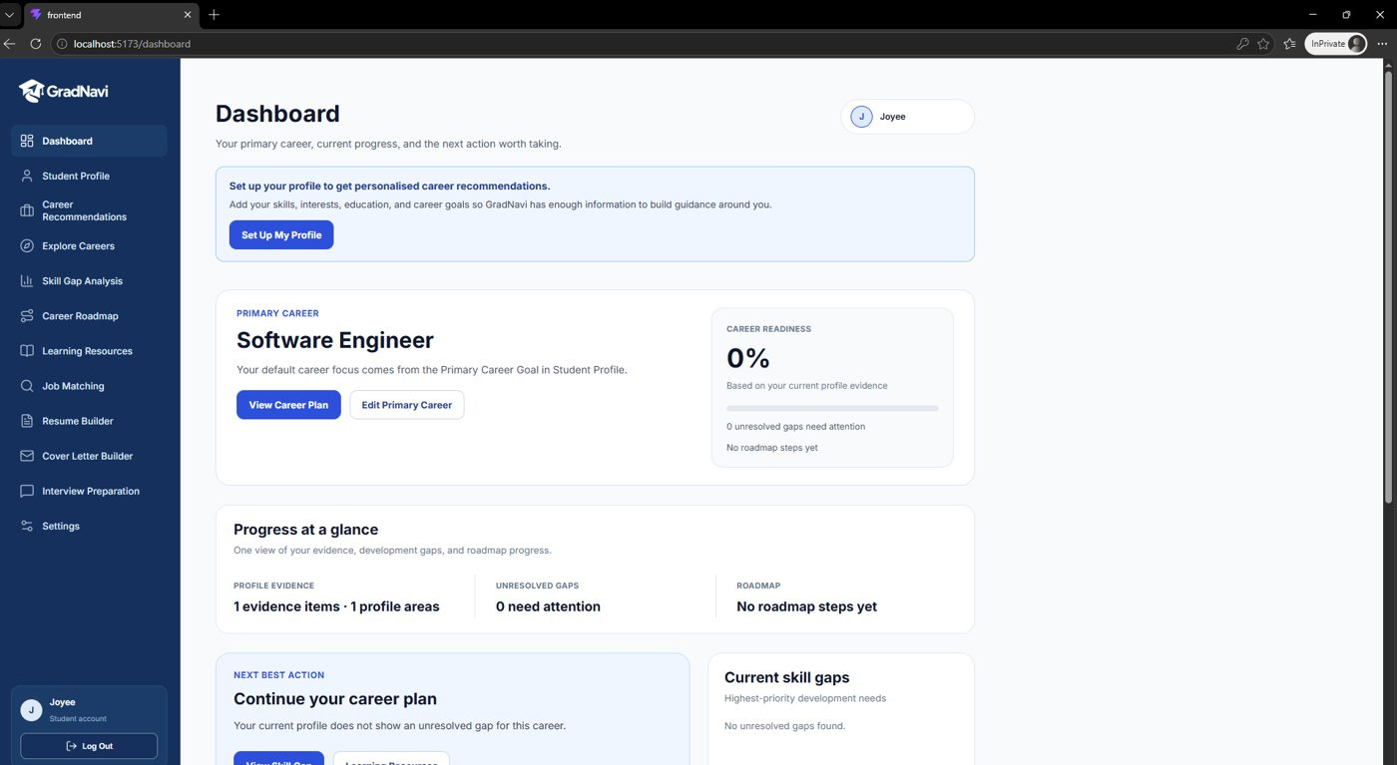
Figure 6: Student Dashboard
- Primary career: the career GradNavi uses by default across all pages. Change it with Edit Primary Career.
- Career readiness: how ready your profile is for that career, as a percentage.
- Progress at a glance: profile evidence, unresolved gaps and roadmap steps.
- Next best action: a suggested next step, such as setting up your profile or continuing your career plan.
Tip: If the dashboard asks you to set up your profile, select Set Up My Profile first. Most other pages need at least a few saved skills.

4. Student Profile
Your Student Profile holds the evidence GradNavi uses: your career goal, skills, education, experience and interests.
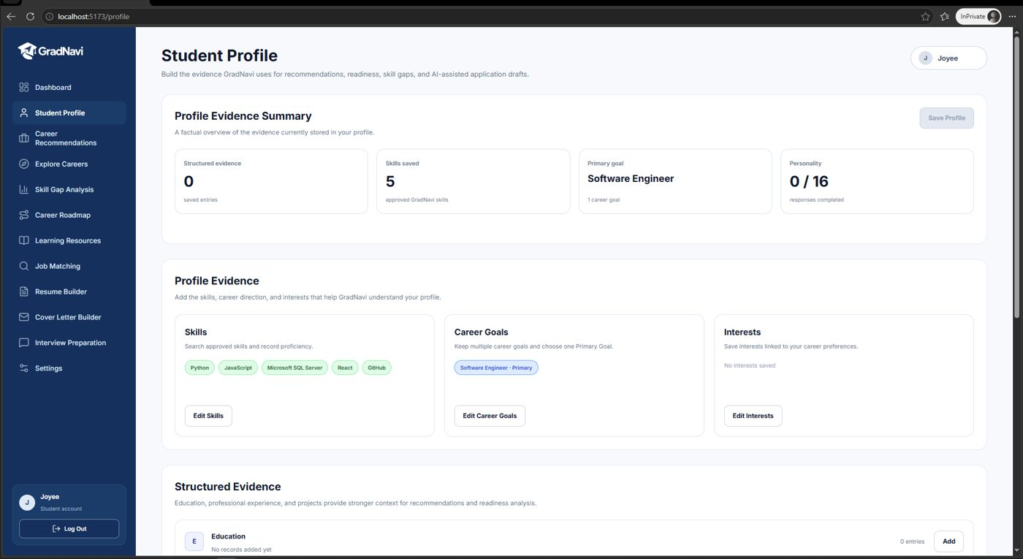
Figure 7: Student Profile with saved skills

4.1 Add or edit skills
- Open Student Profile from the left menu.
- Select Edit Skills.
- Search for a skill (for example Python), select it and choose your proficiency level.
- Repeat for each skill, then select Save.
- Refresh the page to confirm the skills are saved.
Tip: Include both technical skills (such as Python or SQL) and general skills (such as Critical Thinking). Career requirements use both, so adding only technologies can leave your readiness at 0%.

4.2 Set your career goal
Choose your primary career goal in your profile. GradNavi uses it as the default career for Skill Gap Analysis, Career Roadmap and Learning Resources.

5. Career Recommendations
Career Recommendations ranks careers by how well they match your profile.
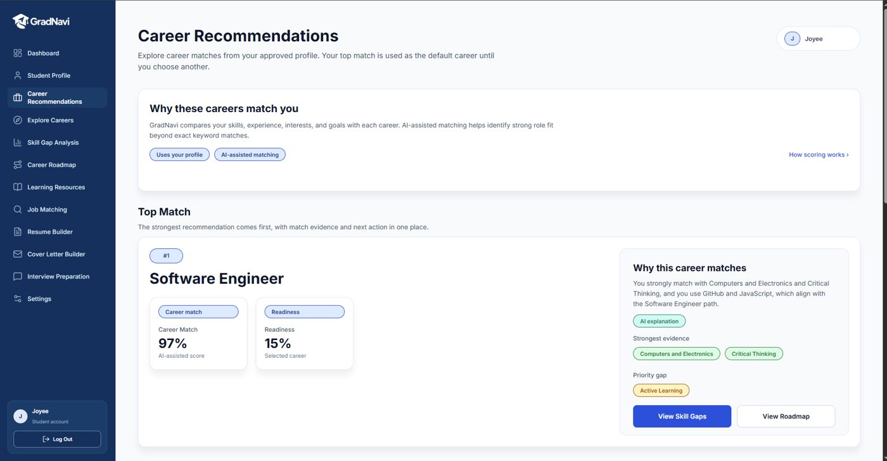
Figure 8: Career Recommendations with the top match
- Career Match: how closely your profile matches the career (AI-assisted score).
- Readiness: how many of the career’s requirements your profile already meets.
- Why this career matches: an AI explanation, your strongest evidence and your priority gap.
Select View Skill Gaps or View Roadmap to continue with that career. Use Explore Careers in the left menu to look at careers beyond your top recommendation.

6. Skill Gap Analysis
Skill Gap Analysis compares your profile with the requirements of a selected career.
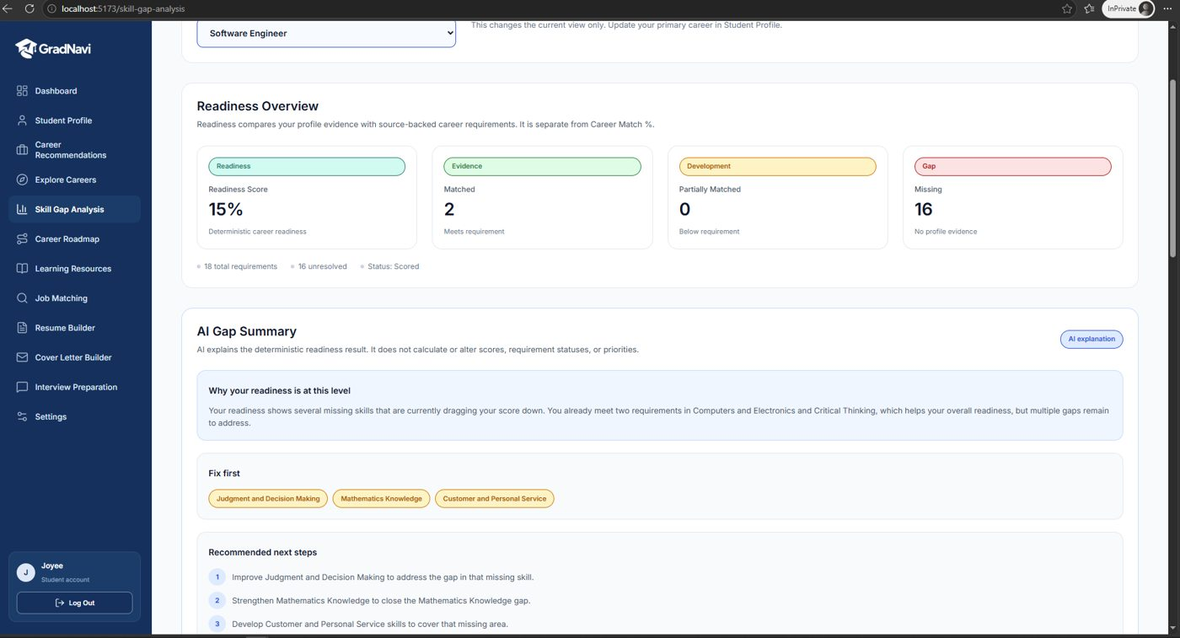
Figure 9: Skill Gap Analysis showing readiness and matched/missing requirements
- Open Skill Gap Analysis.
- Check the Career Focus. It defaults to your primary career; choose another career to compare temporarily.
- Review the Readiness Overview: Matched, Partially Matched and Missing requirements.
- Read the AI Gap Summary for a plain-language explanation and next steps.
- Scroll to Requirement Details for the full list.
Tip: To improve your readiness, add the missing skills you genuinely have to your Student Profile, or use Learning Resources to build them.

7. Career Roadmap
The Career Roadmap turns your unresolved gaps into ordered development steps for your selected career.
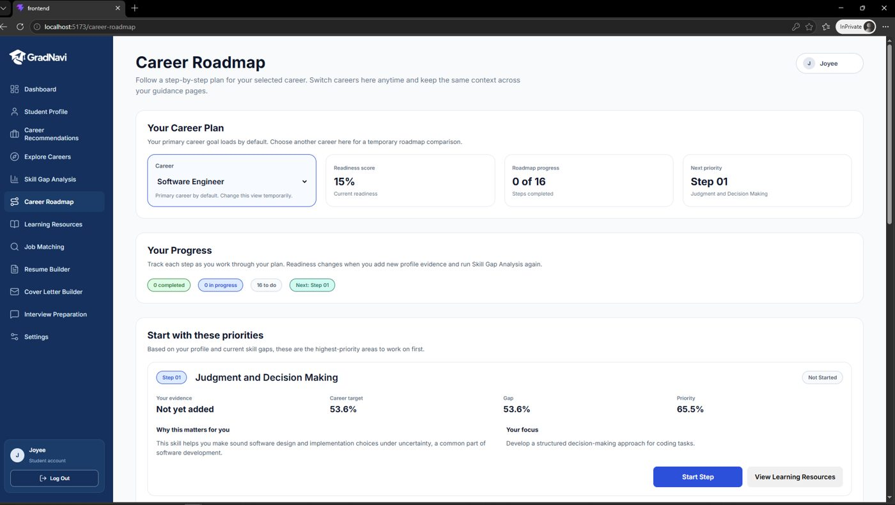
Figure 10: Career Roadmap with ordered steps
- Steps are listed in priority order (Step 01 first).
- Each step explains why it matters and what to focus on.
- Progress updates as your profile improves.

8. Learning Resources
Learning Resources recommends courses, articles, videos and documentation for your unresolved skill gaps.
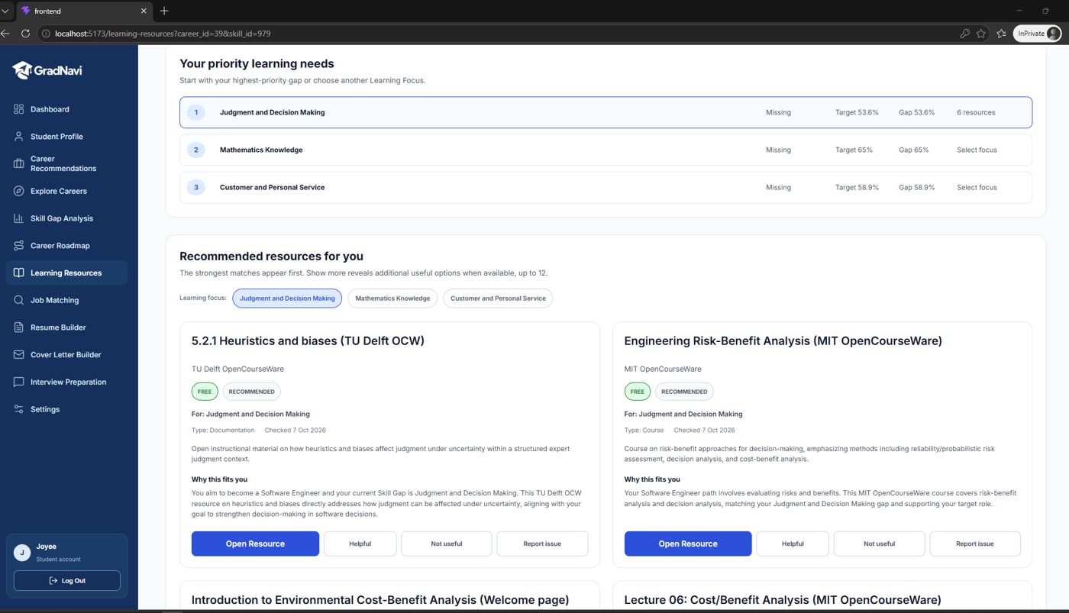
Figure 11: Learning Resources recommended for a skill gap
- Open Learning Resources.
- Choose the career in the Career dropdown. Resources update for that career.
- Review the priority gaps and the recommended resources.
- Read “Why this fits you” on each resource, then open the resource link.
If a resource is broken, outdated or not relevant, use its Report option. Administrators review these reports (see section 14.6).

9. Job Matching
Job Matching compares the requirements in a real job advertisement with the skills saved in your Student Profile.
- Open Job Matching.
- Paste the full job description into the box (up to 20,000 characters).
- Select Analyze Job.
- Review Matched requirements (in your profile) and Not listed in your profile (missing).
- Use the next-step buttons to tailor a resume, start a cover letter or review your skill gaps.
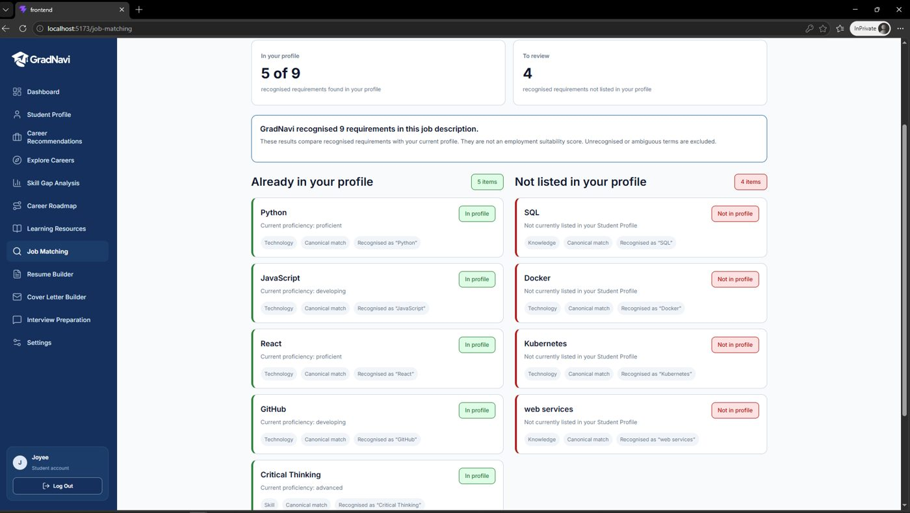
Figure 12: Job Matching results
Tip: The result is a comparison of recognised requirements, not a hiring score. Keep your profile up to date for a more accurate comparison.

10. Resume Builder
Resume Builder creates an AI-generated resume draft tailored to a job description, using only facts from your Student Profile.
- Open Resume Builder, or select Tailor Resume from Job Matching (the job description is filled in for you).
- Check the job description, then select Generate Resume Draft.
- Review each section of the draft.
- Select Edit section to change any text, then Done Editing.
- Select Save Draft to keep your changes.
- Select Download Word (.docx) or Download PDF to save the resume, or Copy Content to paste it elsewhere.
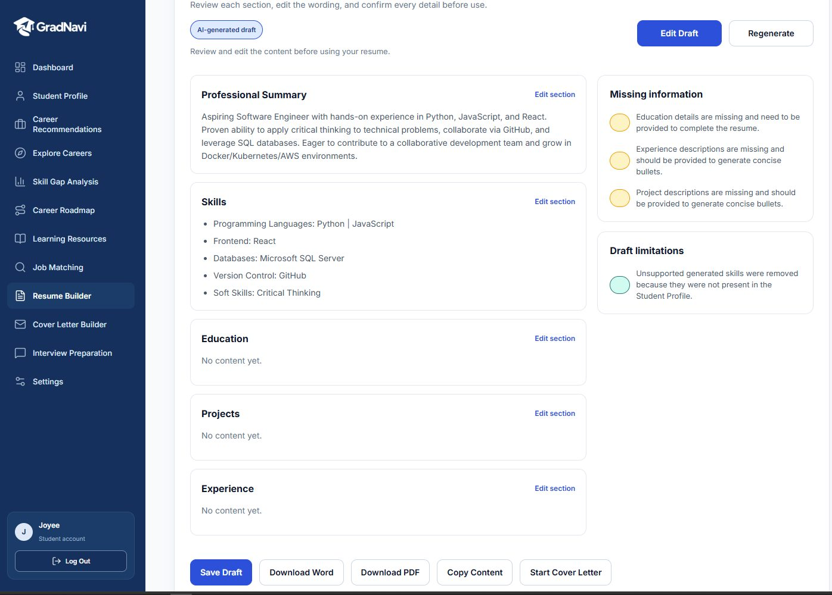
Figure 13: Generated resume draft with review notes
The draft is clearly marked as AI-generated. The Draft limitations panel lists anything removed or not supported by your profile. Always review and edit the content before using your resume.
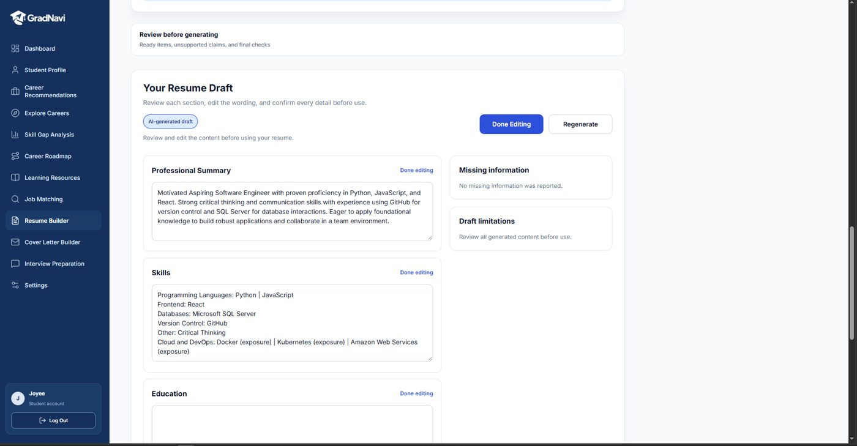
Figure 14: Editing a resume section
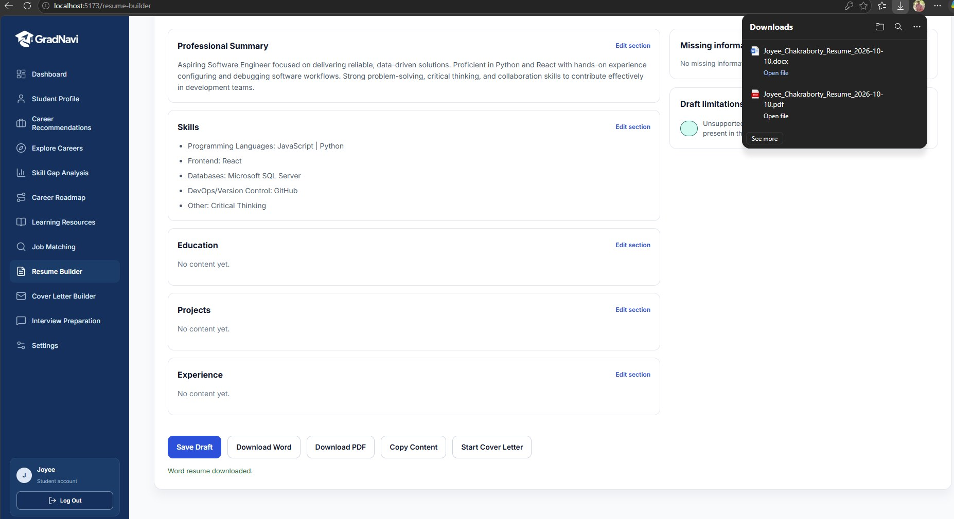
Figure 15: Resume actions: Save Draft, Download Word, Download PDF, Copy Content
Downloaded files are named with your name and the date, for example Joyee_Chakraborty_Resume_2026-10-10.pdf. Select Start Cover Letter to carry this job into Cover Letter Builder.

11. Cover Letter Builder
Cover Letter Builder writes a tailored cover letter draft from your profile and a job description.
- Open Cover Letter Builder, or select Start Cover Letter from Job Matching.
- Enter the Job Title and Company, and check the Job Description.
- Select Generate Cover Letter.
- Review the draft, edit it as needed and copy or download it.
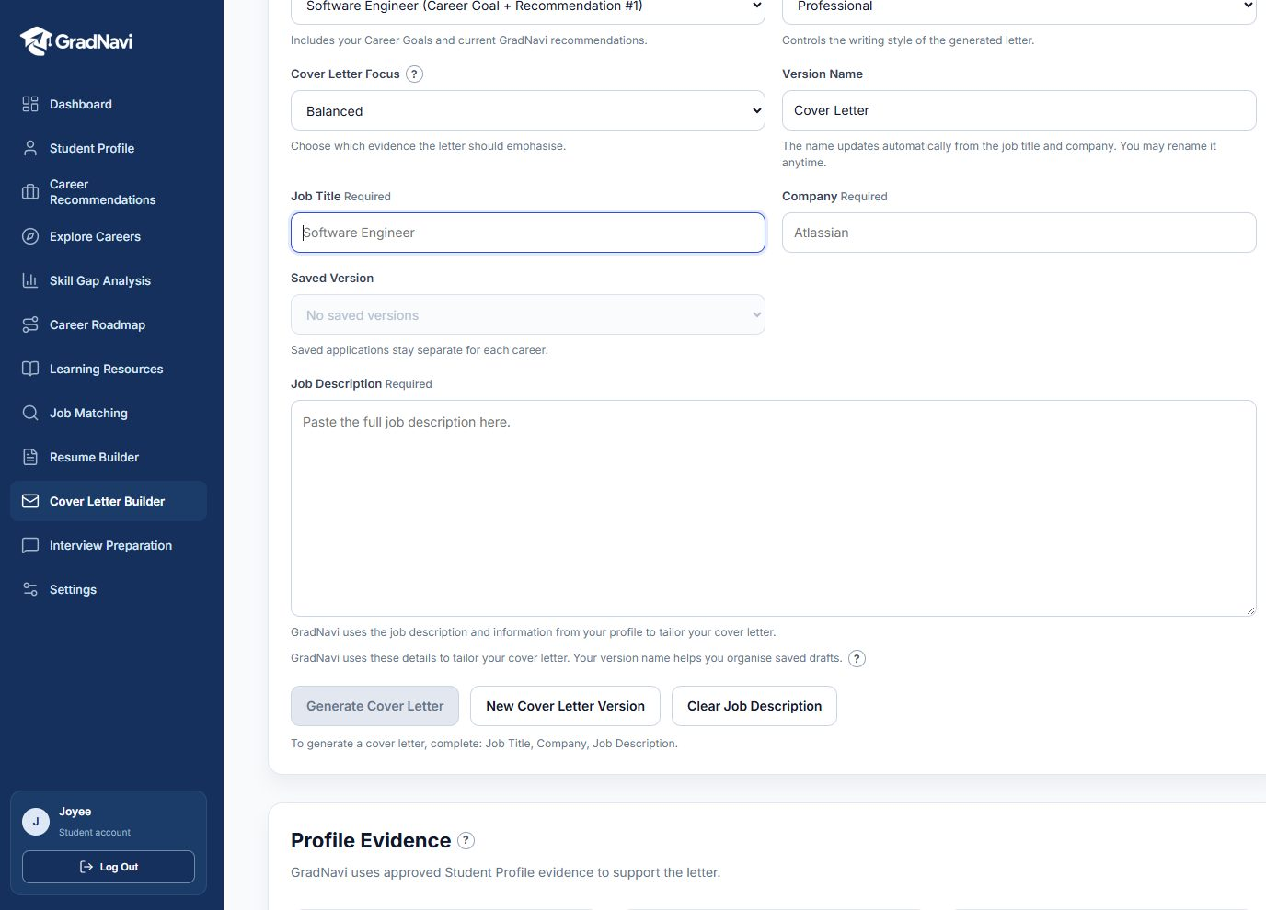
Figure 16: Required fields hint before generating
Job Title, Company and Job Description are required. If any are missing, the page lists them under the Generate button.
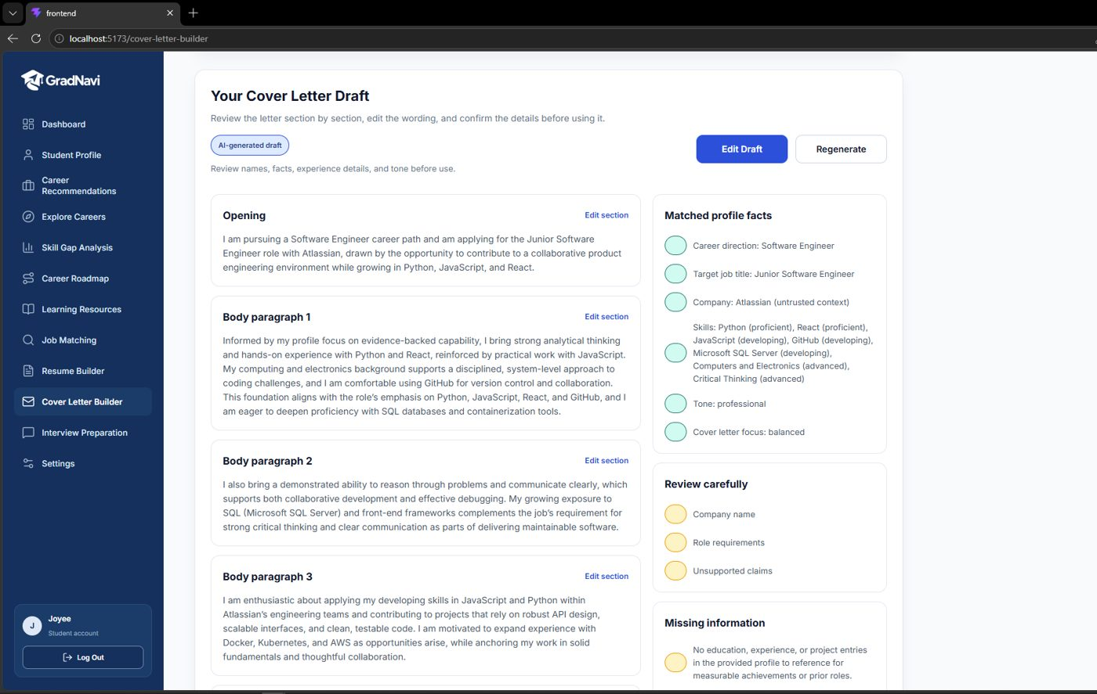
Figure 17: Generated cover letter with review checks
The draft shows which profile facts were used and flags claims you should check carefully before sending.

12. Interview Preparation
Interview Preparation lets you practice role-specific interview questions and get AI feedback on your answers.
- Open Interview Preparation and start a practice session.
- Read the current question (for example Question 1 of 5).
- Type your answer in Your answer.
- Select Get Feedback.
- Move to the next question. When you finish, select End Practice to see your Completion Summary.
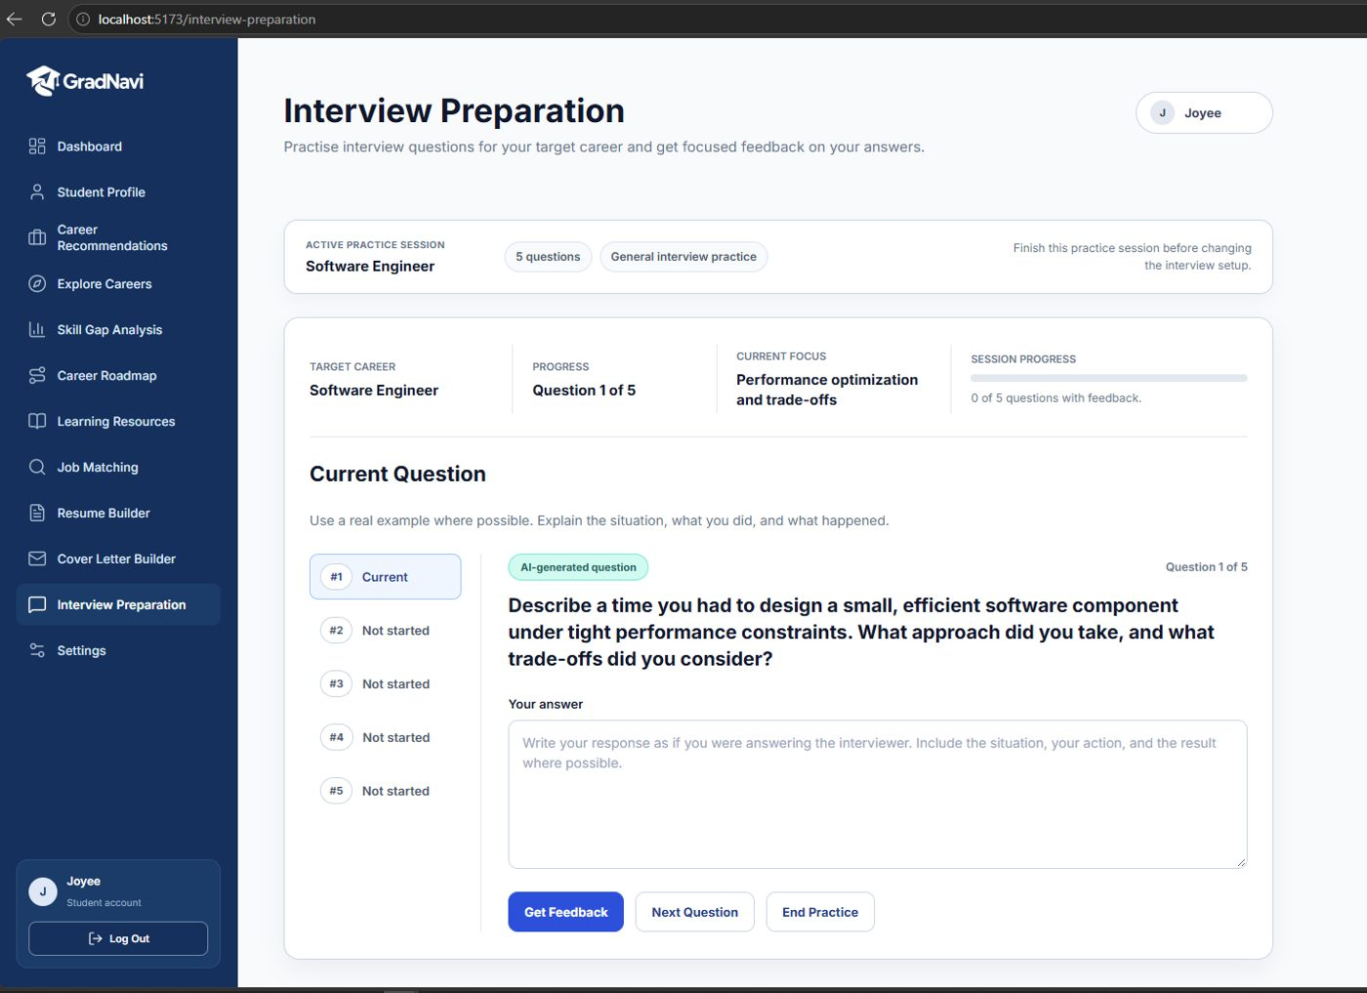
Figure 18: Interview practice question
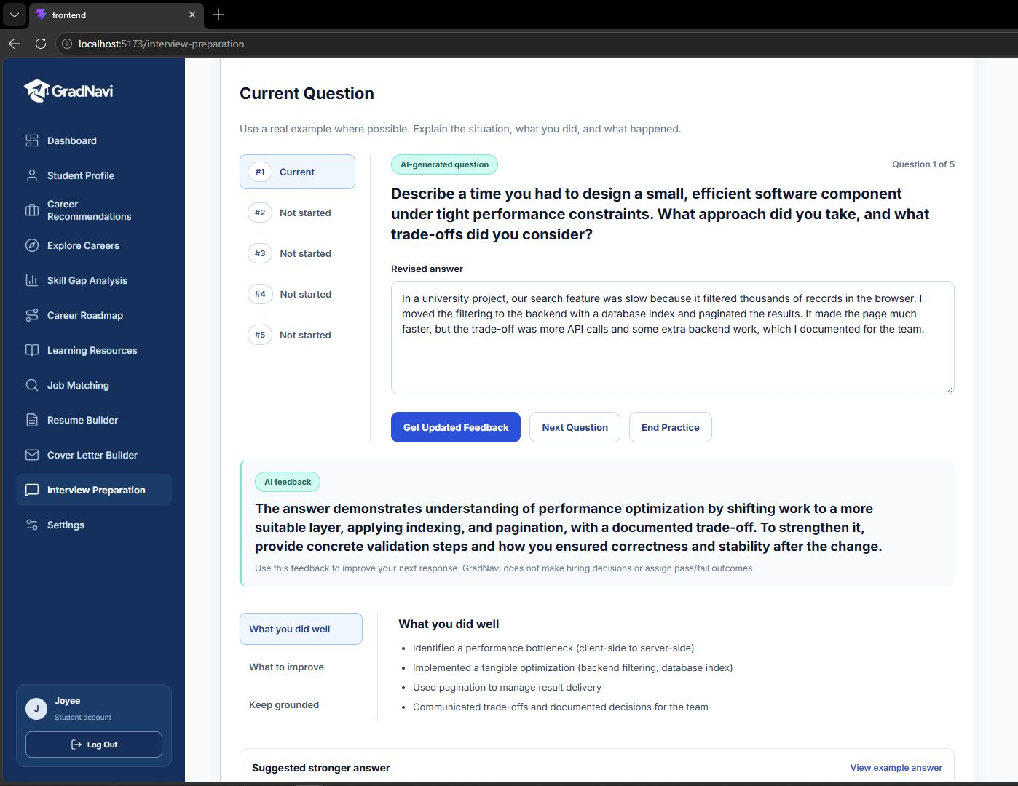
Figure 19: AI feedback on an answer
Feedback shows what you did well, what to improve and a suggested stronger answer. GradNavi does not make hiring decisions or give pass/fail results.

13. Settings and Mobile Use

13.1 Settings
Open Settings from the left menu to manage your account details, profile photo and password.
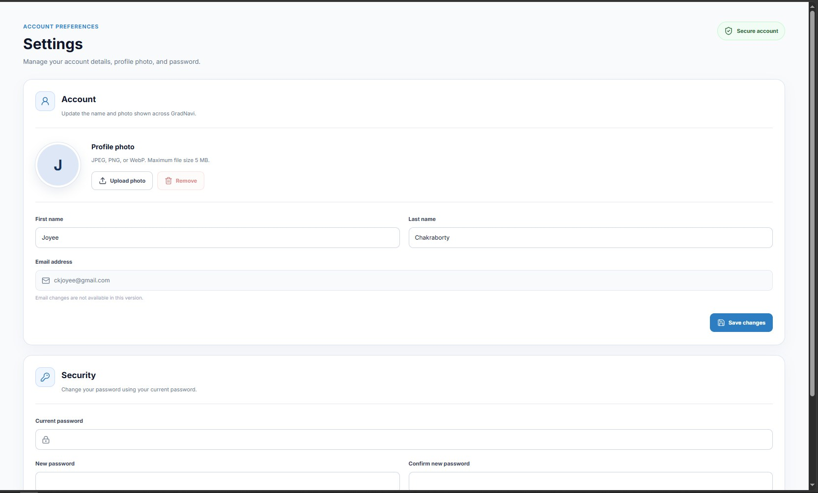
Figure 20: Settings page
- Profile photo: select Upload photo (JPEG, PNG or WebP, up to 5 MB). Use Replace photo to change it or Remove to delete it.
- Name: edit your first or last name, then select Save changes. Your email address cannot be changed in this version.
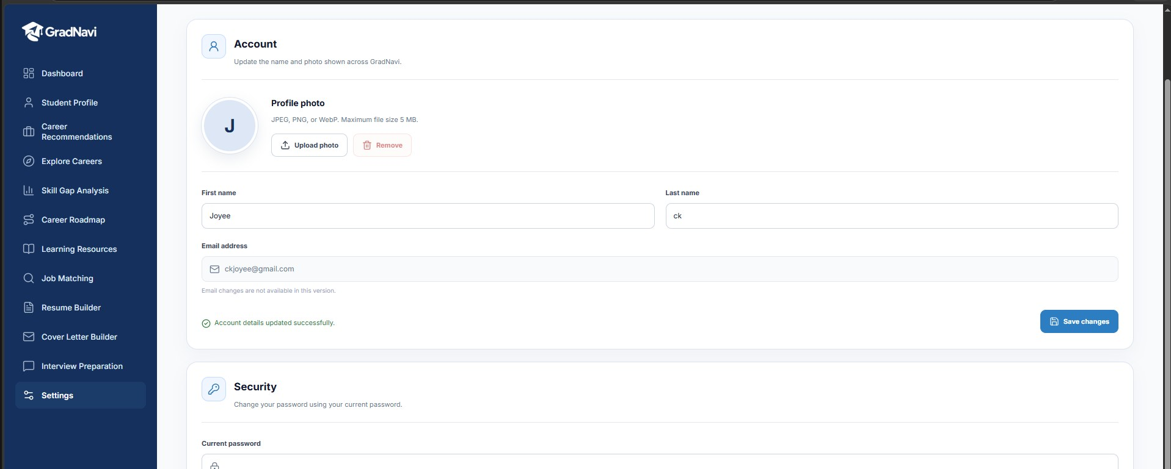
Figure 21: Account details updated successfully after Save changes
- Password: in the Security section, enter your current password, then your new password twice, and save.

13.2 Using GradNavi on a phone
On small screens the left menu is hidden. Select the menu (☰) button at the top right to open it, and pages stack into a single column.
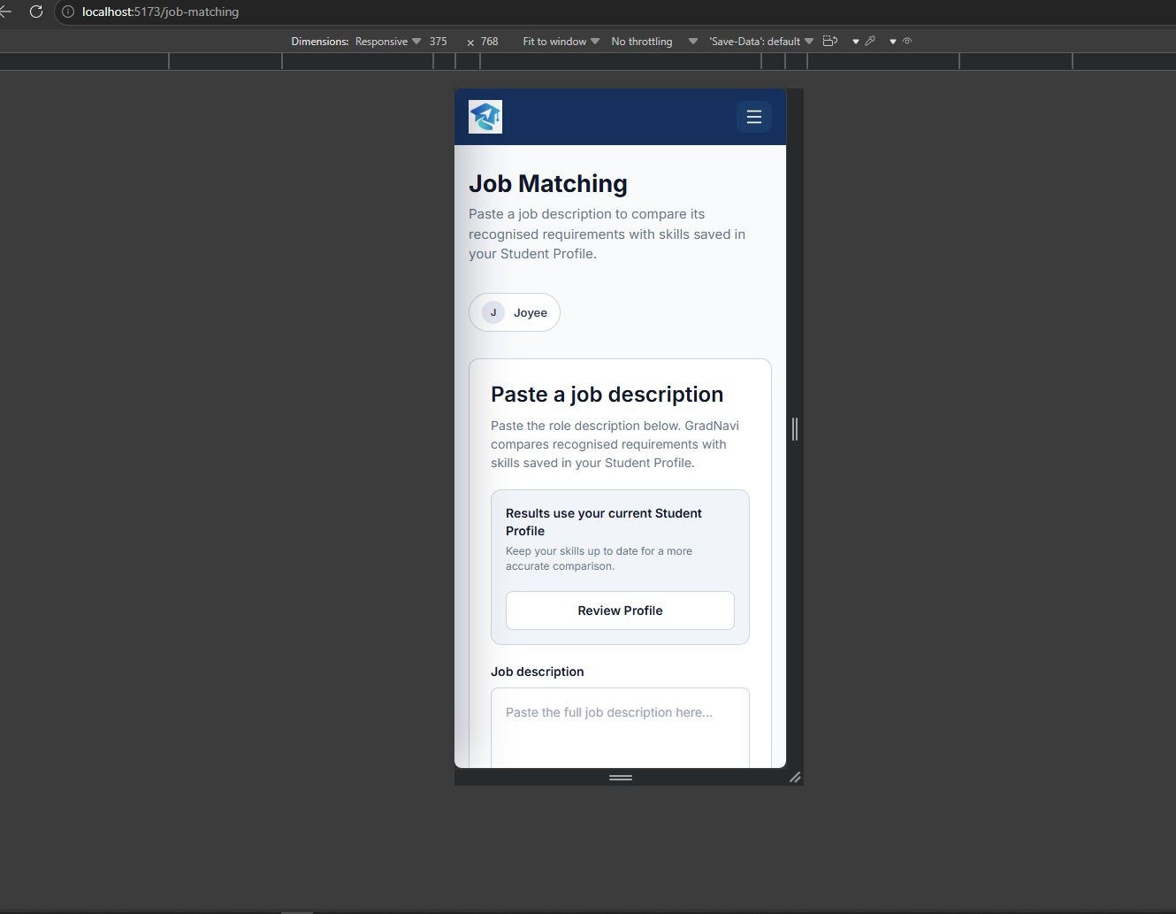
Figure 22: Job Matching on a mobile screen

14. Administrator Guide
Administrator accounts manage GradNavi’s users and reference data. Administrators sign in on the same login page and are taken to the Admin Dashboard. Students cannot open admin pages, and the server rejects admin actions from student accounts.
Every change an administrator makes is recorded in the audit log.

14.1 Admin Dashboard
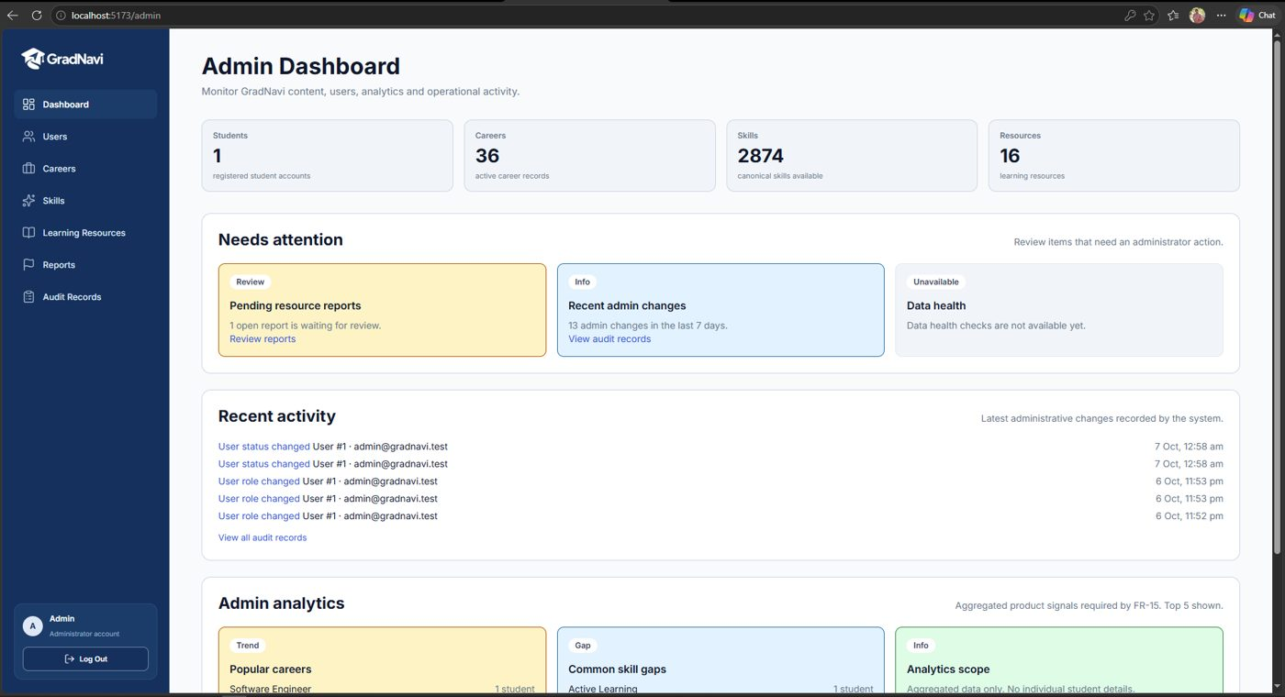
Figure 23: Admin Dashboard
- Counts: students, active careers, skills and learning resources.
- Needs attention: open resource reports, recent admin changes (last 7 days) and data health.
- Recent activity: the latest five admin changes, each linking to its audit record.
- Admin analytics: popular careers and common skill gaps (aggregated only, no individual student details).

14.2 Users
- Open Users. Search by name or email, or filter by role and status.
- To change a role, select Make admin or Make student, read the warning and select Confirm change.
- To block or restore sign-in, select Deactivate or Activate and confirm.
- After a change, select View audit record in the green message to see the logged record.

Tip: You cannot deactivate your own account, and changing your own role signs you out. Only give the Admin role to trusted staff.

14.3 Careers
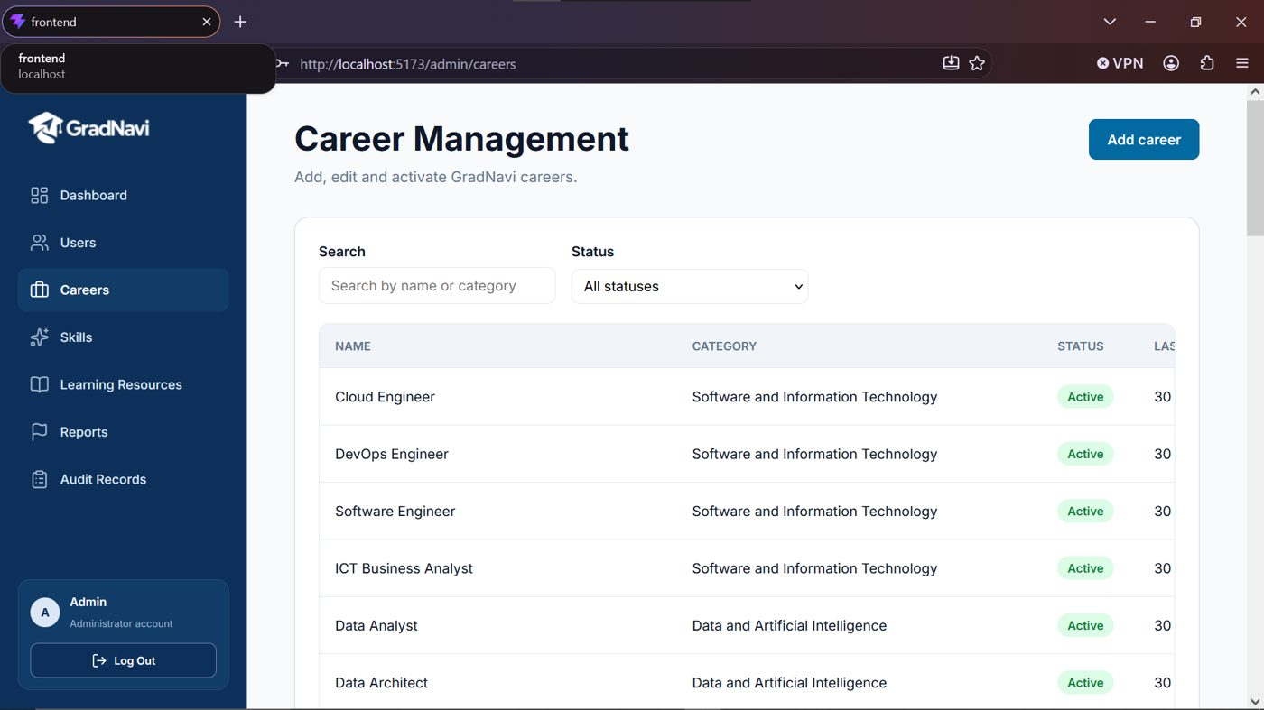
Figure 24: Career Management
- Open Careers. Search by name or category, or filter by status.
- Select Add career, enter the name, category and description, and select Save career.
- Select Edit to update a career.
- Select Deactivate to hide a career from students, or Activate to show it again.
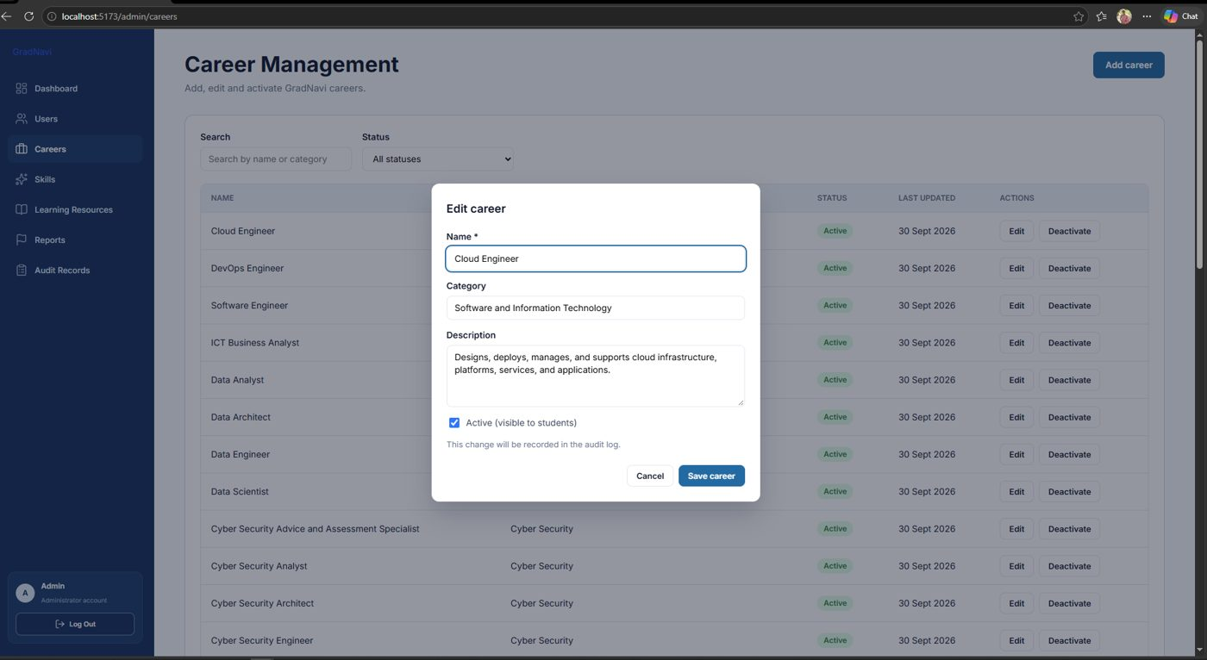
Figure 25: Editing a career
Careers are deactivated rather than deleted so that existing student data is kept. Career names must be unique.

14.4 Skills
Open Skills to add or edit the canonical skills used across GradNavi. Each skill has a name, a type (Skill, Knowledge or Technology), a category and a description. Use search and the type filter to find skills, and Show more to load more results. Renaming a skill changes it everywhere it is used.

14.5 Learning Resources
Open Learning Resources to add, edit, activate or deactivate resources. For each resource you can set the title, URL, provider, type, access (free, freemium or paid), source, health status (Active, Needs review, Broken or Archived) and the skills it supports. Use the health and visibility filters to find resources that need attention.

14.6 Reports
Open Reports to review issues students reported on learning resources. Each report shows the resource, reason, comment and date. Select Resolve or Dismiss for open reports, or Reopen for closed ones. Use the status filter to switch between Open, Resolved, Dismissed and All.

14.7 Audit Records
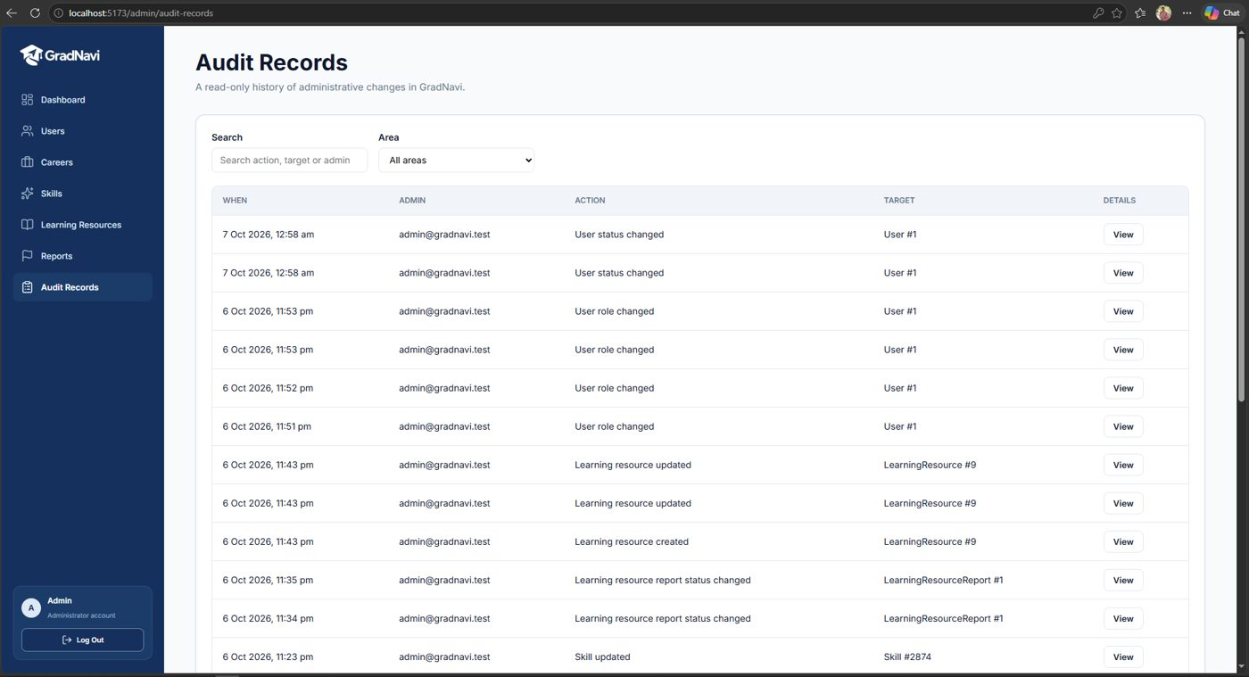
Figure 26: Audit Records
Audit Records is a read-only history of administrative changes. Search by action, target or admin, filter by area, and select View to see the full details of a change, including which fields changed.

15. Troubleshooting and FAQ
Problem | What to do
“Email or password is incorrect” | Check your email and password, or use Forgot password? on the login page.
“Your session has expired” | Sign in again. Sessions end after a period of inactivity.
Readiness shows 0% | Add more skills to your Student Profile, including general skills such as Critical Thinking, then refresh.
A page asks you to set up your profile | Select Set Up My Profile and save at least a few skills.
Generate Cover Letter is disabled | Fill in every field listed under the button (Job Title, Company, Job Description).
“Something went wrong” on a page | Refresh the page. If it continues, try again later or contact the GradNavi team.
Opening an admin page sends you to the dashboard or login | Admin pages need an administrator account.
A learning resource link is broken | Use the Report option on the resource so an administrator can review it.
Remember: AI-generated content (explanations, resumes, cover letters and interview feedback) is a starting point. Always review it before relying on it.

