Already had vscode and python installed but getting edge impulse to run was tricky since it required tinkering with windows machine admin rights to enable scripts.   
model training, it takes awhile to run the epochs.

The uploader.js file isn’t getting installed with the edge impulse commands

It seems like the package installer isn’t getting uploader.js  
If I go to the file manually on github it is a uploader.ts file  
All the files are typescript and not javascript which won’t allow me to use the uploader with my api key.   
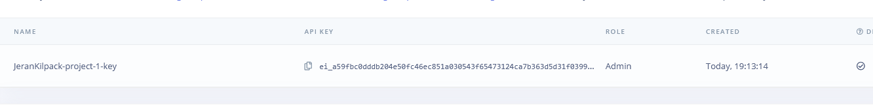

Probably a problem with my personal machines directory. Even after running typescript, the files still are in .ts format and I have the .js file but it won’t be uploaded,  
