**STEP 1. VENV**

Setting up venv. The virtual environment lets me run and process applications as well to have a all in one location for the packages to be installed.   
  
**STEP 2. Installing the libraries**

**Step 3: Create a Virtual IIoT Environment with Multiple Protocols**

mqtt_sensor_simulation.py was able to run smoothly, even though it warns you for an error and to update  
  
the coap script required me to setup a new file server that also required me to adjust my windows firewall.

It took an hour to debug coap_sensor_simulation.py since the code on canvas wasn’t working. My guess is it would work on linux fine but not on windows. I had to disable my firewall completely. I managed to debug it with chatgpt but we were going in circles a lot and now all three .py scripts are running now its time for python   
  
opcua_sensor_simulation.py  
  
opcua worked fine so now its time for visualization.   
  
**VISUALIZATION.   
**



Mosquito visualization script working

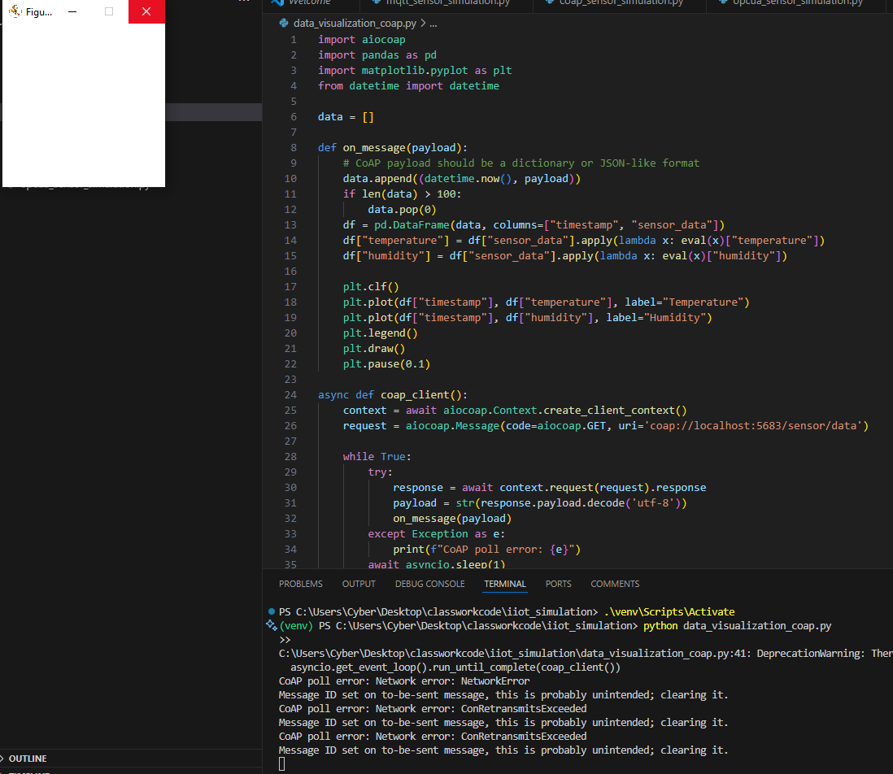

Coap working and waiting.  
had to install the opcua package for that visualization script to work but it was ran fine after.  
  
after creating the 3 scripts(4 including the coap sever script) and the 3 visualizaion scripts when running them all THE VISUALIZATION WORKED!!!

Now all that’s left is putting it on github.

<https://github.com/JeranKilpack/iiot_simulation/tree/main>