Jered Linares

KIEI 451 Final

**Executive Summary:**

git repository:

Live site:

This application is a “capture the flag” game where users can choose to be on the red team or blue team and check into landmarks to claim them for their team. The goal of the game is to check into a set of landmarks daily and hold it the longest for your team.

**MVP Scheme**

Wireframe

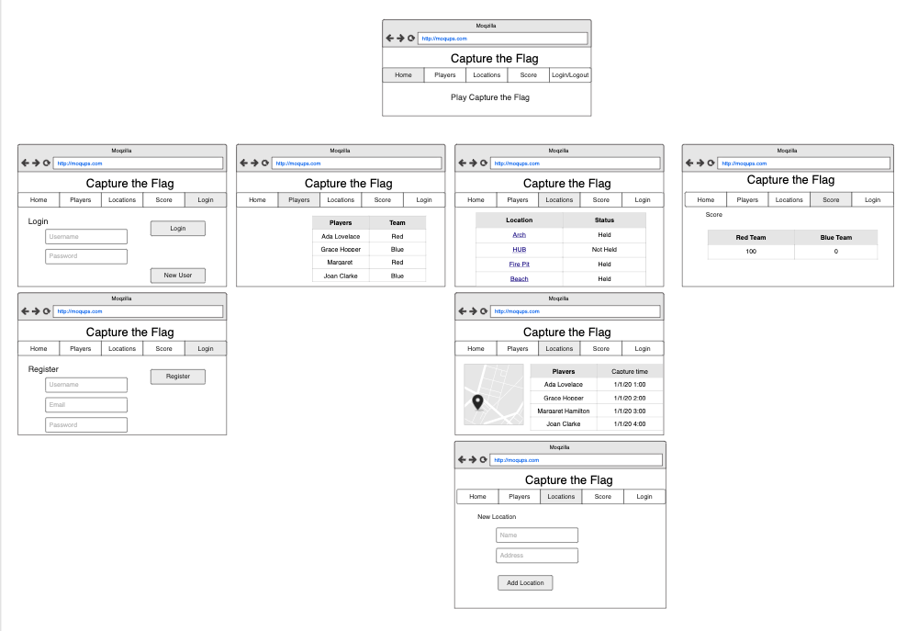

User Stories

As an anonymous user, I want to be able to register to play

As an anonymous user, I want to be able to see the blue and red teams’ scores

As a signed in user, I want to be able to see all players and their team

As a signed in user, I want to be able to go to a location and capture it for my team

As a signed in user, I want to be able to create a new location for the game

Domain Model

