1. In order to change the initial model to accommodate different account types, we would need to create a new entity with the account type and account id as attributes.

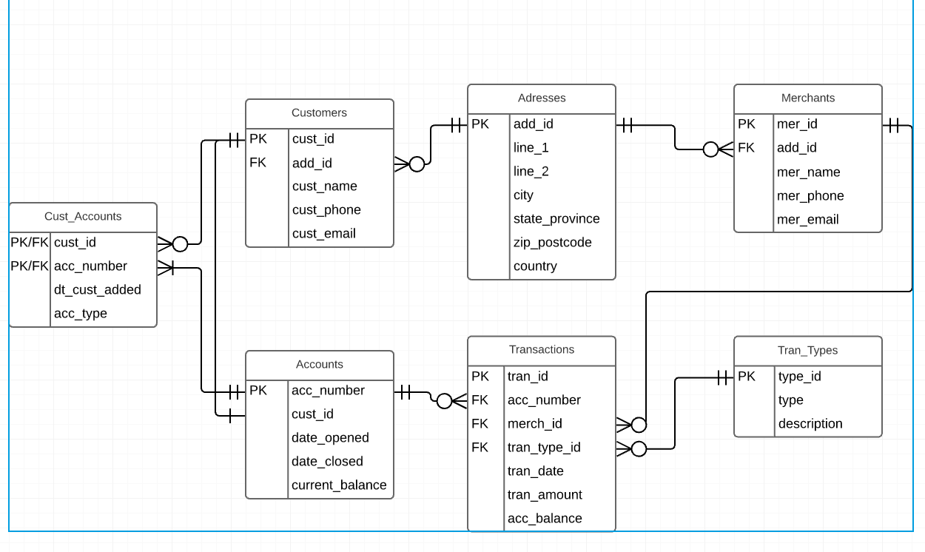

2. MySQL datatypes

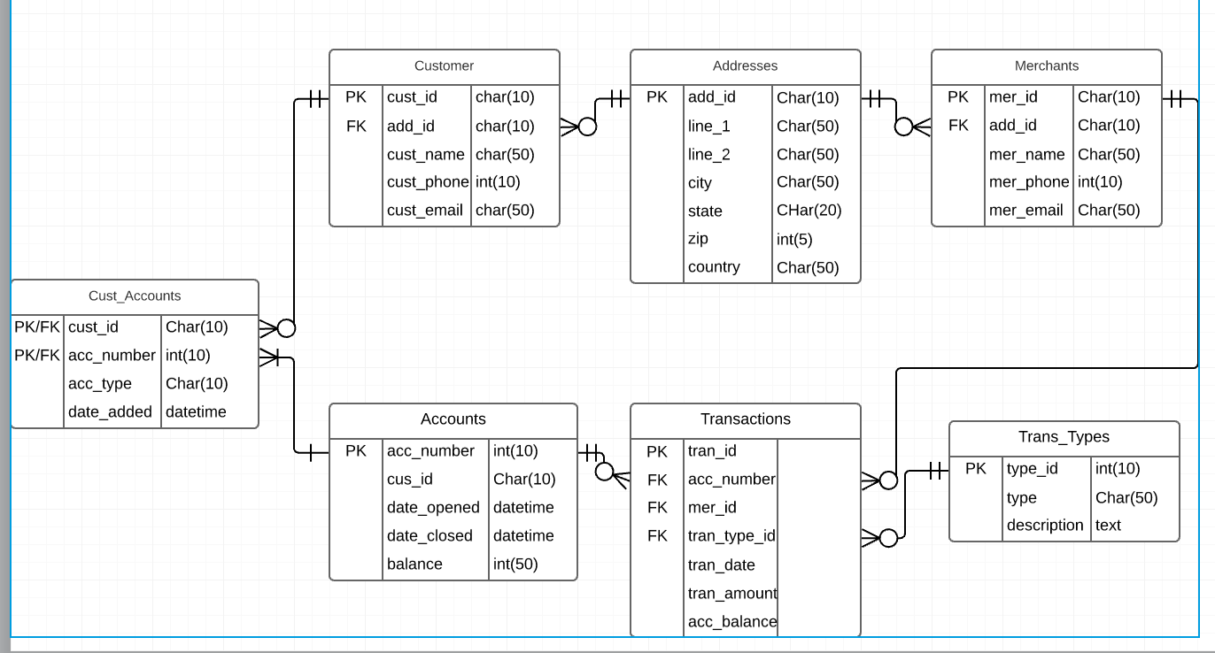

3. Logic ER - csv file

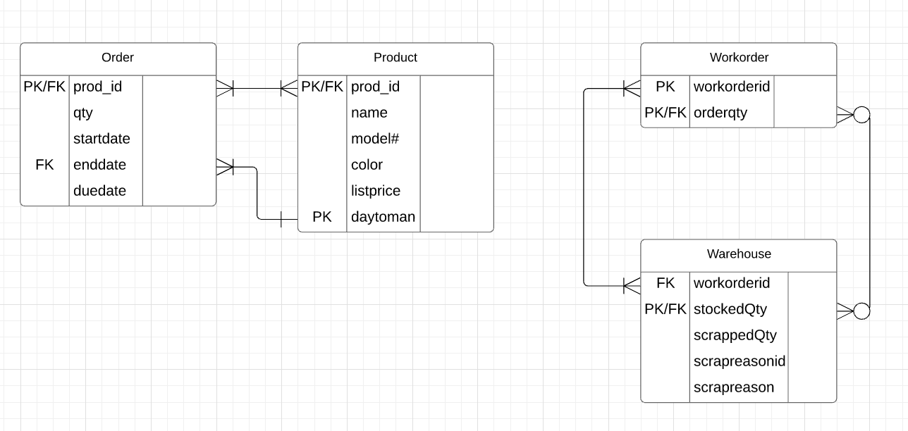

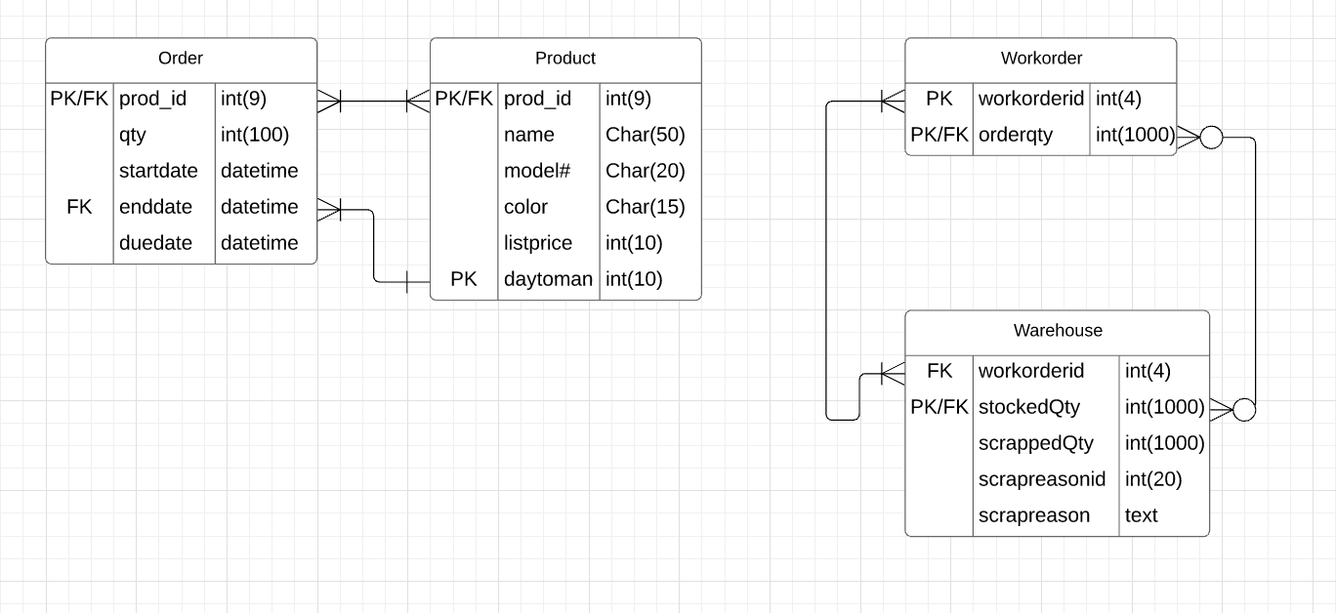4. Physical ER - .csv with data types.

5. Logical ER - many to many correction

