Jered Willoughby

ISQS 6338

(D01) Fall 2018

Module 05 Learning Exercise

1. SELECT \*

FROM shippers

A screenshot of a cell phone


1. SELECT CategoryName, Description

FROM categories

A screenshot of a cell phone


1. SELECT LastName, FirstName, HireDate, Title

FROM employees

WHERE Title = 'Sales Representative'

A screenshot of a cell phone


1. SELECT LastName, FirstName, HireDate, Title, Country

FROM employees

WHERE Title = 'Sales Representative' and Country = 'USA'

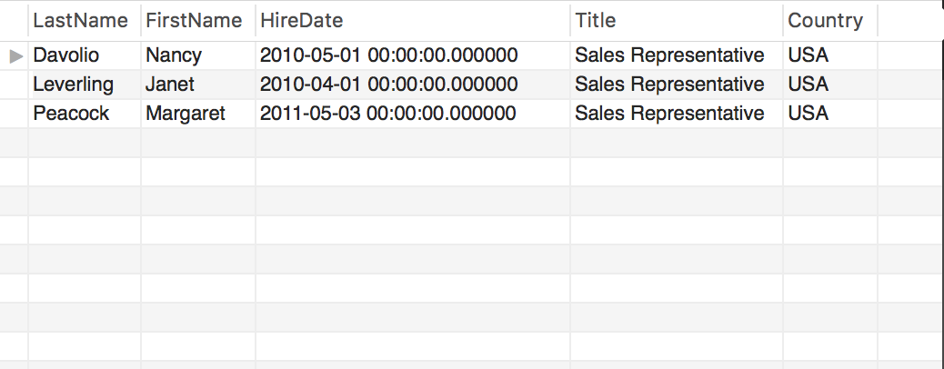

1. SELECT EmployeeID, OrderID, OrderDate

FROM orders

WHERE EmployeeID = '5'

A screenshot of a cell phone


1. SELECT SupplierID, ContactName, ContactTitle

FROM suppliers

WHERE ContactTitle != 'Marketing Manager'

A screenshot of a cell phone


1. SELECT ProductID, ProductName

FROM products

WHERE ProductName LIKE 'queso%'

A screenshot of a social media post


1. SELECT OrderID, CustomerID, ShipCountry

FROM orders

WHERE ShipCountry = 'France' or ShipCountry = 'Belgium'

A screenshot of a cell phone


1. SELECT OrderID, CustomerID, ShipCountry

FROM orders

WHERE ShipCountry = 'Brazil' or ShipCountry = 'Mexico' or ShipCountry = 'Argentina' or ShipCountry = 'Venezuela'

A screenshot of a cell phone


1. SELECT LastName, FirstName, Title, BirthDate

FROM employees

ORDER BY BirthDate ASC, BirthDate

A picture containing text

