RAssign6_Willoughby

Jered Willoughby

9/26/2018

1. For this problem, I followed the example in Dr. Zadeh’s instructional video. We use n for the sample size and NSIM for the simulation amount. Y is the ordinal, random variable that we’re ultimately needing to find the fequency, or realized value. p is the probability, of course suming to one. ntot is the amount of simulations that will be ran. rv=sample is the sample funtion, where rvm=matrix is the matrix function where the data is organized. Average=rowMeans is simply calculating the average. I didn’t put the y Average table in because of the expansive size.

|  |  |
| --- | --- |
| Satisfaction, y | p(y) |
| 1 | 0.05 |
| 2 | 0.10 |
| 3 | 0.15 |
| 4 | 0.20 |
| 5 | 0.50 |
| Total | 1.0 |

n=1000  
NSIM = 10000  
y=c(1, 2, 3, 4, 5)  
p=c(.05, .10, .15, .20, .50)  
ntot = n*NSIM  
rv=sample(y, ntot, p, replace=TRUE)  
rvm =matrix(rv, ncol=n, byrow=TRUE)  
Average =rowMeans(rvm)

hist(Average, freq=FALSE, main=paste("Customer Satisfaction Suvery n=1000"))

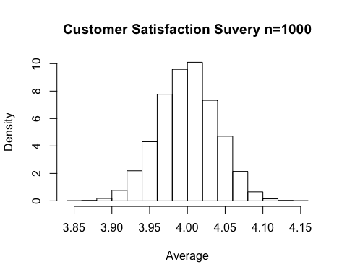

qqnorm(Average)  
qqline(Average)

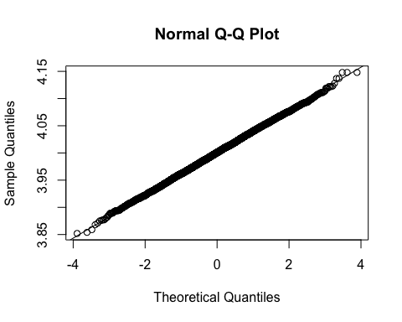

1. Y is normally distributed which is evident from qqplot’s linear distribution following along the qqline. We can also tell from the histogram that 4 is the average ordinal value of the customer’s satisfaction based on the survey. As the sample size increases, then the tendency for normality increase, which is a reiteration of the central limit theorem: “given a sufficiently large sample size from a population with a finite level of variance, the mean of all samples from the same population will be approximately equal to the mean of the population.”