ODB had normalized data, DW did it first but now we denormalized it. Created other aggregated queries to run tables.

**6. Pre-Aggregated Summary Tables (DDL + Population)**

**Summary Table 1: Final Total Cases by Country and Outcome**

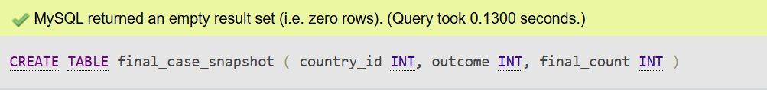

**Summary Table 2: Top 5 Final Case Counts (Weekly Snapshot)**

**OLAP Queries (for Screenshots #8)**

**OLAP Query 1: Final Case Snapshot by Country & Outcome**

Shows the total cumulative case count for each country and outcome at the final reporting week, joined with human-readable names from fact_country and fact_outcome.

**OLAP Query 2: Top 5 Weeks by new Cases per Country**

Displays the top 5 country-outcome combinations with the highest number of newly reported cases in the final week.

**OLAP Query 3: Monthly Case Totals By Country and Outcome**

Aggregates total cumulative cases per month, grouped by country and outcome type. Great for analyzing Long-term trends.



**OLAP Query 4: Total Death Toll over time per Country**

Calculates total deaths per country across all time and shows the total deaths per each country.

