1. Start Environment

1. Preparing ODB

1. Preparing DW

Running Producers and Consumers in our Order

6 different Terminals running

1. Run python3 dw_consumer.py



1. Run python3 odb_producer.py

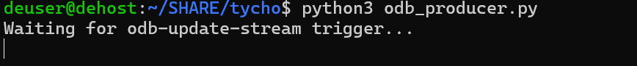

1. Run odb_consumer.py

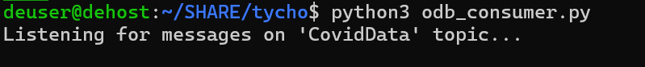

1. Run data_producer.py

