Jeremia Lim

SNHU

CS 340

12/08/2025

README File
The Required Functionality of the Project
This project implements a fully interactive dashboard designed for Gravioso Salvare, an international animal rescue training organization. The goal of the dashboard is to help the organization quickly identify dogs that are suitable for different types of rescue training based on breed, age, and condition at outcome.
The dashboard interacts with a MongoDB database containing the Austin Animal Center Outcomes dataset and provides interactive rescue type filters, interactive data table, interactive pie chart, geolocation map, and branding requirements.
The interactive rescue type filters the dataset using four categories – water rescue, mountain or wilderness rescue, disaster or individual tracking, and reset (remove all filters and shows the entire dataset). Each filter activates specific MongoDB queries defined according to the rescue breed criteria from the Dashboard Specifications Document.
Interactive Rescue Type Filter
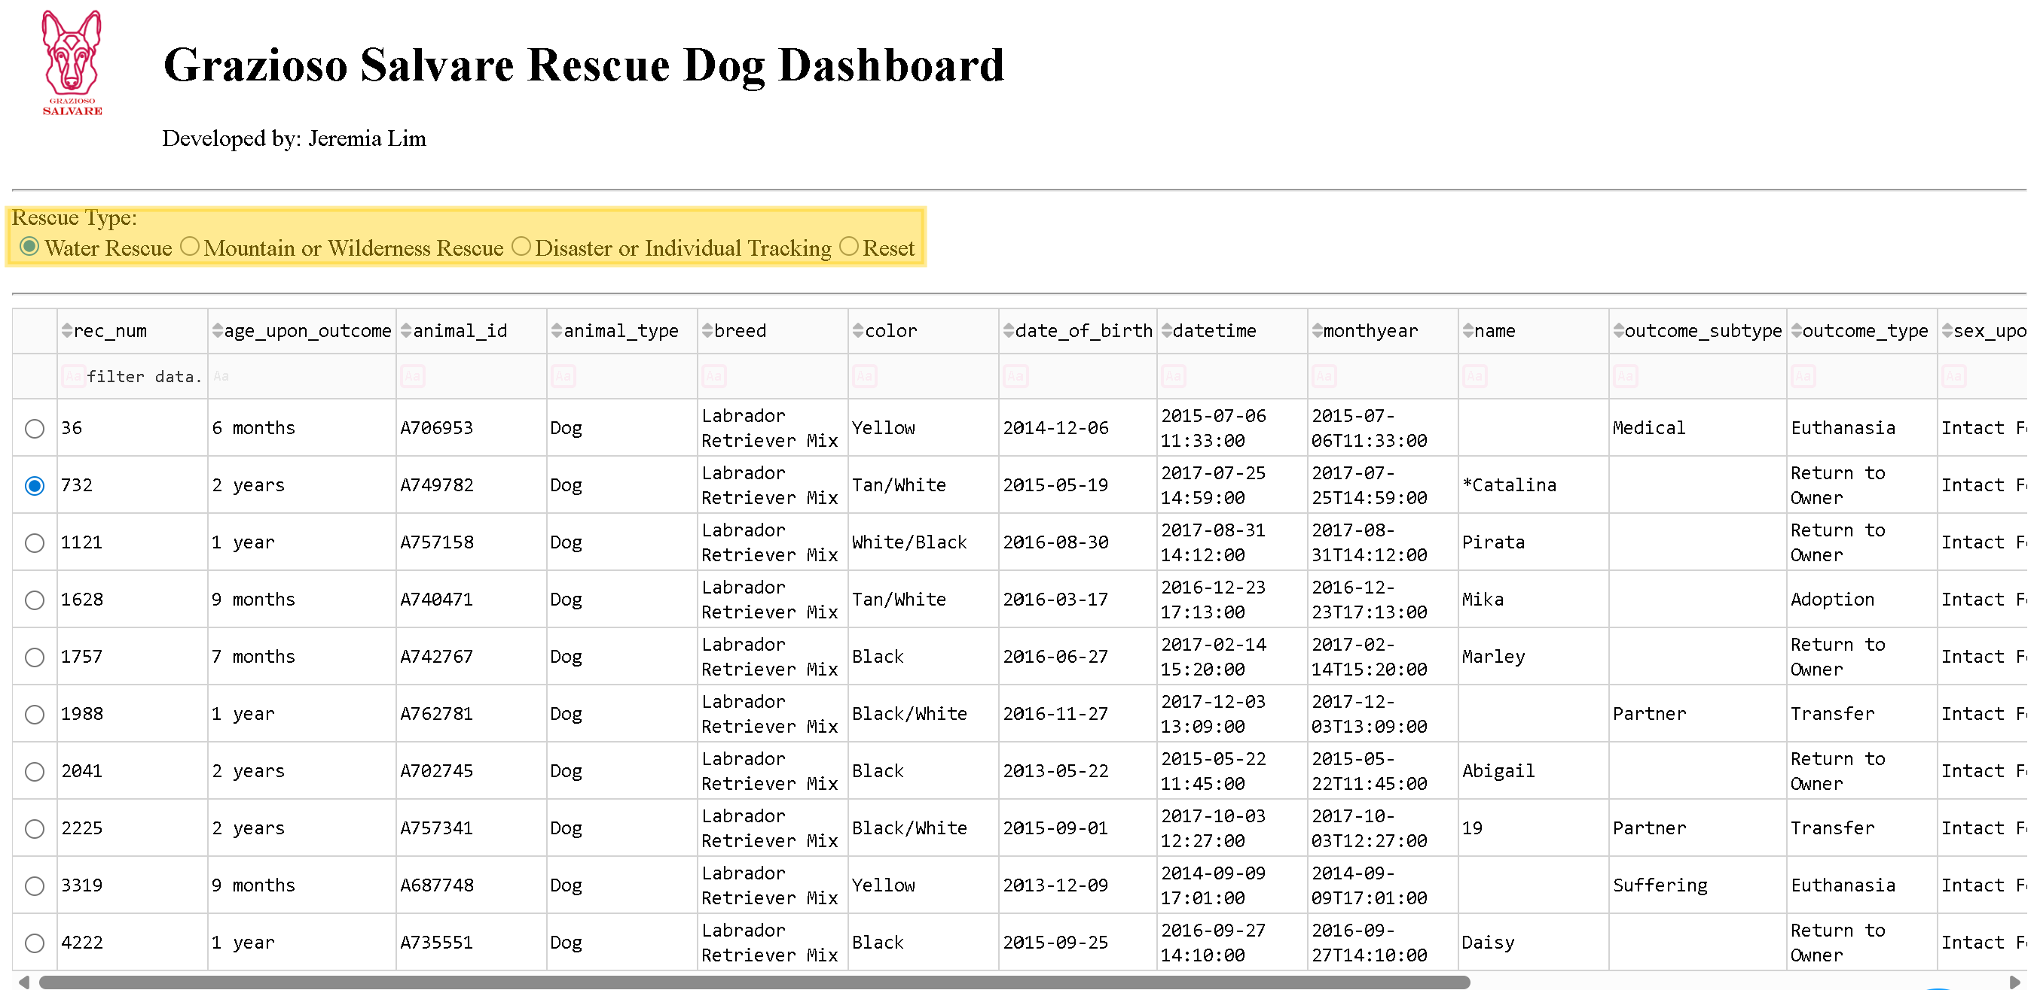
The interactive data table displays data form MongoDB, updates dynamically based on selected rescue type, includes sorting, filtering, and pagination, allows row selection, which updates the map, and highlights selected columns.
Interactive Data Table
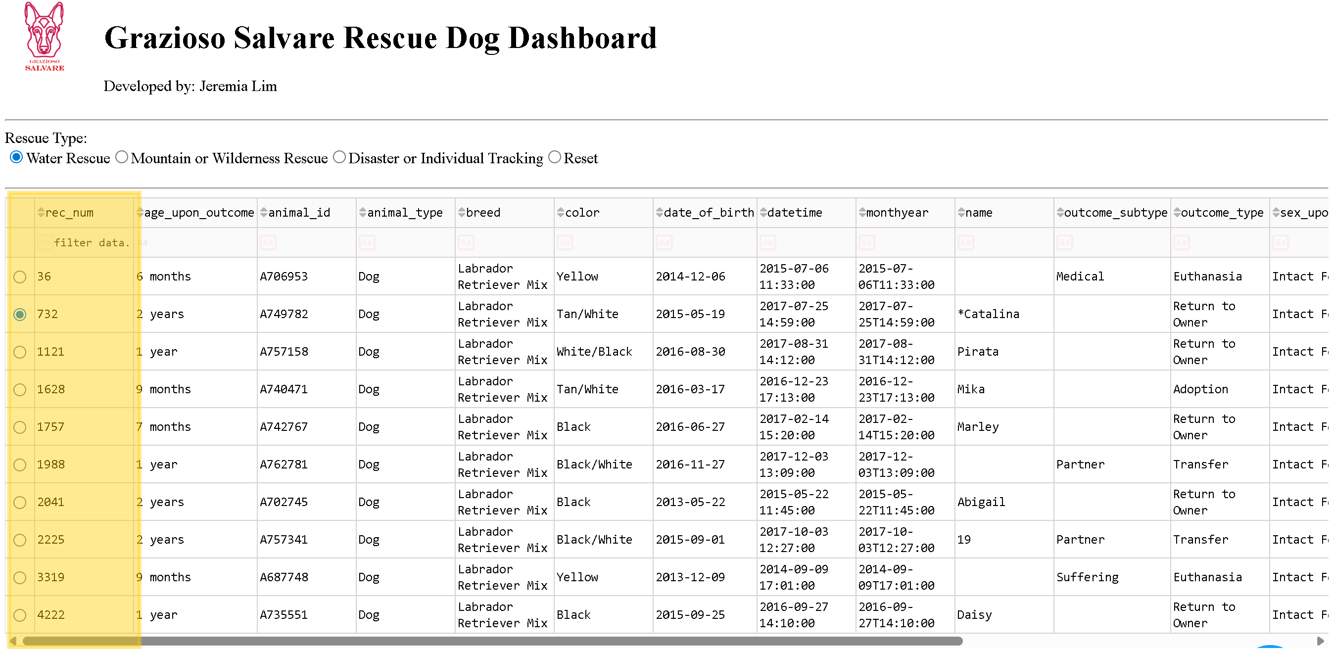
The interactive pie chart shows breed distribution in the current filtered dataset and updates in real time when filters are applied.
The Interactive Pie Chart
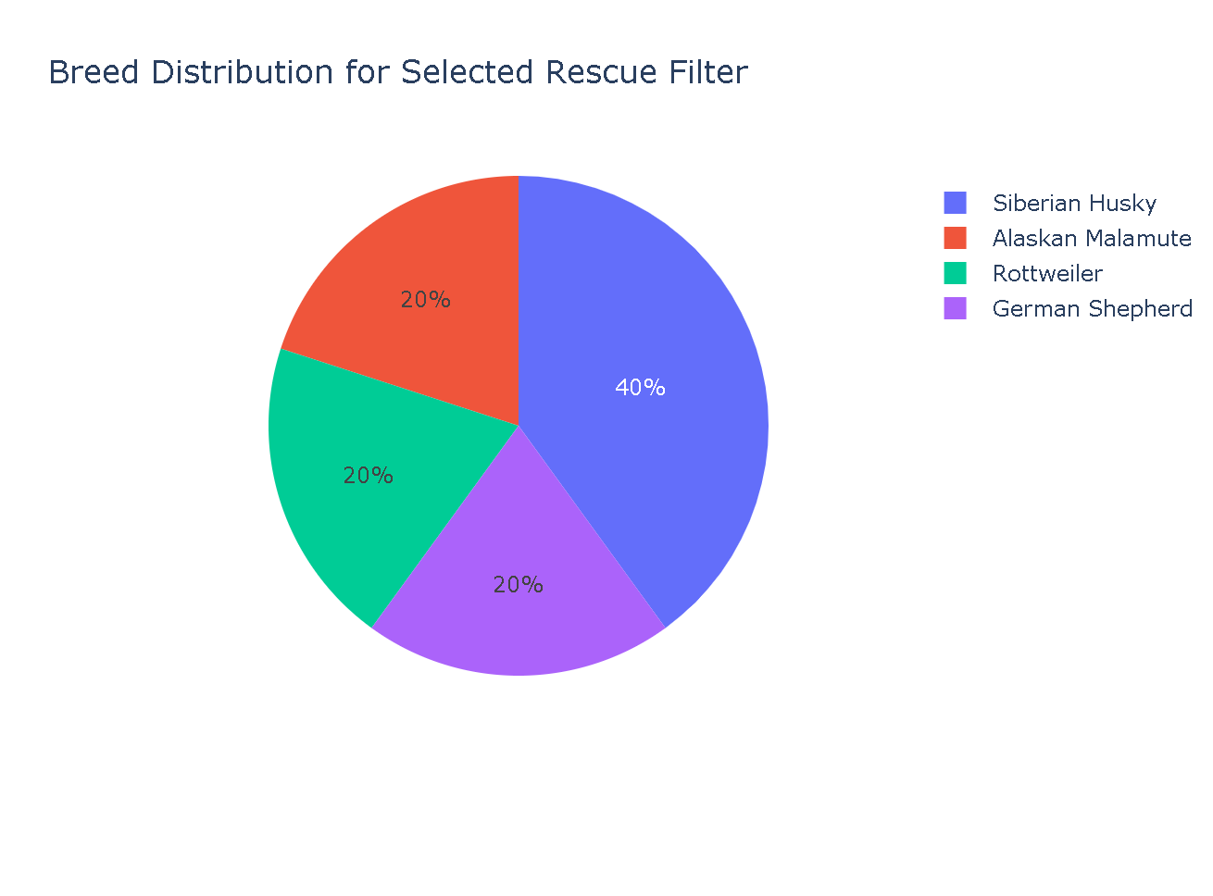
The geolocation map displays a map of Austin, Texas. Clicking a row places a marker at the dog’s recorded coordinates and shows breed (tooltip) and name (popup).
Geolocation Map
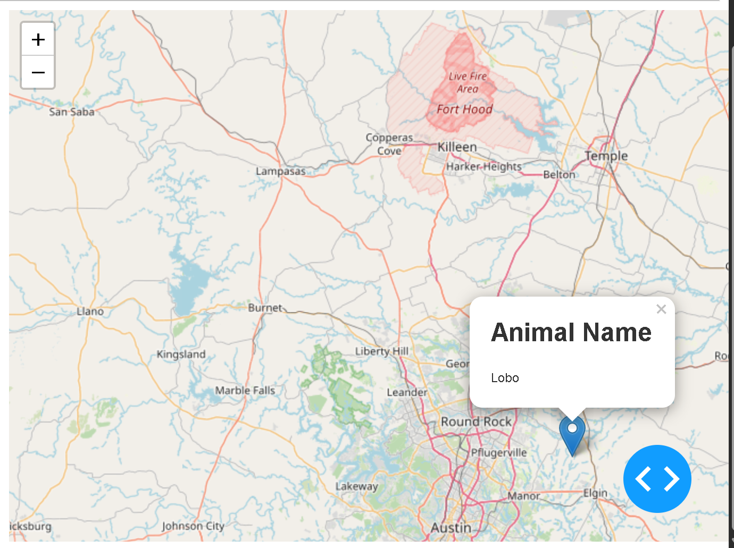
The branding requirements are in high resolution with the Gravioso Salvare logo and unique identifier (Developed by Jeremia Lim), followed with screenshots of each filter being utilized.
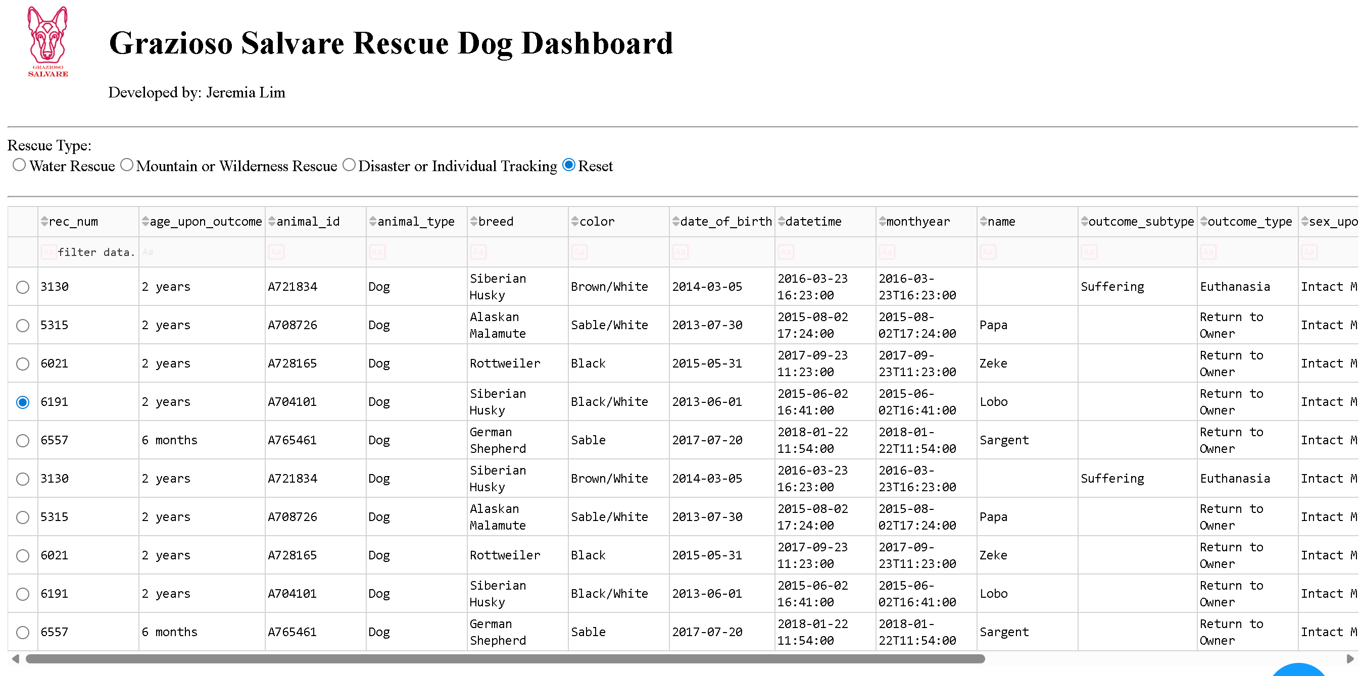
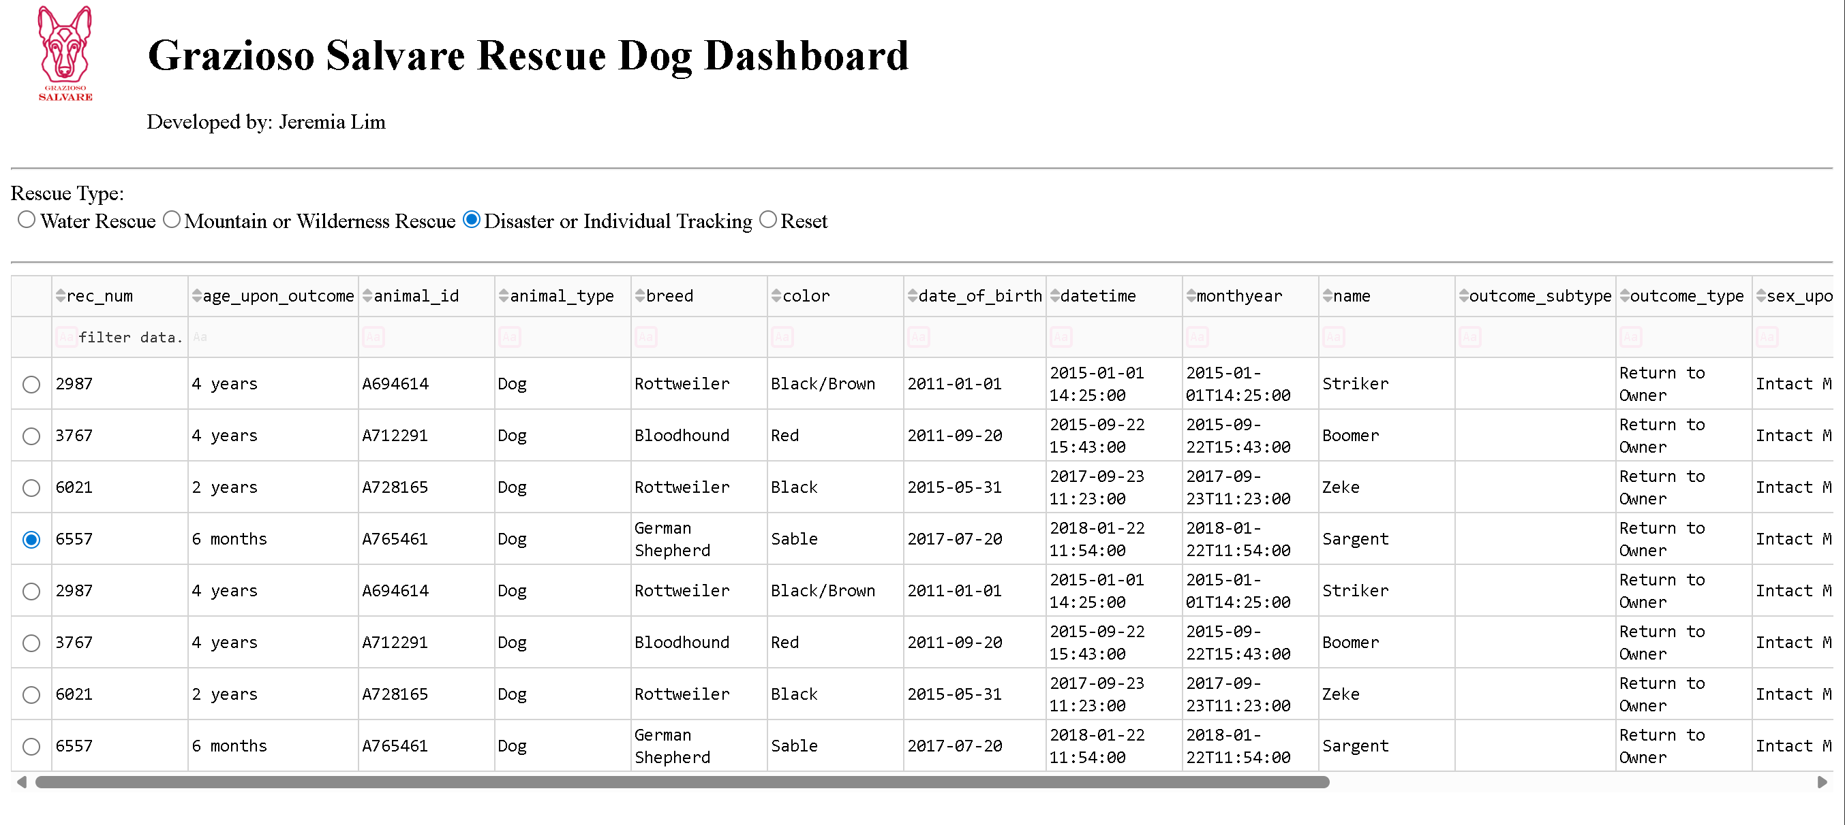
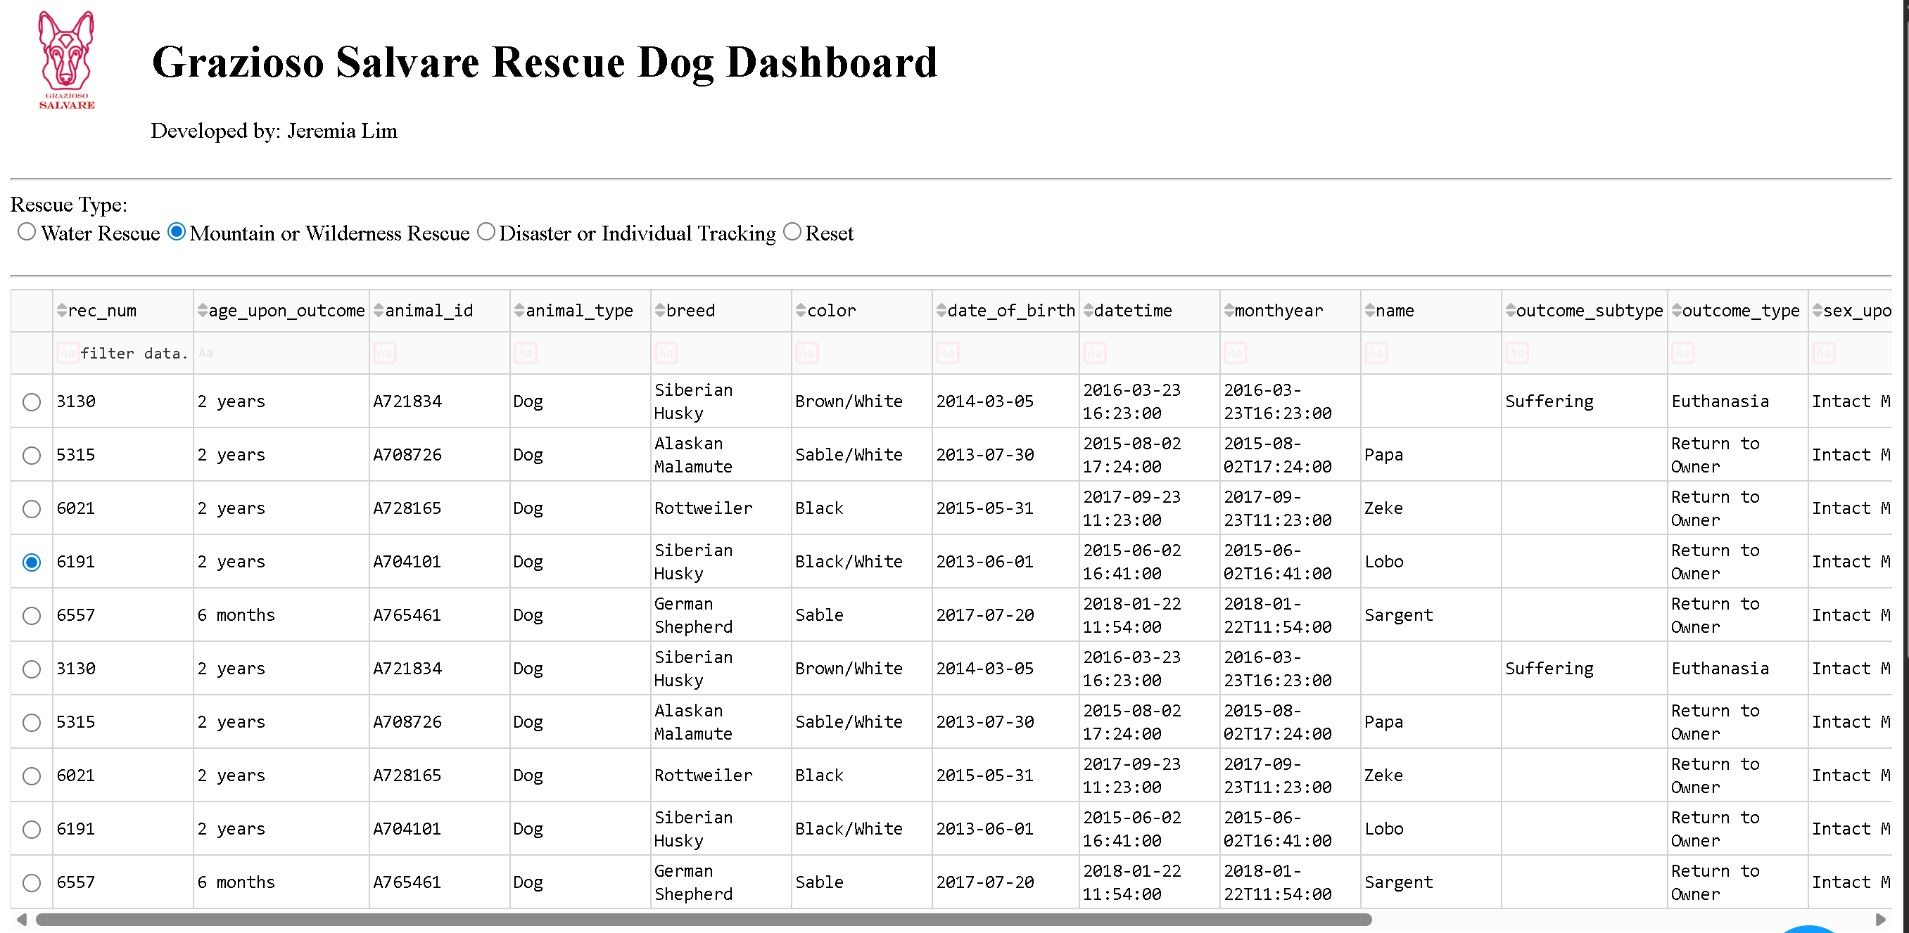
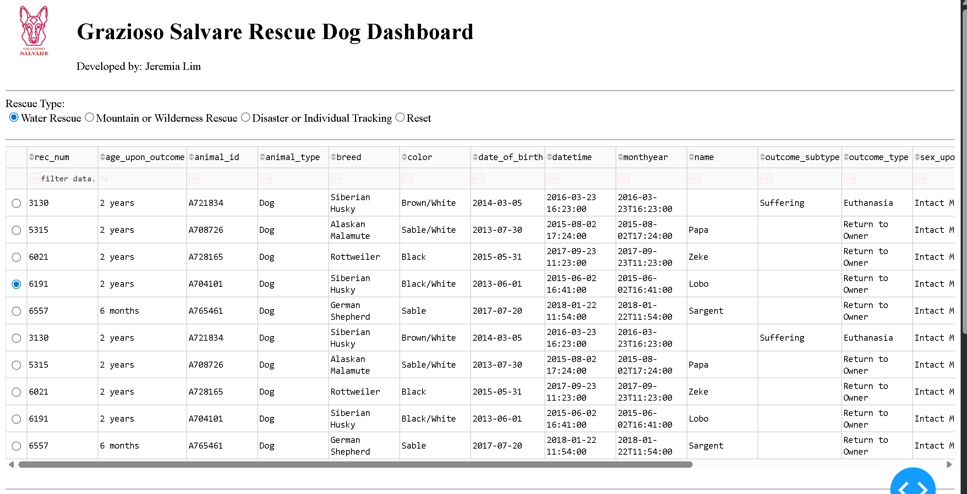
Tools Used to Achieve this Functionality and a Rationale for Why These Tools were used
MongoDB is used as the primary data store. It naturally handles semi-structured data like Austin Animal Center dataset. It stores documents in a JSON-like structure, making it easy to query. It integrates efficiently with Python using PyMongo. It scales well for future expansion.
PyMongo is the database interface. The CRUD class was implemented using PyMongo to connect securely to the MongoDB instance, support create, read, update, and delete operations, and send rescue-specific queries to filter dogs based on rescue type.
Dash Framework was chosen because it supports the MVC pattern cleanly, allows creating interactive browser-based dashboards using Python, provides callback functions to dynamically update table, map, and charts, and is widely used in professional analytics applications.
Dash Leaflet is used for geolocation mapping. It displays markers for selected dogs, allows tooltip and popup information, and integrates seamlessly with Dash.
Plotly Express creates the pie chart because it is automatically responsive, easy to filter based on table data, and clean visual appearance.
Pandas is used to convert MongoDB documents into DataFrames, support filtering, sorting, and grouping operations, and feed cleaned data into Data components.
The Steps That Were Taken to Complete the Project
Step One: Set up Codio Environment
Open the CS-340 project workspace in Codio
Step Two: Load Dataset into MongoDB
Import the Austin Animal Center dataset into the aac.animals collection.
Step Three: Place crud.py in the Project Folder
Ensure your CRUD file contains working connection, read(), create(), update(), delete()
Step Four: Open ProjectTwoDashboard.ipynb
Paste the complete, corrected dashboard code.
Step Five: Run all Cells
Dash will open a browser tab at a /proxy/8050/ URL.
Step Six: Interact with the Dashboard
You should be able to switch rescue filters, view updated table data, view updated breed distribution data, view updated breed distribution chart, and click rows to update the geolocation map.
Identify any Challenges that were encountered and explain how these challenges were overcome
- Sometimes when going through the code, there are syntax errors that are easy fixes. The system found the incorrect spelling (i.e. RESCUE_FIlTERS).
- The data table crashed from _id field changing the line of code to
df.drop(columns=[‘_id’], inplace=True, errors=’ignore’)
- The callback failed before the table loaded. I fixed it by adding a guarded clause
if not selected_column: return[]
Conclusion
This dashboard provides Grazioso Salvare with a powerful, intuitive tool to evaluate rescue training candidates. By integrating MongoDB with a Dash-based front-end, the system allows real-time filtering, visualization, and geolocation mapping.
The application supports mission-critical decisions for the organization and offers a scalable foundation for future enhancements such as adoption statistics, historical trends, or automated recommendations.

