FightTurn!!

What is it??
Turned based fighting game with 8/16 bit graphics and sound.

What Stack??
Vanilla HTML, CSS, javascript.

Does it have a Wireframe??
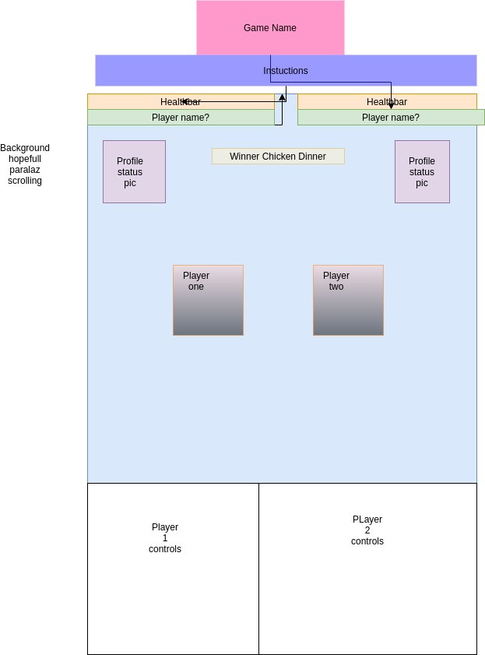

What is the minimum we can expect of FightTurn!!??

The minimum should be :2 players with health bars take simultaneous turns deciding between 3 (or more) options for moves. Each move should have a special, including a SUPER! Move that charges after three hits, thank can only be dodge.
Different gifs for each player state available: Attack one, two, and three, super move, dodge, getting hit, and defeated.
Player pics that change if when player attacking, getting hit, or down.

Game starts ready game start, but include reset button.

How AMAZING are the stretch goals???
Combo/special moves: If one player makes two successful hit in a row a special move is perform that takes of more health.
Character select with different combo/special mover!
Multiple backgrounds with cool transitions.

Find animated pixel art to meet my requirements. The logic getting more complex for each variable added.

