My Thesis

Simon Goring

This is a sample thesis that we’re using to showcase some practical applications of integrated documents.

# Our Sample Thesis

## Knitting your Thesis

Open this Rmd file in RMarkdown. It should all be ready to go, to turn it into a cool HTML document. To do that, look at the RStudio toolbar and click the knit button.

You can also knit (or render) your RMarkdown documents using the command line. There are good reasons for doing this, and cool tricks you can try (see the Tips & Tricks later in the workshop). To do that, go to the folder that your RMarkdown document is in and type in the command:

Rscript -e "rmarkdown::render('filename.Rmd')"

No need to try it here, but just wanted to mention it :)

## Integrating Code

When you’re working on your thesis you’re probably loading some data, and then doing some analysis. We’re going to show a couple ways of doing it, but we’re also going to look at how to integrate that code directly into your text.

### Data Import

We did some work looking at Github repositories earlier, and added information to a Google spreadsheet. I’ve downloaded the data into a CSV file in the data/input directory of this project.

library(assertthat)  
table <- read.csv('data/input/GitHubRepos.csv')

Once the table is read in by the code block above we can say some things about it, for example, I can let you know that there are 200 rows in the table.

There are three stratigraphic sections that we studied and the thickest one was the Something Formation.

I wanted to know how many of the tables had README files. There are 22 README files, out of 151 repositories sampled.

plot(factor(table[,3]))

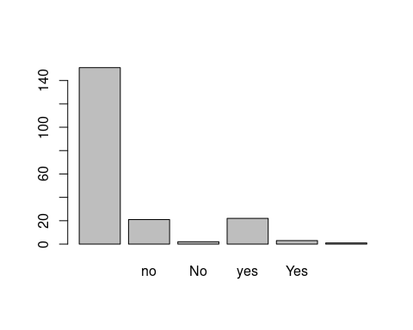

### Dynamic Data

Sometimes we’re working with data that comes from the World Wide Web. The Internet is basically a series of tubes. Some research databases or online tools have packages that allow you to obtain data directly through in internet connection. [xDeepDive](http://geodeepdive.org) is a tool that has harvested full text from hundreds of thousands of journal publications. We can connect to it using a URL:

https://geodeepdive.org/api/

That URL leads you to a help page of sorts. I just want to do a really simple query here. How many papers talk about *climate*?

library(jsonlite)  
climate <- jsonlite::fromJSON('https://geodeepdive.org/api/snippets?term=climate&clean&full_results')

We can look at the result online. The only thing I want to point out is that there are only 1173426 results, meaning less than 300 papers about climate. Shocking!

# Templates

Most universities and departments make a Word or latex template available for theses. For example, the [template in the templates folder](templates/thesistemplate.docx) is provided by [Simon Fraser University](https://www.lib.sfu.ca/help/publish/thesis/templates).

# Bibliography

Pandoc (and by extension, RMarkdown) can support the use of a bibliography in [Bibtex format](http://www.bibtex.org/). These references can be rendered into a number of different formats using an XML-type file called the [Citation Style Language](https://citationstyles.org/), or CSL. These files define how the reference is rendered and referenced in text. You can see a full list of available formats (for a large number of journals) in the [CSL Github styles repository](https://github.com/citation-style-language/styles).

If I wanted to cite a paper, for example, the winner of an IgNobel prize for making feces knives (Eren et al. 2019), I could simply add an in text citation to my bibliography file. We’ll edit this further once we get used to using git workflows.

There’s some great information about [using RMarkdown citations & bibliographies](https://rmarkdown.rstudio.com/authoring_bibliographies_and_citations.html) on the RStudio website.

# References

Eren, Metin I, Michelle R Bebber, James D Norris, Alyssa Perrone, Ashley Rutkoski, Michael Wilson, and Mary Ann Raghanti. 2019. “Experimental Replication Shows Knives Manufactured from Frozen Human Feces Do Not Work.” *Journal of Archaeological Science: Reports* 27: 102002.