(draft) Statement of Case

The Scheme is no longer in accordance with the development plan
- A key requirement of the compulsory purchase code is that the Scheme underlying the Order must conform with the requirements of the statutory development plan. Paragraph 76 of the 06/04 ODPM Circular lists a key consideration as "whether the purpose for which the land is being acquired fits in with the adopted Local Plan for the area" and specifies that "any programme of land assembly needs to be set within a clear strategic framework, and this will be particularly important when demonstrating the justification for acquiring land compulsorily under section 226(1)(a) powers as a means of furthering the well-being of the wider area.".
- The adopted Local Plan for the Scheme underlying this Order (“the Scheme”) is the Aylesbury Area Action Plan 2010 (“AAAP”) [CD2], which was adopted in January 2010 as part of the Acquiring Authority's local development framework.
- As a result of the withdrawal of £180m government funding envisaged by the AAAP and subsequent changes in housing policy affecting the viability of the Scheme, it now fails to comply with the following requirements of the development plan:
    - Minimum number of new homes requirements
    - Net loss of affordable housing requirements
    - Dwelling size requirements
    - Minimum space standards
    - Wheelchair accessible requirements
    - Tenure requirements
    - Renewable Energy requirements
    - Building Heights requirements
    - Sunlight/Daylight requirements
    - Open Space requirements
    - Transport/public realm requirements
    - Private Amenity Space requirements
    - Dual aspect design requirements
    - Privacy and overlooking requirements
    - Play Space requirements
    - Land use requirements
    - Density requirements
    - Monitoring and compliance
    - Infrastructure/public sector funding requirements
- These numerous failures to meet with the AAAP's minimum policy requirements and those of the local development framework, are set out in detail by the 35% Campaign in their witness evidence and are relied upon but not be addressed in detail here.

The Scheme is not viable.
- Paragraph 22 of the ODPM Circular 06/04 requires the Acquiring Authority to demonstrate that the Scheme underlying the Order is financially viable and therefore deliverable.
- The Objectors submit that there are four main factors which demonstrate that the Scheme is not financially viable:
  - The Scheme was not viable in the first place
  - £180m of allocated government funding has been withdrawn since the AAAP was adopted
  - The government has cut the amount housing associations can charge for (social) rents and introduced a cap in Local Housing Allowance
  - Construction costs have been spiralled 10% annually since the Scheme was modelled and DPA signed in 2014

a) The scheme was not viable in the first place
- The AAAP's 2009 Sustainability Assessment said:
"Early financial modelling indicated that about 5000 homes would need to be provided on the footprint of the estate to make any redevelopment financially viable. All the options therefore were predicated around this figure."
"Following consultation on these options, the council decided to revise options relating to housing, in order to meet concerns that the scheme needed to be more family friendly. These revisions related to housing tenure, density, type of homes, bedroom split, tall buildings and provision of private amenity space. The overall numbers of units to be provided were reduced from 5,000 new dwellings to 4,200 new dwellings."
- Documents submitted prior to the examination in public of the AAAP in 2009, show that the Aylesbury scheme as envisaged is was not viable and that the viability gap is being bridged by shortchanging leaseholders. In Jan 2009, the draft Aylesbury Area Action Plan showed that there was a funding shortfall of £299m.
The following is an extract from page 92 of the appendices to the draft AAAP:
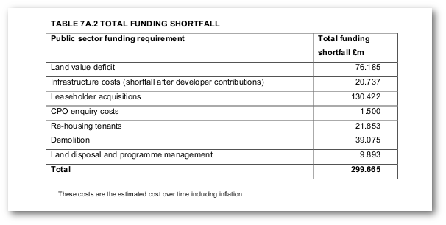
- The National Policy Planning Framework (NPPF) requires that Local Plans are viable and therefore deliverable (Para 174). This is one of the key tests in assessing the “soundness” of a Local Plan at an examination in public.
- The inspector at the examination in public of Southwark's AAAP, flagged up the significant funding gap to the Council. Her final report on the AAAP shows that the Acquiring Authority's solution to the funding gap was to arbitrarily slash the cost estimates, without providing any evidence base or justification for doing so. The £130m originally estimated for leasehold acquisitions of the circa 500 leasehold properties on the estate was arbitrarly reduced by 50% without explanation.
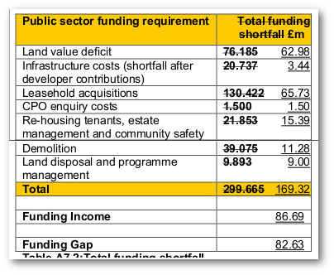
Table of Recommended Changes to AAAP (2009) showing cost estimates slashed
- Altogether, the cost estimates were reduced by around a half, reducing the funding gap from £299m down to £169m and this is the figure given in the final adopted version of the AAAP.
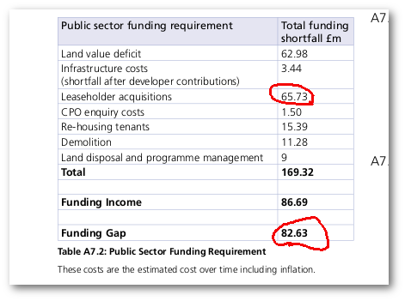
Extract from final adopted version of Aylesbury Area Action Plan 2010 showing the funding gap

b) £180m of central government funding was withdrawn from the Scheme post adoption of the AAAP
- The Acquiring Authority was expecting to cover the remaining £169m funding shortfall with government PFI funding and this satisfied the inspector at the Examination in Public. However, just under a year after the Area Action Plan was adopted, the government withdrew all PFI funding for the scheme.
- At the previous inquiry NHHT claimed that it had 'applied' for central government funding from the ‘Estate Regeneration Fund’. Its updated Statement of Case also says that it has 'applied' for funding from the same programme. The Objectors seek clarification as to whether this is the same application (that has taken over 3 years to process) or a separate application, the first having been rejected.

c) The government has reduced the social rent levels that housing associations can charge.
- In 2015, the government introduced reforms to the amount of rent housing associations can charge under social rented tenancies in its Housing & Planning Act, forcing them to reduce social rents by 1% per year.
- The Financial Times reported that the changes could force housing associations into a financial cirisis, explaining that according to Treasury forecasts landlords’ rents will be 12 per cent lower than previously forecast by 2020-21. The Office for Budget Responsibility said the drop in rental income was likely to result in housing associations calling off plans to build 14,000 homes; the National Housing Federation said this figure was nearer to 27,000.
- NHHT's 2016 financial statement confirmed that "Following changes announced by the Government in July 2015, we paused our start on sites to reassess scheme viability and to review our blend of tenures to reflect Government priorities .. Starts on site slowed down as we paused to reappraise the tenure split of schemes following the social rent cuts announced in the Government’s summer budget."
- In September 2016, the Acquiring Authority announced at a Cabinet meeting that "the impact of measures in the Housing and Planning Act have reduced the ability of NHHT’s Board to progress Phase 2 and Plot 18 at this stage" (para 8) and that "due to the costs" and "CPO delay", NHHT was no longer willing to fund the demolition costs of the FDS that it was obliged to under the terms of the Development Partnership Agreement (DPA) - (para 12).
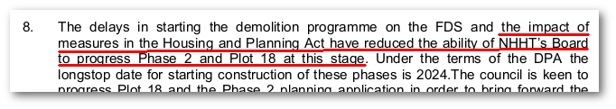
- NHHT's board's refusal to continue funding the Scheme as a result of viability concerns, provides evidence that just because NHHT is running a bumper surplus and has liquidity, it's board will not proceed with schemes that are not financially viable, regardless of any contractual obligations to do so.
- The Objectors note the evidence provided to the previous inquiry, with which the Acquiring Authority successfully argued that there was both board-level approval and contractual requirements in the DPA, obliging NHHT to proceed with the FDS Scheme regardless of whether it is viable or not. (see paras 92 and 388 of the inspector's report)
- The Acquiring Authority's updated Statement of Case claims similarly: "this phase of the development is not subject to viability testing" (para 11.2.6). The Objectors submit that NHHT's board decision not to continue funding the Scheme provides clear evidence to the contrary.
- In June 2016 NHHT's credit rating was downgraded by Moodys. The downgrade report mentioned NHHT's significant development pipeline and its three major schemes; the Aylesbury estate, Canada Water and a scheme in Hounslow.
- The Moodys report states that just 7% of the homes in NHHT's pipeline are social rent. From this it can only be understood that the replacement 'social rent' homes on the FDS must have been included in these figures as affordable rent.
- As a result, the capex to revenue ratio reported to Moodys and other credit agencies, must have been based on the provision of affordable rent not social rent. Had it been based on social rent then the capex to revenue ratio would have been much higher. This suggests that either Moodys have been given incorrect info on the tenure mix of NHHT's pipeline or the replacement 'social rent' homes on the Aylesbury will be Affordable Rent.
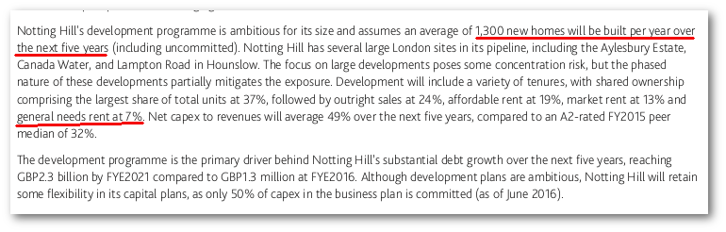
- Paragraphs 8.10-8.11 of the Acquiring Authority’s updated statement of case make much of the ‘strength of robustness of NHHT’s financial standing’. The Objectors submit that this is a result of NHHT’s board’s tough business-minded approach; i.e. ensuring that schemes are financially viable and offer a healthy operating margin before proceeding – or stalling and extracting concessions from development partners if they don’t. Paragraph 8.10 confirms that its average operating margin is 34% - this is nearly 10% above the industry average.

d) Construction costs have spiralled since DPA financial modelling
- This article in the Financial Times confirms that construction costs in London have been spiralling since the DPA was agreed in April 2014, by as much as 10% per year.
- The ‘viability note’ disclosed under FOI in March 2015, shows that the estimated construction costs for the FDS are £145m. This means an extra scheme cost of up to £50m since the viability of the scheme was originally modelled.
- It is understood unredacted sections of the DPA so far disclosed, that NHHT’s delivery partner Barratt homes has been contracted to deliver the private homes on the estate. The terms of the agreement were that it would construct the private homes and sell them. It would be allowed to keep the sales proceeds up to a rate of £471 per sqft. Any proceeds above which would be shared equally between NHHT and the Acquiring Authority (after deduction of NHHT’s priority return of 21%). According to the ‘viability note’ referred to above, this would have provided NHHT with an estimated “cross subsidy of £6.7m between the sale and rent tenures” on the FDS.
- The Objectors understand that Barratt has since withdrawn from this agreement. Spiralling construction costs would clearly have impacted on such an agreement where sales revenue is capped. The Objectors seek clarification on whether Barratt has withdrawn; on what grounds; if a replacement delivery partner has signed an agreement; the details of any such agreement and resulting cross subsidy expectations.

Failure to demonstrate Scheme is viable and therefore deliverable
- Paragraph 16 (iii) of Appendix A of the 06/2004 Circular says(emphasis added):
"Any decision about whether to confirm an order made under section 226(1)(a) of the 1990 Act will be made on its own merits, but the factors which the Secretary of State can be expected to consider include .. (iii) the potential financial viability of the scheme for which the land is being acquired. A general indication of funding intentions, and of any commitments from third parties, will usually suffice to reassure the Secretary of State that there is a reasonable prospect that the scheme will proceed. The greater the uncertainty about the financial viability of the scheme, however, the more compelling the other grounds for undertaking the compulsory purchase will need to be. The timing of any available funding may also be important. For example, a strict time-limit on the availability of the necessary funding may be an argument put forward by the acquiring authority to justify proceeding with the order before finalising the details of the replacement scheme and/or the statutory planning position."
- The Objectors submit that there is indeed "great uncertainty about the financial viability of the scheme" and that therefore the Acquiring Authority is required to make a "more compelling" case for "the other grounds for undertaking the compulsory purchase".
- Paragraph 19 of the ODPM 06/04 Circular states that “If an Acquiring Authority cannot show that all the necessary resources are likely to be available to achieve that end within a reasonable time-scale, it will be difficult to show conclusively that the compulsory acquisition of the land included in the order is justified in the public interest.”
- Paragraph 20 of the ODPM 06/04 Circular says:
"In preparing its justification, the acquiring authority should provide as much information as possible about the resource implications of both acquiring the land and implementing the scheme for which the land is required. It may be that the scheme is not intended to be independently financially viable, or that the details cannot be finalised until there is certainty about the assembly of the necessary land. In such instances, the acquiring authority should provide an indication of how any potential shortfalls are intended to be met. This should include the degree to which other bodies (including the private sector) have agreed to make financial contributions or to underwrite the scheme, and on what basis such contributions or underwriting is to be made."
- The October 2015 review of the ODPM 06/04 Circular went to further to say the substantive information must be provided: "the acquiring authority should provide substantive information as to the sources of funding available for both acquiring the land and implementing the scheme for which the land is required."
- Contrary to the requirements of paragraphs 20 of ODPM Circular 06/2004, insufficient information is given in the Acquiring Authority's Statement of Case, detailing the cost of the scheme or how it will be funded.
- In March 2016, the Acquiring Authority introduced a new policy (Development Viability SPD 2016), requiring viability assessments to be submitted in conjunction will all planning applications involving the provision of affordable housing and requiring them to be publicly available.
- The Objectors note NHHT's intention to submit a revised planning application for the FDS and therefore request that the viability assessment is made available for scrutiny well before commencement the inquiry.
- Given the concerns raised at the previous inquiry about the wording of the section 106 agreement, the Objectors also request that a copy of the revised (signed) section 106 agreement is made available for scrutiny well before commencement of the inquiry.
- The Objectors also request that a copy of any funding agreements and full details of any other further funding commitments are supplied to well before commencement of the inquiry.
- The Objectors note the DCLG's 10 May letter to the Acquiring Authority, containing a warning that any delay in providing information may result in a request for adjournment: "It is important that those whose interest or rights are included in the order should be in a position to put their case at the inquiry without having to probe for further details. If they have to do this during the inquiry, they may not be in a position to deal with the additional information and this could lead to a request for an adjournment.”
The non-viability of the Scheme may result in it not being delivered in a reasonable timeframe
- The Wood Dene estate, an estate owned by the Acquiring Authority in Peckham, was demolished in 2007 and is due to be redeveloped by NHHT. However, it has left the site empty for 10 years without building any new homes. This Objectors submit that this will be likely future of the FDS if the order is confirmed.
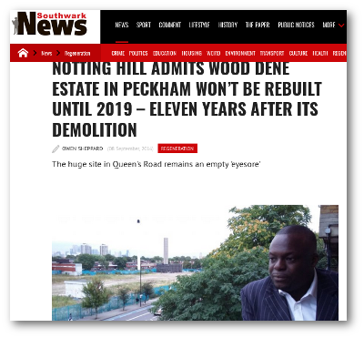
- The AAAP said that the FDS development would be completed by 2016. The DPA says that the FDS will be completed by 2021, but NHHT have now put this back to 2024. See more info here.
- This is further evidence of the Scheme's failure to comply with the development plan and contractual requirements. It is also a breach of the compulsory purchase code (ODPM 06/04), which says that the Acquiring Authority must show that there is a "realistic prospect of the land being brought into beneficial use within a reasonable timeframe". The Objectors submit that seven years is not a reasonable timeframe.
- The Objectors note that there is nothing in the DPA compelling NHHT to complete any of the development phases should NHHT declare them unviable.

NHHT breaches terms of DPA & refuses to continue funding Scheme
- NHHT has breached various provisions in the DPA including its obligation to purchase 5 P&R (Purchase & Repair) street properties on the open market, that it was to repair and subsequently provide on shared equity terms to leaseholders on the FDS, in order to provide a wider rehousing choice (see para 4.2.2.13 of the DPA Business Plan Section 4).
- The Acquiring Authority claimed in its response to a Cabinet question from leaseholders, that NHHT has indeed provided 2 such properties to leaseholders on the FDS, but the Objectors were not aware of such offers. The Objectors request that the Acquiring Authority provide details of these two properties and explain why only 2 of the 5 street properties have been purchased by NHHT under its DPA obligations and why none of the Objectors have not been offered a P&R street property.
- This is of particular importance given that in November 2015, one of the Objectors (whose mother is wheelchair bound) wrote to NHHT asking why it was unable to offer any properties with wheelchair access. NHHT responding by claiming that it didn't have any wheelchair-accessible properties available via the shared equity scheme and advised her to apply to the Council for rehousing assistance instead. (correspondence is here.
- In order to avoid increasing the burden on the Council’s limited available stock and burgeoning housing waiting list, the DPA also requires NHHT to provide 142 'target rent' homes from its own existing stock (outside the development area) to rehouse existing Aylesbury tenants, 35 of which to be provided by 2017 - (paras 4.2.2.2 and 4.2.3.4 of the DPA Business Plan section 4).
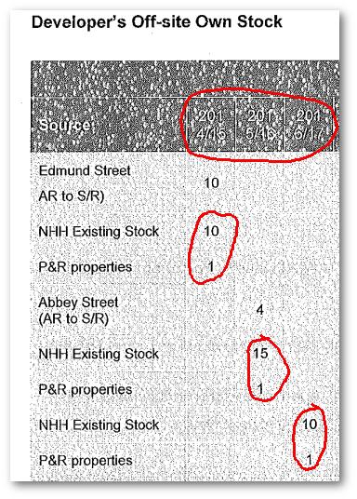
- The Objectors request that the inquiry is provided with details of how many of these 35 have actually been provided and used to house existing Aylesbury secure tenants? The DPA also says that NHHT will purchase a number of street properties and offer them to Aylesbury tenants at 'target rent'. According to the DPA, three of these should have been provided by 2017. The Acquiring Authority is requested to provide details confirming that NHHT has also complied with this obligation of the DPA.
- NHHT's commitment to the Scheme is further brought into question when the Acquiring Authority declared at a Cabinet meeting in September 2016, that "the impact of measures in the Housing and Planning Act have reduced the ability of NHHT’s Board to progress Phase 2 and Plot 18 at this stage" (para 8). It went on to add that "due to the costs" and "CPO delay" (para 12), NHHT was no longer willing to fund the demolition costs for the FDS.
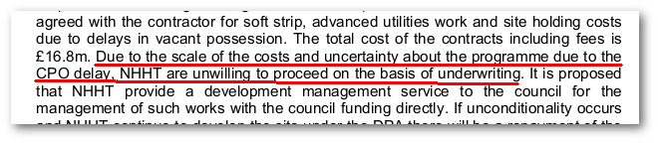
- The DPA stipulates that NHHT must pay the demoliton costs in respect of the FDS (para 4.1.4), the demolition cost was subsequently to be deducted from the £16.3m total (of 3 fixed land payments £1.2m; £2.4m; £12.7m) - (para 1.2.2) that NHHT was supposed to pay the Acquiring Authority upon transfer of the land.
- NHHT's refusal to carry out its obligations under the terms of the DPA means that, not only is the Acquiring Authority now having to fund the £16.8m demolition costs itself plus a 2% management fee to NHHT, but it will only receive the third (and largest £12.7m) of the £16.3m fixed payments when the FDS development is completed in 2024.
- In summary, the Acquiring Authority is having to stump up £16.8m, of which it will receive just £16.3m in return in at least 7 years time - resulting in a net loss on the sale of 4.4 hectares of public-owned land.
- The Acquiring Authority may argue that it has an 'overage agreement' in the DPA, meaning that it receives a percentage share of NHHT's 'overage' profit. However, such agreements bring notoriously uncertain results, as demonstrated by the Acquiring Authority's regeneration of the Silwood estate in Bermondsey that it redeveloped in partnership with NHHT. A similar agreement here resulted in an 'overage' payment of just £546,047 to the Acquiring Authority. An FOI request shows that there was disagreement between the parties about the amount of overage paid with the Acquiring Authority arguing that more overage was due.
- In total, Southwark agreed to fund £27m of the ongoing costs of progressing the scheme (over the next 3 years alone) that NHHT was originally required to fund under the terms of the DPA. These comprise:
  - £0.8m for the demolition of Plot 18
  - £16.8m demolition costs for the FDS
  - £2m to underwrite the cost of Plot 18’s planning application
  - £2m to underwrite the design fees for phase 2
  - £5.5m to construct the replacement facility for Ellison House
- These costs are in addition to the Council’s other costs that it has already allocated to the scheme to pay for rehousing of tenants and buyback of leaseholders. In total the Council is now forecast to spend £76.7m over the next five years on progressing decant and demolition, plus an additional £32.4m on the new community facilities that were supposed to be funded by the Acquiring Authority's delivery partner(s). (see para 8.14 of the AA's updated Statement of Case)
- At the previous inquiry it was established that the Acquring Authority had already spent £46m progressing the Scheme up to 2014.
- These significant funding requirements were not envisaged at the time that the Acquiring Authority made the decision to progress the scheme. In the September 27th 2005 report to the Executive (Appendix C), members were given costing estimates showing that the redevelopment would be more or less cost neutral to the Acquiring Authority over the duration of the Scheme.
- Compulsory purchase orders issued under Section 226(1)(a) of the TCPA are subject to S226(1A) which sets out the "wellbeing" test. This says that the Acquiring authority must not exercise the power unless it thinks that the proposed development, redevelopment or improvement is likely to achieve the promotion or improvement of the economic, social or environmental well being for its area.
- Circular 06/2004 makes it clear that the exercise of CPO powers pursuant to this section, in terms of the benefit (or disbenefits) to be derived, need not be restricted to the land the subject of the proposed order.
- The Objectors submit that the impact of the Scheme on the Acquiring Authority's Housing Investment Programme (HIP) budget (as a result of funding commitments not envisaged by the AAAP), should be considered as part of the 'wellbeing' test in relation to the order; i.e. that confirmation of the order would result in harm to the social and environmental wellbeing of 5,000 households in the wider area, whose homes do not meet minimum Decent Homes Standards (DHS) and will remain so because funding set aside for their refurbishment has been diverted to pay for demolition of the FDS - as a result of NHHT's refusal to continue demolition funding.
- A further impact of the drawing down funding from the HIP will result in there being less funding available for the estimated cost of £100m to install sprinklers in the Acquiring Authority's tower blocks, recommended by a fire safety review following the Grenfell disaster.
- The Objectors submit that Acquiring Authority's Sep 2016 Cabinet decision to deviate from the terms of the DPA and redirect £21m of funding to the Scheme, failed in its PSED duty to consider the resulting impact on protected groups.
- Paragraph 18 of the Cabinet report acknowledges that "In bringing forward this funding from the HRA, the council recognises that there will be some knock-on impact on other housing investment projects."
- However, it does not consider whether this 'knock-on impact on other housing investment projects' falls disproportionately on any protected groups, i.e. those 5,000+ households whose homes will remain substandard for longer as a result, or residents in tower blocks whose lives will remain at risk because the Acquiring Authority is unable to fund fire safety measures.

Breach of Public Sector Equalities Duty (PSED)
- In paragraph 4.8 of its updated Statement of Case, the Acquiring Authority claims that "All resident leaseholders from the Order Land were offered a new apartment within the new development at Site 1a. One leaseholder accepted that offer and qualified for a secure tenancy within that development."
- The reason that only one of the leaseholders accepted the offer of a new apartment on Site 1a is because the shared equity lease with Site 1a freeholder London & Quadrant, doesn't offer full uplift to shared equity owners.
- This means that when the leaseholder comes to sell the property or it is sold upon decease, then they don't receive the full capital uplift of their share. Indeed, for 2-bed properties there is no capital uplift whatsoever see details of L&R lease here.
- In his evidence to the site 7 CPO inquiry, Mark Maginn explains that leaseholders are assessed for rehousing on a 'cascade' assessment basis;
"The purpose of the financial assessment is to determine which category of assistance a homeowner may qualify for .. Assistance accordingly works as a cascade." (paras 4.4/4.5)
"Homeowners that are assessed as being able to afford less than 25% to less than 100% of the costs of home ownership are recommended for shared ownership (purchase of vacant property from Council owned stock)." (para 6.8)
"Homeowners that are assessed as being able to afford less than 25% of the costs of home ownership are recommended for a Council/RSL tenancy." (para 6.7)
- Given the capital uplift small print in the shared equity deal and the strict 'cascade' qualifying criteria, it is no surprise that none of the leaseholders from the Order land applied for a shared equity flat on phase 1a and only one qualified for a tenancy.
- The AAAP said that there are a "range of options for leaseholders whose interests are being bought out". (A7.4.1/A7.1.18)
- These were also referred to in the AAAP's Equalities Impact Assessment, which made specific reference to the "re-housing policy framework for leaseholders and tenants in November 2006":
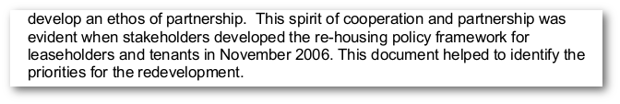
- The AAAP's EqIA therefore relied directly upon the mitigation measures in place at the time for leaseholders- i.e. the rehousing options enshrined in the Council's Nov 2006 rehousing policy.
- Among its options for leaseholders, the Nov 2006 rehousing policy offered a like-for-like 'property swap' for leaseholders (option D). This would involve a direct exchange for another council-owned property elsewhere in the borough at no financial cost to the leaseholder.
- The 2006 policy and the Council's Handbook for leaseholders clearly states the 'property swap' as one of the six available rehousing options:
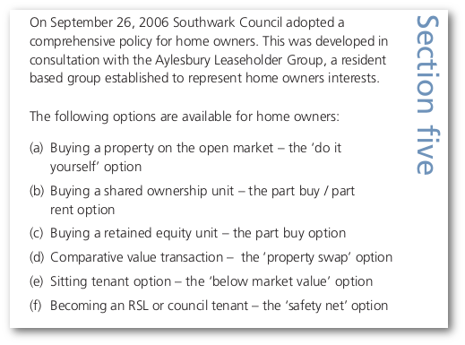
- The handbook goes further and gives a detailed description of the property swap (comparative value transaction) option available to leaseholders:
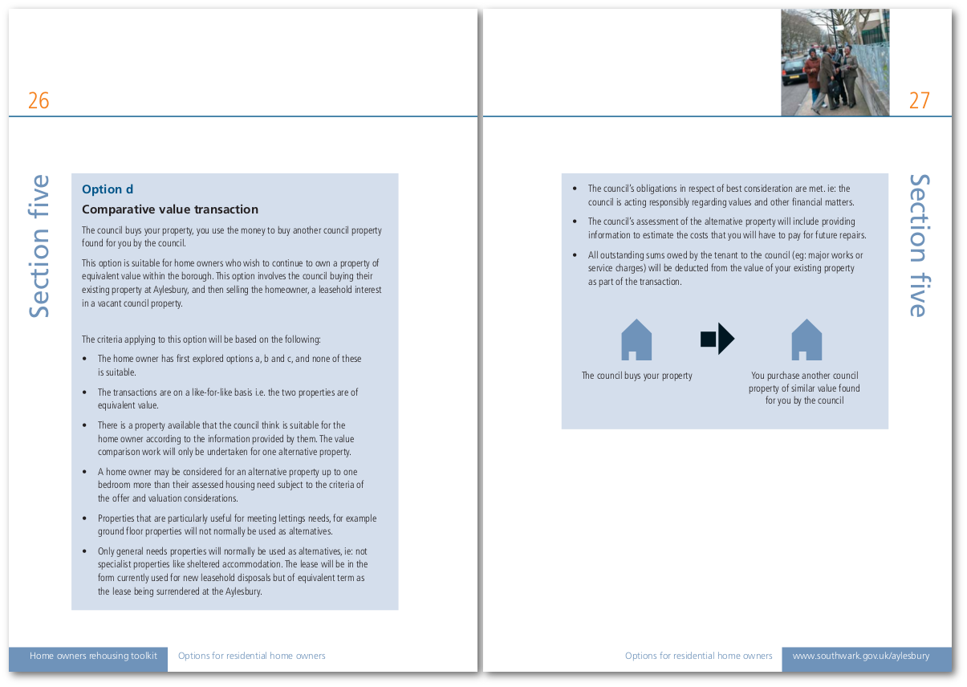
- This option was subsequently withdrawn following adoption of the AAAP (Cabinet item 9, 14 Dec 2010). In his evidence to the site 7 CPO, the Acquiring Authority's Mark Maginn exlained that the option was withdrawn because it was 'unworkable and restricted choice' (para 3.4).
- The Objectors submit that the Scheme no longer complies with the PSED because one of the key rehousing options (PSED mitigation measures) set out in the EqIA against which the AAAP’s PSED was assessed, has been withdrawn. Indeed it was the only rehousing option that would have enabled leaseholders to remain 100% homeowners in the borough - i.e. not impoverished by the shared ownership options.
- Inspector Coffey said in her report that leaseholders are left with two bleak options: moving out of the area or remaining but being impoverished. The Objectors submit that the like-for-like property swap was the only option that would have enabled leaseholders to remain in the area without being impoverished. We will need to show that the shared equity deal impoverishes leaseholders despite change in the £16k policy. (Investigate service charges etc)

Compensation issues
- The Acquiring Authority has argued that the Objectors' argument that leaseholders are being forced out of the area because the compensation receive is insufficent, is a valuation issue which should be dealt with instead by the Upper Tribunal.
- However, the Acquiring Authority openly acknowledges that the compensation levels are insufficient:
"It is acknowledged that the market value compensation for properties on the Estate is sometimes insufficient to buy outright a comparable non-estate property in the area" (updated SoC, para 5.5)
"Addressing the needs of longstanding resident leaseholders is important as they have particular difficulties in finding new homes, as in general the value of their property is lower than other similar sized properties in the borough." (Paragraph 4.2.1.12 of the DPA Business Plan)
"The council’s ownership schemes were in recognition of the fact that the price offered might not enable a leaseholder to buy another property." (minutes of 10/03/2014 Overview and Scrutiny Committee)
"Some Councils offer equivalent exchange whereby a leaseholder swops his/her property for another of the same value. This has been considered but the properties being regenerated in this Borough tend to be at the lowest level of the value scale. There are unlikely to be similar equivalents that aren’t part of regeneration schemes so such an offer would be hollow." (OSC Committee report 10/03/14)
- Given that the Acquiring Authority acknowledges that the compensation payable is insufficient for leaseholders to remain in the area. It follows that the rehousing options on offer are critical in determining whether or not leaseholders' human rights have been sufficiently safeguarded. In particular those rehousing options against which the AAAP’s PSED was assessed (i.e. the like-for-like swap option) and which were subseqently withdrawn.

Conclusion
- The Scheme underlying the Order fails to comply with the requirements of the AAAP and wider development plan.
- One of the key rehousing options (PSED mitigation measures) that that the AAAP relied upon to satisfy its PSED requirement has been withdrawn.
- The Scheme is not viable and therefore unlikely to be delivered within a reasonable timeframe or in accordance with the requirements of the development plan.
- The Acquiring Authority concludes in paragraph 7.39 of its updated Statement of Case by claiming that the AAAP policies "were supported by 82% of residents who attended the final exhibition of the plans".
- The Objectors point out that the final exhibition of the plans referred to (30/10/2008-02/11/2008) was attended by just 54 people, who were not necessarily all Aylesbury residents and only 46 of which completed a questionnaire. The 86% of 'residents' who supported the plans were thus from a sample of just 46 local residents.
- Given that the estate was home to 7,500 people and given that there is no information confirming how many of the 46 questionnaires were completed by Aylesbury residents. This cannot be used as reliable evidence that the majority of Aylesbury estate residents supported the AAAP plans. The Objectors have shown how, in any event the Scheme as it is now proposed has made significant departures from the AAAP's plans.
- In summary, the Acquiring Authority's decision to pursue compulsory purchase powers instead of negotiating with the Objectors is oppressive. The remaining leaseholders have shown themselves to be reasonable and dignified people who have continued to engage constructively. Their demands are reasonable: the Acquiring Authority should either replace their homes in a like-for-like swap for another of its properties elsewhere in the borough, as per its original policy commitment.
- The Compulsory Purchase Code requires the Acquiring Authority to make a 'compelling case' in the public interest for compulsory purchase powers to be used. For the reasons outlined in this statement of case it has clearly failed to do so and has failed the 'wellbeing' test; as such the order should not be confirmed. The Objectors add that non-conformation of the order will not result in the end of the Acquiring Authority's scheme as has been implied; it will simply mean that the Acquiring Authority will have to rehouse remaining leaseholders using the option promised to them at the time the AAAP was agreed (like-for-like swap).

Information requested by Objectors (and for inclusion in core bundle)
In its 10 May letter to the Acquiring Authority, the DCLG wrote: "It is important that those whose interest or rights are included in the order should be in a position to put their case at the inquiry without having to probe for further details. If they have to do this during the inquiry, they may not be in a position to deal with the additional information and this could lead to a request for an adjournment."
In order to avoid a 'probe for further details' and possible adjournment required if we have to do this at the time of the inquiry, the Objectors request that the following information is provided at the Acquiring Authority's earliest convenience and in any case at least 28 working days before commencement of the inquiry:

- The viability assessment submitted in conjunction with the revised planning application.
- The signed section 106 agreement (or signed variations to the existing section 106 agreement as the case may be) in relation to the revised planning application.
- Part 2 of Schedule 1 of the DPA describes a 'Steering Group' to "monitor and provide a forum to discuss the performance of the parties’ obligations under" the DPA. It holds quarterly meetings and an 'Annual Business Plan Review. Please provide a copy of all minutes from these meetings (required to be recorded by NHHT under paragraph 2.16) since the start of 2015.
- A copy of the framework to measure the success of the Scheme commissioned by NHHT and referred to in paragraph xx. (Our request to be provide this to the previous inquiry was not complied with)
- The most recent 'Risk Log' for the Scheme submitted in accordance with the requirements of section 13 of the DPA Business Plan. ("13.2.1: It is intended that the risk log will be a live document and updated regularly throughout the Project").
- The stock condition survey referred to in paragraph 25 of this May 2011 Cabinet report, (which the Acquiring Authority failed to provide to the previous inquiry despite our request months in advance)
- Full details of how many tenants and leaseholders have been decanted to date and where they have been displaced to. (including a breakdown of how many decanted from each phase and how many rehoused on site, plus details of whether secure tenants or temporary licencees).
- Details of elderly leaseholder on the order land, Mr Crossfield (28 Arklow, London SE17 2BJ) who it is understood deceased at the beginning of this year. Had Mr Crossfield's rehousing application been rejected? Was his death connected with any incident on the order land or disconnection of services? (i.e. heating/hot water/electricity - given that the Arklow block is adjacent to the demolition works)
- Full details of the two leaseholders who supposedly took up NHHT's shared equity offer (and contractual commitment) to purchase and repair 5 street properties.
- Details of whether NHHT has complied with its contractual obligation to provide 35 social rent units by 2017 from its existing stock for the rehousing of Aylesbury tenants (see paras 4.2.2.2 and 4.2.3.4 of the DPA Business Plan section 4).
- Full details of the Acquiring Authority's audit conducted in accordance with the Ombudsman's directions (ref:16005626) concerning monitoring of compliance with section 106 requirements.
- Clarification is sought on whether NHHT's development partner (Barratt Homes) has withdrawn from its involvement in the Scheme. If so, please provide details of any replacement development partner and copies of any agreements with them.
- Paragraph 7.11 of the Acquiring Authority's updated Statement of Case claims that there will be a gain in affordable housing floorspace on the FDS of 3,232sqm. The Objectors dispute this figure (we calculate net loss of 24,707sqm) and seek clarification of how it has been calculated.
- Paragraph 10.9 of the Acquiring Authority's updated Statement of Case says: "The Council has kept and continues to keep detailed records about the owners and occupiers of the interests in the Order Land." The Objectors request that copies of these 'detailed records' are provided before the inquiry commences (with personal information redacted if necessary).
- Full details of the location and number of dwellings on the estate that currently meet/fail Decent Homes Standard.
- Unredacted copies of all deeds of variation to the 28 April 2014 Development Partnership Agreement.
- Unredacted copy of the closed 20 Sep 2016 Cabinet decision report, which agreed funding significant funding changes with NHHT.
- Minutes from the NHHT board meeting (referred to in the Sep 2016 Cabinet report) which decided not to continue funding with the Scheme.
- Full copy of NHHT's bid for funding from the GLA's Affordable Homes Programme in respect of the FDS including details of 'Benchmark Rent Levels' for any 'London Affordable Rent' homes funded by this programme.

Docs for submission in core bundle
- A copy of the 2009 Leaseholders Toolkit showing the like-for-like property swap option.
- Ensure that a copy of the 2006 leaseholder rehousing policy with details of the like-for-like options is either already in the core bundle or submitted for inclusion.
- Submit copy of Letter to Site 7 leaseholders with the Acquiring Authority warning that re-housing offers will be withdrawn once CPO procedures start (evidence of failure to take reasonable steps to negotiate by agreement).
- A copy of This Guardian article
- A copy of This Guardian article
- A copy of This article by a former NHHT board member
- A copy of This Guardian article
- A copy of This article in the Financial Times
- The viability note disclosed under FOI in 2015
- The London Plan’s Planning for Equality and Diversity SPG
- The 2005 Review of the Acquiring Authority’s Equality and Diversity Framework
- A copy of this Guardian article
- A copy of Southwark Council’s Approach to Equality

Alternative refurbishment scheme (notes)
- Work out how much the Council receives in rental income from tenants on the Aylesbury estate. Say it should use this on refurb/maintenance. We know the Council rent levels but we don't know how much it is charging the temporary tenants. An FOI request has been submitted to find this out.
- Paragraph 1.2.4 of the AAAP says that the estate needs to be redeveloped because "it would cost too much to bring the homes up to decent homes standard". But information in from the Council's Housing Commission HINES estates costings show that only half of estate's homes failed to meet DHS in 2011. @. This Cabinet item from 2011 gives details of 'High Investment Needs estates' and gives cost estimates of the DHS works.
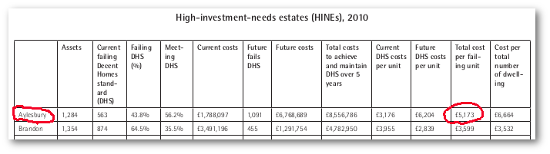
- Appendix 6 of the Cabinet item shows the Aylesbury as not being the most costly of the estates. We could find out the actual costs of other estates on the list and do a comparison. Here's the link to appendix 6
- Southwark has in any case recently spent £12.5m to Major Works bringing homes on phase 3/4 of the estate up to Decent Homes Standard.
- On the question of sources of funding a refurb scheme, This report describes different funding for DHS works, including the 'GLA Backlog fund' and the accompanying appendices show that the Four Squares estate (a High Investment Needs estate) was brought up to DHS for just £12m. Work out how much this is per unit and also show similar comparables.
Council spending £10m per year on temporary accommodation:
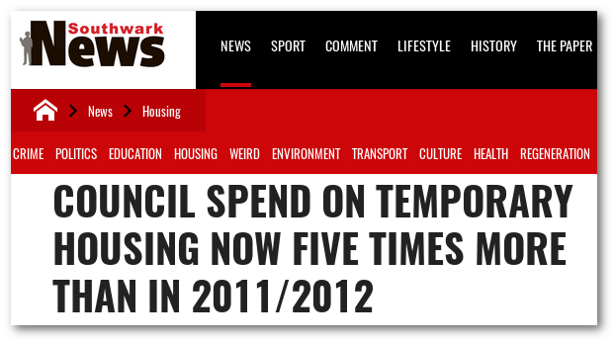
- The Acquiring Authority is spending £380k per dwelling on building new Council homes (not even including land acquisition costs) - it is spending £49m this year alone on building new council homes (see Budget Book 2016/17). The Objectors submit that this would be better spent on refurbishing the dwellings which is estimated at just £xx,xxx per dwelling.
- Last year the Acquiring Authority spent £14.2m purchasing homes from developers on the open market to use as council housing. The Objectors submit that these funds would be better used refurbishing the dwellings on the order land.
- As another potential source of funding, one could also include the Section 106 off-site pooled funding that developers often pay in lieu of providing affordable housing on site.
- The AAAP envisaged redevelopment because at the time it said that: "it would cost too much to bring the homes up to decent homes standards". It asserted that redevlopement would also enable an uplift in density to 4200 new homes and that these would be of better quality in terms of environment and sustainability. Given that the scheme fails to conform with these objectives and given the significant number of homes on the estate brought up to DHS in the interim, the Objectors submit that refurbishment would be a more economically efficent and socially equitable option.
- The Council has spent £46m redeveloping just 112 homes on the Aylesbury estate to date and has allocated £96m to the Scheme over next five years alone. How many homes could be refurbished with £96m based on the 2005 refurb costings adjusted for inflation?
- In 2012, the Acquiring Authority spent several million pounds on fire safety works at the Aylesbury estate. This was carried out following a fire in one of its tower blocks in Peckham (Lakanal House) and a borough-wide fire safety review.
- The Objectors note that the existing buildings on the estate have not been wrapped in combustible cladding and all benefit from at least two stairwells, which was not the case in the recent Grenfell Tower incident. The same cannot be said for the proposed tall buildings on the FDS, which only propose one single stairwell (check this?).
- The Acquiring Authority has intimated that there are structural problems with the 5 and 6 storey blocks on the estate. However, the Alan Conisbee report on which this is based recommended removal of mains gas from these blocks and it is understood that these blocks now comply with BRE safety standards as a result. If this is not the case then the Acquiring Authority will need to explain why it has continued to house families in these blocks for the past 12 years if they are structurally unsound.
- All we need to show is that bringing existing homes (on the order land) up to decent homes standard, will cost less (per dwelling) than the amount the AA is spending on redevelopment (per dwelling). This will result in less expenditure from the AA's Housing Investment Programme which will in turn mean that it can spend more on bringing the 5,000+ council homes in the borough that fail to meet Decent Homes Standard up to DHS. It will also mean that more funds are available in the HIP for installing sprinkler systems in its blocks, recommended following the Grenfell Tower disaster.
- In summary, the 'wellbeing' test is better satisfied by bringing homes on the order land up to DHS as it is less costly than redeveloping them. This will result in more sub-standard council homes in the borough being brought up to DHS and more fire safety works being able to be completed, as more funds will be available in the HIP.

