Phase 1b/1c revised CPO Inquiry
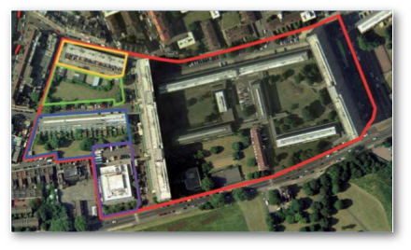

Viability
- ODPM Circular 2005 says that the scheme underlying the order must be viable. Documents show that the Aylesbury scheme as envisaged is still not viable and that the viability gap is being bridged by shortchanging leaseholders. In Jan 2009, the draft Aylesbury Area Action Plan showed that there was a funding shortfall of £299m.
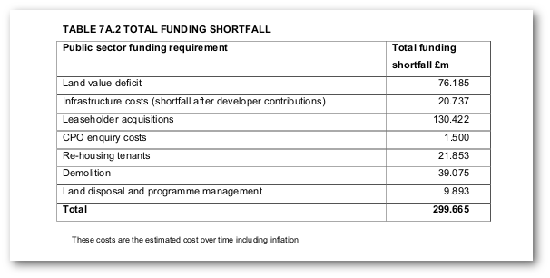
Page 92 of the appendices to the draft AAAP
- One of the key requirements of an Area Action Plan is that it must be shown to be viable and therefore deliverable. The inspector at the examination in public of Southwark's AAAP, flagged up the significant funding gap to the Council and her final report on the AAAP shows that the Council's solution was to arbitrarily slash the cost estimates, without providing any evidence base or justification for doing so. The £130m originally estimated for leasehold acquisitions of the circa 500 leasehold properties on the estate was slashed by half. There is no explanation as to why the Council slashed its estimate of the market value of leaseholders' homes by 50% overnight.
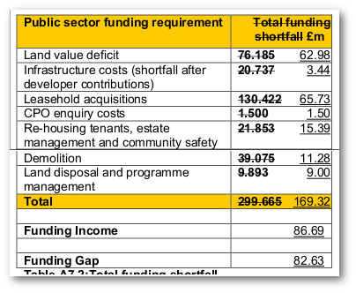
Table of Recommended Changes to AAAP (2009) showing cost estimates slashed
- Altogether, the cost estimates were reduced by around a half, reducing the funding gap from £299m down to £169m and this is the figure given in the final adopted version of the AAAP.
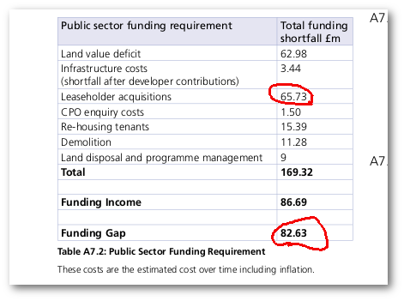 Extract from final adopted version of Aylesbury Area Action Plan 2010 showing the funding gap
- The Council was expecting to cover the funding shortfall with government PFI funding and this is how the Area Action Plan was deemed sound at its Examination in Public. However, just under a year after the Area Action Plan was adopted, the government withdrew all PFI funding for the scheme.

Credit rating downgrade
- In June 2016 NHHT was downgraded by credit agency Moodys. The Moodys downgrade mentioned NHHT's significant development pipeline and listed its largest three projects; Aylesbury estate, Canada Water and a scheme in Hounslow. It said that the capital expenditure to revenues ratio would average 49% over the next five years, but this is based on the figure given of 7% social rented tenure. So the replacement 'social' homes on the FDS must have been included in these figures as affordable rent. To conclude: Moody's capex to revenue ratio must have been based on the provision of affordable rent not social rent. Had it been based on social rent then the capex to revenue ratio would have been much higher. So either Moodys have been given incorrect info on the tenure mix of NHHT's pipeline or the replacement 'social' homes on the Aylesbury will be affordable rent..
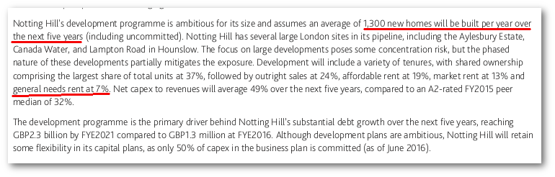
Moodys downgrading

DPA provisions breached
- NHHT has breached various provisions in the DPA including its obligation to purchase 5 street properties that it was to offer on shared equity terms to leaseholders in phase 1b/1c. The Council claims in its response to our Cabinet question that NHHT has indeed provided 2 such properties to leaseholders on the FDS. We should seek more details of this and ask why these were not offered to Beverley and Agnes.
- The following changes to the funding programme show how NHHT is rolling back on its funding commitments to the scheme. In September 2016, Southwark agreed a number of changes to the development agreement with NHHT. Southwark agreed to forward fund £21m of the ongoing costs of progressing the scheme, that NHHT was originally required to fund under the terms of the Development Partnership Agreement. These comprised:
- £16.8m demolition costs for the First Development Site
- £0.8m for the demolition of Plot 18
- £2m to underwrite the cost of Plot 18’s planning application
- £2m to underwrite the design fees for phase 2
- These costs are in addition to the Council’s other costs that it has already agreed to allocate to the scheme. In total the Council is now forecast to spend £52.5m over the next three years on the Aylesbury redevelopment scheme.
- Notting Hill Housing’s commitment to the scheme is also plainly a concern. The Cabinet report goes on to say that ‘if the scheme has not proceeded in accordance with the DPA (Development Partnership Agreement)’ then ‘at that point all design work will pass to the council enabling the council to market the site’(para. 13) - in plain language: if Notting Hill drops out then Southwark takes over and looks for another developer.
- NHHT is also now reducing the number of affordable units in plot 18, its first phase of development to be completed on the estate. It is moving these to be delivered instead on the FDS. Note that the 9 May Cabinet report announced a change of phasing: the FDS has been swapped with plot 18 - i.e. the FDS will instead be the second phase of development completed by NHHT after plot 18. Fresh planning applications for both sites are expected shortly.

Deliverability
- Show how Wood Dene estate was demolished in 2007 and how NHHT has left the site empty for 10 years without building any new homes. This will be the future of phase 1b/1c.
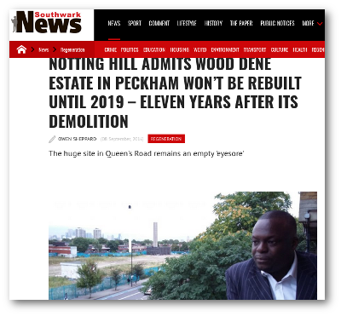
- The DPA says that the FDS will be completed by 2021, but NHHT have now put this back to 2024. See here.
- Circular ODPM/2005 says that there needs to be evidence that the scheme underlying the Order will be completed in a 'reasonable' time period; we need to look up case identifying how 'reasonable time period' is to be interpreted.

Tenure switch
- Submit copy of Southwark's evidence from previous Inquiry where they claim to have robust S106 monitoring procedures.
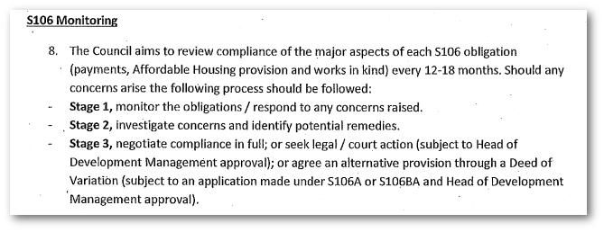 Extract from Southwark's evidence to first Inquiry
- Submit copy of Ombudsman decision and Sunday Times article showing Southwark's failure to monitor S106 AH tenure delivery, as a result of it not having any monitoring procedures. Show how it therefore misled the previous Inquiry with its evidence claiming to have robust monitoring procedures.
- Highlight NHHT's other developments where social rent intended but affordable rent delivered - i.e. the one in Lambeth delivered on the Claremont East estate.
- Show how the breach at Bermondsey Spa hasn't been resolved, i.e. the Council hasn't taken effective action to recover the SR homes - i.e. there still remains a net loss across the Bermondsey Spa and Manor Place Depot sites.
- Re-run all of our previous criticisms of Kate Davies and her predeliction for affordable rent and privatisation. Include also Steve Hilditch's recent article criticising Davies and Notting Hill (Hilditch is a former NHHT board member).
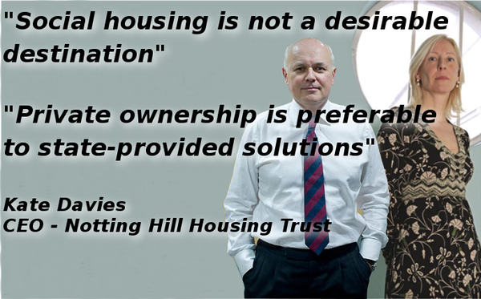
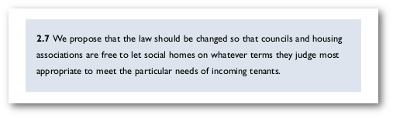

Bashing NHHT
- Submit the Southwark News article on NHHT's rent hikes and evictions at its St. James estate in Bermondsey. Include MP Neil Coyle's criticisms and Cllr Pollak's quote saying NHHT is acting like a 'predatory landlord'.
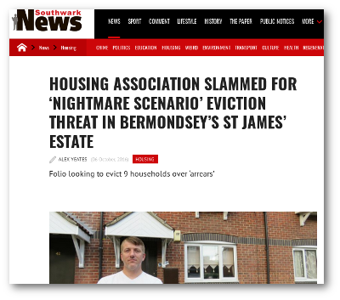
- Highlight NHHT's profit margin in the DPA.
- Show how Wood Dene estate and Decathlon sites appear to have stalled. Point out affordable scandal at the Decathlon site (blog post to be drafted still) and the low level of social rented housing at the Wood Dene site. Make the point that NHHT successfully argued (using viability assessments) that it wasn't viable to provide more than the pitiful 15% (avg) social rented housing across both sites. So how can it be possible that the FDS site can viably provide over 40% social rented?
- Include evidence on the Silwood estate and the 3 missing social rented housing units that NHHT should have delivered according to the planning consent and S106 agreement.
- Show HCA/GLA stats showing how many thousands of homes NHHT has converted to affordable rent.

Refurb/Alternative to scheme underlying the CPO
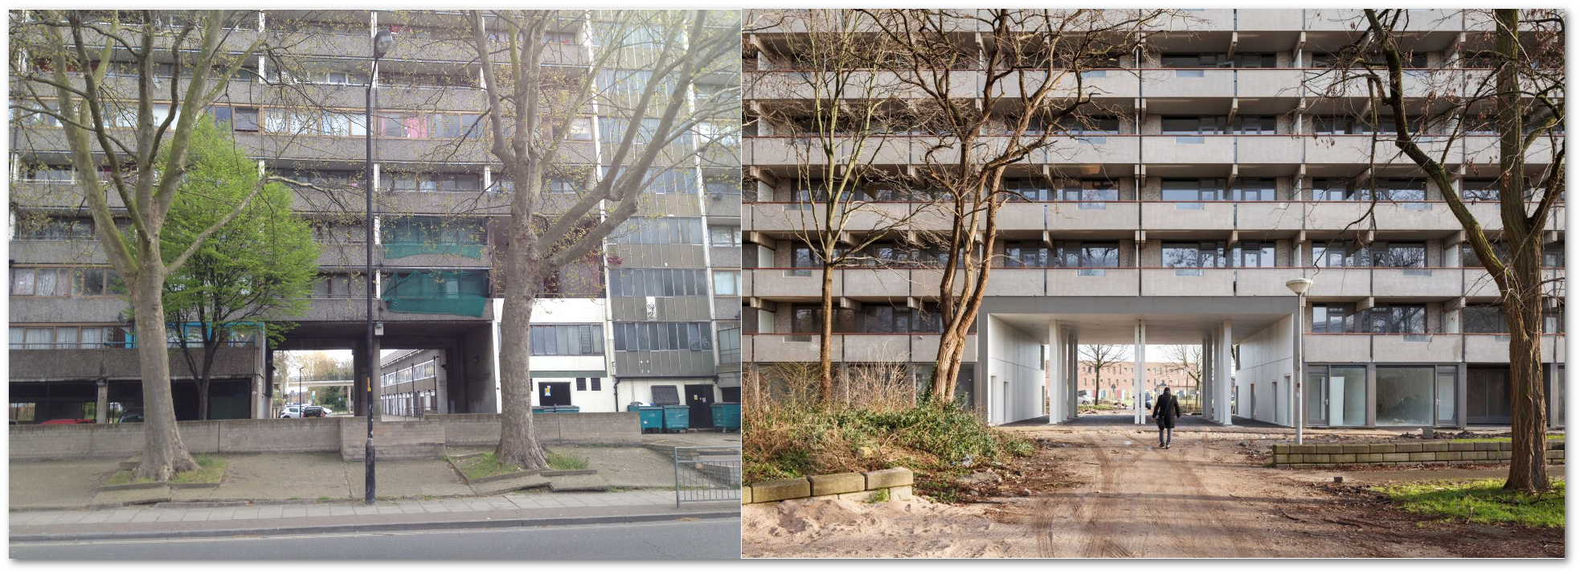
- This report describes different funding for DHS works, including the 'GLA Backlog fund' and the accompanying appendices show that the Four Squares estate (a High Investment Needs estate) was brought up to DHS for just £12m. Work out how much this is per unit and also show similar comparables.
- On the question of sources of funding a refurb scheme, one could also include the Section 106 off-site pooled funding and that set aside for new Council homes. Refurbishment would also help the Council save on the £10m per year it is having to spend on temporary accommodation:
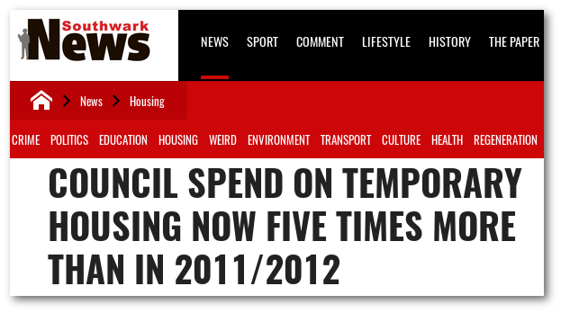
- This Cabinet item from 2011 gives details of 'High Investment Needs estates' and gives cost estimates of DHS works.
- Appendix 6 of the Cabinet item shows the Aylesbury as not being the most costly of the estates. We could find out the actual costs of other estates on the list and do a comparison. Here's the link to appendix 6
- Southwark has in any case already committed £12.5m to Major Works bringing homes on phase 3/4 of the estate up to Decent Homes Standard.

PSED
- The only Equalities Assessment conducted on the scheme to date (the 2009 EqIA which accommpanied the AAAP), relied upon the mitigation measures in place at the time for leaseholders- i.e. the rehousing options enshrined in the Council's 2006 rehousing policy which included the like-for-like 'propery swap' for leaseholders. The 2006 policy and the Council's Handbook for leaseholders clearly state the 'property swap' as one of the available rehousing options:
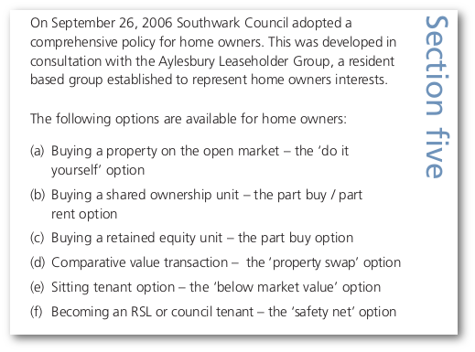 Extract from the Leaseholders Handbook
- The handbook gives a detailed description of the property swap policy available to leaseholders:
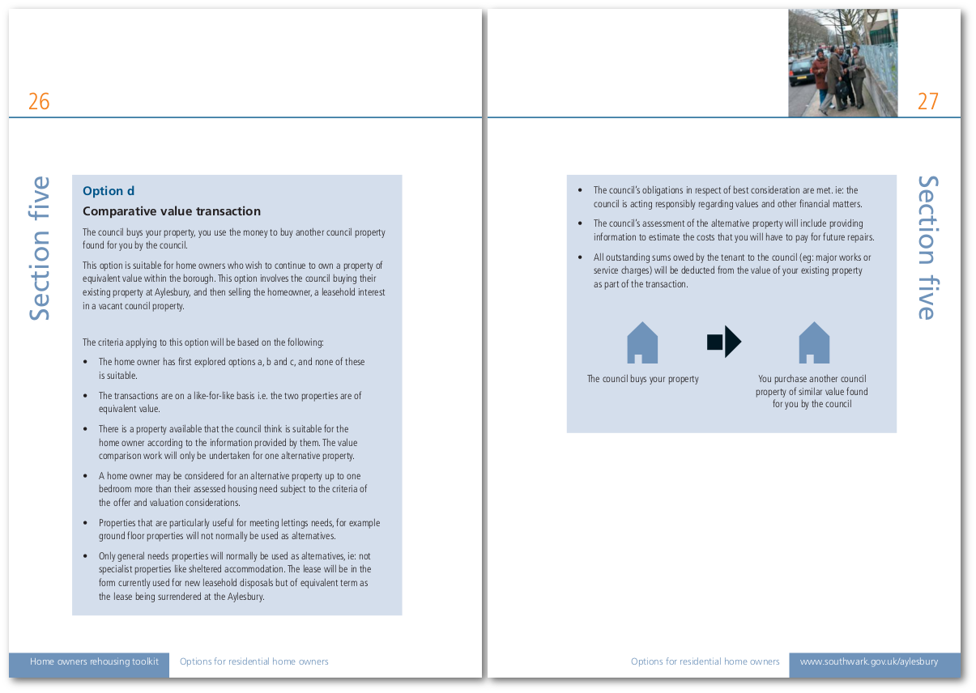 Extract from the Leaseholders Handbook
- The EqIA specifically references the 2006 rehousing policy for leaseholders which it says offers leaseholders the 'widest possible choice of rehousing opportunities':
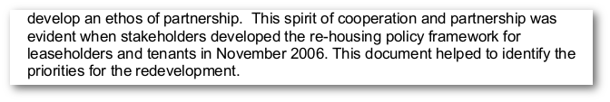
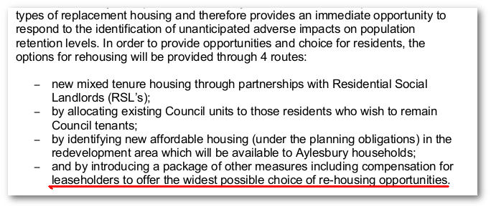
- Given that the 'property swap' option was subsequently withdrawn in 2010, it can be argued that the scheme doesn't comply with the PSED because one of the mitigation measures set out in the EqIA which underlies the AAAP has been withdrawn. Indeed it was the only mitigation measure that would have enabled leaseholders to remain 100% homeowners in the borough - i.e. not impoverished by the shared ownership options.
- Inspector Coffey said that leaseholders are left with two bleak options: moving out of the area or remaining but being impoverished. Like-for-like swap was the only option that would have enabled leaseholders to remain in the area without being impoverished. We will need to show that the shared equity deal impoverishes leaseholders despite change in the £16k policy. (Investigate service charges etc)

Non conformity with AAAP

Retail
- AAAP policy COM6 says "Provide 1,750 square metres of new local retail facilities (convenience retail, cafes and restaurants) within the action area core".
- How much retail is being provided in the new FDS planning application? is it proportionate to achieving the 1,750 sqm across the masterplan site as a whole?

BRE Sunlight/Daylight
- See what the new FDS application does about the BRE sunlight/daylight issues. Given the density it will be difficult to resolve.
- Policy A6.7.8 of the AAAP says "At least 75% of apartments in each development should have dual aspect."
- How many of the homes in the new FDS application are due to be dual aspect?

Sustainable Energy
- Show how the sustainable energy requirements of the AAAP are not being adhered to - ie. biomass (see draft blog post on phase 1a having delivered gas boilers when it should have been biomass)
- This press release says that biomass was to be provided on phase 1a but we know from classeur blog post that biomass was never provided. The planning committee report and s106 for phase 1a also stipulated biomass.
- AAAP policy BH7 says "All new homes within the action area core should meet Code for Sustainable Homes Level 4 up to 2016 and Level 6 beyond".
- But in its Energy Strategy submitted pursuant to conditions of the S106 agreement, NHHT says that the zero carbon homes requirement has been removed (16/AP/2887).
- What does the new FDS application say about renewable energy provision?

Community Spine, Green Fingers and Westmoreland Plaza
- The AAAP says that there will be a 21 metre-wide 'community spine' running east to west through the site. This will provide a cycle and pedestrian route throughout the entire site, connecting the new community facilities to the Walworth road. It also says there will be three 'green fingers' extending in to the estate from Burgess Park, providing public green space and pedestrian/cycle access. Furthermore it lists a public plaza 'Westmoreland Rd Plaza' on the order land.
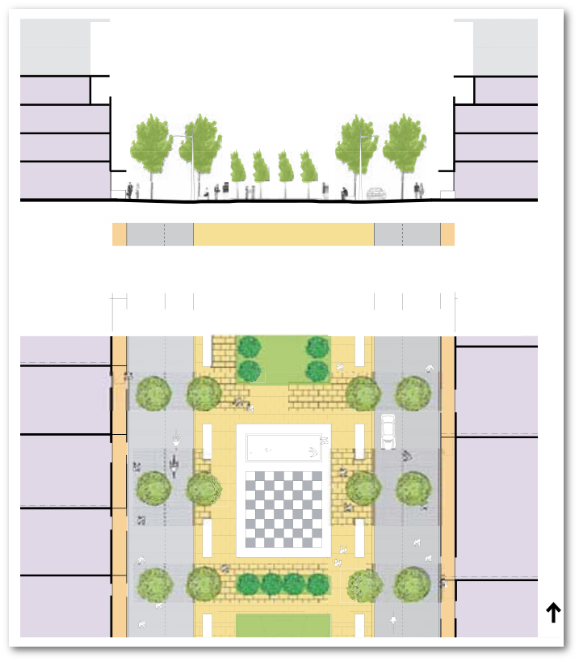 Extract from AAAP
- The AAAP diagram for the order land shows the community spine (3), one of the green fingers dissecting the FDS (10) and Westmoreland Plaza (9) on the order land, but these were not included in the existing FDS planning consent. Does the new application include these?
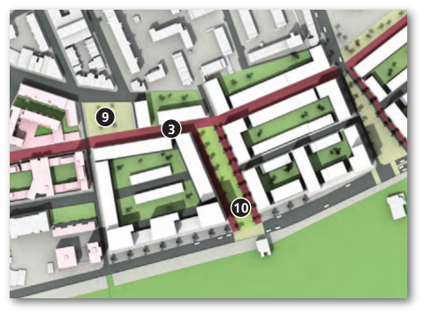 Extract from AAAP
- The New Southwark Plan (the Council's strategic planning framework) says that there will be a 'Southwark Spine', dedicated cycle route running North/South through the borough and passing through the middle of the new Aylesbury estate. But this was not included in the masterplan application.
- Also to my knowledge, the previous FDS application didn't include any segregated cycle routes - we need to see what the new application says about cycle routes.

Open Space
- Policy 4.5.1 of the AAAP envisages no net loss of open space, but the approved masterplan application (ref:14/AP/3844) acknowledges that there will be a net loss of 1.8 hectares of open space:
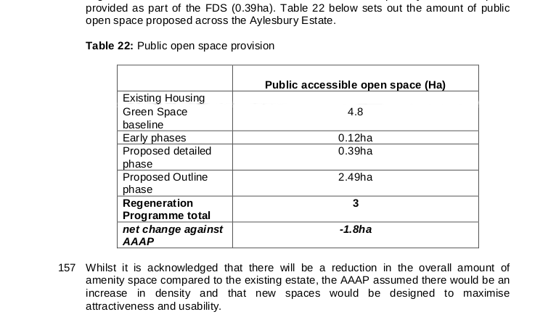 Extract from the planning committee report for the masterplan application.
- Also, the replacement open space will be gated - see Harvard Gardens.

Play Space
- Policy PL6 of the AAAP says "All development proposals must provide 10sqm of children’s play space / youth space per child bed space. Doorstep playable space should be provided within each of the housing blocks, whilst larger local playable spaces should be provided within selected housing blocks and within the green fingers and existing local parks, in accordance with Figure 12. New youth space should be provided within the larger areas of public open space."
- What does the new FDS application say about open space and play space?

Infrastructure funding
- Page 75 of the AAAP describes infrastructure funding. It says the developer will pay a tariff which will fund community facilities like the energy centre (£13m) and health centre (£4m). We now know that the Council is paying for the health centre from its own funds and that the energy centre is not being delivered.
- The AAAP doesn't say what the tariff is.. it says that details of the tariff will be published in an SPD but I can't find any such SPD..

Density
- The AAAP says "The HCA has also recently admitted Aylesbury phases 2 and 3 to round 6 of the government backed Private Finance Initiative (PFI). Under this programme it is proposed that the council will effectively deliver 1000 new homes of which around 400 will be affordable council owned new homes".
- We know that the HCA PFI finance was scrapped shortly after the AAAP was adopted and we know that none of the new homes proposed will be Council owned.
- The AAAP says that 1419 units are required in phase 1, but given that only 408 units have been delivered on the other phase 1 sites [1a (261 units) & site 7 (147 units)] and only 840 units are proposed in the FDS application, then there is a shortfall of 171 between the number of units proposed on the Order Land and the number required by the AAAP.
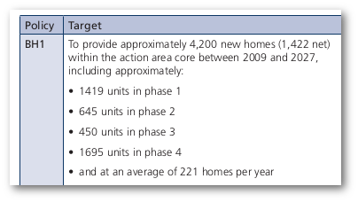
- The AAAP says that the scheme will deliver 1,450 extra new homes to contribute to the London Plan requirement of 16,300 new homes by 2016/2017. We can show that the scheme is providing less than the 1,450 promised and that Southwark has failed miserably to come anywhere near the 16,300 target.
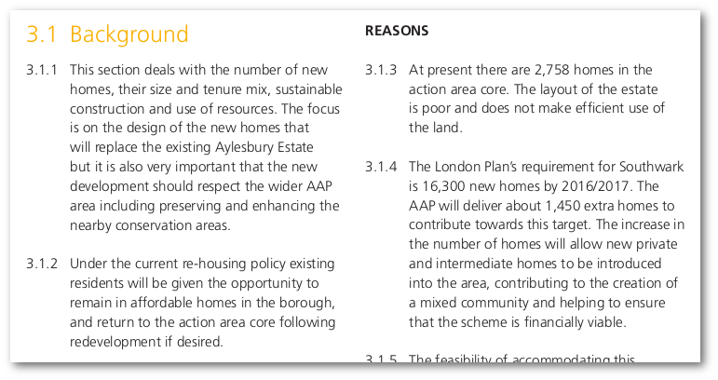
- Provide evidence showing the vast gap between the number of units required by more recent planning policy and the numbers being delivered. Show how supply shortage is fuelling the current housing crisis.

Room Sizes
- The AAAP says that:
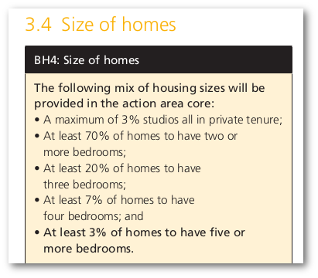
- Does the accommodation schedule in the new planning application for the FDS conform with these requirements?

Displacement
- How many rehoused on estate footprint as per EqIA and AAAP intention?
- Why have only 10 of the estate's 200 leaseholders decanted to date taken up the shared equity offer? Where did the rest of the leaseholders go?

Compensation issues
- The Council acknowledges that the value of homes on the Aylesbury are lower than any other properties in the borough and that their shared ownership options are a recognition of this.
- The minutes of 10/03/2014 Overview and Scrutiny Committee confirm that the Council's principal surveyor said "The council’s ownership schemes were in recognition of the fact that the price offered might not enable a leaseholder to buy another property."
- In his report to that Committee, the Principal Surveyor said "Some Councils offer equivalent exchange whereby a leaseholder swops his/her property for another of the same value. This has been considered but the properties being regenerated in this Borough tend to be at the lowest level of the value scale. There are unlikely to be similar equivalents that aren’t part of regeneration schemes so such an offer would be hollow. "

Rehousing options
- In his evidence to the site 7 CPO inquiry, Mark Maginn explains that leaseholders are assessed for rehousing on a 'cascade' basis; i.e. they are assessed to see if they can afford shared ownership before being considered for shared equity or other rehousing options. Given that shared ownership is much less attractive and more costly than shared equity, it is no surprise that only 10 of the over 200 leaseholders decanted have qualified for and taken up shared equity.
- Request stock condition survey mentioned here: Paragraph 25 details the stock condition survey undertaken in 2010 which has provided the most robust and extensive information to date on the state of the Council's housing stock. http://moderngov.southwark.gov.uk/documents/s19609/Report%20Housing%20investment%20programme%20and%20revised%20strategy.pdf
Request details of rehousing: How many leaseholders rehoused as tenants? where? RSL etc? How many shared ownership/equity etc. Where did they go?
Creation Trust displacement map for phase 2 - how many tenants rehoused on footprint? Where did leaseholders go?
More detail on the two leaseholders who supposedly took up NHHT's P&R street properties (see response to Cabinet question).
NHHT social life survey
Are there any reports required by the DPA that we can make a request for - or meetings of yearly scheduled meetings related to the DPA?
Request tenure delivery information: has the AA checked what tenure was delivered on completed phases? it claimed to have done so at the Oct 2015 INquiry but we now know that was a lie. Has the AA completed audit and what are the results for phase 1a and site 7?
Biomass? was it delivered?

