CS 405 Module One – Numeric Overflow and Underflow Activity
Name: Jeremiah Longwa
Course: CS 405 Secure Coding
Assignment: 1-3 Activity: Numeric Overflow Coding
In this activity, the goal was to identify, prevent, and report numeric overflow and underflow conditions in a C++ application. The original implementation performed repeated addition and subtraction operations without validating whether the result would exceed the valid range of the data type, which could lead to undefined behavior particularly dangerous in a banking application.
To address this issue, the add_numbers and subtract_numbers template functions were modified to detect overflow and underflow before performing arithmetic operations. This was accomplished using the C++ Standard Library’s std::numeric_limits to compare the current value against the maximum and minimum allowable values for each data type. By performing these checks prior to addition or subtraction, the program prevents invalid arithmetic from occurring.
Both functions were updated to return a std::pair<bool, T>, where the boolean value indicates whether the operation was successful. If an overflow or underflow condition is detected, the function returns false along with the last safe numeric value. This approach allows the calling functions to be notified of failure without causing undefined behavior.
The test_overflow and test_underflow functions were also modified to interpret the success or failure result and clearly display the numeric output along with an overflow or underflow status (true or false) to the console. This ensures that the user is informed when a calculation fails due to numeric limits.
Integer overflow and underflow were the primary focus, as integer wraparound can cause serious security and financial issues in real-world systems. Floating-point types were also tested; however, floating-point overflow behaves differently in C++ and results in large values or infinity rather than undefined behavior. The program accounts for this distinction while maintaining consistent reporting behavior.
Overflow Testing:
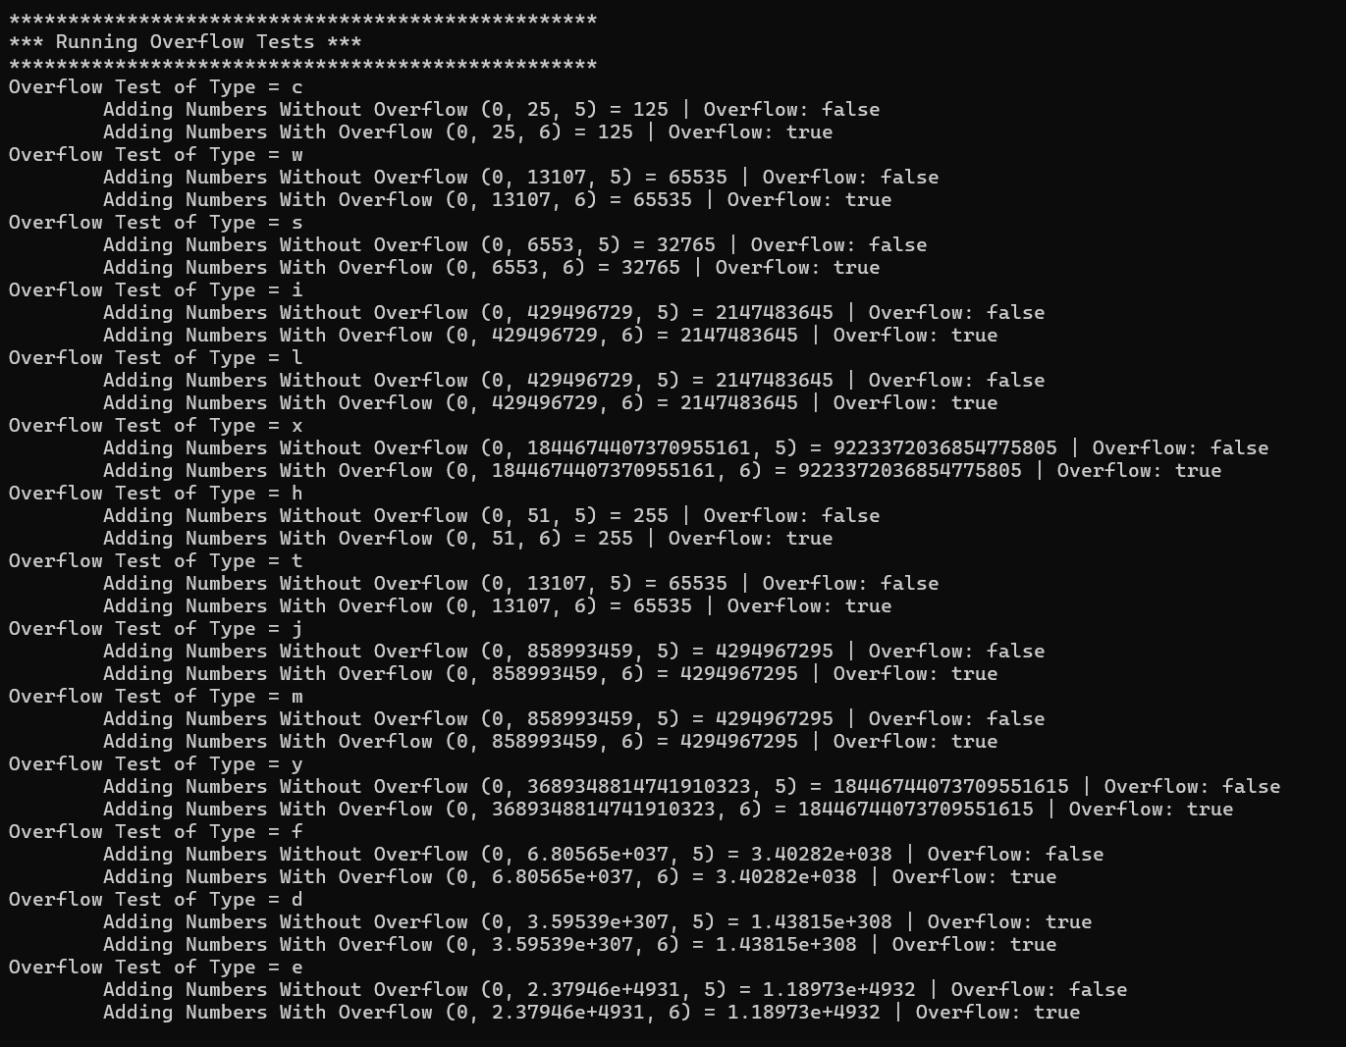
Underflow Testing:
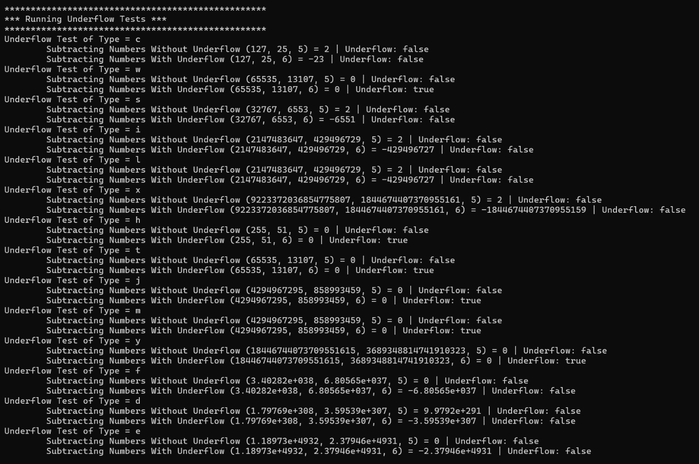
Conclusion
This solution successfully demonstrates secure numeric handling by detecting and preventing overflow and underflow conditions, notifying the calling functions, and clearly reporting results to the user. The implementation follows C++ best practices, uses standard library features, and ensures reliable behavior across multiple primitive data types, making it suitable for secure software development in sensitive applications such as banking systems.

