CS 405 Module Four - Exceptions Activity
Figure 1 below shows the successful execution of the Exceptions.cpp program. The output demonstrates correct handling of standard exceptions, custom exceptions, and safe program continuation without crashing.
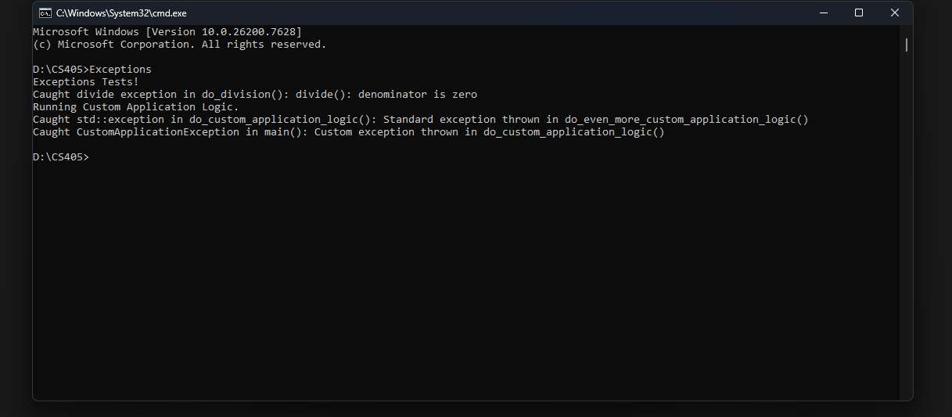
Process Summary
In this activity, structured exception handling was implemented to prevent abrupt program termination. A standard C++ exception was thrown to handle divide-by-zero errors and was caught locally within a noexcept function. Another standard exception was thrown during application logic execution and handled using a std::exception handler. Additionally, a custom exception derived from std::exception was created, thrown, and explicitly caught in main(). A catch-all handler was implemented at the application boundary to ensure stability. This approach demonstrates robust error handling, improved reliability, and adherence to C++ best practices.

